SUPPLEMENTARY MATERIAL LEGENDS
Supplementary Table S1. Overall annual mortality involving heart failure and acute myocardial infarction in U.S. adults aged 25 years or older, 1999 to 2024
Supplementary Table S2. Sex-stratified age-adjusted mortality rates per 100,000 involving heart failure and acute myocardial infarction in U.S. adults aged 25 years or older, 1999 to 2024
Supplementary Table S3. Race/ethnicity-stratified age-adjusted mortality rates per 100,000 involving heart failure and acute myocardial infarction in U.S. adults aged 25 years or older, 1999 to 2024
Supplementary Table S4. Census region-stratified age-adjusted mortality rates per 100,000 involving heart failure and acute myocardial infarction in U.S. adults aged 25 years or older, 1999 to 2024
Supplementary Table S5: Urbanization-stratified age-adjusted mortality rates per 100,000 involving heart failure and acute myocardial infarction in U.S. adults aged 25 years or older, 1999 to 2020.
Supplementary Table S6. Crude mortality rates per 100,000 involving heart failure and acute myocardial infarction stratified by ten-year age group in the United States, 1999–2024.
Supplementary Table S7. Deaths involving heart failure and acute myocardial infarction stratified by place of death
Supplementary Table S8. Observed-versus-Expected Mortality Involving Heart Failure and Acute Myocardial Infarction in U.S. Adults Aged ≥25 Years, 2020–2024.
Supplementary Table S9. Interrupted Time-Series Sensitivity Analysis of Mortality Involving Heart Failure and Acute Myocardial Infarction in U.S. Adults Aged ≥25 Years, 1999–2024.
Supplementary Table S10. Joinpoint Regression Analysis Specifications Used for Temporal Trend Modeling.
Supplementary Figure S1. Observed and Expected Age-Adjusted Mortality Rates Involving Heart Failure and Acute Myocardial Infarction, 2015–2024.
Supplementary Figure S2. Interrupted Time-Series Sensitivity Analysis of Mortality Involving Heart Failure and Acute Myocardial Infarction, 1999–2024.
Supplementary Table S1. Overall annual mortality involving heart failure and acute myocardial infarction in U.S. adults aged 25 years or older, 1999 to 2024
Year | Deaths | Population | AAMR (95% CI) | SE
1999 | 26,905 | 180,408,769 | 15.32 (15.14-15.50) | 0.09
2000 | 26,653 | 181,984,640 | 14.94 (14.76-15.12) | 0.09
2001 | 25,598 | 184,305,128 | 14.11 (13.93-14.29) | 0.09
2002 | 25,000 | 186,208,028 | 13.62 (13.44-13.80) | 0.09
2003 | 24,226 | 188,090,429 | 12.98 (12.82-13.14) | 0.08
2004 | 23,014 | 190,205,384 | 12.16 (12.00-12.32) | 0.08
2005 | 22,721 | 192,551,384 | 11.75 (11.59-11.91) | 0.08
2006 | 21,230 | 195,019,359 | 10.71 (10.57-10.85) | 0.07
2007 | 20,206 | 197,403,777 | 9.99 (9.85-10.13) | 0.07
2008 | 19,854 | 199,795,090 | 9.60 (9.46-9.74) | 0.07
2009 | 18,631 | 202,107,016 | 8.82 (8.68-8.96) | 0.07
2010 | 18,104 | 203,891,983 | 8.40 (8.28-8.52) | 0.06
2011 | 18,106 | 206,592,936 | 8.17 (8.05-8.29) | 0.06
2012 | 17,988 | 208,826,037 | 7.93 (7.81-8.05) | 0.06
2013 | 17,876 | 211,085,314 | 7.70 (7.58-7.82) | 0.06
2014 | 18,188 | 213,809,280 | 7.63 (7.51-7.75) | 0.06
2015 | 18,665 | 216,553,817 | 7.67 (7.55-7.79) | 0.06
2016 | 18,928 | 218,641,417 | 7.61 (7.49-7.73) | 0.06
2017 | 19,608 | 221,447,331 | 7.73 (7.61-7.85) | 0.06
2018 | 19,895 | 223,311,190 | 7.68 (7.56-7.80) | 0.06
2019 | 20,101 | 224,981,167 | 7.60 (7.50-7.70) | 0.05
2020 | 21,984 | 226,635,013 | 8.17 (8.05-8.29) | 0.06
2021 | 23,346 | 228,238,412 | 8.92 (8.80-9.04) | 0.06
2022 | 22,702 | 229,508,599 | 8.25 (8.13-8.37) | 0.06
2023 | 21,566 | 231,529,762 | 7.84 (7.74-7.94) | 0.05
2024 | 21,396 | 235,615,087 | 7.55 (7.45-7.65) | 0.05

AAMR = age-adjusted mortality rate per 100,000 population; CI = confidence interval; SE = standard error. Rates were age-adjusted to the 2000 U.S. standard population.

Supplementary Table S2. Sex-stratified age-adjusted mortality rates per 100,000 involving heart failure and acute myocardial infarction in U.S. adults aged 25 years or older, 1999 to 2024
Year | Male (AAMR, 95%CI) | Female (AAMR, 95%CI)
1999 | 19.05 (18.72-19.38) | 12.84 (12.62-13.06)
2000 | 18.73 (18.40-19.06) | 12.49 (12.27-12.71)
2001 | 17.52 (17.21-17.83) | 11.93 (11.73-12.13)
2002 | 16.93 (16.62-17.24) | 11.44 (11.24-11.64)
2003 | 16.13 (15.84-16.42) | 10.82 (10.62-11.02)
2004 | 15.04 (14.75-15.33) | 10.14 (9.96-10.32)
2005 | 14.48 (14.21-14.75) | 9.86 (9.68-10.04)
2006 | 13.33 (13.08-13.58) | 8.94 (8.76-9.12)
2007 | 12.25 (12.00-12.50) | 8.41 (8.25-8.57)
2008 | 11.83 (11.59-12.07) | 8.06 (7.90-8.22)
2009 | 11.02 (10.78-11.26) | 7.33 (7.17-7.49)
2010 | 10.53 (10.31-10.75) | 6.96 (6.82-7.10)
2011 | 10.41 (10.19-10.63) | 6.58 (6.44-6.72)
2012 | 10.00 (9.78-10.22) | 6.45 (6.31-6.59)
2013 | 9.80 (9.60-10.00) | 6.14 (6.00-6.28)
2014 | 9.83 (9.63-10.03) | 6.02 (5.88-6.16)
2015 | 9.69 (9.49-9.89) | 6.15 (6.01-6.29)
2016 | 9.87 (9.67-10.07) | 5.90 (5.78-6.02)
2017 | 10.00 (9.80-10.20) | 6.01 (5.89-6.13)
2018 | 10.10 (9.90-10.30) | 5.79 (5.67-5.91)
2019 | 10.05 (9.85-10.25) | 5.74 (5.62-5.86)
2020 | 10.86 (10.66-11.06) | 6.09 (5.97-6.21)
2021 | 11.72 (11.52-11.92) | 6.75 (6.61-6.89)
2022 | 11.04 (10.84-11.24) | 6.15 (6.03-6.27)
2023 | 10.38 (10.18-10.58) | 5.83 (5.71-5.95)
2024 | 9.92 (9.74-10.10) | 5.61 (5.49-5.73)

Abbreviation: AAMR = age-adjusted mortality rate per 100,000 population; CI = confidence interval. Rates were age-adjusted to the 2000 U.S. standard population.

Supplementary Table S3. Race/ethnicity-stratified age-adjusted mortality rates per 100,000 involving heart failure and acute myocardial infarction in U.S. adults aged 25 years or older, 1999 to 2024
Year | NH White | NH Black or African American | NH American Indian or Alaska Native | NH Asian or Pacific Islander | Hispanic or Latino
1999 | 15.50 (15.30-15.70) | 15.98 (15.31-16.65) | 15.75 (12.54-18.96) | 8.89 (7.87-9.91) | 11.70 (10.90-12.50)
2000 | 15.19 (14.99-15.39) | 15.66 (15.01-16.31) | 12.36 (9.62-15.10) | 7.99 (7.05-8.93) | 11.47 (10.71-12.23)
2001 | 14.37 (14.17-14.57) | 14.39 (13.76-15.02) | 9.35 (7.00-11.70) | 7.07 (6.23-7.91) | 11.23 (10.50-11.96)
2002 | 13.71 (13.53-13.89) | 14.54 (13.93-15.15) | 12.95 (10.30-15.60) | 8.78 (7.86-9.70) | 10.65 (9.94-11.36)
2003 | 13.21 (13.03-13.39) | 13.14 (12.55-13.73) | 14.84 (11.98-17.70) | 6.66 (5.90-7.42) | 10.26 (9.59-10.93)
2004 | 12.35 (12.17-12.53) | 12.71 (12.14-13.28) | 12.98 (10.33-15.63) | 6.76 (6.00-7.52) | 9.40 (8.77-10.03)
2005 | 11.83 (11.65-12.01) | 13.01 (12.44-13.58) | 7.77 (5.75-9.79) | 7.23 (6.49-7.97) | 9.27 (8.66-9.88)
2006 | 10.85 (10.69-11.01) | 11.51 (10.98-12.04) | 11.19 (8.78-13.60) | 7.09 (6.36-7.82) | 8.78 (8.21-9.35)
2007 | 10.10 (9.94-10.26) | 10.94 (10.43-11.45) | 8.95 (6.93-10.97) | 6.40 (5.73-7.07) | 8.15 (7.62-8.68)
2008 | 9.78 (9.62-9.94) | 10.07 (9.60-10.54) | 8.95 (6.89-11.01) | 5.35 (4.76-5.94) | 7.72 (7.21-8.23)
2009 | 9.01 (8.87-9.15) | 9.23 (8.78-9.68) | 11.19 (8.88-13.50) | 5.52 (4.95-6.09) | 6.73 (6.28-7.18)
2010 | 8.59 (8.45-8.73) | 9.05 (8.60-9.50) | 7.73 (5.87-9.59) | 5.29 (4.74-5.84) | 6.40 (5.97-6.83)
2011 | 8.38 (8.24-8.52) | 8.67 (8.24-9.10) | 9.42 (7.50-11.34) | 4.59 (4.10-5.08) | 6.28 (5.87-6.69)
2012 | 8.16 (8.02-8.30) | 8.30 (7.89-8.71) | 9.72 (7.78-11.66) | 4.51 (4.04-4.98) | 5.91 (5.52-6.30)
2013 | 7.88 (7.74-8.02) | 8.33 (7.92-8.74) | 8.00 (6.33-9.67) | 4.61 (4.16-5.06) | 5.74 (5.37-6.11)
2014 | 7.83 (7.69-7.97) | 8.28 (7.89-8.67) | 9.03 (7.27-10.79) | 4.47 (4.04-4.90) | 5.89 (5.52-6.26)
2015 | 7.83 (7.71-7.95) | 8.44 (8.05-8.83) | 8.14 (6.49-9.79) | 4.51 (4.10-4.92) | 5.98 (5.63-6.33)
2016 | 7.80 (7.68-7.92) | 8.38 (7.99-8.77) | 9.45 (7.74-11.16) | 4.32 (3.93-4.71) | 5.96 (5.61-6.31)
2017 | 7.88 (7.76-8.00) | 8.50 (8.13-8.87) | 8.20 (6.67-9.73) | 4.72 (4.33-5.11) | 6.15 (5.82-6.48)
2018 | 7.77 (7.65-7.89) | 8.02 (7.67-8.37) | 6.44 (5.26-7.62) | 4.57 (4.18-4.96) | 6.07 (5.74-6.40)
2019 | 7.69 (7.57-7.81) | 8.62 (8.25-8.99) | 7.62 (6.35-8.89) | 3.98 (3.63-4.33) | 6.39 (6.06-6.72)
2020 | 8.19 (8.07-8.31) | 9.57 (9.20-9.94) | 8.44 (7.17-9.71) | 4.74 (4.37-5.11) | 7.27 (6.92-7.62)
2021 | 9.06 (8.92-9.20) | 9.92 (9.53-10.31) | 8.15 (6.92-9.38) | 5.02 (4.63-5.41) | 7.38 (7.03-7.73)
2022 | 8.37 (8.25-8.49) | 9.40 (9.03-9.77) | 6.98 (5.86-8.10) | 4.74 (4.39-5.09) | 6.69 (6.38-7.00)
2023 | 7.93 (7.81-8.05) | 9.35 (8.98-9.72) | 5.53 (4.57-6.49) | 4.11 (3.78-4.44) | 6.36 (6.05-6.67)
2024 | 7.57 (7.45-7.69) | 8.98 (8.63-9.33) | 6.84 (5.80-7.88) | 4.38 (4.05-4.71) | 5.91 (5.62-6.20)

Abbreviation: NH = non-Hispanic; AAMR = age-adjusted mortality rate per 100,000 population; CI = confidence interval. Rates were age-adjusted to the 2000 U.S. standard population.
Supplementary Table S4. Census region-stratified age-adjusted mortality rates per 100,000 involving heart failure and acute myocardial infarction in U.S. adults aged 25 years or older, 1999 to 2024
Year | Northeast | Midwest | South | West
1999 | 13.76 (13.39-14.13) | 17.37 (16.98-17.76) | 15.95 (15.64-16.26) | 13.24 (12.85-13.63)
2000 | 13.47 (13.10-13.84) | 16.24 (15.87-16.61) | 16.14 (15.83-16.45) | 12.82 (12.45-13.19)
2001 | 13.11 (12.76-13.46) | 15.43 (15.06-15.80) | 14.96 (14.67-15.25) | 12.10 (11.75-12.45)
2002 | 12.29 (11.94-12.64) | 14.62 (14.27-14.97) | 14.48 (14.19-14.77) | 12.17 (11.82-12.52)
2003 | 11.47 (11.14-11.80) | 13.87 (13.52-14.22) | 13.76 (13.47-14.05) | 11.95 (11.60-12.30)
2004 | 10.95 (10.62-11.28) | 12.49 (12.16-12.82) | 13.00 (12.73-13.27) | 11.31 (10.98-11.64)
2005 | 10.73 (10.42-11.04) | 12.13 (11.82-12.44) | 12.61 (12.34-12.88) | 10.61 (10.30-10.92)
2006 | 9.50 (9.21-9.79) | 11.22 (10.91-11.53) | 11.54 (11.29-11.79) | 9.92 (9.61-10.23)
2007 | 8.83 (8.54-9.12) | 9.92 (9.63-10.21) | 11.02 (10.78-11.26) | 9.27 (8.98-9.56)
2008 | 8.23 (7.96-8.50) | 9.75 (9.48-10.02) | 10.56 (10.32-10.80) | 9.01 (8.72-9.30)
2009 | 7.50 (7.25-7.75) | 9.02 (8.75-9.29) | 9.66 (9.44-9.88) | 8.36 (8.09-8.63)
2010 | 7.60 (7.35-7.85) | 8.35 (8.10-8.60) | 9.19 (8.97-9.41) | 7.94 (7.69-8.19)
2011 | 7.32 (7.07-7.57) | 8.32 (8.07-8.57) | 8.64 (8.42-8.86) | 7.99 (7.74-8.24)
2012 | 7.05 (6.80-7.30) | 8.12 (7.87-8.37) | 8.56 (8.36-8.76) | 7.35 (7.11-7.59)
2013 | 6.98 (6.74-7.22) | 7.92 (7.68-8.16) | 8.12 (7.92-8.32) | 7.19 (6.95-7.43)
2014 | 6.68 (6.44-6.92) | 7.99 (7.75-8.23) | 8.21 (8.01-8.41) | 7.10 (6.86-7.34)
2015 | 6.64 (6.40-6.88) | 7.88 (7.64-8.12) | 8.16 (7.96-8.36) | 7.48 (7.24-7.72)
2016 | 6.52 (6.28-6.76) | 7.75 (7.51-7.99) | 8.04 (7.86-8.22) | 7.59 (7.35-7.83)
2017 | 6.22 (6.00-6.44) | 8.10 (7.86-8.34) | 8.22 (8.04-8.40) | 7.68 (7.44-7.92)
2018 | 6.16 (5.94-6.38) | 8.02 (7.78-8.26) | 8.31 (8.13-8.49) | 7.48 (7.24-7.72)
2019 | 5.84 (5.62-6.06) | 7.83 (7.59-8.07) | 8.31 (8.13-8.49) | 7.55 (7.33-7.77)
2020 | 6.25 (6.03-6.47) | 8.53 (8.29-8.77) | 8.98 (8.78-9.18) | 7.90 (7.66-8.14)
2021 | 6.42 (6.18-6.66) | 9.35 (9.10-9.60) | 9.93 (9.73-10.13) | 8.91 (8.66-9.16)
2022 | 6.02 (5.80-6.24) | 8.64 (8.40-8.88) | 9.13 (8.95-9.31) | 8.30 (8.06-8.54)
2023 | 5.63 (5.41-5.85) | 8.11 (7.87-8.35) | 8.85 (8.67-9.03) | 7.59 (7.37-7.81)
2024 | 5.40 (5.20-5.60) | 7.59 (7.37-7.81) | 8.64 (8.46-8.82) | 7.29 (7.07-7.51)

Abbreviation: AAMR = age-adjusted mortality rate per 100,000 population; CI = confidence interval. Rates were age-adjusted to the 2000 U.S. standard population.

Supplementary Table S5: Urbanization-stratified age-adjusted mortality rates per 100,000 involving heart failure and acute myocardial infarction in U.S. adults aged 25 years or older, 1999 to 2020.
Urbanization | Year | Age Adjusted Rate
Metropolitan | 1999 | 14.07 (13.87-14.26)
Metropolitan | 2000 | 13.8 (13.61-14)
Metropolitan | 2001 | 13.07 (12.89-13.26)
Metropolitan | 2002 | 12.6 (12.42-12.78)
Metropolitan | 2003 | 11.82 (11.65-12)
Metropolitan | 2004 | 11.04 (10.87-11.2)
Metropolitan | 2005 | 10.55 (10.39-10.71)
Metropolitan | 2006 | 9.64 (9.49-9.8)
Metropolitan | 2007 | 9.04 (8.89-9.18)
Metropolitan | 2008 | 8.58 (8.44-8.72)
Metropolitan | 2009 | 7.76 (7.63-7.89)
Metropolitan | 2010 | 7.59 (7.46-7.72)
Metropolitan | 2011 | 7.27 (7.14-7.39)
Metropolitan | 2012 | 7.04 (6.91-7.16)
Metropolitan | 2013 | 6.89 (6.77-7)
Metropolitan | 2014 | 6.78 (6.67-6.9)
Metropolitan | 2015 | 6.78 (6.67-6.9)
Metropolitan | 2016 | 6.76 (6.65-6.88)
Metropolitan | 2017 | 6.84 (6.73-6.95)
Metropolitan | 2018 | 6.81 (6.69-6.92)
Metropolitan | 2019 | 6.74 (6.63-6.85)
Metropolitan | 2020 | 7.22 (7.1-7.33)
Nonmetropolitan | 1999 | 20.5 (20.02-20.98)
Nonmetropolitan | 2000 | 19.85 (19.38-20.33)
Nonmetropolitan | 2001 | 18.74 (18.28-19.19)
Nonmetropolitan | 2002 | 17.86 (17.41-18.3)
Nonmetropolitan | 2003 | 17.92 (17.48-18.37)
Nonmetropolitan | 2004 | 16.91 (16.48-17.34)
Nonmetropolitan | 2005 | 16.93 (16.5-17.36)
Nonmetropolitan | 2006 | 15.6 (15.19-16)
Nonmetropolitan | 2007 | 14.31 (13.92-14.7)
Nonmetropolitan | 2008 | 14.26 (13.88-14.64)
Nonmetropolitan | 2009 | 13.57 (13.2-13.95)
Nonmetropolitan | 2010 | 12.27 (11.92-12.63)
Nonmetropolitan | 2011 | 12.51 (12.16-12.87)
Nonmetropolitan | 2012 | 12.19 (11.84-12.54)
Nonmetropolitan | 2013 | 11.56 (11.22-11.89)
Nonmetropolitan | 2014 | 11.89 (11.55-12.23)
Nonmetropolitan | 2015 | 12.08 (11.74-12.42)
Nonmetropolitan | 2016 | 11.77 (11.43-12.1)
Nonmetropolitan | 2017 | 12.02 (11.69-12.36)
Nonmetropolitan | 2018 | 11.98 (11.65-12.32)
Nonmetropolitan | 2019 | 11.95 (11.62-12.27)
Nonmetropolitan | 2020 | 13.1 (12.76-13.45)

Note: Comparable urbanization classifications were not available through 2024; therefore, this analysis was restricted to 1999–2020.

Supplementary Table S6. Crude mortality rates per 100,000 involving heart failure and acute myocardial infarction stratified by ten-year age group in the United States, 1999–2024.
Year | 25-34 years | 35-44 years | 45-54 years | 55-64 years | 65-74 years | 75-84 years | 85+ years
1999 | 0.08 (0.06-0.10) | 0.36 (0.30-0.42) | 1.67 (1.53-1.81) | 7.58 (7.23-7.93) | 25.79 (25.06-26.52) | 76.05 (74.50-77.60) | 246.75 (241.97-251.53)
2000 | 0.07 (0.05-0.09) | 0.33 (0.27-0.39) | 1.75 (1.61-1.89) | 7.84 (7.49-8.19) | 23.82 (23.11-24.53) | 74.22 (72.71-75.73) | 244.36 (239.66-249.06)
2001 | 0.08 (0.06-0.10) | 0.34 (0.28-0.40) | 1.62 (1.50-1.74) | 6.74 (6.43-7.05) | 22.35 (21.66-23.04) | 71.15 (69.68-72.62) | 232.30 (227.75-236.85)
2002 | 0.06 (0.04-0.08) | 0.41 (0.35-0.47) | 1.61 (1.49-1.73) | 6.48 (6.17-6.79) | 20.86 (20.19-21.53) | 66.78 (65.37-68.19) | 230.18 (225.67-234.69)
2003 | 0.05 (0.03-0.07) | 0.36 (0.30-0.42) | 1.53 (1.41-1.65) | 6.16 (5.87-6.45) | 19.43 (18.80-20.06) | 63.34 (61.97-64.71) | 222.45 (218.08-226.82)
2004 | 0.06 (0.04-0.08) | 0.38 (0.32-0.44) | 1.56 (1.44-1.68) | 5.72 (5.45-5.99) | 18.18 (17.57-18.79) | 58.45 (57.14-59.76) | 209.18 (204.97-213.39)
2005 | 0.06 (0.04-0.08) | 0.36 (0.30-0.42) | 1.48 (1.36-1.60) | 5.75 (5.48-6.02) | 17.52 (16.93-18.11) | 56.57 (55.28-57.86) | 201.37 (197.31-205.43)
2006 | 0.05 (0.03-0.07) | 0.34 (0.28-0.40) | 1.54 (1.42-1.66) | 5.14 (4.89-5.39) | 16.07 (15.50-16.64) | 51.91 (50.68-53.14) | 182.27 (178.47-186.07)
2007 | 0.10 (0.06-0.14) | 0.38 (0.32-0.44) | 1.41 (1.29-1.53) | 5.00 (4.76-5.24) | 15.17 (14.62-15.72) | 46.88 (45.70-48.06) | 170.75 (167.14-174.36)
2008 | 0.09 (0.07-0.11) | 0.27 (0.21-0.33) | 1.40 (1.28-1.52) | 4.65 (4.41-4.89) | 13.94 (13.43-14.45) | 46.15 (44.99-47.31) | 165.57 (162.06-169.08)
2009 | 0.06 (0.04-0.08) | 0.27 (0.21-0.33) | 1.33 (1.23-1.43) | 4.43 (4.21-4.65) | 13.12 (12.63-13.61) | 42.54 (41.42-43.66) | 149.22 (145.95-152.49)
2010 | 0.05 (0.03-0.07) | 0.25 (0.21-0.29) | 1.33 (1.23-1.43) | 4.27 (4.05-4.49) | 12.40 (11.93-12.87) | 40.11 (39.03-41.19) | 143.75 (140.57-146.93)
2011 | 0.05 (0.03-0.07) | 0.33 (0.27-0.39) | 1.29 (1.19-1.39) | 4.09 (3.89-4.29) | 12.72 (12.25-13.19) | 38.78 (37.72-39.84) | 136.83 (133.81-139.85)
2012 | 0.05 (0.03-0.07) | 0.28 (0.22-0.34) | 1.29 (1.19-1.39) | 4.06 (3.86-4.26) | 12.24 (11.79-12.69) | 37.79 (36.75-38.83) | 131.88 (128.94-134.82)
2013 | 0.07 (0.05-0.09) | 0.29 (0.23-0.35) | 1.25 (1.15-1.35) | 4.21 (4.01-4.41) | 11.86 (11.43-12.29) | 36.11 (35.09-37.13) | 127.15 (124.31-129.99)
2014 | 0.07 (0.05-0.09) | 0.30 (0.24-0.36) | 1.34 (1.22-1.46) | 4.53 (4.31-4.75) | 12.11 (11.70-12.52) | 35.83 (34.83-36.83) | 122.36 (119.60-125.12)
2015 | 0.06 (0.04-0.08) | 0.33 (0.27-0.39) | 1.42 (1.30-1.54) | 4.56 (4.34-4.78) | 12.30 (11.89-12.71) | 36.22 (35.22-37.22) | 120.83 (118.11-123.55)
2016 | 0.06 (0.04-0.08) | 0.31 (0.25-0.37) | 1.47 (1.35-1.59) | 4.59 (4.37-4.81) | 12.52 (12.11-12.93) | 35.84 (34.86-36.82) | 118.61 (115.94-121.28)
2017 | 0.06 (0.04-0.08) | 0.39 (0.33-0.45) | 1.47 (1.35-1.59) | 4.88 (4.66-5.10) | 12.81 (12.40-13.22) | 35.73 (34.77-36.69) | 118.90 (116.23-121.57)
2018 | 0.09 (0.07-0.11) | 0.38 (0.32-0.44) | 1.59 (1.47-1.71) | 4.97 (4.75-5.19) | 12.60 (12.21-12.99) | 36.15 (35.21-37.09) | 115.01 (112.40-117.62)
2019 | 0.08 (0.06-0.10) | 0.42 (0.36-0.48) | 1.56 (1.44-1.68) | 5.01 (4.79-5.23) | 12.79 (12.40-13.18) | 35.89 (34.97-36.81) | 111.48 (108.93-114.03)
2020 | 0.10 (0.08-0.12) | 0.50 (0.43–0.57) | 1.96 (1.82–2.10) | 5.87 (5.63-6.11) | 14.30 (13.89-14.71) | 37.97 (37.03-38.91) | 113.35 (110.80-115.90)
2021 | 0.14 (0.10-0.18) | 0.50 (0.43–0.56) | 2.01 (1.87–2.14) | 6.40 (6.16-6.64) | 15.56 (15.15-15.97) | 40.52 (39.54-41.50) | 128.95 (126.07-131.83)
2022 | 0.12 (0.08-0.16) | 0.52 (0.45–0.59) | 1.94 (1.80–2.07) | 6.04 (5.80-6.28) | 14.58 (14.17-14.99) | 38.55 (37.63-39.47) | 114.33 (111.72-116.94)
2023 | 0.08 (0.06-0.10) | 0.48 (0.42–0.54) | 1.95 (1.81-2.08) | 5.57 (5.33-5.81) | 13.84 (13.45-14.23) | 34.95 (34.09-35.81) | 112.66 (110.01-115.31)
2024 | 0.08 (0.06-0.10) | 0.47 (0.40–0.53) | 1.86 (1.72-1.99) | 5.49 (5.27-5.71) | 13.17 (12.80-13.54) | 34.03 (33.21-34.85) | 106.73 (104.20-109.26)

Abbreviation: AAMR = age-adjusted mortality rate per 100,000 population; CI = confidence interval. Rates were age-adjusted to the 2000 U.S. standard population.
Supplementary Table S7. Deaths involving heart failure and acute myocardial infarction stratified by place of death
Place of death | Deaths | Exact % | Whole %
Inpatient medical facility | 260,954 | 47.23% | 47%
Outpatient/ER | 56,475 | 10.22% | 10%
Dead on arrival | 3,926 | 0.71% | 1%
Medical facility status unknown | 475 | 0.09% | 0%
Decedent’s home | 116,651 | 21.11% | 21%
Hospice | 13,046 | 2.36% | 2%
Nursing/LTC | 85,241 | 15.43% | 15%
Other | 14,689 | 2.66% | 3%
Unknown place of death | 1,030 | 0.19% | 0%
Total displayed | 552,487 | 100.00% | 99%

Note: Percentages may not sum to 100% because of rounding. Reported place-of-death categories sum to 552,487 deaths; four deaths are not represented because CDC WONDER suppresses cells with small counts in the 2021–2024 place-of-death query. Suppressed values were not estimated or imputed.

Supplementary Table S8. Observed-versus-Expected Mortality Involving Heart Failure and Acute Myocardial Infarction in U.S. Adults Aged ≥25 Years, 2020–2024
Year | Observed AAMR | Expected AAMR | Lower 95% PI | Upper 95% PI | Absolute Difference | Percentage Difference | Classification
2020 | 8.17 | 7.64 | 7.36 | 7.92 | 0.53 | 7.00% | Above expected range
2021 | 8.92 | 7.63 | 7.31 | 7.95 | 1.29 | 16.90% | Above expected range
2022 | 8.25 | 7.62 | 7.25 | 7.99 | 0.63 | 8.20% | Above expected range
2023 | 7.84 | 7.62 | 7.19 | 8.04 | 0.22 | 2.90% | Within expected range
2024 | 7.55 | 7.61 | 7.13 | 8.08 | −0.06 | −0.8% | Within expected range

Note: Expected AAMRs for 2020–2024 were projected from an ordinary least-squares linear regression fitted to annual AAMRs from 2015–2019, with calendar year modeled as a continuous predictor. Ninety-five percent prediction intervals (PIs) were generated for each projected year. Absolute difference was calculated as observed AAMR minus expected AAMR, and percentage difference as [(observed − expected)/expected] × 100. An observed rate was classified as above or below the expected range when it exceeded the upper or lower 95% prediction limit, respectively. AAMR, age-adjusted mortality rate per 100,000 population; PI, prediction interval.

Supplementary Table S9. Interrupted Time-Series Sensitivity Analysis of Mortality Involving Heart Failure and Acute Myocardial Infarction in U.S. Adults Aged ≥25 Years, 1999–2024
Model Term | Estimate | Standard Error | 95% CI | P Value
Intercept | 14.251 | 0.486 | 13.243 to 15.259 | <0.001
Pre-pandemic time trend (per year) | −0.415 | 0.047 | −0.512 to −0.317 | <0.001
Immediate level change in 2020 | 2.891 | 0.749 | 1.337 to 4.445 | 0.001
Post-2020 slope change (per year) | 0.183 | 0.085 | 0.007 to 0.359 | 0.042

Note: Segmented interrupted time-series regression was fitted to annual overall AAMRs from 1999–2024 with 2020 prespecified as the interruption point. The model included continuous time, a pandemic-period indicator (0 through 2019; 1 from 2020 onward), and time after the interruption (0 through 2019; 1–5 for 2020–2024). Inference used Newey–West heteroscedasticity- and autocorrelation-consistent standard errors with one lag. The pre-pandemic time-trend coefficient represents the annual slope before 2020; the level-change coefficient represents the immediate change in 2020; and the post-2020 slope-change coefficient represents the change in annual slope after the interruption. CI, confidence interval.

Supplementary Table S10. Joinpoint Regression Analysis Specifications Used for Temporal Trend Modeling
Parameter | Setting Used
Joinpoint software | Joinpoint Regression Program, version 6.0.1
Search method | Grid Search
Minimum observations before first joinpoint | 2
Minimum observations after last joinpoint | 2
Minimum observations between consecutive joinpoints | 2
Grid points between adjacent observed x-values | 0
Minimum number of joinpoints | 0
Maximum number of joinpoints | 4
Model selection method | Permutation Test
Overall significance level | 0.05
Number of permutations | 4,499
APC/AAPC/Tau confidence interval method | Parametric method
AAPC range | Entire study period
AAPC period | 1999–2024
Error structure | Annual mortality rates analyzed using corresponding standard errors under the heteroscedastic-errors option
Trend measure | Annual Percent Change (APC) with 95% CI
Overall trend summary | Average Annual Percent Change (AAPC) with 95% CI
Statistical significance | APC/AAPC considered significant when the 95% CI did not include zero
Application across analyses | Same Joinpoint settings applied to overall, sex, race/ethnicity, Census region, urbanization, and age-stratified analyses, using the appropriate annual rate and standard error for each stratum

Note: This table summarizes the Joinpoint Regression Program settings applied to the overall and subgroup mortality trend analyses. Analyses were performed using Joinpoint Regression Program version 6.0.1 with the Grid Search method, allowing 0 to 4 joinpoints. A minimum of two observations was required before the first and after the last joinpoint and between consecutive joinpoints. Model selection was based on the permutation test with an overall significance level of 0.05 and 4,499 permutations. Parametric confidence intervals were used for annual percent change (APC) and average annual percent change (AAPC) estimates, with AAPC calculated across the full study period from 1999 through 2024. The same model specifications were applied consistently across the overall, sex, race/ethnicity, U.S. Census region, urbanization, and age-stratified analyses, using the corresponding annual mortality rates and standard errors for each stratum.

Supplementary Figure S1. Observed and Expected Age-Adjusted Mortality Rates Involving Heart Failure and Acute Myocardial Infarction, 2015–2024.
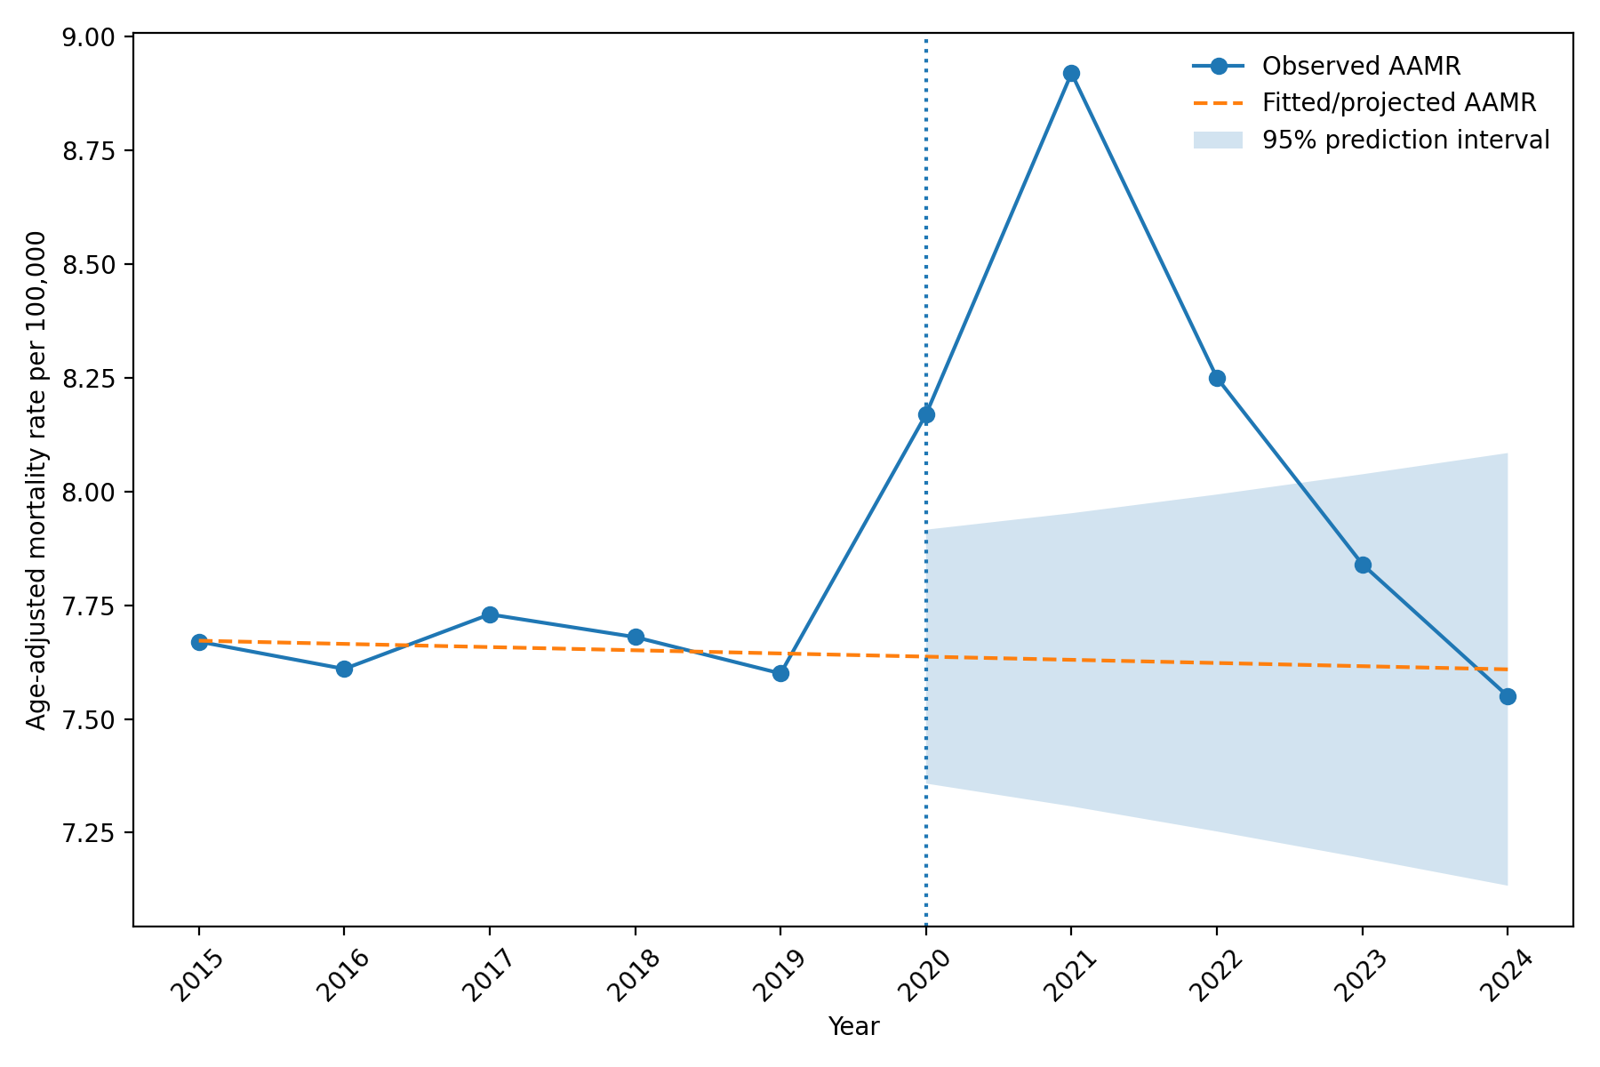
Note: Observed age-adjusted mortality rates (AAMRs) are shown alongside rates projected from the 2015–2019 pre-pandemic linear trend. Expected AAMRs for 2020–2024 were generated using ordinary least-squares regression with calendar year as a continuous predictor. The shaded area represents the 95% prediction interval. The vertical reference line denotes the beginning of the pandemic period in 2020. AAMR = age-adjusted mortality rate per 100,000 population.
Supplementary Figure S2. Interrupted Time-Series Sensitivity Analysis of Mortality Involving Heart Failure and Acute Myocardial Infarction, 1999–2024.
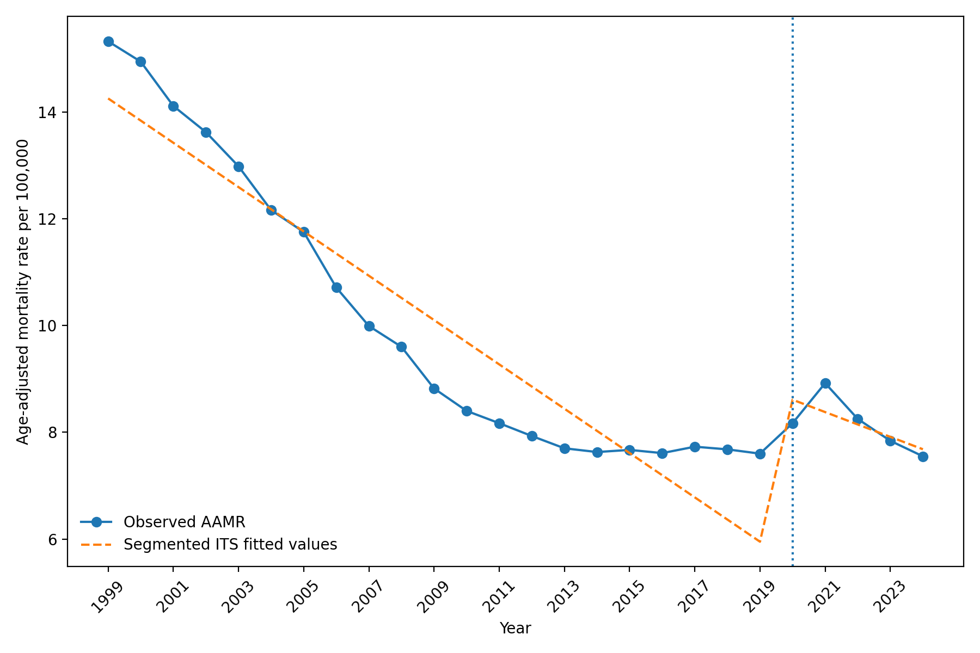
Note: Observed annual age-adjusted mortality rates are shown with fitted values from a segmented interrupted time-series regression using 2020 as the prespecified interruption point. The model included continuous time, a pandemic-period indicator, and time after the interruption. Inference used Newey–West heteroscedasticity- and autocorrelation-consistent standard errors with one lag. The vertical reference line denotes the interruption point in 2020. AAMR = age-adjusted mortality rate per 100,000 population.

