Supplementary material
Supplementary Table 1
Variable | Before matching SMD | After matching SMD
Age | 1.137 | 0.054
Gender | 0.848 | -0.029
DM | 0.297 | -0.153
Hypertension | 0.454 | 0.008
Smoking | -0.053 | -0.07
Dyslipidemia | 0.013 | -0.112
CVA | 0.209 | 0.137
PVD | 0.18 | -0.107
HbA1c | 0.172 | -0.042
Time from symptom onset-to-hospital arrival time | 0.368 | -0.052
Time from hospital arrival to PCI | 0.303 | 0.028

Supplementary Table 2
Univariable and Multivariable Logistic Regression After PSM-
Predictors of All-Cause Mortality
Model | Predictor | OR (95% CI) | p value
Univariable | Moderate/severe TR | 2.04 (1.11-3.74) | 0.021
 | Age | 1.11 (1.09-1.13) | <0.001
 | Peak CPK per 100 U/L | 1.01 (1.00-1.01) | 0.033
 | EF <50% | 4.14 (2.21-7.76) | <0.001
 | RVD | 4.72 (2.46-9.06) | <0.001
 | Moderate/severe MR | 5.15 (3.42-7.74) | <0.001
Multivariable | Moderate/severe TR | 2.43 (1.33-4.45) | 0.004
 | Age | 1.1 (1.08-1.12) | <0.001
 | Peak CPK per 100 U/L | 1.00 (1.00-1.01) | 0.156
 | EF <50% | 2.88 (1.47-5.65) | 0.002
 | RVD | 2.01 (0.87-4.62) | 0.1
 | Moderate/severe MR | 2.29 (1.40-3.76) | <0.001

Supplementary Figure 1
Chart flow
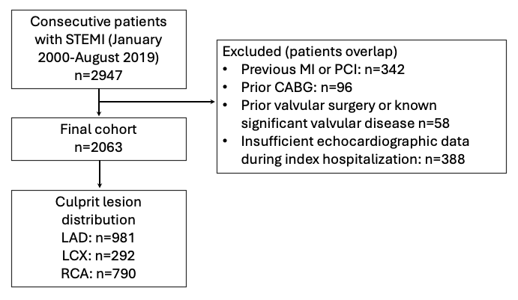

Supplementary Figure 2
Covariate balance before and after propensity score matching
