Additional file 1
Figure e1: Overall NASA TLX

Series choreography Parallel choreography
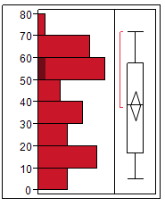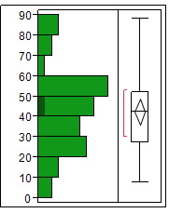

Figure e2: Time to task completion
Series choreography Parallel choreography
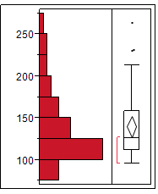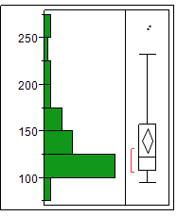

Figure e3: Series choreography NASA TLX per type of case per subject
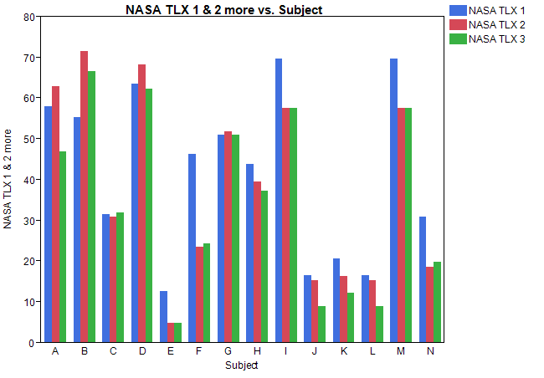

NASA TLX Case 1 NASA TLX Case 2 NASA TLX Case 3
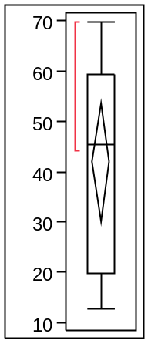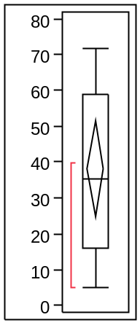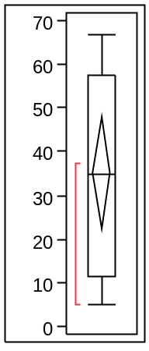

Median (IQR)
45 (20 – 59) | 35 (16 – 59) | 35 (12 – 58)

Figure e4: Parallel choreography NASA TLX per type of case per subject
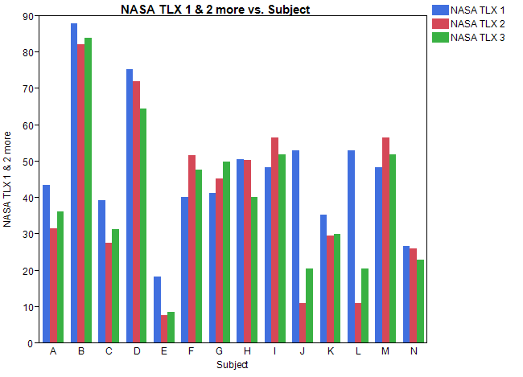
NASA TLX Case 1 NASA TLX Case 2 NASA TLX Case 3
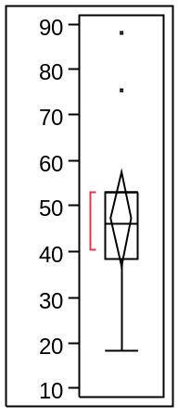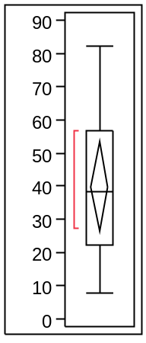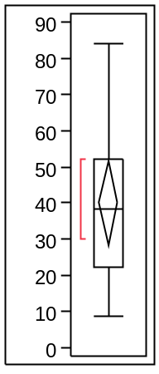

Median (IQR)
46 (38 – 53) | 39 (22 – 57) | 38 (22 – 52)

Figure e5: Time to completion of task per case type

Time case 1 Time case 2 Time case 3

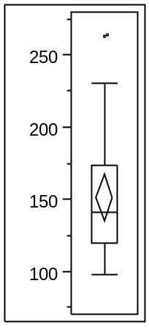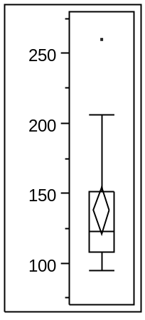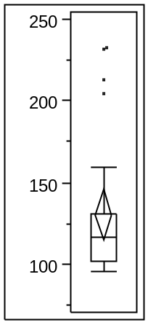

Table E1: NASA TLX subscales per subject for series and parallel
Subject | NASA TLX subscale | Mean raw rating series  (+ SD) | Mean raw rating parallel (+ SD) | Wilcoxon Signed Rank, P =
A | Mental demand | 68.3 (+ 2.9) | 35 (+ 8.7) | 0.25
 | Physical demand | 60 (+ 8.6) | 35 (+ 5) | 0.25
 | Temporal demand | 71.7 (+ 5.8) | 43.3 (+ 5.8) | 0.25
 | Performance | 40 (+ 17.3) | 33.3 (+ 10.4) | 0.5
 | Effort | 60 (+8.7) | 43.3 (+ 10.4) | 0.25
 | Frustration | 61.7 (+ 2.9) | 33.3 (+ 2.9) | 0.25
B | Mental demand | 73.3 (+ 20.8) | 88.3 (+ 2.9) | 0.5
 | Physical demand | 15 (+ 5) | 18.3 (+ 14.4) | 1.0
 | Temporal demand | 33.3 (+ 18.9) | 51.7 (+ 10.4) | 0.25
 | Performance | 90 (+ 0) | 83.3 (+ 5.8) | 0.5
 | Effort | 48.3 (+ 12.6) | 76.7 (+ 23.1) | 0.5
 | Frustration | 31.7 (+ 30.6) | 91.7 (+ 2.9) | 0.25
C | Mental demand | 18.3 (+ 2.9) | 23.3 (+ 10.4) | 0.75
 | Physical demand | 8.3 (+ 2.9) | 11.7 (+ 2.9) | 0.5
 | Temporal demand | 21.7 (+ 7.6) | 31.7 (+ 7.6) | 0.25
 | Performance | 46.7 (+ 20.2) | 43.3 (+ 2.9) | 0.75
 | Effort | 16.7 (+ 5.8) | 30 (+ 5) | 0.25
 | Frustration | 41.7 (+ 7.6) | 40 (+ 5) | 1.0
D | Mental demand | 58.3 (+ 5.8) | 75 (+ 5) | 0.25
 | Physical demand | 58.3 (+ 5.8) | 56.7 (+ 2.9) | 1.0
 | Temporal demand | 58.3 (+ 5.8) | 71.7 (+ 10.4) | 0.25
 | Performance | 88.3 (+ 2.9) | 55 (+ 5) | 0.25
 | Effort | 38.3 (+ 2.9) | 78.3 (+ 7.6) | 0.25
 | Frustration | 31.7 (+ 10.4) | 61.7 (+ 11.5) | 0.025
E | Mental demand | 5 (+ 0) | 13.3 (+ 10.4) | 0.5
 | Physical demand | 5 (+ 0) | 16.7 (+ 16.1) | 0.5
 | Temporal demand | 5 (+ 0) | 8.3 (+ 2.9) | 0.5
 | Performance | 10 (+ 8.7) | 6.7 (+ 2.9) | 1.0
 | Effort | 8.3 (+ 5.8) | 11.7 (+ 5.8) | 1.0
 | Frustration | 5 (+ 0) | 13.3 (+ 10.4) | 0.5
F | Mental demand | 30 (+ 10) | 66.7 (+ 20.2) | 0.25
 | Physical demand | 10 (+ 0) | 8.3 (+ 2.9) | 1.0
 | Temporal demand | 33.3 (+ 10.4) | 40 (+ 15) | 1.0
 | Performance | 35 (+ 34.7) | 20 (+ 8.7) | 1.0
 | Effort | 33.3 (+ 15.3) | 36.7 (+ 15.3) | 1.0
 | Frustration | 13.3 (+ 7.6) | 51.7 (+ 7.6) | 0.25
G | Mental demand | 28.3 (+ 5.8) | 28.3 (+ 5.8) | 1.0
 | Physical demand | 5 (+ 0) | 5 (+ 0) | 1.0
 | Temporal demand | 65 (+ 5) | 58.3 (+ 7.6) | 0.5
 | Performance | 45 (+ 5) | 36.7 (+ 2.9) | 0.25
 | Effort | 30 (+ 13.2) | 30 (+ 5) | 1.0
 | Frustration | 63.3 (+ 2.9) | 58.3 (+ 2.9) | 0.5
H | Mental demand | 68.3 (+ 5.8) | 76.7 (+ 5.8) | 0.25
 | Physical demand | 5 (+ 0) | 5 (+ 0) | 1.0
 | Temporal demand | 50 (+ 0) | 60 (+ 8.7) | 0.25
 | Performance | 30 (+ 13.2) | 30 (+ 13.2) | 1.0
 | Effort | 5 (+ 0) | 5 (+ 0) | 1.0
 | Frustration | 5 (+ 0) | 5 (+ 0) | 1.0
I | Mental demand | 66.7 (+ 7.6) | 53.3 (+ 10.4) | 0.5
 | Physical demand | 40 (+ 8.7) | 35 (+ 8.7) | 0.25
 | Temporal demand | 61.7 (+ 12.6) | 50 (+ 8.7) | 0.75
 | Performance | 65 (+ 8.7) | 60 (+ 5) | 0.5
 | Effort | 56.7 (+ 12.6) | 53.3 (+ 7.6) | 1.0
 | Frustration | 50 (+ 21.8) | 35 (+ 0) | 0.5
J | Mental demand | 13.3 (+ 7.6) | 36.7 (+ 34) | 0.5
 | Physical demand | 5 (+ 0) | 5 (+ 0) | 1.0
 | Temporal demand | 13.3 (+ 2.9) | 30 (+ 30.4) | 0.75
 | Performance | 13.3 (+ 2.9) | 20 (+ 10) | 0.5
 | Effort | 16.7 (+ 7.6) | 21.7 (+ 5.8) | 1.0
 | Frustration | 6.7 (+ 2.9) | 13.3 (+ 10.4) | 0.5
K | Mental demand | 20 (+ 8.7) | 38.3 (+ 2.9) | 0.25
 | Physical demand | 8.3 (+ 2.9) | 10 (+ 0) | 0.5
 | Temporal demand | 15 (+ 5) | 31.7 (+ 7.6) | 0.25
 | Performance | 15 (+ 0) | 23.3 (+ 2.9) | 0.25
 | Effort | 20 (+ 10) | 35 (+ 5) | 0.25
 | Frustration | 13.3 (+ 5.8) | 30 (+ 0) | 0.25
L | Mental demand | 5 (+ 0) | 5 (+ 0) | 1.0
 | Physical demand | 5 (+ 0) | 5 (+ 0) | 1.0
 | Temporal demand | 5 (+ 0 ) | 5 (+ 0) | 1.0
 | Performance | 13.3 (+ 2.9) | 11.7 (+ 2.9) | 1.0
 | Effort | 6.7 (+ 2.9) | 5 (+ 0) | 1.0
 | Frustration | 18.3 (+ 2.9) | 20 (+ 0) | 1.0
M | Mental demand | 36.7 (+ 5.8) | 36.7 (+ 11.5) | 1.0
 | Physical demand | 31.7 (+ 2.9) | 33.3 (+ 5.8) | 1.0
 | Temporal demand | 70 (+ 0) | 70 (+ 18.0) | 1.0
 | Performance | 70 (+ 0) | 70 (+ 8.7) | 1.0
 | Effort | 33.3 (+ 2.9) | 35 (+ 10) | 1.0
 | Frustration | 40 (+ 5) | 35 (+ 5) | 0.5
N | Mental demand | 23.3 (+ 5.8) | 28.3 (+ 7.6) | 0.5
 | Physical demand | 10 (+ 0) | 10 (+ 0) | 1.0
 | Temporal demand | 25 (+ 8.7) | 28.3 (+ 2.9) | 0.75
 | Performance | 21.7 (+ 2.9) | 23.3 (+ 2.9) | 1.0
 | Effort | 23.3 (+ 10.4) | 21.7 (+ 2.9) | 1.0
 | Frustration | 25 (+ 8.7) | 26.7 (+ 7.6) | 1.0

Table E2: Comments from participants during debriefing
Artificial environment, no preference
In simulation scenarios I liked series better. Parallel was difficult because of prompts.
Preference: Ideally should be parallel in the ICU. Series may be well suited to outpatient medicine. Further studies should focus on real time simulation in sim lab.
Series is better for critically ill patients, less demand mentally. SAMPLE organizes afterward.
After I completed the study, I realized that I like the parallel model of getting the history.
Prefer parallel over series.
Parallel seemed to provide more clinically useful information in a more rapid fashion. Likely less time needed with parallel compared to stepwise series investigation/history.
I feel that the series approach is more similar to my current practice and therefore easier for me to accomplish.

