Supplementary Information

Supplementary Table 1 Counts of attendances to ED before and during the pandemic period stratified by age, ethnicity and deprivation decile. For ethnic groups a row-wise test of proportion p value is shown for individual categories in addition to the overall chi-squared test.

Characteristic | Overall, N = 38,336¹ | During 1st wave, N = 14,828¹ | Pre-pandemic, N = 23,508¹ | p-value²
Age Group |  |  |  | <0.001
[18,26.7] | 6,470 (17%) | 1,951 (13%) | 4,519 (19%)
(26.7,35.4] | 5,856 (15%) | 2,129 (14%) | 3,727 (16%)
(35.4,44.1] | 4,479 (12%) | 1,794 (12%) | 2,685 (11%)
(44.1,52.8] | 4,162 (11%) | 1,740 (12%) | 2,422 (10%)
(52.8,61.5] | 4,583 (12%) | 1,933 (13%) | 2,650 (11%)
(61.5,70.2] | 3,499 (9.1%) | 1,448 (9.8%) | 2,051 (8.7%)
(70.2,78.9] | 3,385 (8.8%) | 1,401 (9.4%) | 1,984 (8.4%)
(78.9,87.6] | 3,748 (9.8%) | 1,547 (10%) | 2,201 (9.4%)
(87.6,96.3] | 1,994 (5.2%) | 827 (5.6%) | 1,167 (5.0%)
(96.3,105] | 152 (0.4%) | 58 (0.4%) | 94 (0.4%)
Unknown | 8 | 0 | 8
Mean age | 51 | 53 | 50 | <0.001
Gender |  |  |  | 0.8
Female | 19,607 (51%) | 7,594 (51%) | 12,013 (51%)
Male | 18,729 (49%) | 7,234 (49%) | 11,495 (49%)
Ethnic Group |  |  |  | <0.001
 |  |  |  | Row-wise
Asian - Any Other Asian Background | 444 (1.2%) | 183 (1.2%) | 261 (1.1%) | 1
Asian or Asian British - Bangladeshi | 90 (0.2%) | 38 (0.3%) | 52 (0.2%) | 1
Asian or Asian British - Indian | 319 (0.8%) | 128 (0.9%) | 191 (0.8%) | 1
Asian or Asian British - Pakistani | 423 (1.1%) | 143 (1.0%) | 280 (1.2%) | 0.6
Black - Any Other Black Background | 175 (0.5%) | 73 (0.5%) | 102 (0.4%) | 1
Black or Black British - African | 279 (0.7%) | 108 (0.7%) | 171 (0.7%) | 1
Black or Black British - Caribbean | 115 (0.3%) | 35 (0.2%) | 80 (0.3%) | 0.9
Mixed - Any Other Mixed Background | 196 (0.5%) | 86 (0.6%) | 110 (0.5%) | 1
Mixed - White and Asian | 107 (0.3%) | 57 (0.4%) | 50 (0.2%) | 0.04
Mixed - White and Black African | 71 (0.2%) | 31 (0.2%) | 40 (0.2%) | 1
Mixed - White and Black Caribbean | 102 (0.3%) | 30 (0.2%) | 72 (0.3%) | 0.8
Other - Any Other Ethnic Group | 393 (1.0%) | 162 (1.1%) | 231 (1.0%) | 1
Other - Chinese | 142 (0.4%) | 38 (0.3%) | 104 (0.4%) | 0.07
Other - Not Known | 371 (1.0%) | 121 (0.8%) | 250 (1.1%) | 0.258
Other - Not Stated | 5,966 (16%) | 2,351 (16%) | 3,615 (15%) | 1
White - Any Other White Background | 3,494 (9.1%) | 1,142 (7.7%) | 2,352 (10%) | <0.001
White - British | 25,430 (66%) | 10,006 (67%) | 15,424 (66%) | 0.003
White - Irish | 219 (0.6%) | 96 (0.6%) | 123 (0.5%) | 1
Decile |  |  |  | 0.4
1 | 412 (1.1%) | 154 (1.1%) | 258 (1.1%)
2 | 2,326 (6.2%) | 886 (6.1%) | 1,440 (6.3%)
3 | 1,928 (5.1%) | 756 (5.2%) | 1,172 (5.1%)
4 | 2,212 (5.9%) | 834 (5.7%) | 1,378 (6.0%)
5 | 3,160 (8.4%) | 1,207 (8.3%) | 1,953 (8.5%)
6 | 3,768 (10%) | 1,440 (9.8%) | 2,328 (10%)
7 | 6,181 (16%) | 2,381 (16%) | 3,800 (17%)
8 | 4,866 (13%) | 1,944 (13%) | 2,922 (13%)
9 | 5,873 (16%) | 2,348 (16%) | 3,525 (15%)
10 | 6,793 (18%) | 2,676 (18%) | 4,117 (18%)
Unknown | 817 | 202 | 615
¹n (%)
²Pearson's Chi-squared test; Wilcoxon rank sum test; Kruskal-Wallis rank sum test

Supplementary Table 2 Counts for medical admissions showing age, gender, ethnicity and deprivation for the pre-pandemic period and first wave of the pandemic stratified by COVID-19 and non-COVID-19 primary diagnosis.

Characteristic | COVID-19, N = 488¹ | During, N = 2,556¹ | Pre, N = 4,242¹ | p-value² | Row-wise p value pre vs during (Non-COVID-19) | Row-wise p value non-COVID-19 vs COVID-19 during.
Age Groups |  |  |  | <0.001
[18,26.6] | 4 (0.8%) | 84 (3.3%) | 136 (3.2%)
(26.6,35.2] | 14 (2.9%) | 98 (3.8%) | 154 (3.6%)
(35.2,43.8] | 17 (3.5%) | 120 (4.7%) | 176 (4.1%)
(43.8,52.4] | 51 (10%) | 207 (8.1%) | 263 (6.2%)
(52.4,61] | 82 (17%) | 260 (10%) | 383 (9.0%)
(61,69.6] | 49 (10%) | 291 (11%) | 477 (11%)
(69.6,78.2] | 86 (18%) | 460 (18%) | 788 (19%)
(78.2,86.8] | 104 (21%) | 572 (22%) | 973 (23%)
(86.8,95.4] | 75 (15%) | 421 (16%) | 811 (19%)
(95.4,104] | 6 (1.2%) | 43 (1.7%) | 81 (1.9%)
Mean age | 69 | 69 | 71 | <0.001
Gender |  |  |  | 0.7
Female | 231 (48%) | 1,195 (47%) | 2,035 (48%)
Male | 251 (52%) | 1,336 (53%) | 2,178 (52%)
Unknown | 6 | 25 | 29
Deprivation Decile |  |  |  | 0.4
1 | 3 (0.6%) | 21 (0.8%) | 42 (1.0%)
2 | 31 (6.5%) | 156 (6.2%) | 211 (5.1%)
3 | 23 (4.8%) | 91 (3.6%) | 156 (3.8%)
4 | 17 (3.5%) | 136 (5.4%) | 205 (4.9%)
5 | 28 (5.8%) | 195 (7.8%) | 327 (7.9%)
6 | 53 (11%) | 239 (9.5%) | 396 (9.5%)
7 | 88 (18%) | 398 (16%) | 714 (17%)
8 | 64 (13%) | 336 (13%) | 541 (13%)
9 | 88 (18%) | 441 (18%) | 706 (17%)
10 | 85 (18%) | 497 (20%) | 856 (21%)
Unknown | 8 | 46 | 88
Ethnic Group |  |  |  | <0.001
Asian - Any Other Asian Background | 12 (2.5%) | 17 (0.7%) | 27 (0.6%) |  | 1 | 0.008
Asian or Asian British - Bangladeshi | 2 (0.4%) | 9 (0.4%) | 5 (0.1%) |  | 1 | 1
Asian or Asian British - Indian | 6 (1.2%) | 15 (0.6%) | 19 (0.5%) |  | 1 | 1
Asian or Asian British - Pakistani | 3 (0.6%) | 21 (0.8%) | 31 (0.7%) |  | 1 | 1
Black - Any Other Black Background | 1 (0.2%) | 4 (0.2%) | 12 (0.3%) |  | 1 | 1
Black or Black British - African | 10 (2.1%) | 14 (0.6%) | 23 (0.5%) |  | 1 | 0.02
Black or Black British - Caribbean | 2 (0.4%) | 6 (0.2%) | 9 (0.2%) |  | 1 | 1
Mixed - Any Other Mixed Background | 3 (0.6%) | 6 (0.2%) | 14 (0.3%) |  | 1 | 1
Mixed - White and Asian | 1 (0.2%) | 6 (0.2%) | 7 (0.2%) |  | 1 | 1
Mixed - White and Black African | 2 (0.4%) | 0 (0%) | 7 (0.2%) |  | 1 | 0.3
Mixed - White and Black Caribbean | 2 (0.4%) | 3 (0.1%) | 8 (0.2%) |  | 1 | 1
Other - Any Other Ethnic Group | 6 (1.2%) | 11 (0.4%) | 19 (0.5%) |  | 1 | 0.8
Other - Chinese | 2 (0.4%) | 2 (<0.1%) | 7 (0.2%) |  | 1 | 1
Other - Not Known | 3 (0.6%) | 13 (0.5%) | 17 (0.4%) |  | 1 | 1
Other - Not Stated | 97 (20%) | 347 (14%) | 446 (11%) |  | 0.002 | 0.006
White - Any Other White Background | 9 (1.9%) | 88 (3.5%) | 176 (4.2%) |  | 1 | 1
White - British | 318 (66%) | 1,959 (77%) | 3,354 (80%) |  | 0.58 | <0.001
White - Irish | 3 (0.6%) | 10 (0.4%) | 32 (0.8%) |  | 1 | 1
Unknown | 6 | 25 | 29
¹n (%); Mean, Median
²Pearson's Chi-squared test; Kruskal-Wallis rank sum test

Supplementary Table 3 Oxygen usage and mean NEWS2 score with missing data counts for ED attendances stratified by pre or during the pandemic first wave.
Characteristic | During, N = 14,828¹ | Pre-pandemic, N = 23,508¹ | p-value²
Oxygen use |  |  | <0.001
No | 10,234 (93%) | 15,183 (96%)
Yes | 804 (7.3%) | 692 (4.4%)
Unknown | 3,790 | 7,633
Mean NEWS2 score | 2.38 | 2.02 | <0.001
Unknown | 4,759 | 9,124
¹n (%); Mean
²Pearson's Chi-squared test; Wilcoxon rank sum test

Supplementary Table 4 Oxygen usage and NEWS2 score for medical admissions pre and during the pandemic first wave excluding COVID-19 admissions.

Characteristic | During, N = 2,556¹ | Pre-pandemic, N = 4,242¹ | p-value²
Oxygen use |  |  | 0.030
No | 2,039 (82%) | 3,529 (84%)
Yes | 437 (18%) | 653 (16%)
Unknown | 80 | 60
Mean NEWS2 score | 3.2 | 3.7 | <0.001
Unknown | 373 | 741
¹n (%); Mean
²Pearson's Chi-squared test; Wilcoxon rank sum test

Supplementary Table 5 NEWS2 score and oxygen usage during the pandemic first wave comparing admissions with and without a primary diagnosis of COVID-19.
Characteristic | COVID-19, N = 488¹ | During, N = 2,556¹ | p-value²
Oxygen usage |  |  | <0.001
No | 229 (48%) | 2,039 (82%)
Yes | 250 (52%) | 437 (18%)
Unknown | 9 | 80
Mean NEWS2 score | 4.49 | 3.18 | <0.001
Unknown | 38 | 373
¹n (%); Mean
²Pearson's Chi-squared test; Wilcoxon rank sum test

Supplementary Figures

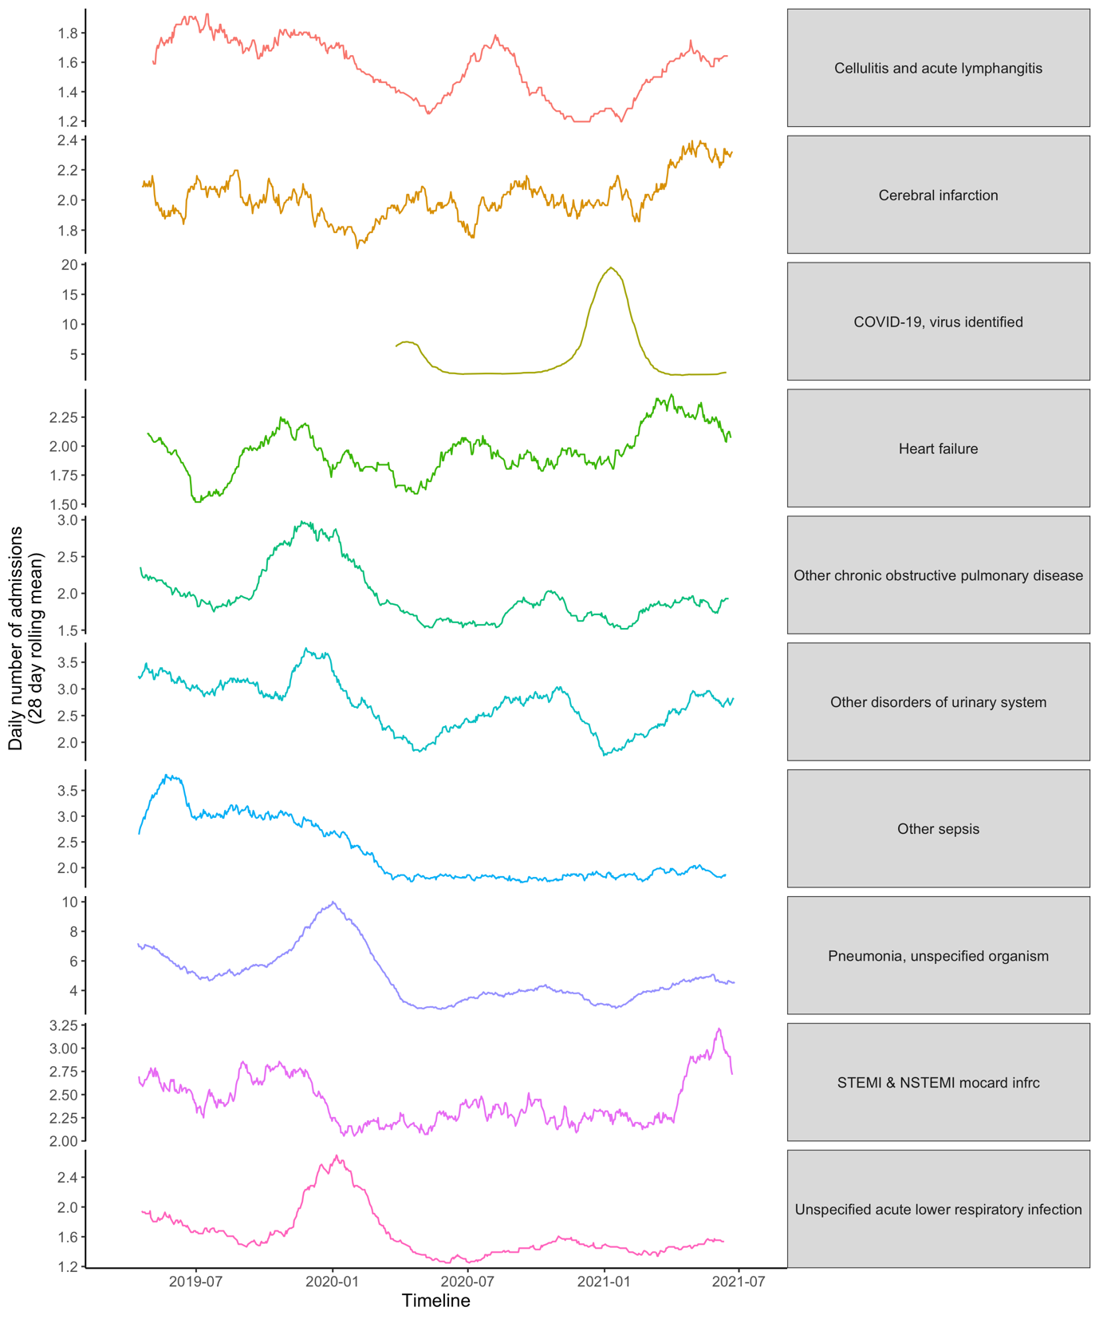
Supplementary Figure 1 Daily number of admissions to acute medicine stratified by primary diagnosis - data as per Figure 6 but shown in individual panels to aid inspection of individual diagnoses.

