Supplementary Table 1. Summary of diagnostic codes for substance use-related presentations
Supplementary Table 1.1. Summary of ICD-10-CA codes for substance use categories
Substance use category | ICD-10-CA codes | ICD-10-CA Description
Alcohol | E244 | Alcohol-induced pseudo-Cushing’s syndrome
Alcohol | F10.– | Mental and behavioural disorders due to use of alcohol
Alcohol | G312 | Degeneration of nervous system due to alcohol
Alcohol | G621 | Alcoholic polyneuropathy
Alcohol | G721 | Alcoholic myopathy
Alcohol | I426 | Alcoholic cardiomyopathy
Alcohol | K292 | Alcoholic gastritis
Alcohol | K70.– | Alcoholic liver disease
Alcohol | K852 | Alcohol-induced acute pancreatitis
Alcohol | K860 | Alcohol-induced chronic pancreatitis
Alcohol | O354– | Maternal care for (suspected) damage to fetus from alcohol
Alcohol | Q860 | Fetal alcohol syndrome (dysmorphic)
Alcohol | R780 | Finding of alcohol in blood
Alcohol | T51.– | Toxic effects of alcohol
Alcohol | X45 | Accidental poisoning by and exposure to alcohol
Alcohol | X65 | Intentional self-poisoning by and exposure to alcohol
Alcohol | Y15 | Poisoning by and exposure to alcohol, undetermined intent
Opioids | F11.– | Mental and behavioural disorders due to use of opioids
Opioids | T400 | Poisoning by opium
Opioids | T401 | Poisoning by heroin
Opioids | T402 | Poisoning by other opioids
Opioids | T403 | Poisoning by methadone
Opioids | T404 | Poisoning by other synthetic narcotics
Opioids | T406 | Poisoning by other and unspecified narcotics
Stimulants, cocaine, psychoactive and hallucinogens-related | F15.– | Mental and behavioural disorders due to use of other stimulants, including caffeine
Stimulants, cocaine, psychoactive and hallucinogens-related | T436 | Poisoning by other stimulants and amphetamines
Stimulants, cocaine, psychoactive and hallucinogens-related | F14.– | Mental and behavioural disorders due to use of cocaine
Stimulants, cocaine, psychoactive and hallucinogens-related | T405 | Poisoning by cocaine
Stimulants, cocaine, psychoactive and hallucinogens-related | F19.– | Mental and behavioural disorders due to use of multiple drug use and use of other psychoactive substances
Stimulants, cocaine, psychoactive and hallucinogens-related | T438 | Poisoning by other psychotropic drugs, not elsewhere classified
Stimulants, cocaine, psychoactive and hallucinogens-related | T439 | Poisoning by psychotropic drug, unspecified
Stimulants, cocaine, psychoactive and hallucinogens-related | X41 (when coded without T42–T43) | Accidental poisoning by and exposure to antiepileptic, sedative-hypnotic, antiparkinsonism and psychotropic drugs, not elsewhere classified
Stimulants, cocaine, psychoactive and hallucinogens-related | X61 (when coded without T42–T43) | Intentional self-poisoning by and exposure to antiepileptic, sedative-hypnotic, antiparkinsonism and psychotropic drugs, not elsewhere classified
Stimulants, cocaine, psychoactive and hallucinogens-related | Y11 (when coded without T42–T43) | Poisoning by and exposure to antiepileptic, sedative-hypnotic, antiparkinsonism and psychotropic drugs, not elsewhere classified, undetermined intent
Stimulants, cocaine, psychoactive and hallucinogens-related | Y12 (when coded without T40.–) | Poisoning by and exposure to narcotics and psychodysleptics, [hallucinogens], not elsewhere classified, undetermined intent
Stimulants, cocaine, psychoactive and hallucinogens-related | F16.– | Mental and behavioural disorders due to use of hallucinogens
Stimulants, cocaine, psychoactive and hallucinogens-related | T408 | Poisoning by lysergide [LSD]
Stimulants, cocaine, psychoactive and hallucinogens-related | T409 | Poisoning by other and unspecified psychodysleptics [hallucinogens]
Stimulants, cocaine, psychoactive and hallucinogens-related | X42 (when coded without T40.–) | Accidental poisoning by and exposure to narcotics and psychodysleptics [hallucinogens], not elsewhere classified
Stimulants, cocaine, psychoactive and hallucinogens-related | X62 (when coded without T40.–) | Intentional self-poisoning by and exposure to narcotics and psychodysleptics [hallucinogens], not elsewhere classified
Other substance use | F12.– | Mental and behavioural disorders due to use of cannabinoids
Other substance use | T407 | Poisoning by cannabis (derivatives)
Other substance use | F13.– | Mental and behavioural disorders due to use of sedatives or hypnotics
Other substance use | T423 | Poisoning by barbiturates
Other substance use | T424 | Poisoning by benzodiazepines
Other substance use | T426 | Poisoning by other antiepileptic and sedative-hypnotic drugs
Other substance use | T427 | Poisoning by antiepileptic and sedative-hypnotic drugs, unspecified
Other substance use | F18.– | Mental and behavioural disorders due to use of volatile solvents
Other substance use | F55 | Abuse of non-dependence-producing substances

Supplementary Table 1.2. Summary of ICD-9 codes for substance use categories
Substance use category | ICD-9 codes | ICD-9 Description
Alcohol | 291.0 | Alcohol intoxication delirium or withdrawal delirium
Alcohol | 291.1 | Alcohol-induced major neurocognitive disorder, amnestic confabulatory type
Alcohol | 291.2 | Alcohol-induced major neurocognitive disorder, nonamnestic confabulatory type
Alcohol | 291.81 | Alcohol withdrawal
Alcohol | 291.82 | Alcohol-induced sleep disorder
Alcohol | 291.89 | Alcohol-induced anxiety disorder, bipolar and related disorder, depressive disorder, mild neurocognitive disorder or sexual dysfunction
Alcohol | 291.9 | Alcohol-induced psychotic disorder or unspecified alcohol-related disorder
Alcohol | 303.00  303.0– | Alcohol intoxication
Alcohol | 303.90  303.9– | Alcohol use disorder, moderate/severe
Alcohol | 305.00  305.0– | Alcohol use disorder, mild
Opioids | 304.00  304.0– | Opioid use disorder, moderate or severe
Opioids | 305.50  305.5– | Opioid use disorder, mild
Stimulants, cocaine, psychoactive and hallucinogens-related | 304.20  304.2– | Cocaine use disorder, moderate or severe
Stimulants, cocaine, psychoactive and hallucinogens-related | 304.40  304.4– | Amphetamine-type substance use disorder, moderate or severe
Stimulants, cocaine, psychoactive and hallucinogens-related | 304.50  304.5– | Other hallucinogen use disorder, moderate or severe
Stimulants, cocaine, psychoactive and hallucinogens-related | 305.30  305.3– | Other hallucinogen use disorder, mild
Stimulants, cocaine, psychoactive and hallucinogens-related | 305.60  305.6– | Cocaine use disorder, mild
Stimulants, cocaine, psychoactive and hallucinogens-related | 305.70  305.7– | Amphetamine-type substance use disorder, mild
Stimulants, cocaine, psychoactive and hallucinogens-related | 304.60  304.6– | Inhalants and phencyclidine use disorder, moderate or severe
Other substance use | 304.10  304.1– | Sedative, hypnotic or anxiolytic use disorder, moderate or severe
Other substance use | 304.30  304.3– | Cannabis use disorder, moderate or severe
Other substance use | 305.20  305.2– | Cannabis use disorder, mild
Other substance use | 305.40  305.4– | Sedative, hypnotic or anxiolytic use disorder, mild
Other substance use | 292.0 | Substance withdrawal
Other substance use | 292.81 | Substance/medication-induced intoxication delirium
Other substance use | 292.82 | Substance-induced major neurocognitive disorder
Other substance use | 292.84 | Substance-induced depressive; substance-induced bipolar and related disorder
Other substance use | 292.85 | Substance-induced sleep disorder
Other substance use | 292.89 | Substance-induced: anxiety disorder, mild neurocognitive disorder, obsessive-compulsive and related disorder, sexual dysfunction, intoxication, other (or unknown)
Other substance use | 292.9 | Substance-induced psychotic disorder; unspecified substance-related disorder
Other substance use | 304.90  304.9– | Other (or unknown) substance use disorder, moderate or severe
Other substance use | 305.90  305.9– | Other (or unknown) substance use disorder, mild

Supplementary Table 2. Variable checklist for each database
Database | Variables | Definition
National Ambulatory Care Reporting System (NACRS)-Patient Level | Number of patients | Count of patients
 | Gender | Original data
 | Age | Original data
 | Number of ED visits per patient | Count of ED visits individually
 | Rural/urban | Derived from the truncated postal code. Rural residence had “0” in the second position of the truncated postal code
National Ambulatory Care Reporting System (NACRS)-Visit Level | Number of ED visits | Count of ED visits
 | Arrive by ambulance | Original data
 | Triage level | Original data
 | Visit disposition | Original data
 | ICD-10-CA ED diagnosis chapters | Classified primary ED diagnosis into ICD-10-CA diagnosis chapter
 | Top 5 main problem | Top 5 primary ED diagnosis with ICD-10-CA code
Hospitalization Characteristics (DAD) | Number of patients | Count of patients
Hospitalization Characteristics (DAD) | Gender | Original data
Hospitalization Characteristics (DAD) | Age | Original data
Hospitalization Characteristics (DAD) | Number of admissions per patient | Count of admissions individually
Hospitalization Characteristics (DAD) | Number of admissions | Count of admissions
Hospitalization Characteristics (DAD) | Total length of stay (days) | Original data
Hospitalization Characteristics (DAD) | Disposition | Original data
Hospitalization Characteristics (DAD) | ICD-10-CA primary diagnosis chapters | Classified the most responsible diagnosis for the patient during hospitalization into ICD-10-CA diagnosis chapter
Hospitalization Characteristics (DAD) | Top 5 diagnosis | Top 5 the most responsible diagnosis for the patient during hospitalization with ICD-10-CA code
Mental Health Hospitalization Characteristics (HMHDB) (ON and AB) | Number of patients | Count of patients
 | Age | Original data
 | Number of mental health admissions per person | Count of mental health admissions individually
 | Gender | Original data
 | Homelessness | Original data: indicates whether a person was homeless on admission
 | Number of mental health admissions | Count of mental health admissions
 | Data source | Original data: indicates the original data source for the record
 | Length of stay at hospital (days) | Original data: the total number of days the person was hospitalized.
 | Discharge disposition | Original data: broad mental health category based on the most responsible separation diagnosis code
 | Diagnosis category | Original data
Medical service billing (MSP) dataset (B.C. only) | Number of patients | Count of patients
Medical service billing (MSP) dataset (B.C. only) | Total number of any MSP claims | Count of any MSP claims
Medical service billing (MSP) dataset (B.C. only) | Claim specialty group | Original data
Medical service billing (MSP) dataset (B.C. only) | MSP billing-related diagnosis (ICD-9) chapters | Classified the MSP billing-related diganosis into ICD-9 diagnosis chapter
Medical service billing (MSP) dataset (B.C. only) | Service location | Original data
Medical service billing (MSP) dataset (B.C. only) | Number of individual MSP claims | Count of MSP claims individually
Medical service billing (MSP) dataset (B.C. only) | Number of patients with general practice (GP) claim | Count of patients with GP claims
Medical service billing (MSP) dataset (B.C. only) | Number of GP claim per patient | Count of MSP GP claims divided by the total number of patients
Medical service billing (MSP) dataset (B.C. only) | Majority source of care | Identify whether ≥50% of patients’ services were provided by a single general practitioner, among patients who received ≥3 family doctor services in one year
Medical service billing (MSP) dataset (B.C. only) | Total number of GP claims | Count of MSP GP claims
Medication (Pharmanet) dataset (B.C. only) | Number of patients | Count of patients
Medication (Pharmanet) dataset (B.C. only) | Total number of entries for all medications | Count of medications
Medication (Pharmanet) dataset (B.C. only) | Number of drugs per individual by generic name | Count of drugs based on generic name (original data) individually
Medication (Pharmanet) dataset (B.C. only) | Number of drugs per individual by generic name | Count of drugs based on DINPIN (original data) individually
Medication (Pharmanet) dataset (B.C. only) | Top 10 American Hospital Formulary Service 1st tier classification | Original data: classified drugs based on American Hospital Formulary Service classification (AHFS) classification system, 1st tier and select top 10
Vital Events and Statistics Deaths dataset (B.C. only) | Number of deaths | Count of deaths
Vital Events and Statistics Deaths dataset (B.C. only) | Age at death | Original data
Vital Events and Statistics Deaths dataset (B.C. only) | Number of ED visits among deaths | Count of ED visits among deaths
Vital Events and Statistics Deaths dataset (B.C. only) | Days between last ED visit and death | Count days between last ED visit date and death date
Vital Events and Statistics Deaths dataset (B.C. only) | Last ED visit ICD-10-CA diagnosis chapters among deaths | Last ED visit diagnosis classified into ICD-10-CA diagnosis chapters
Vital Events and Statistics Deaths dataset (B.C. only) | Top 5 death cause ICD-10 code | Original data: ICD-10-CA code for death cause and select top 5
Footnote: Drug identification numbers (DINs) are Health Canada-assigned classifications for all drugs marketed in Canada (https://www.canada.ca/en/health-canada/services/drugs-health-products/drug-products/fact-sheets/drug-identification-number.html).
Product identification numbers (PINs) are an additional classification in B.C.’s PharmaCare system for certain drug products (https://www2.gov.bc.ca/gov/content/health/practitioner-professional-resources/pharmacare/pharmacies/product-identification-numbers).

Supplementary Table 3. Pseudo F values for number of subgroups for Ontario, from 1-10
K Means subgroup number | 1 | 2 | 3 | 4 | 5 | 6 | 7 | 8 | 9 | 10
W | 195890 | 169401.2 | 152148.7 | 135691.3 | 123384.2 | 113045.4 | 104209.3 | 95567.5 | 87910.0 | 83308.9
Pseudo F | Inf | 3062.9 | 2815.5 | 2896.4 | 2877.2 | 2870.4 | 2871.4 | 2936.6 | 3006.4 | 2940.0
Footnote: Two subgroups were chosen based on optimization of the pseudo-F statistic value, which compares between-cluster to within-cluster sum-of-squares.

Supplementary Table 4. Pseudo F values for number of subgroups for Alberta, from 1-10
K Means subgroup number | 1 | 2 | 3 | 4 | 5 | 6 | 7 | 8 | 9 | 10
W | 76870.0 | 66418.7 | 59992.5 | 54489.0 | 49100.0 | 43990.6 | 40799.4 | 37152.8 | 34367.0 | 32256.5
Pseudo F | Inf | 1209.4 | 1081.0 | 1052.0 | 1086.3 | 1148.3 | 1131.8 | 1172.9 | 1187.1 | 1179.9
Footnote: Two subgroups were chosen based on optimization of the pseudo-F statistic value, which compares between-cluster to within-cluster sum-of-squares.

Supplementary Table 5. Pseudo F values for number of subgroups for B.C., from 1-10
K Means subgroup number | 1 | 2 | 3 | 4 | 5 | 6 | 7 | 8 | 9 | 10
W | 94020 | 80939.1 | 73597.77 | 64630.93 | 58493.51 | 53170.3 | 46626.69 | 41243.71 | 37622.54 | 34368.47
Pseudo F | -Inf | 1519.33 | 1304.176 | 1424.642 | 1426.987 | 1443.906 | 1591.747 | 1717.433 | 1760.241 | 1811.436
Footnote: Two subgroups were chosen based on optimization of the pseudo-F statistic value, which compares between-cluster to within-cluster sum-of-squares.

Supplementary Figure 1. Visual Representation of Subgroups for Ontario
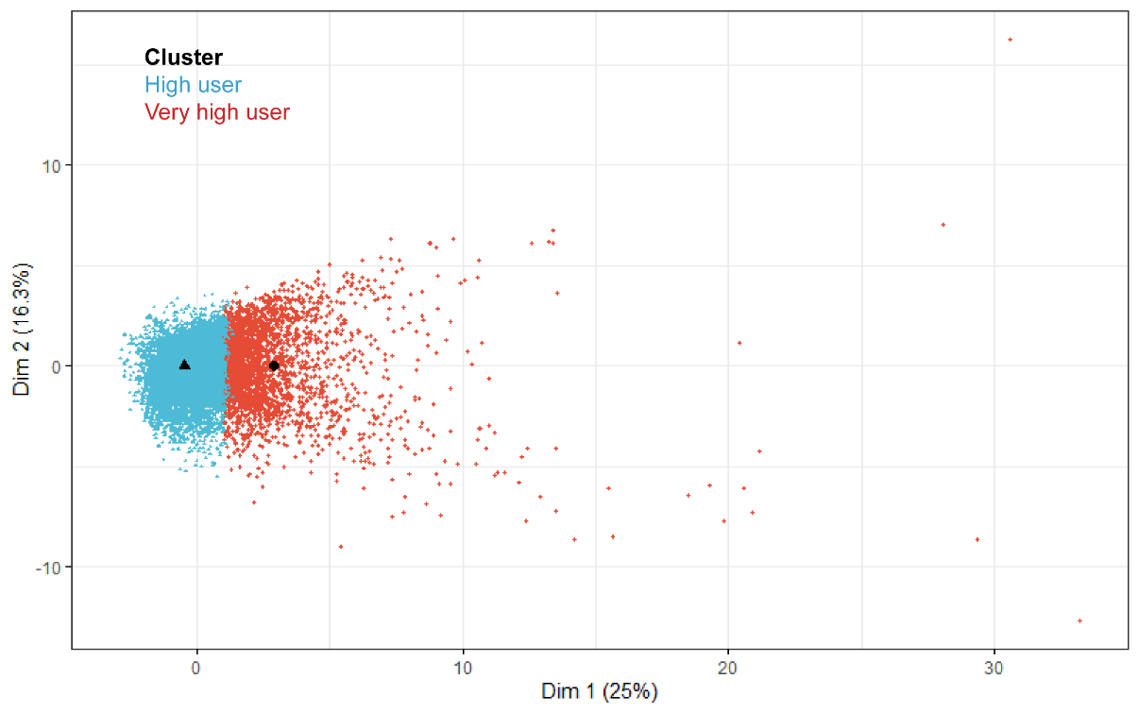
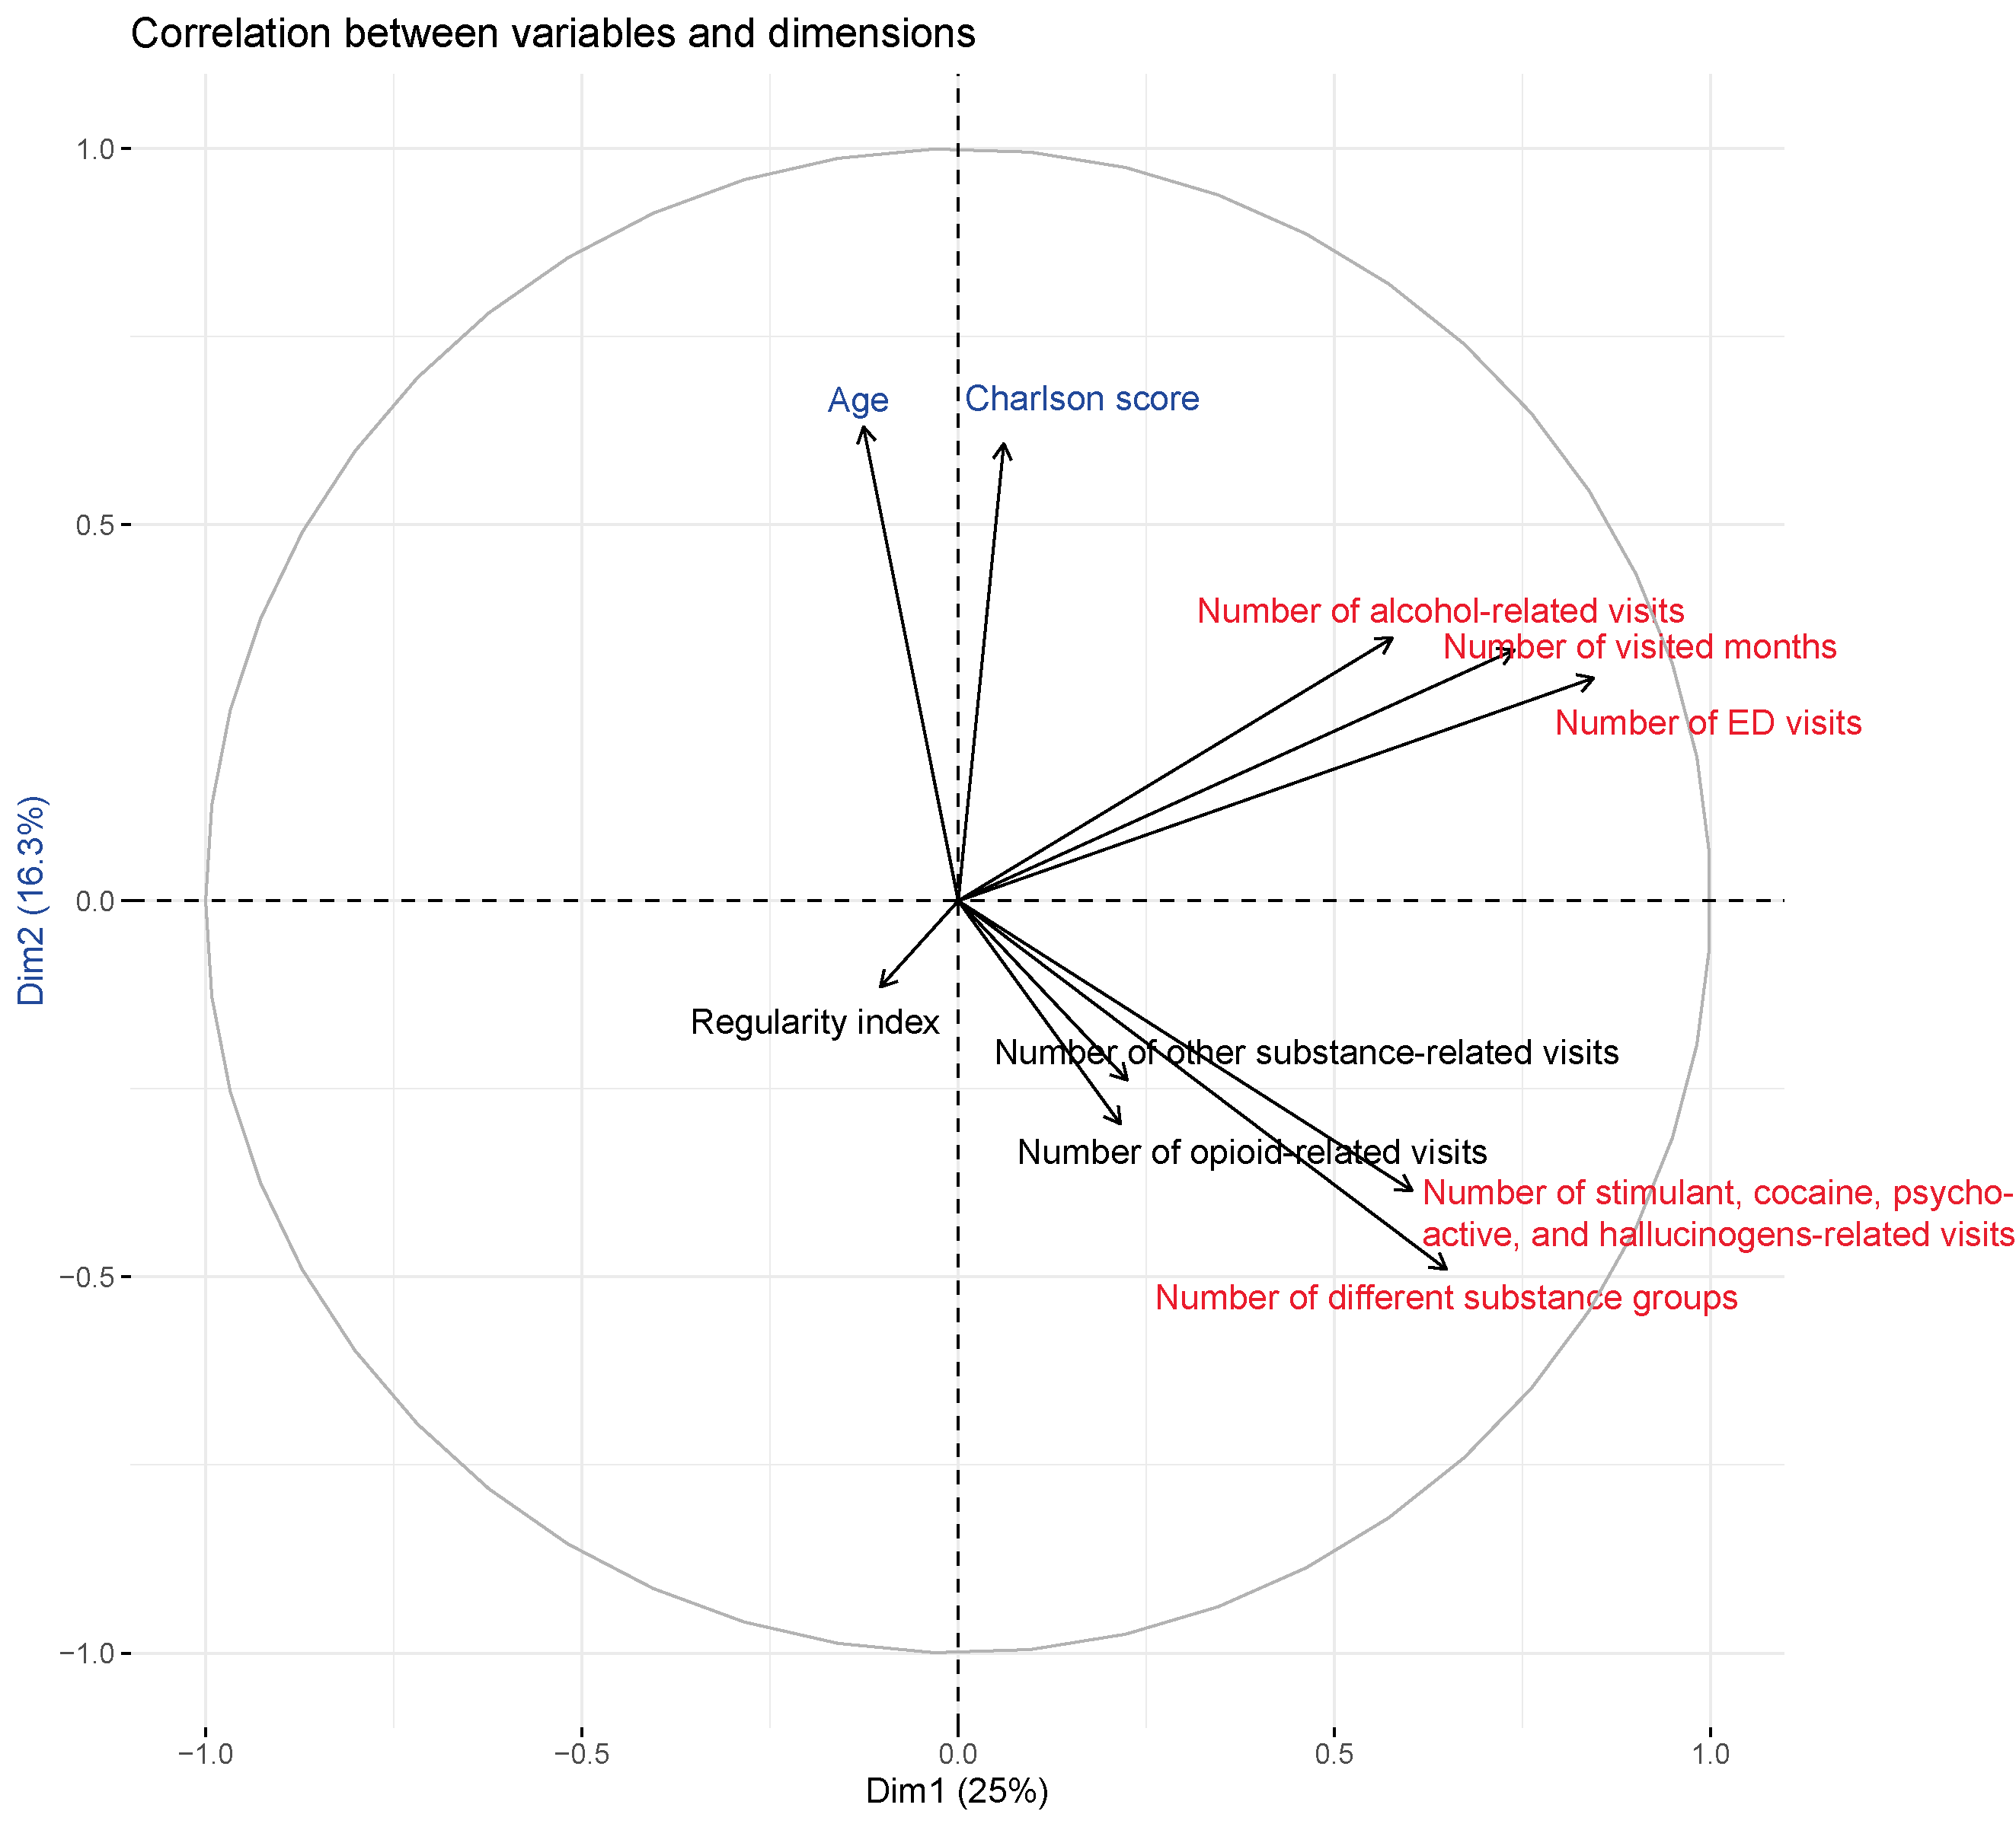
Footnote: Black markers indicate the cluster mean for each group.
We were interested in a graphical representation of our subgroups, but doing so required a reduction of the dimensionality of the data so that it could be represented on a graph. One approach to this is to apply a principal components-type analysis after clustering, and then plotting the most important variables against the second most important variables (these are Dim1 and Dim2). Supplementary Figure 1 shows clusters of samples in Ontario based on their similarity. Dimension 1 accounted for 25% of the information. Dimension 2 accounted for 16.3% of the information.
The plot above suggests that number of alcohol-related diagnoses, number of stimulants, cocaine, psychoactive and hallucinogens-related diagnoses, number of distinct substance groups, number of months that the patient visited an ED, and ED visit number had strong positive effects on Dimension 1. Regularity index had a strong negative effect on Dimension 1. Age at index, and Charlson comorbidity index had strong positive effects on Dimension 2.

Supplementary Figure 2. Visual Representation of Subgroups for Alberta
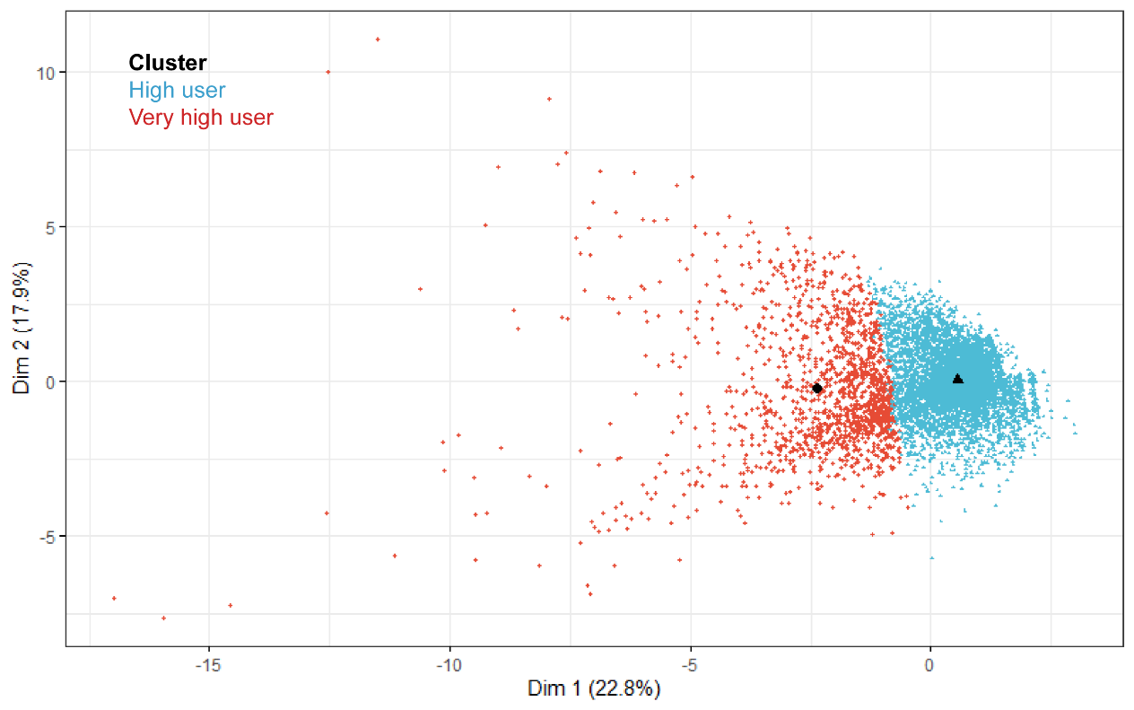
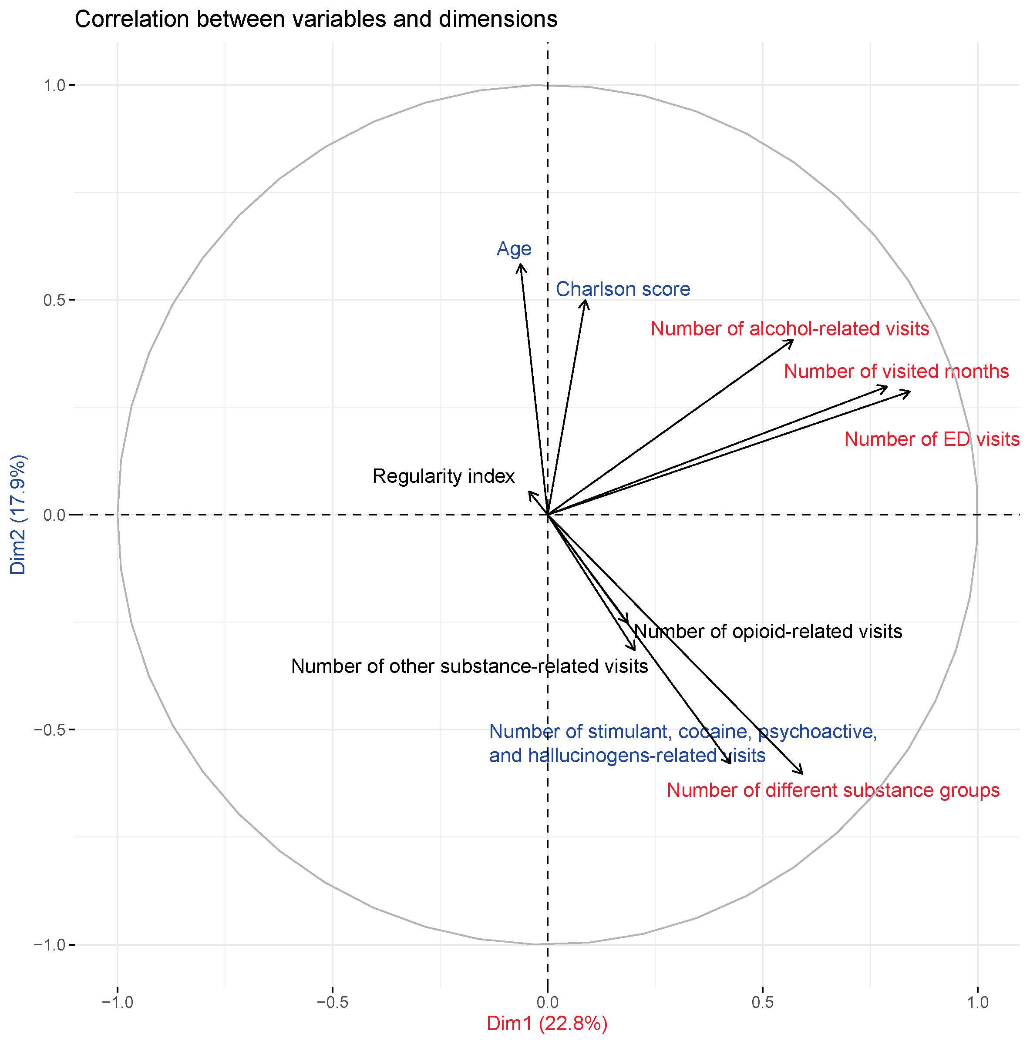
Footnote: Black markers indicate the cluster mean for each group.
We were interested in a graphical representation of our subgroups, but doing so required a reduction of the dimensionality of the data so that it could be represented on a graph. One approach to this is to apply a principal components-type analysis after clustering, and then plotting the most important variables against the second most important variables (these are Dim1 and Dim2). Supplementary Figure 2 shows clusters of samples in Alberta based on their similarity. Dimension 1 accounted for 22.8% of the information. Dimension 2 accounted for 17.9% of the information.
The plot above suggests that number of alcohol-related diagnoses, number of distinct substance groups, number of months that the patient visited an ED, and ED visit number had strong positive effects on Dimension 1. Regularity index had a strong negative effect on Dimension 1. Age at index, and Charlson comorbidity index had strong positive effects on Dimension 2. Number of stimulants, cocaine, psychoactive and hallucinogens-related diagnoses had strong negative effects on Dimension 2.

Supplementary Figure 3. Visual Representation of Subgroups for B.C.
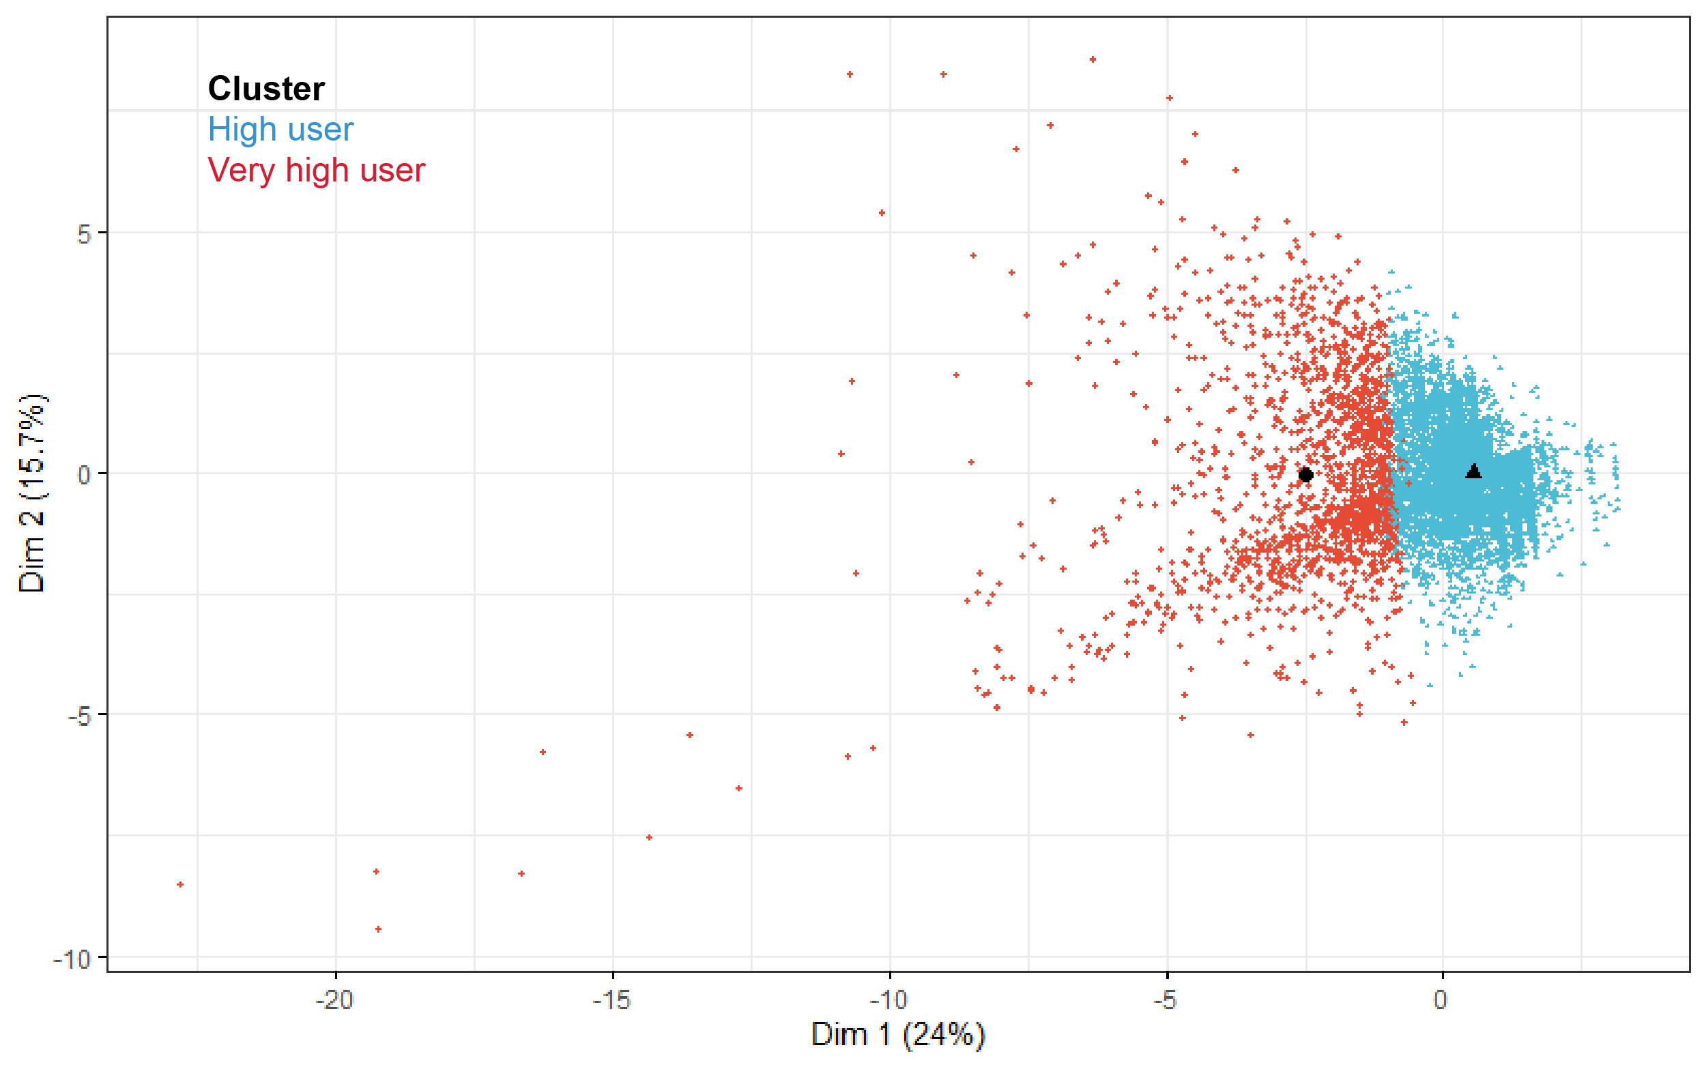
Footnote: Black markers indicate the cluster mean for each group.
Dim 1 and Dim 2 represent the first two dimensions in a principal component analysis. In order to visualize our cluster analysis, we used principal component analysis to project the initial data onto the first two principal components. The contribution of each variable to the first two dimensions is shown in the following table:
Variables | Dim.1 | Dim.2
Age | 0.1% | 21.6%
Number of visits to the ED | 29.9% | 5.2%
Number of alcohol-related visits | 15.4% | 6.1%
Number of stimulants, cocaine, psychoactive and hallucinogens-related visits | 7.7% | 19.1%
Number of opioid-related visits | 2.7% | 13.1%
Number of other substance-related visits | 0.6% | 0.8%
Number of different substance groups | 14.0% | 18.6%
Weighted Charlson score | 1.1% | 11.5%
Number of months in the year visited ED | 27.3% | 4.0%
Regularity index | 1.2% | 0.0%

Supplementary Table 6. Demographic and healthcare utilization characteristics of subgroups of people with frequent ED visits (top 10%) and substance use in Ontario, Alberta, and B.C. (April 1st, 2014 to March 31st, 2015)
Characteristics | Ontario |  | Alberta |  | British Columbia
 | Extreme (N=2,669) | Moderate (N=16,921) | Extreme (N=1,468) | Moderate (N=6,220) | Extreme (N=1,690) | Moderate (N=7,713)
Subgroup Characteristics (All Clustering Variables)
Age (years)
Median (IQR) | 36 (27-49) | 40 (27-54) | 38 (29-49) | 37 (27-50) | 45 (33-53) | 44 (31-56)
Total number of ED visits
Median (IQR) | 19 (13-28) | 5 (4-8) | 19 (15-27) | 6 (5-9) | 13 (10-20) | 4 (3-6)
Number of alcohol-related ED visits
Median (IQR) | 1 (0-7) | 0 (0-1) | 2 (0-7) | 1 (0-2) | 1 (0-4) | 0 (0-1)
Number of stimulants, cocaine, psychoactive and hallucinogens-related ED visits
Median (IQR) | 1 (0-2) | 0 (0-0) | 0 (0-1) | 0 (0-0) | 0 (0-1) | 0 (0-0)
Number of opioid-related visits
Median (IQR) | 0 (0-1) | 0 (0-0) | 0 (0-0) | 0 (0-0) | 0 (0-0) | 0 (0-0)
Number of other substance-related ED visits
Median (IQR) | 0 (0-0) | 0 (0-0) | 0 (0-0) | 0 (0-0) | 0 (0-0) | 0 (0-0)
Number of different substance groups for which patients made ED visits
Median (IQR) | 2 (1-2) | 1 (1-1) | 1 (1-2) | 1 (1-1) | 1 (1-2) | 1 (0-1)
Weighted Charlson Comorbidity Index
Median (IQR) | 0 (0-0) | 0 (0-0) | 0 (0-0) | 0 (0-0) | 0 (0-0) | 0 (0-0)
Number of months of the year that patents visited EDs
Median (IQR) | 8 (7-10) | 4 (3-5) | 8 (7-10) | 4 (3-5) | 7 (6-9) | 3 (3-4)
Regularity index of ED visits
Median (IQR) | 0.2×10⁻² (0.1×10⁻² -0.5×10⁻²) | 0.5×10⁻³ (0.2×10⁻³ -1.4×10⁻³) | 0.2×10⁻² (0.1×10⁻² -0.4×10⁻²) | 0.5×10⁻³ (0.3×10⁻³ -1.1×10⁻³) | 1.5×10⁻³ (0.8×10⁻³ -3.1×10⁻³) | 0.5×10⁻³ (0.2×10⁻³ -1.5×10⁻³)
ED Visit Characteristics (NACRS)
Number of ED visits (for any reason) | 66,655 | 102,807 | 34,400 | 44,193 | 28,893 | 39,181
Triage level among ED visits, n (%)
1 (Resuscitation) | 1,019 (1.5) | 2,076 (2.0) | 452 (1.3) | 629 (1.4) | 276 (1.0) | 506 (1.3)
2 (Emergent) | 18,995 (28.5) | 30,633 (29.8) | 6,415 (18.6) | 8,647 (19.6) | 5,269 (18.2) | 8,239 (21)
3 (Urgent) | 31,378 (47.1) | 47,046 (45.8) | 13,322 (38.7) | 17,561 (39.7) | 15,882 (55.0) | 20,148 (51.4)
4 (Less-urgent) | 11,771 (17.7) | 18,477 (18.0) | 9,544 (27.7) | 11,894 (26.9) | 6,319 (21.9) | 8,751 (22.3)
5 (Non-urgent) | 2,907 (4.4) | 3,839 (3.7) | 3,823 (11.1) | 4,116 (9.3) | 1,086 (3.8) | 1,444 (3.7)
9 (Unknown) | 496 (0.7) | 629 (0.6) | 713 (2.1) | 1,221 (2.8) | 61 (0.2) | 93 (0.2)
NA | 89 (0.1) | 107 (0.1) | 131 (0.4) | 125 (0.3) | 0 (0.0) | 0 (0.0)
ED diagnosis (ICD-10-CA) chapters among ED visits, n (%)
Chapter 1-Infectious and parasitic diseases (A00-B99) | 815 (1.2) | 1,713 (1.7) | 563 (1.6) | 804 (1.8) | 359 (1.2) | 556 (1.4)
Chapter 2-Neoplasms (C00-D48) | 44 (0.1) | 169 (0.2) | 24 (0.1) | 54 (0.1) | 21 (0.1) | 34 (0.1)
Chapter 3-Hematologic and immunologic diseases (D50-D89) | 85 (0.1) | 283 (0.3) | 43 (0.1) | 114 (0.3) | 33 (0.1) | 97 (0.2)
Chapter 4-Endocrine, nutritional and metabolic diseases (E00-E90) | 636 (1.0) | 1229 (1.2) | 408 (1.2) | 651 (1.5) | 271 (0.9) | 343 (0.9)
Chapter 5-Mental and behavioral disorders (F00-F99) | 27,788 (41.7) | 33,587 (32.7) | 10,834 (31.5) | 12,086 (27.3) | 7,144 (24.7) | 7,377 (18.8)
Chapter 6-Diseases of the nervous system (G00-G99) | 1,154 (1.7) | 1,517 (1.5) | 981 (2.9) | 771 (1.7) | 222 (0.8) | 302 (0.8)
Chapter 7&8-Diseases of the eye, adnexa, ear and mastoid process (H00-H95) | 307 (0.5) | 798 (0.8) | 227 (0.7) | 397 (0.9) | 127 (0.4) | 224 (0.6)
Chapter 9-Diseases of the circulatory system (I00-I99) | 530 (0.8) | 1,555 (1.5) | 221 (0.6) | 637 (1.4) | 303 (1.0) | 495 (1.3)
Chapter 10-Diseases of the respiratory system | 1,714 (2.6) | 3,710 (3.6) | 1,130 (3.3) | 1,745 (3.9) | 960 (3.3) | 1,106 (2.8)
Chapter 11-Diseases of the digestive system (K00-K93) | 2,457 (3.7) | 7,174 (7.0) | 1,861 (5.4) | 3,206 (7.3) | 1016 (3.5) | 1,505 (3.8)
Top 5 Chapter 11 Diagnosis
 | Constipation (K590):  282 (0.4) | Acute pancreatitis, unspecified (K859):  770 (0.7) | Periapical abscess without sinus (K047):  173 (0.5) | Alcoholic gastritis (K292):  364 (0.8)
 | Toothache NOS (K0887):  207 (0.3) | Gastrointestinal haemorrhage, unspecified (K922):  547 (0.5) | Alcoholic gastritis (K292):  147 (0.4) | Acute pancreatitis, unspecified (K859):  271 (0.6)
 | Gastrointestinal haemorrhage, unspecified (K922):  140 (0.2) | Hepatic failure, unspecified (K729):  473 (0.5) | Toothache NOS (K0887):  131 (0.4) | Gastritis, unspecified (K297):  199 (0.5)
 | Gastritis, unspecified (K297):  133 (0.2) | Constipation (K590):  381 (0.4) | Gastritis, unspecified (K297):  119 (0.3) | Gastrointestinal haemorrhage, unspecified (K922):  193 (0.4)
 | Acute pancreatitis, unspecified (K859):  133 (0.2) | Alcoholic cirrhosis of liver (K703):  378 (0.4) | Gastrointestinal haemorrhage, unspecified (K922):  103 (0.3) | Periapical abscess without sinus (K047):  160 (0.4)
Chapter 12-Dermatologic diseases (L00-L99) | 1,476 (2.2) | 2,775 (2.7) | 927 (2.7) | 1,309 (3.0) | 789 (2.7) | 1,290 (3.3)
Chapter 13- Diseases of the musculoskeletal system and connective tissue (M00-M99) | 3,018 (4.5) | 4,134 (4.0) | 1,777 (5.2) | 1,863 (4.2) | 1023 (3.5) | 1,312 (3.3)
Chapter 14-Diseases of the genitourinary system (N00-N99) | 967 (1.5) | 2,275 (2.2) | 570 (1.7) | 957 (2.2) | 485 (1.7) | 665 (1.7)
Chapter 15-Pregnancy, childbirth and the puerperium (O00-O99) | 148 (0.2) | 458 (0.4) | 153 (0.4) | 285 (0.6) | 14 (0.0) | 52 (0.1)
Chapter 16- Certain conditions originating in the perinatal period | 1 (0.0) | 1 (0.0) | 1 (0.0) | 0 (0.0) | 0 (0.0) | <5 (0.0)
Chapter 17 - Congenital malformations, deformations and chromosomal abnormalities | 8 (0.0) | 21 (0.0) | 15 (0.0) | 11 (0.0) | 0 (0.0) | 0 (0.0)
Chapter 18-Symptoms, signs and abnormal findings (R00-R99) | 11,862 (17.8) | 18,079 (17.6) | 5,385 (15.7) | 6,342 (14.4) | 4,591 (15.9) | 5,439 (13.9)
Chapter 19-Injury, poisoning and certain other consequences of external causes (S00-T98) | 7,608 (11.4) | 15,890 (15.5) | 5,426 (15.8) | 8,838 (20.0) | 4,700 (16.3) | 6,518 (16.6)
Chapter 21-Factors influencing health status and contact with health services (Z00-Z99) | 6,037 (9.1) | 7,439 (7.2) | 3,854 (11.2) | 4,123 (9.3) | 1,831 (6.3) | 1,903 (4.9)
NA | 0 (0.0) | 0 (0.0) | 0 (0.0) | 0 (0.0) | 5,004 (17.3) | 9,962 (25.4)
Hospitalization Characteristics (DAD)
 | Extreme (N=2,669) | Moderate (N=16,921) | Extreme (N=1,468) | Moderate (N=6,220) | Extreme (N=1,690) | Moderate (N=7,713)
Number of admissions (for any reason) | 4,498 | 13,648 | 3,647 | 6,981 | 5,499 | 10,446
Primary diagnosis ICD-10-CA chapters among admissions, n (%)
Chapter 1-Certain infectious and parasitic diseases (A00-B99) | 154 (3.4) | 405 (3.0) | 110 (3.0) | 171 (2.4) | 143 (2.6) | 278 (2.7)
Chapter 2-Neoplasms (C00-D48) | 18 (0.4) | 104 (0.8) | 9 (0.2) | 32 (0.5) | 9 (0.2) | 68 (0.7)
Chapter 3-Diseases of the blood and blood-forming organs and certain disorders involving the immune mechanism (D50-D89) | 20 (0.4) | 100 (0.7) | 24 (0.7) | 43 (0.6) | 23 (0.4) | 54 (0.5)
Chapter 4-Endocrine, nutritional and metabolic diseases (E00-E90) | 164 (3.6) | 490 (3.6) | 90 (2.5) | 198 (2.8) | 179 (3.3) | 285 (2.7)
Chapter 5-Mental and behavioral disorders (F00-F99) | 1,106 (24.6) | 2,694 (19.7) | 1,596 (43.8) | 2,861 (41) | 2,812 (51.1) | 4,919 (47.1)
Chapter 6-Diseases of the nervous system (G00-G99) | 116 (2.6) | 344 (2.5) | 91 (2.5) | 113 (1.6) | 96 (1.7) | 141 (1.3)
Chapter 7-Diseases of the eye and adnexa (H00-H59) | 4 (0.1) | 10 (0.1) | 3 (0.1) | 11 (0.2) | 6 (0.1) | 6 (0.1)
Chapter 8-Diseases of the ear and mastoid process (H60-H95) | 3 (0.1) | 5 (0.0) | 4 (0.1) | 2 (0.0) | 0 (0.0) | 6 (0.1)
Chapter 9-Diseases of the circulatory system (I00-I99) | 181 (4) | 734 (5.4) | 67 (1.8) | 239 (3.4) | 169 (3.1) | 441 (4.2)
Chapter 10-Diseases of the respiratory system | 277 (6.2) | 813 (6.0) | 257 (7.0) | 360 (5.2) | 368 (6.7) | 535 (5.1)
Chapter 11-Diseases of the digestive system (K00-K93) | 629 (14.0) | 3,444 (25.2) | 479 (13.1) | 1224 (17.5) | 566 (10.3) | 1,240 (11.9)
Chapter 12-Diseases of the skin and subcutaneous tissue (L00-L99) | 145 (3.2) | 209 (1.5) | 101 (2.8) | 110 (1.6) | 96 (1.7) | 173 (1.7)
Chapter 13- Diseases of the musculoskeletal system and connective tissue (M00-M99) | 105 (2.3) | 232 (1.7) | 56 (1.5) | 95 (1.4) | 91 (1.7) | 206 (2.0)
Chapter 14-Diseases of the genitourinary system (N00-N99) | 88 (2.0) | 339 (2.5) | 67 (1.8) | 129 (1.8) | 90 (1.6) | 204 (2.0)
Chapter 15-Pregnancy, childbirth and the puerperium (O00-O99) | 30 (0.7) | 71 (0.5) | 34 (0.9) | 65 (0.9) | 13 (0.2) | 82 (0.8)
Chapter 17-Congenital malformations, deformations and chromosomal abnormalities (Q00-Q99) | 1 (0.0) | 4 (0.0) | 0 (0.0) | 3 (0.0) | 0 (0.0) | 7 (0.1)
Chapter 18-Symptoms, signs and abnormal clinical and laboratory findings, not elsewhere classified (R00-R99) | 467 (10.4) | 1,074 (7.9) | 207 (5.7) | 321 (4.6) | 373 (6.8) | 647 (6.2)
Chapter 19-Injury, poisoning and certain other consequences of external causes (S00-T98) | 934 (20.8) | 2,371 (17.4) | 412 (11.3) | 909 (13.0) | 426 (7.7) | 1,049 (10.0)
Chapter 21-Factors influencing health status and contact with health services (Z00-Z99) | 56 (1.2) | 205 (1.5) | 40 (1.1) | 95 (1.4) | 39 (0.7) | 105 (1.0)
NA | 0 (0.0) | 0 (0.0) | 0 (0.0) | 0 (0.0) | 0 (0.0) | 0 (0.0)
Mental Health Admission Characteristics (HMHDB)
 | Extreme (N=2,669) | Moderate (N=16,921) | Extreme (N=1,468) | Moderate (N=6,220) | Extreme (N=1,690) | Moderate (N=7,713)
Age of patients with at least one mental health admission
Median (IQR) | 35 (27-48) | 41 (28-54) | 38 (29-49) | 39 (29-52) | NA | NA
Sex among patients with at least one admission, n (%)
Male | 858 (61.1) | 3,731 (61.6) | 432 (62.2) | 1142 (61.8) | NA | NA
Female | 546 (38.9) | 2,321 (38.3) | 263 (37.8) | 707 (38.2) | NA | NA
Others | 1 (0.1) | 2 (0.0) | 0 (0.0) | 0 (0.0) | NA | NA
Number of mental health admissions (for any reason) | 4,294 | 10,229 | 1,605 | 2,876 | NA | NA
Length of stay (days) among mental health admissions
Median (IQR) | 3 (1-8) | 4 (2-11) | 3 (1-6) | 4 (2-10) | NA | NA

