Supplemental Materials

Supplemental Table 1: definitions of all variables for the three variable types used in this study. Three groups of variables were defined: demographic and vital, laboratory and advanced haematological (sapphire). Area under the receiver operator curve (AUROC) indicate the univariate diagnostics performance computed on all data. CoV: Coefficient of Variance
Type | Variable | Definition | AUROC
Demographic and vital | age | Age | 0.604
Demographic and vital | sex | Sex | 0.512
Demographic and vital | fio2 | Fraction of inspired oxygen | 0.589
Demographic and vital | gcs | Glasgow Coma Scale | 0.607
Demographic and vital | hr | Heart rate | 0.749
Demographic and vital | rr | Respiratory rate | 0.748
Demographic and vital | sbp | Systolic blood pressure | 0.675
Demographic and vital | spo2 | Oxygen saturation | 0.562
Demographic and vital | temp | Temperature | 0.658
Laboratory | alat | ALAT | 0.551
Laboratory | alk_phos | Alkaline phosphatase | 0.549
Laboratory | asat | ASAT | 0.613
Laboratory | creat | Plasma creatinine | 0.561
Laboratory | crp | CRP | 0.749
Laboratory | gamma_gt | Gamma-GT | 0.643
Laboratory | glucose | Glucose | 0.590
Laboratory | ld | Lactate dehydrogenase | 0.614
Laboratory | potassium | Potassium | 0.523
Laboratory | sodium | Sodium | 0.606
Laboratory | urea | Urea | 0.646
Sapphire | bas | Basophilic granulocyte absolute count | 0.559
Sapphire | blst | Blast absolute count | 0.503
Sapphire | bnd | Banded granulocyte absolute count | 0.698
Sapphire | eos | Eosinophil granulocyte absolute count | 0.654
Sapphire | hb | Hemoglobin | 0.584
Sapphire | hdw | Hemobloin distribution width | 0.514
Sapphire | ht | Hematocrit | 0.578
Sapphire | ig | Immature granulocyte absolute count | 0.688
Sapphire | irf | Immature reticulocyte fraction | 0.647
Sapphire | lacv | CV of variance of lymphocyte size | 0.59
Sapphire | lamn | Mean lymphocyte size | 0.655
Sapphire | licv | CV of lymphocyte complexity of intracellular structure | 0.532
Sapphire | limn | Lymphocyte complexity of intracellular structure | 0.598
Sapphire | lym | Lymphocyte absolute count | 0.567
Sapphire | lyme | Lymphocyte (excluding atypical lymphocytes) absolute count | 0.567
Sapphire | mch | Mean corpuscular hemoglobin | 0.533
Sapphire | mchc | Mean corpuscular hemoglobin concentration | 0.556
Sapphire | mchcr | Mean corpuscular HGB concentration per reticulocyte | 0.597
Sapphire | mchr | Mean corpuscular HGB per reticulocyte | 0.58
Sapphire | mcv | Mean corpuscular volume | 0.513
Sapphire | mcvr | Mean corpuscular volume of reticulocytes | 0.546
Sapphire | mon | Monocyte absolute count | 0.456
Sapphire | mone | Monocyte (excluding blasts) absolute count | 0.547
Sapphire | mpv | Mean platalet volume | 0.56
Sapphire | nacv | CV of neutrophil size | 0.575
Sapphire | namn | Mean neutrophil size | 0.685
Sapphire | ndcv | CV of neutrophil depolarization | 0.552
Sapphire | ndmn | Neutrophil lobularity/granularity and nuclear lobularity | 0.571
Sapphire | neu | Neutrophil granulocytes absolute count | 0.678
Sapphire | nfcv | CV of fluorescence for DNA/RNA staining in neutrophils | 0.52
Sapphire | nfmn | Fluorescence for DNA/RNA staining in neutrophils | 0.59
Sapphire | nicv | CV of neutrophil complexity of intracellular structure | 0.618
Sapphire | nimn | Neutrophil complexity of intracellular structure | 0.573
Sapphire | npcv | CV of neutrophil lobularity, granularity and nuclear segmentation | 0.615
Sapphire | npmn | Neutrophil lobularity, granularity and nuclear segmentation | 0.66
Sapphire | nrbc | Nucleated Red Blood Cells (NRBC) absolute count | 0.505
Sapphire | pbas | Percentage of basophilic granulocytes | 0.619
Sapphire | pblst | Percentage of blasts | 0.501
Sapphire | pbnd | Percentage of banded granulocytes | 0.702
Sapphire | pct | Plateletcrit | 0.543
Sapphire | pdw | Platelet distribution width | 0.553
Sapphire | peos | Percentage of eosinophilic granulocytes | 0.726
Sapphire | phpo | Percent of RBCs with HGB concentration less than 28 g/dL | 0.525
Sapphire | phpr | Percent of RBCs with HGB concentration more than 41 g/dL | 0.502
Sapphire | picv | CV of platelet complexity of intracellular structure | 0.588
Sapphire | pig | Percentage of immature granulocytes | 0.684
Sapphire | pimn | Platelet complexity of intracellular structure | 0.539
Sapphire | plt | Platelet absolute count | 0.524
Sapphire | plti | Platelet count by impedance | 0.529
Sapphire | plto | Platelet count by optics | 0.524
Sapphire | plym | Percentage of lymphocytes | 0.658
Sapphire | plyme | Percentage of lymphocytes excluding atypical lymphocytes | 0.659
Sapphire | pmac | Percentage of red blood cells with volume greater than 120 fL | 0.513
Sapphire | pmic | Percentage of red blood cells with volume less than 60 fL | 0.578
Sapphire | pmon | Percentage of monocytes | 0.669
Sapphire | pmone | Percentage of monocytes excluding blasts | 0.67
Sapphire | pneu | Percentage neutrophilic granulocytes | 0.704
Sapphire | pnrbc | Percentage of nucleated red blood cells per 100 white blood cells | 0.505
Sapphire | ppcv | CV of platelet lobularity/granularity | 0.576
Sapphire | ppmn | Platelet lobularity/granularity | 0.563
Sapphire | pretc | Percentage of reticulocytes | 0.552
Sapphire | prp | Percentage of reticulated platelets | 0.644
Sapphire | pseg | Percentage of segmented granulocytes | 0.528
Sapphire | pvlym | Percentage of atypical lymphocytes | 0.487
Sapphire | rbcfcv | CV of FL1 signal (presence of NRBCs) | 0.518
Sapphire | rbcfmn | Mean of FL1 signal (presence of NRBCs) | 0.518
Sapphire | rbci | Red blood cell count by impedance | 0.568
Sapphire | rbcicv | CV of red blood cell complexity of intracellular structure | 0.537
Sapphire | rbcimn | Red blood cell complexity of intracellular structure | 0.542
Sapphire | rbco | Red blood cell count by optics | 0.566
Sapphire | rdw | Red blood cell distribution width | 0.583
Sapphire | retc | Reticulocyte absolute count | 0.535
Sapphire | seg | Segmented granulocyte absolute count | 0.613
Sapphire | vlym | Atypical lymphocyte absolute count | 0.487
Sapphire | wbc | White blood cell absolute count | 0.652
Sapphire | wvf | White blood cell viability fraction | 0.512

Supplemental Table 2: algorithms used in this study and the associated hyperparameters that were optimized in the double loop cross validation (DLCV). Configuration of hyperparameters may improve the performance of machine learning algorithms. Configurations are shown of both the Lasso (L1) and Random Forest (RF) machine learning algorithms that were optimized in he DLCV
Algorithm | Category | Hyperparameter
Logistic regression (LR) | Conventional | -
Lasso (L1) | Regularization | Lambda: from 0 to 1
Random Forest (RF) | Non-linear trees | ntree: {25, 50, 75}  mtry: {2, 4, 6}  min_n: {50, 75, 100}

Supplemental Table 3: immunocompromised definitions. A patient was considered immunocompromised if the patients met one of the conditions described below.
Neutropenia | Neutrophil cell count <0.5 x 10⁹ during presentation at the emergency department.
Autologous stem-cell Tx within last 6 months | Autologous stem-cell transplantation within 6 months previous to the emergency department visit.
Allogenic stem-cell Tx within last 6 months | Allogenic stem-cell transplantation within 6 months previous to the emergency department visit.
Solid organ Tx (using immunosuppressives within last 6 months) | Patient with a history of solid organ transplantation (e.g. heart, lung, liver, kidney etc.) and using immunosuppressives within last 6 months.
Corticosteroids equivalent of prednisolone dose > 700mg total and/or 20 mg per day | Usage of a cumulative dose of prednisone >700 mg and/or a dose of 20mg prednisone per day (or equivalent corticosteroid dosage) previous to emergency department visit.
Anti-CD-20 therapy within last six months. | Treatment within last six months with one of the following medicaments: rituximab, ocrelizumab, veltuzumab, obinutuzumab or ofatumumab.
Biologicals (anti-TNF, anti-IL-1, anti-IL-6, nataluzimab etc) within the last 6 months | Treatment within last six months with a biological, including but not limited to: anti-TNF, anti-IL-1, anti-IL-6
MTx/azathioprine/6MP within last 6 months | Treatment within the last six months with one of the following medicaments: methotrexate, purine antagonists
(Functional) hypo/asplenia | Asplenia at the time of visiting the emergency department. This condition can be primary or acquired, for example due to surgery or multiple splenic infarctions
Primary immunodeficiency | A primary immunodeficiency diagnosed by a paediatrician, internist or immunologist, documented in the patient’s medical history.
CD4-penia <200/mm3 | During the emergency department visit a documented CD4-count <200/mm³
Hypogammaglobulinemia | During the emergency department visit or in the patient’s medical history a documented shortage of gamma globulins  Please note: IgA-deficiency is covered by this

Supplemental Figure 1: scheme of the double loop cross validation. HP: hyperparameter, CV: cross validation. *: data was stratified on both label and patient ID.
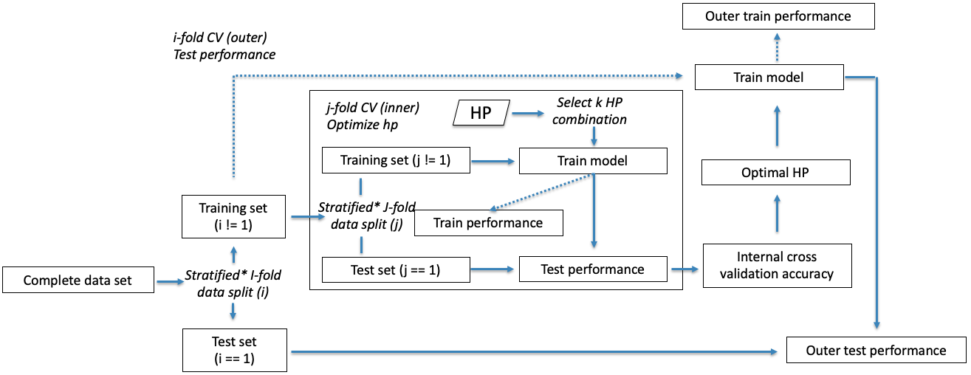
Supplemental Figure 2: dendrogram of all 95 variables computed with Euclidean distance. Length of each node depicts the similarity between variables. The blue circle represents the 0.80 cut-off. Colours represent the variable groups: vital (purple), demographic (red), laboratory (green) and advanced haematological (blue).
