Figure S1a: Fall injuries distributed by district in Malawi
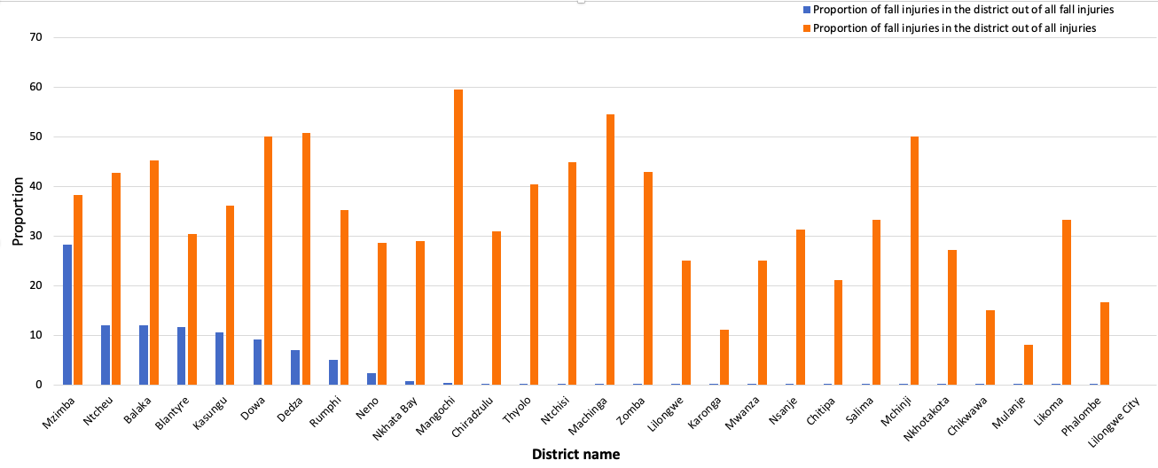
-Overall, 42% of injuries had documented district name for injury settings.
-Overall, less than 20 injuries were recorded in, Mchinji, Salima, Nkhotakota, Nsanje, Likoma, Chitipa, Phalombe and Lilongwe districts.

Figure S1b: Fall injuries distributed by district in Tanzania
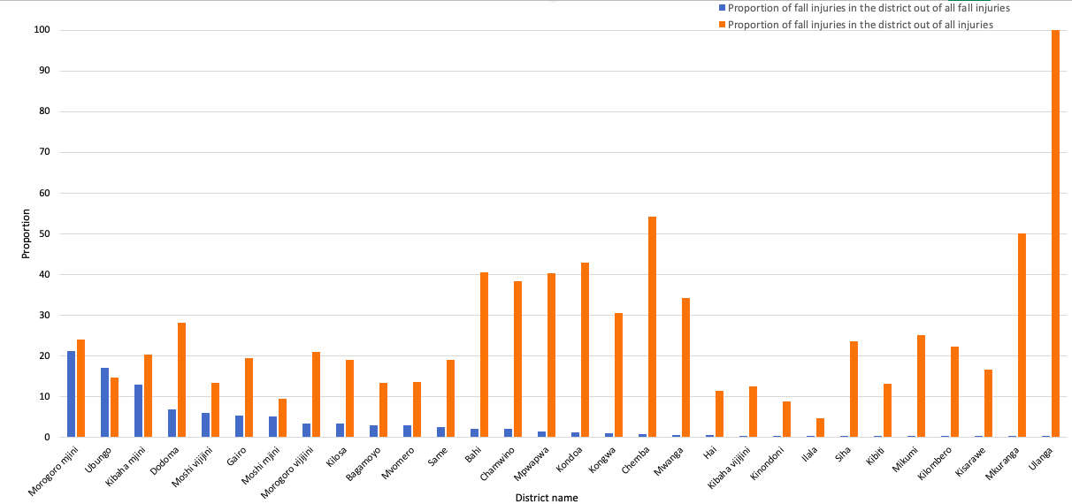
-Overall, 74% of injuries had documented district name for injury settings.
-Overall, less than 20 injuries were recorded in Kigamboni, Kilombero, Kisarawe, Mikumi, Mkuranga, Rufiji, Siha, and Ulanga districts. Also, Rombo (n=22) and Temeke (n=53) districts had no records of fall related injuries.

Figure s2a: Number of injuries distributed by months in Malawi
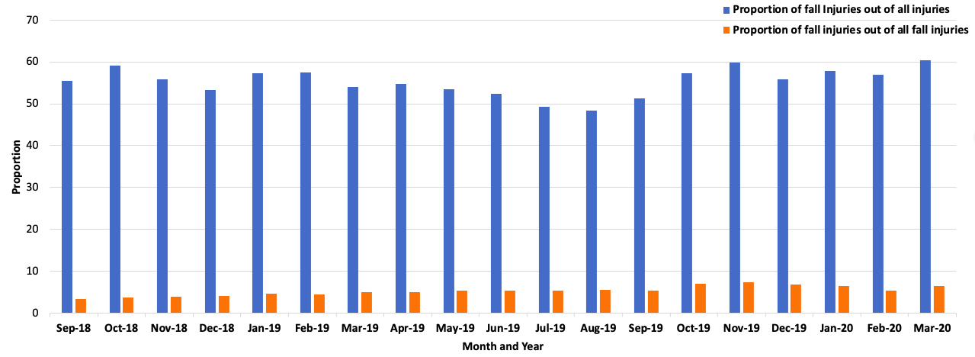

Figure s2b: Number of injuries distributed by months in Tanzania
