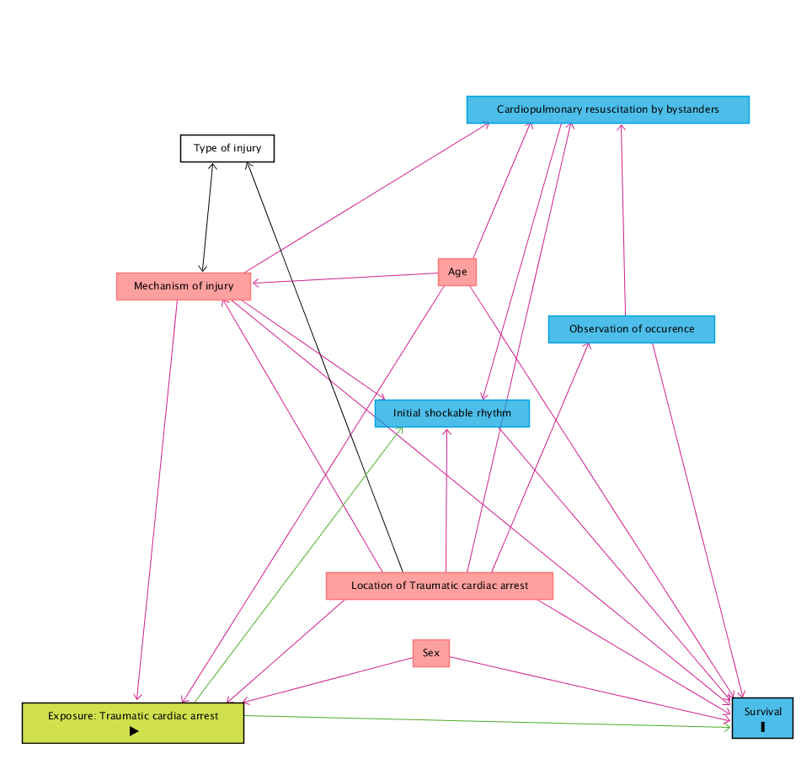
Supplementary 1 Directed acyclic graph of predefined included variables

The variables are selected based on the Utstein style.

