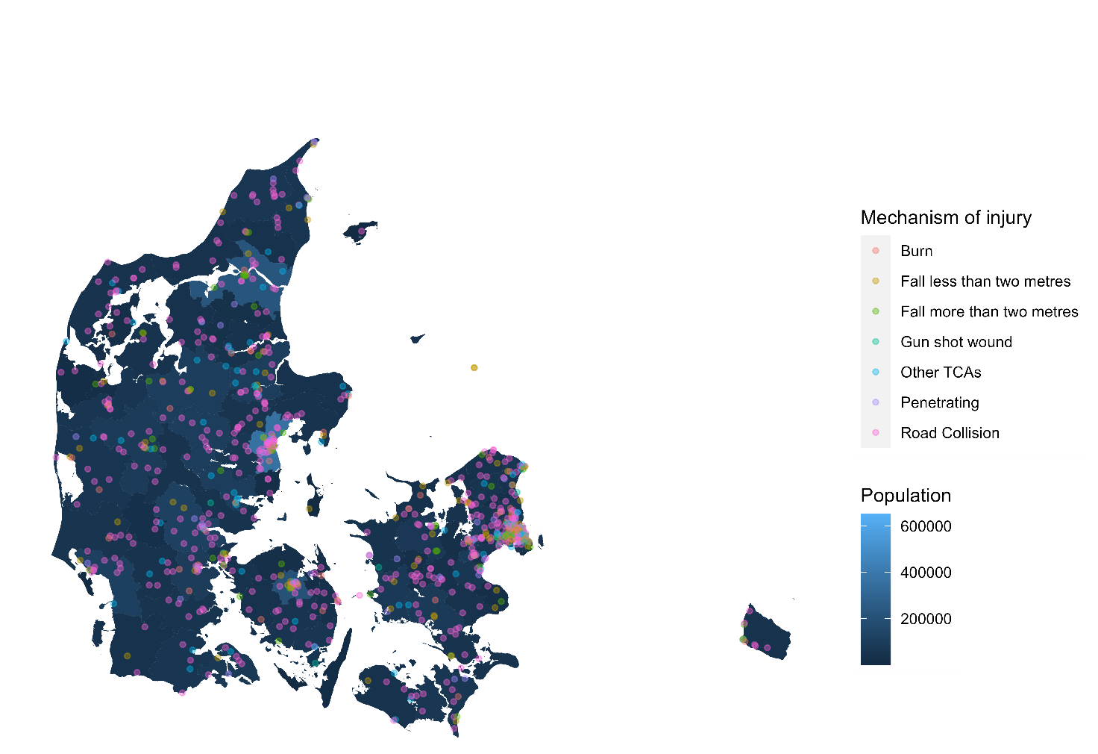
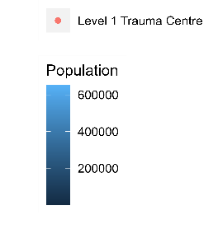
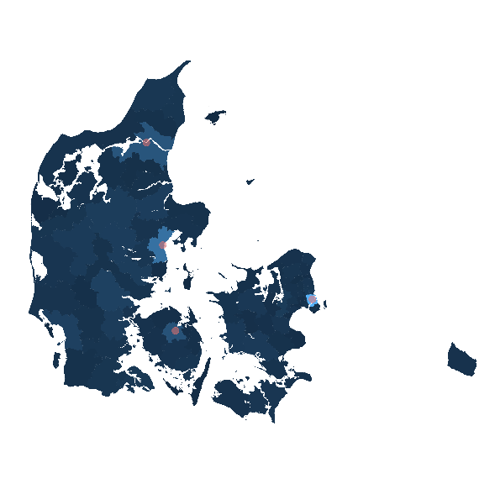
Supplementary 3 The geographical location of traumatic cardiac arrests in Denmark according to mechanism of injury, level 1 trauma centres and population density.

The figure was generated using R statistical software version 4.1.3 (2022-03-10), using the mapDK R package version 0.3.0 (Barfort 2016).

