ELECTRONIC SUPPLEMENTARY MATERIAL

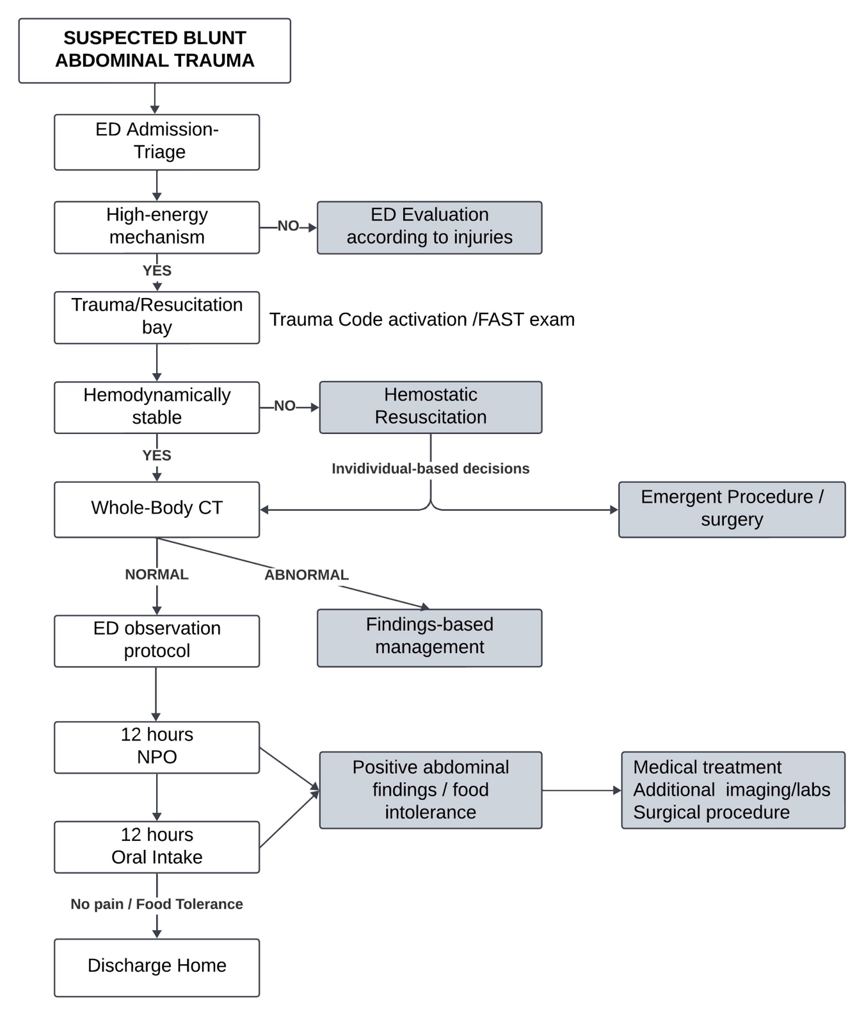
Supplementary Figure 1. Flow diagram of the institutional suspected blunt abdominal trauma protocol. ED Emergency Department, FAST Focused Assessment with Sonography for Trauma, CT Computed Tomography, NPO nothing by mouth.

