Search strategy
- PubMed
#1 (Ketamine [Mesh]) OR (2-(2-Chlorophenyl)-2-(methylamino)cyclohexanone) OR (CI-581) OR (CI 581) OR CI581 OR Ketalar OR Ketaset OR Ketanest OR Calipsol OR Kalipsol OR Calypsol OR (Ketamine Hydrochloride)
#2 (Rapid Sequence Induction and Intubation [Mesh]) OR (Rapid Sequence Intubation) OR (Intubation, Rapid Sequence) OR (Rapid Sequence Induction)
#3 (Emergency Endotracheal Intubation) OR (Emergency Intubation)
#4 #2 OR #3
#5 #1 AND #4
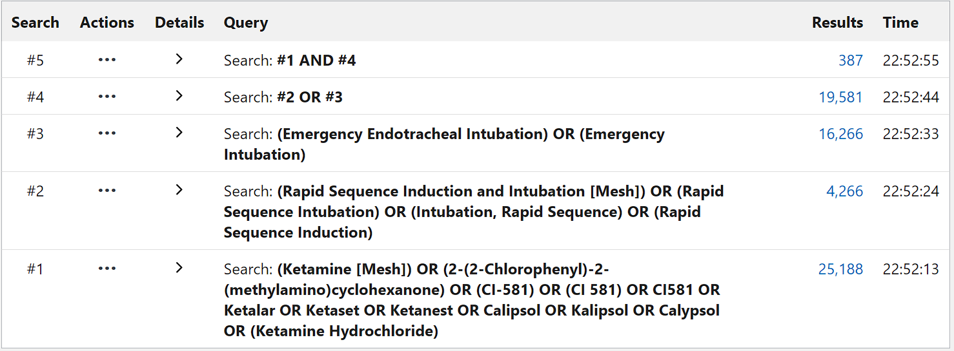
- Embase
No. Query Results
#11. #1 AND #10
#10. #6 OR #9
#9. #7 OR #8
#8. 'emergency intubation'
#7. 'emergency endotracheal intubation'
#6. #2 OR #3 OR #4 OR #5
#5. 'rapid sequence induction'
#4. 'intubation, rapid sequence'
#3. 'rapid sequence intubation'
#2. 'rapid sequence induction and intubation'
#1. 'ketamine'/exp OR ketamine
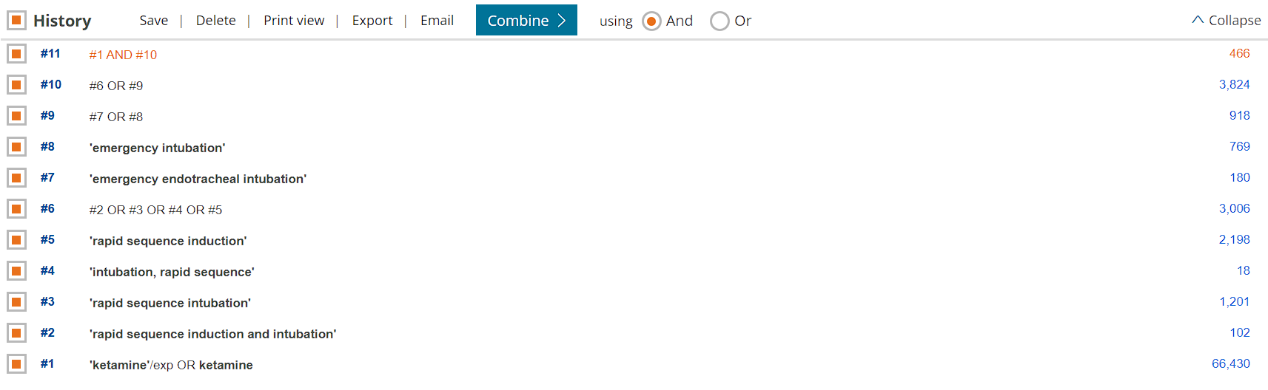
- Cochrane Library
#1 (*ketamine):ti,ab,kw
#2 Rapid Sequence Induction and Intubation
#3 Emergency Intubation
#4 #2 OR #3
#5 #1 AND #4
