Supplementary material of “Measuring the crowding of Emergency Departments: an assessment of the NEDOCS in Lombardy, Italy, and the development of a new objective indicator based on the waiting time for the first clinical assessment”

Figure S1. Flow chart of patients’ selection according to inclusion criteria in 2022. We excluded the patients who arrived at an ED in the first week of 2022 (i.e., before January 8, 2022) because our dataset did not include patients arriving at the ED in 2021 and, consequently, we were not able to reliably estimate the number of patients in the ED in the first days of the year. Similarly, we excluded the patients arriving on December 31, 2022, as we could not estimate the number of patients who were in the ED while these patients waited for the start of the visit.
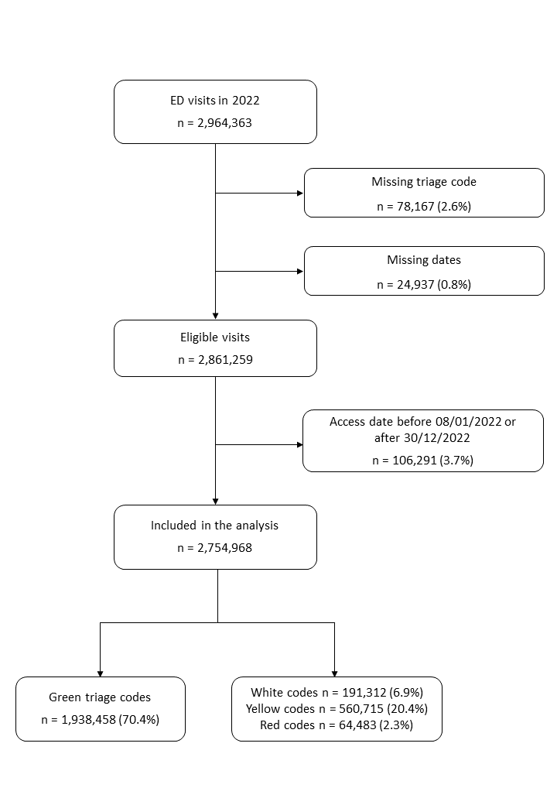
Figure S2. Flow chart of patients’ selection according to inclusion criteria in 2023. We applied the same exclusion criteria than 2022 data.
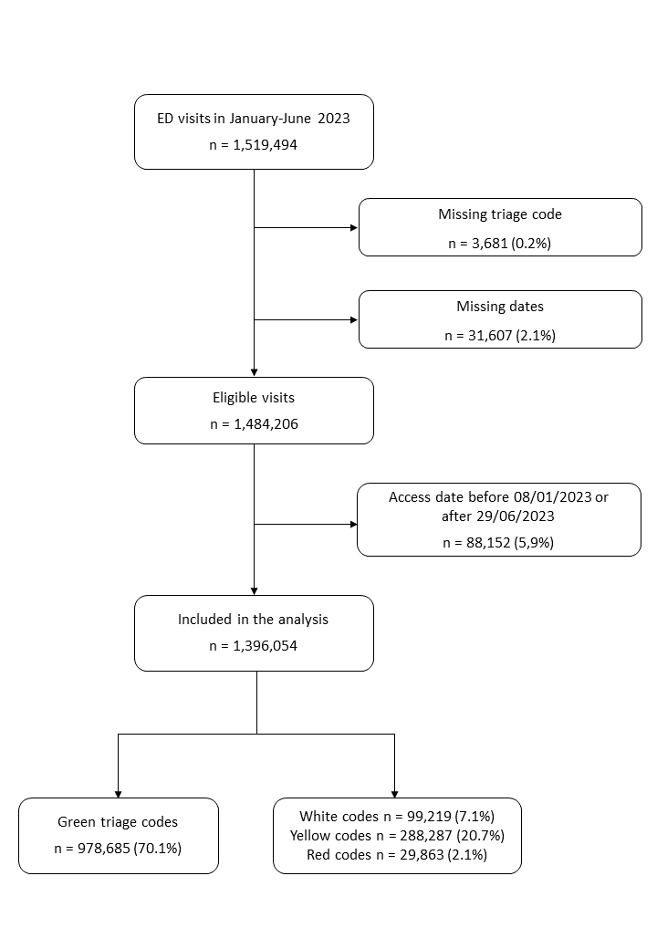

Figure S3. Estimated linear relationship between the number of patients in the ED and the waiting time stratified for the four triage codes for all Lombardy centres. 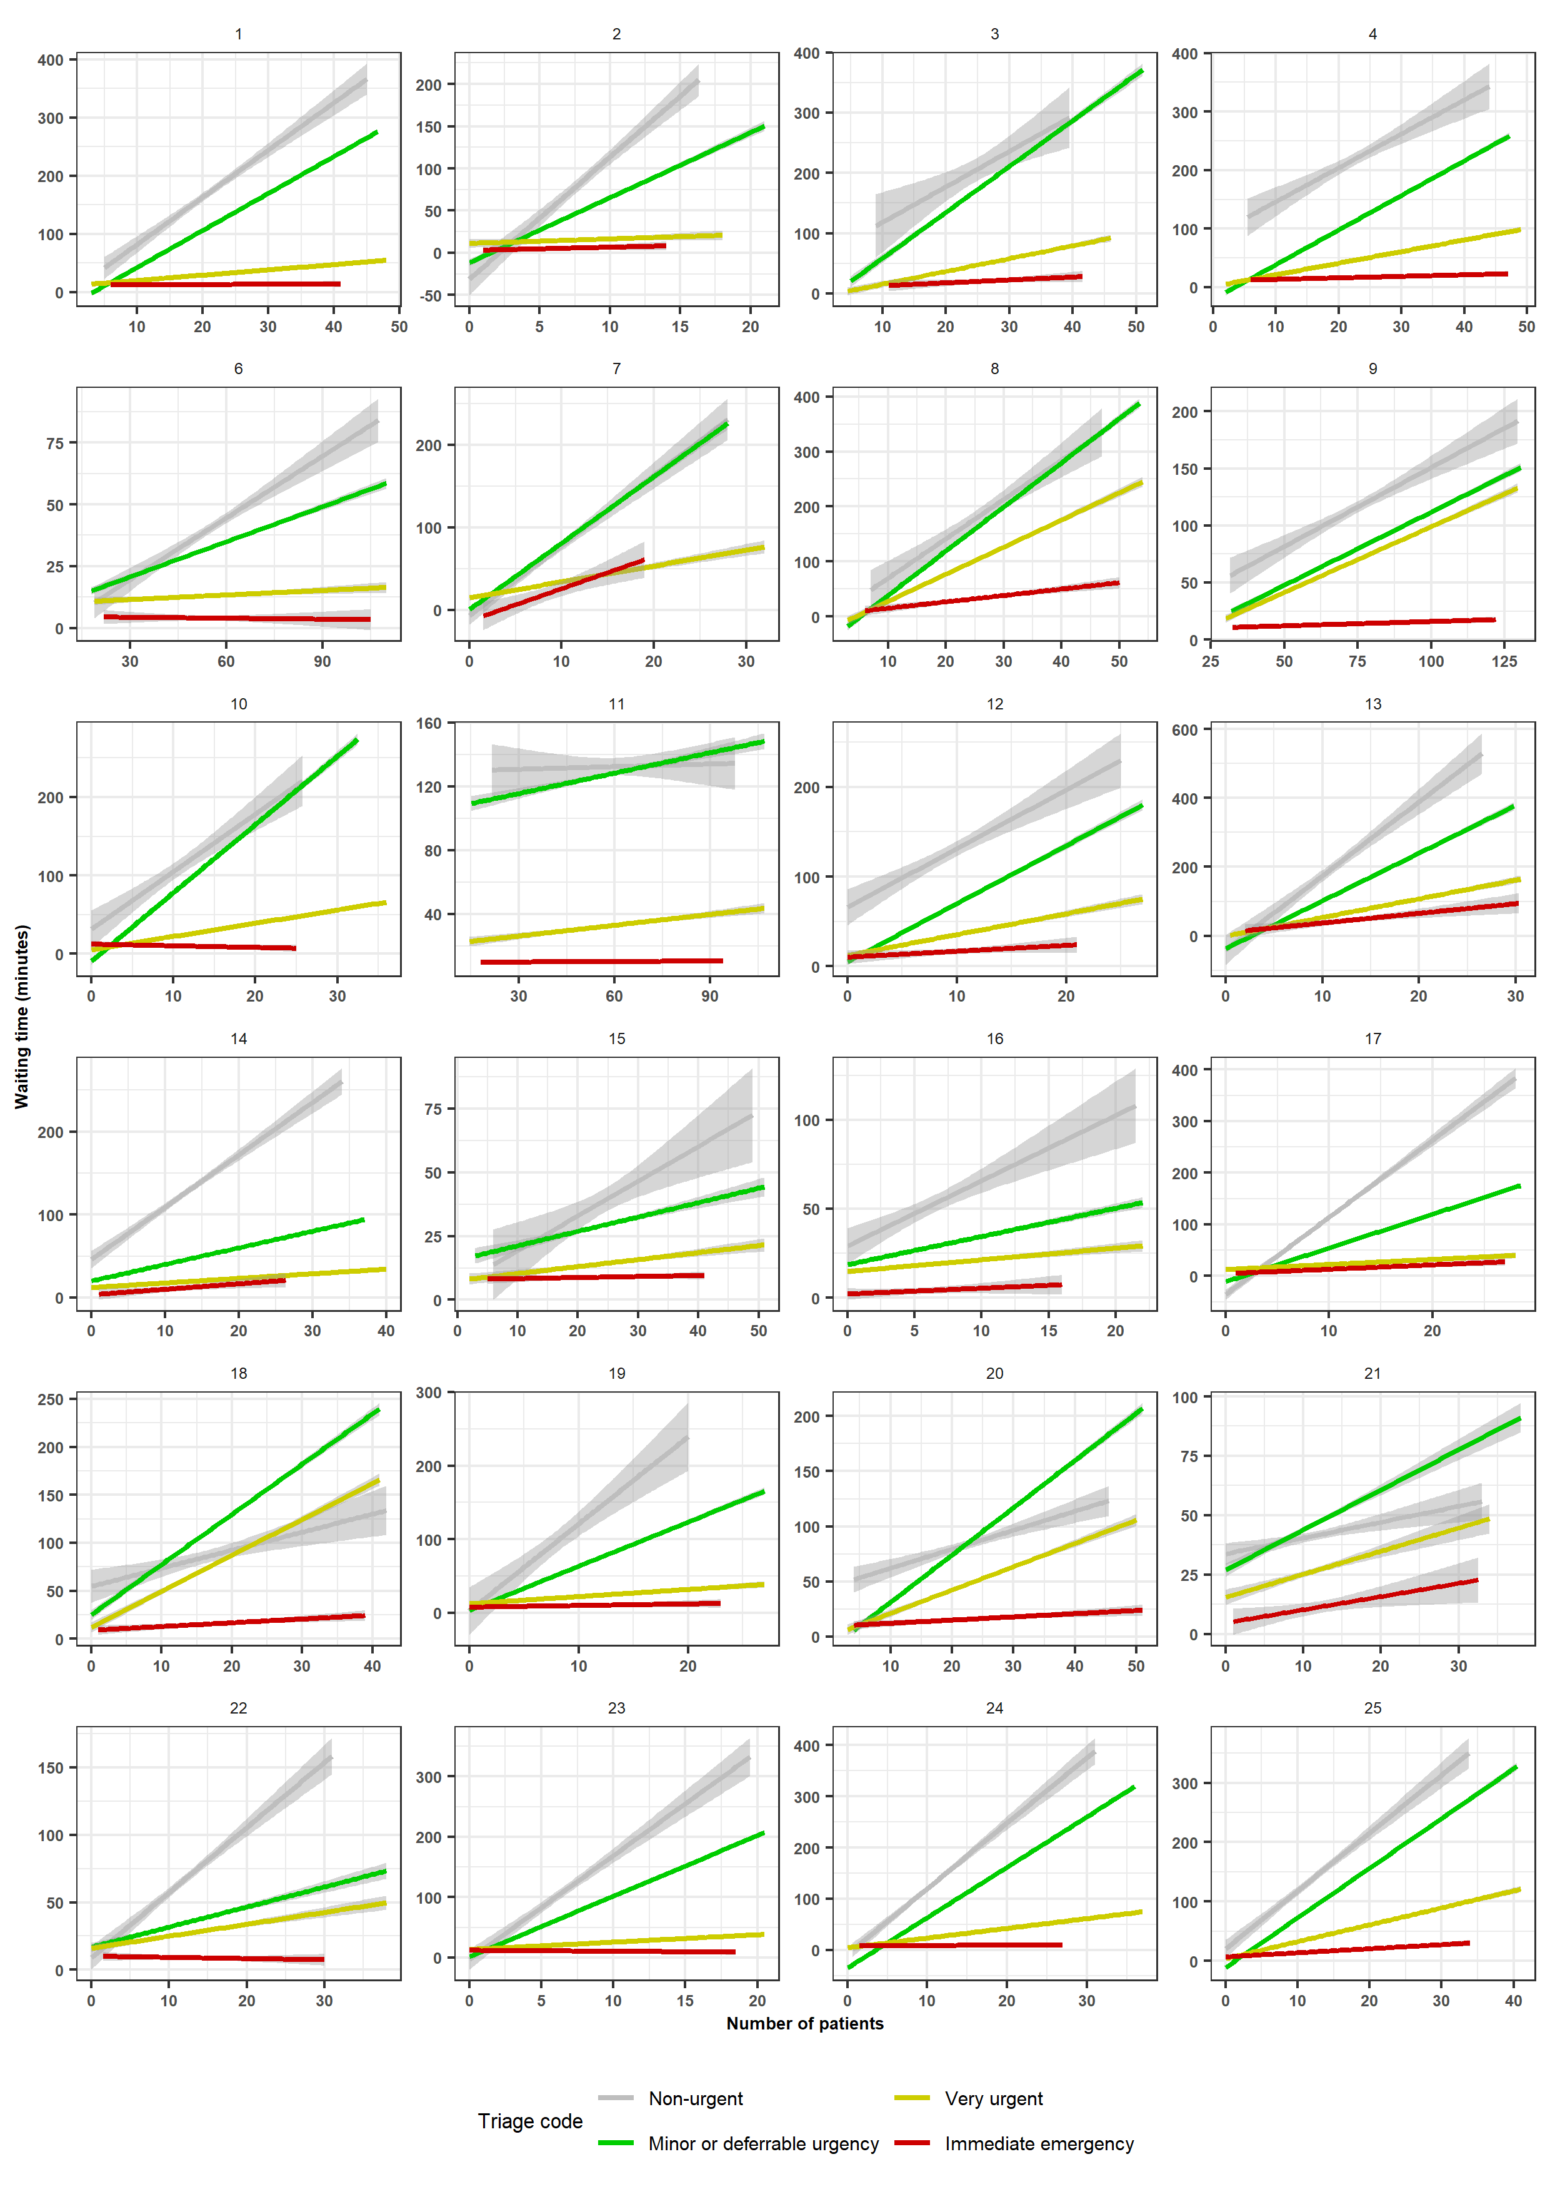
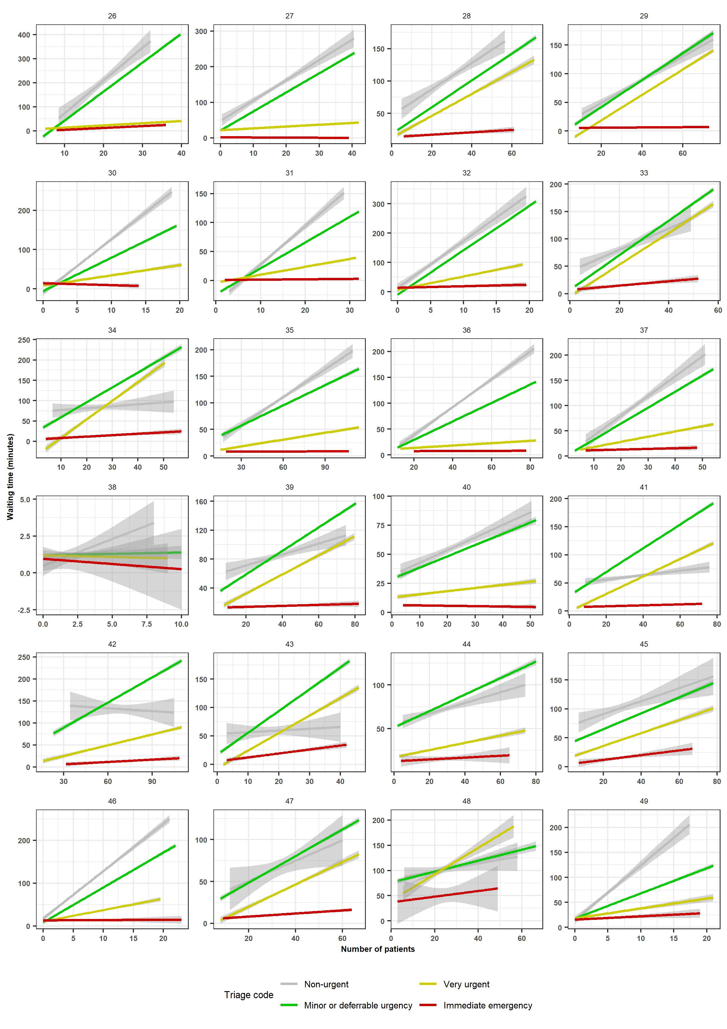

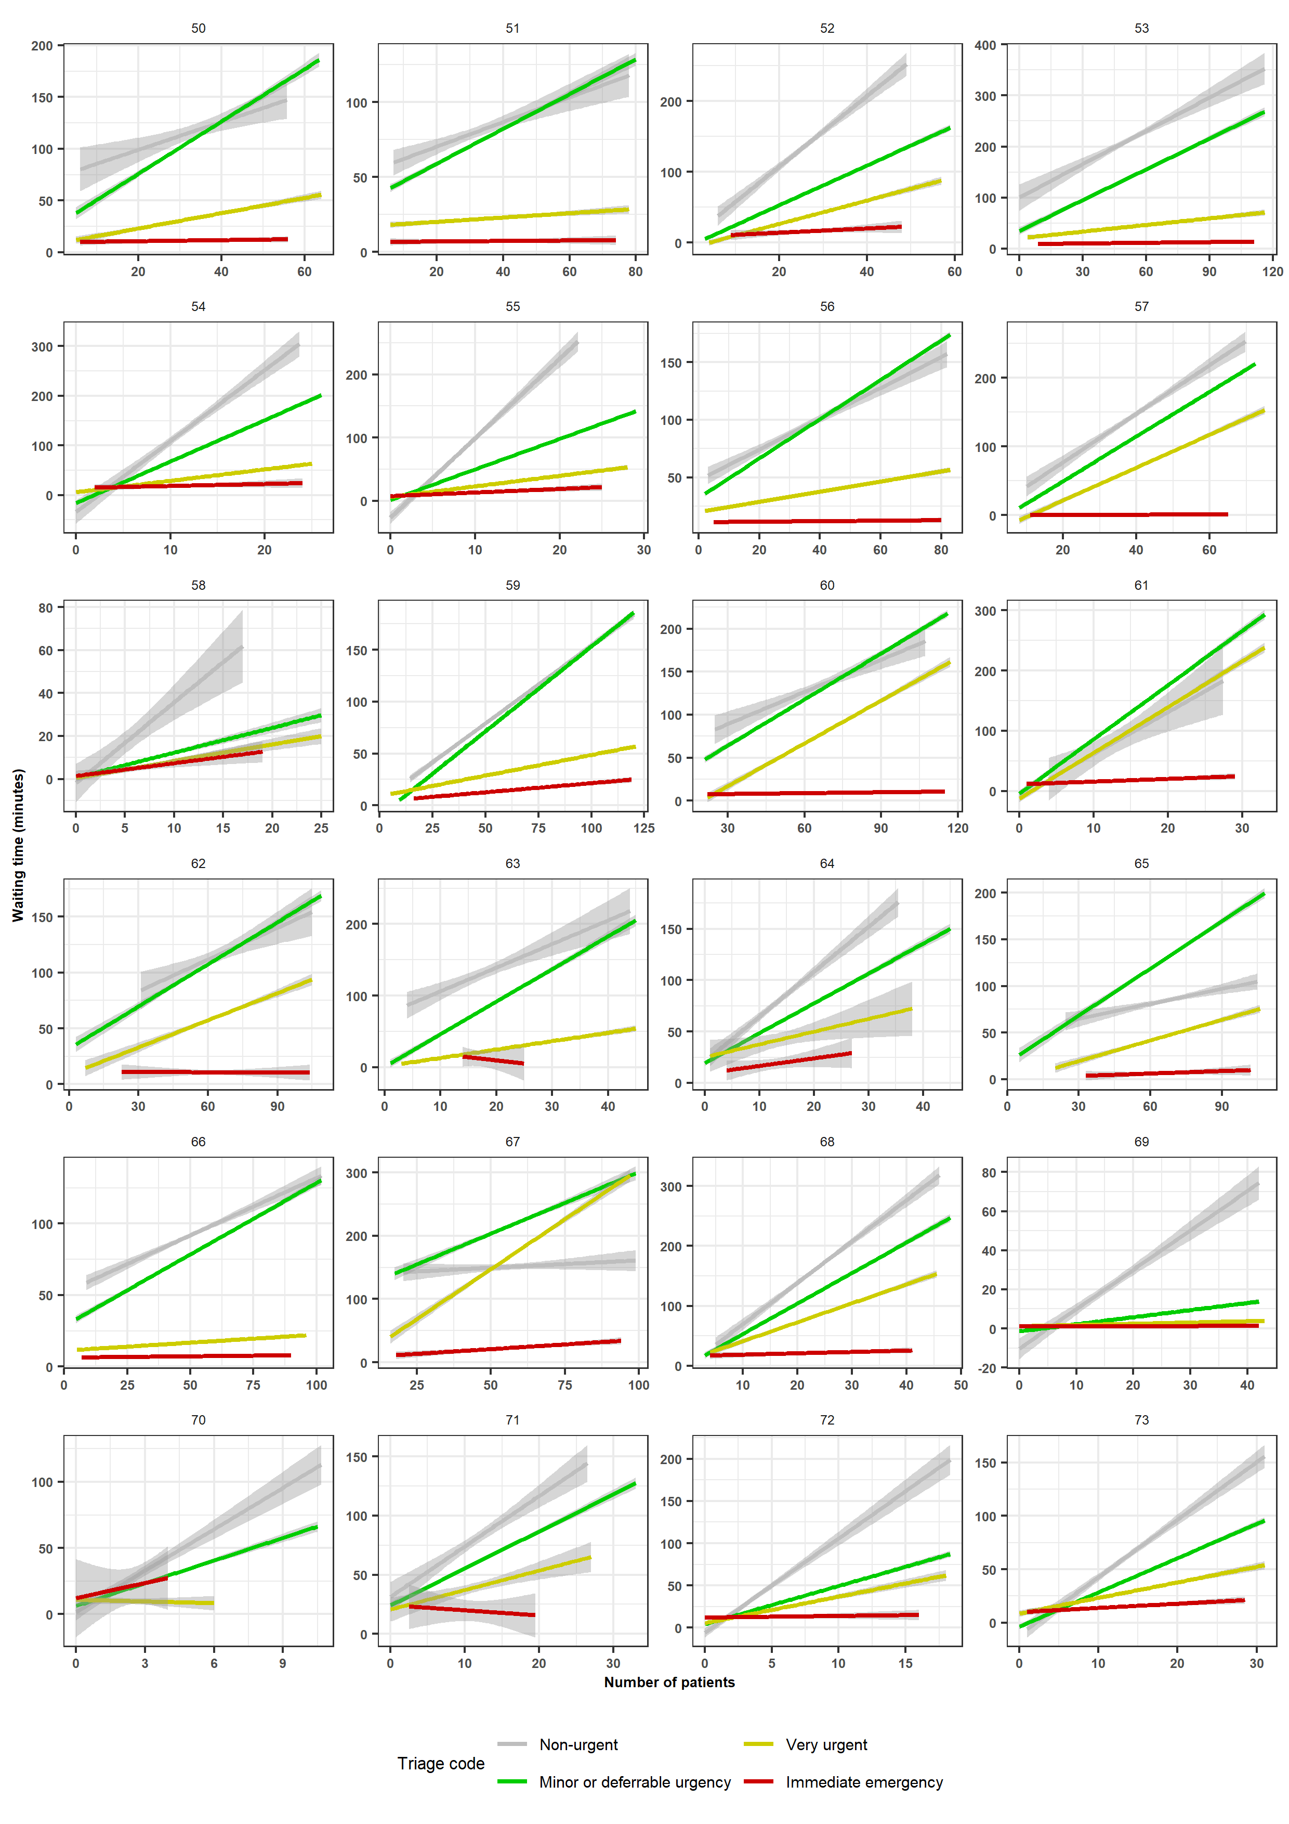

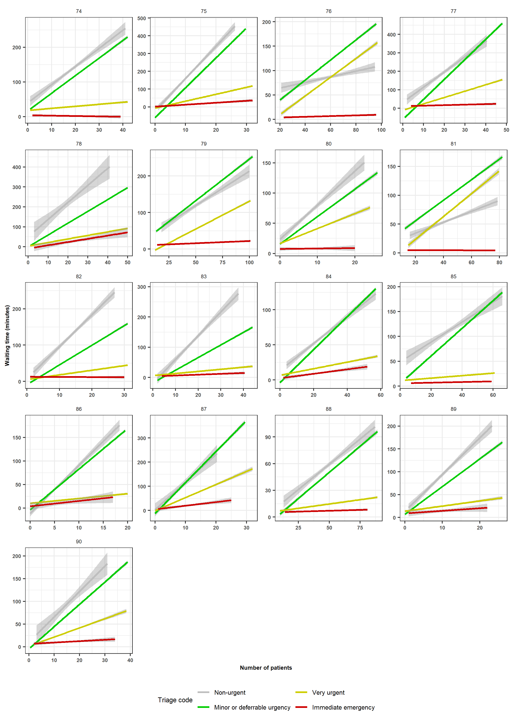

Figure S4. Distribution of the slopes of the linear regression models of the waiting time on the number of patients by triage code.

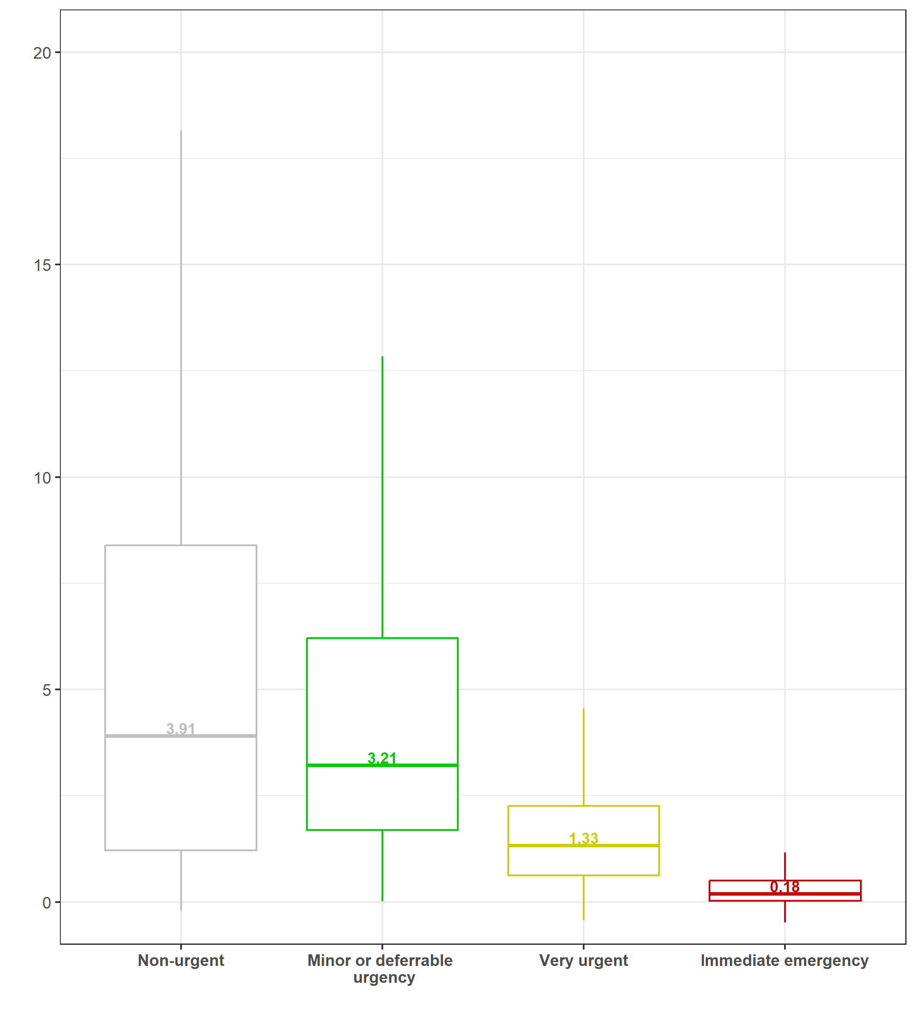

Figure S5. Distribution of the waiting times for physician initial assessment of minor or deferrable urgency patients (development dataset).

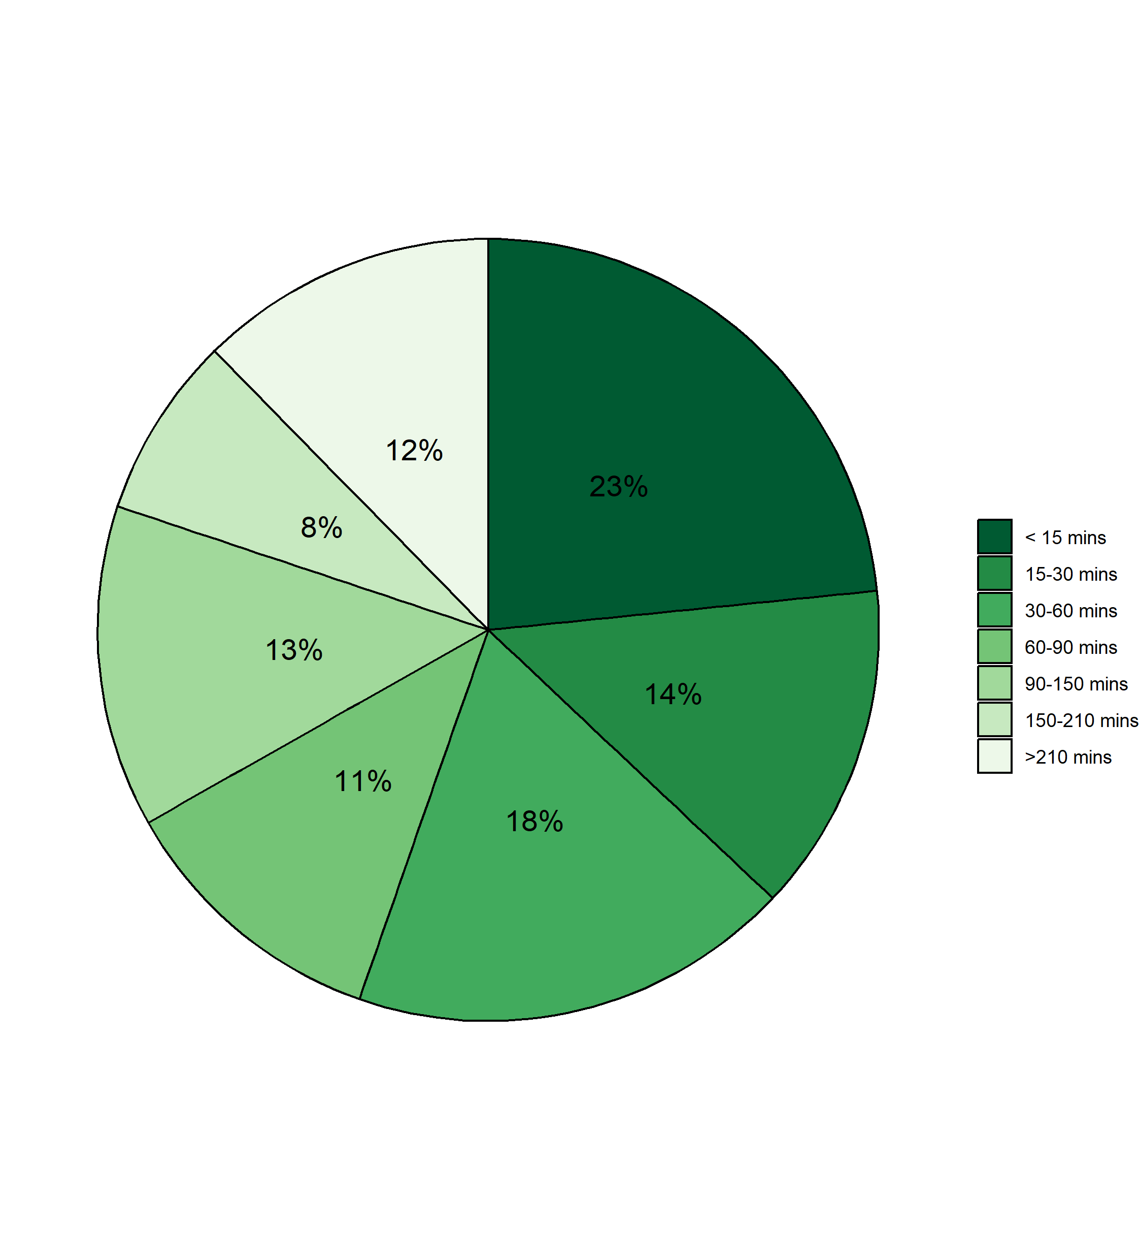

Figure S6. Example of cutoffs estimates for a DEA-I.

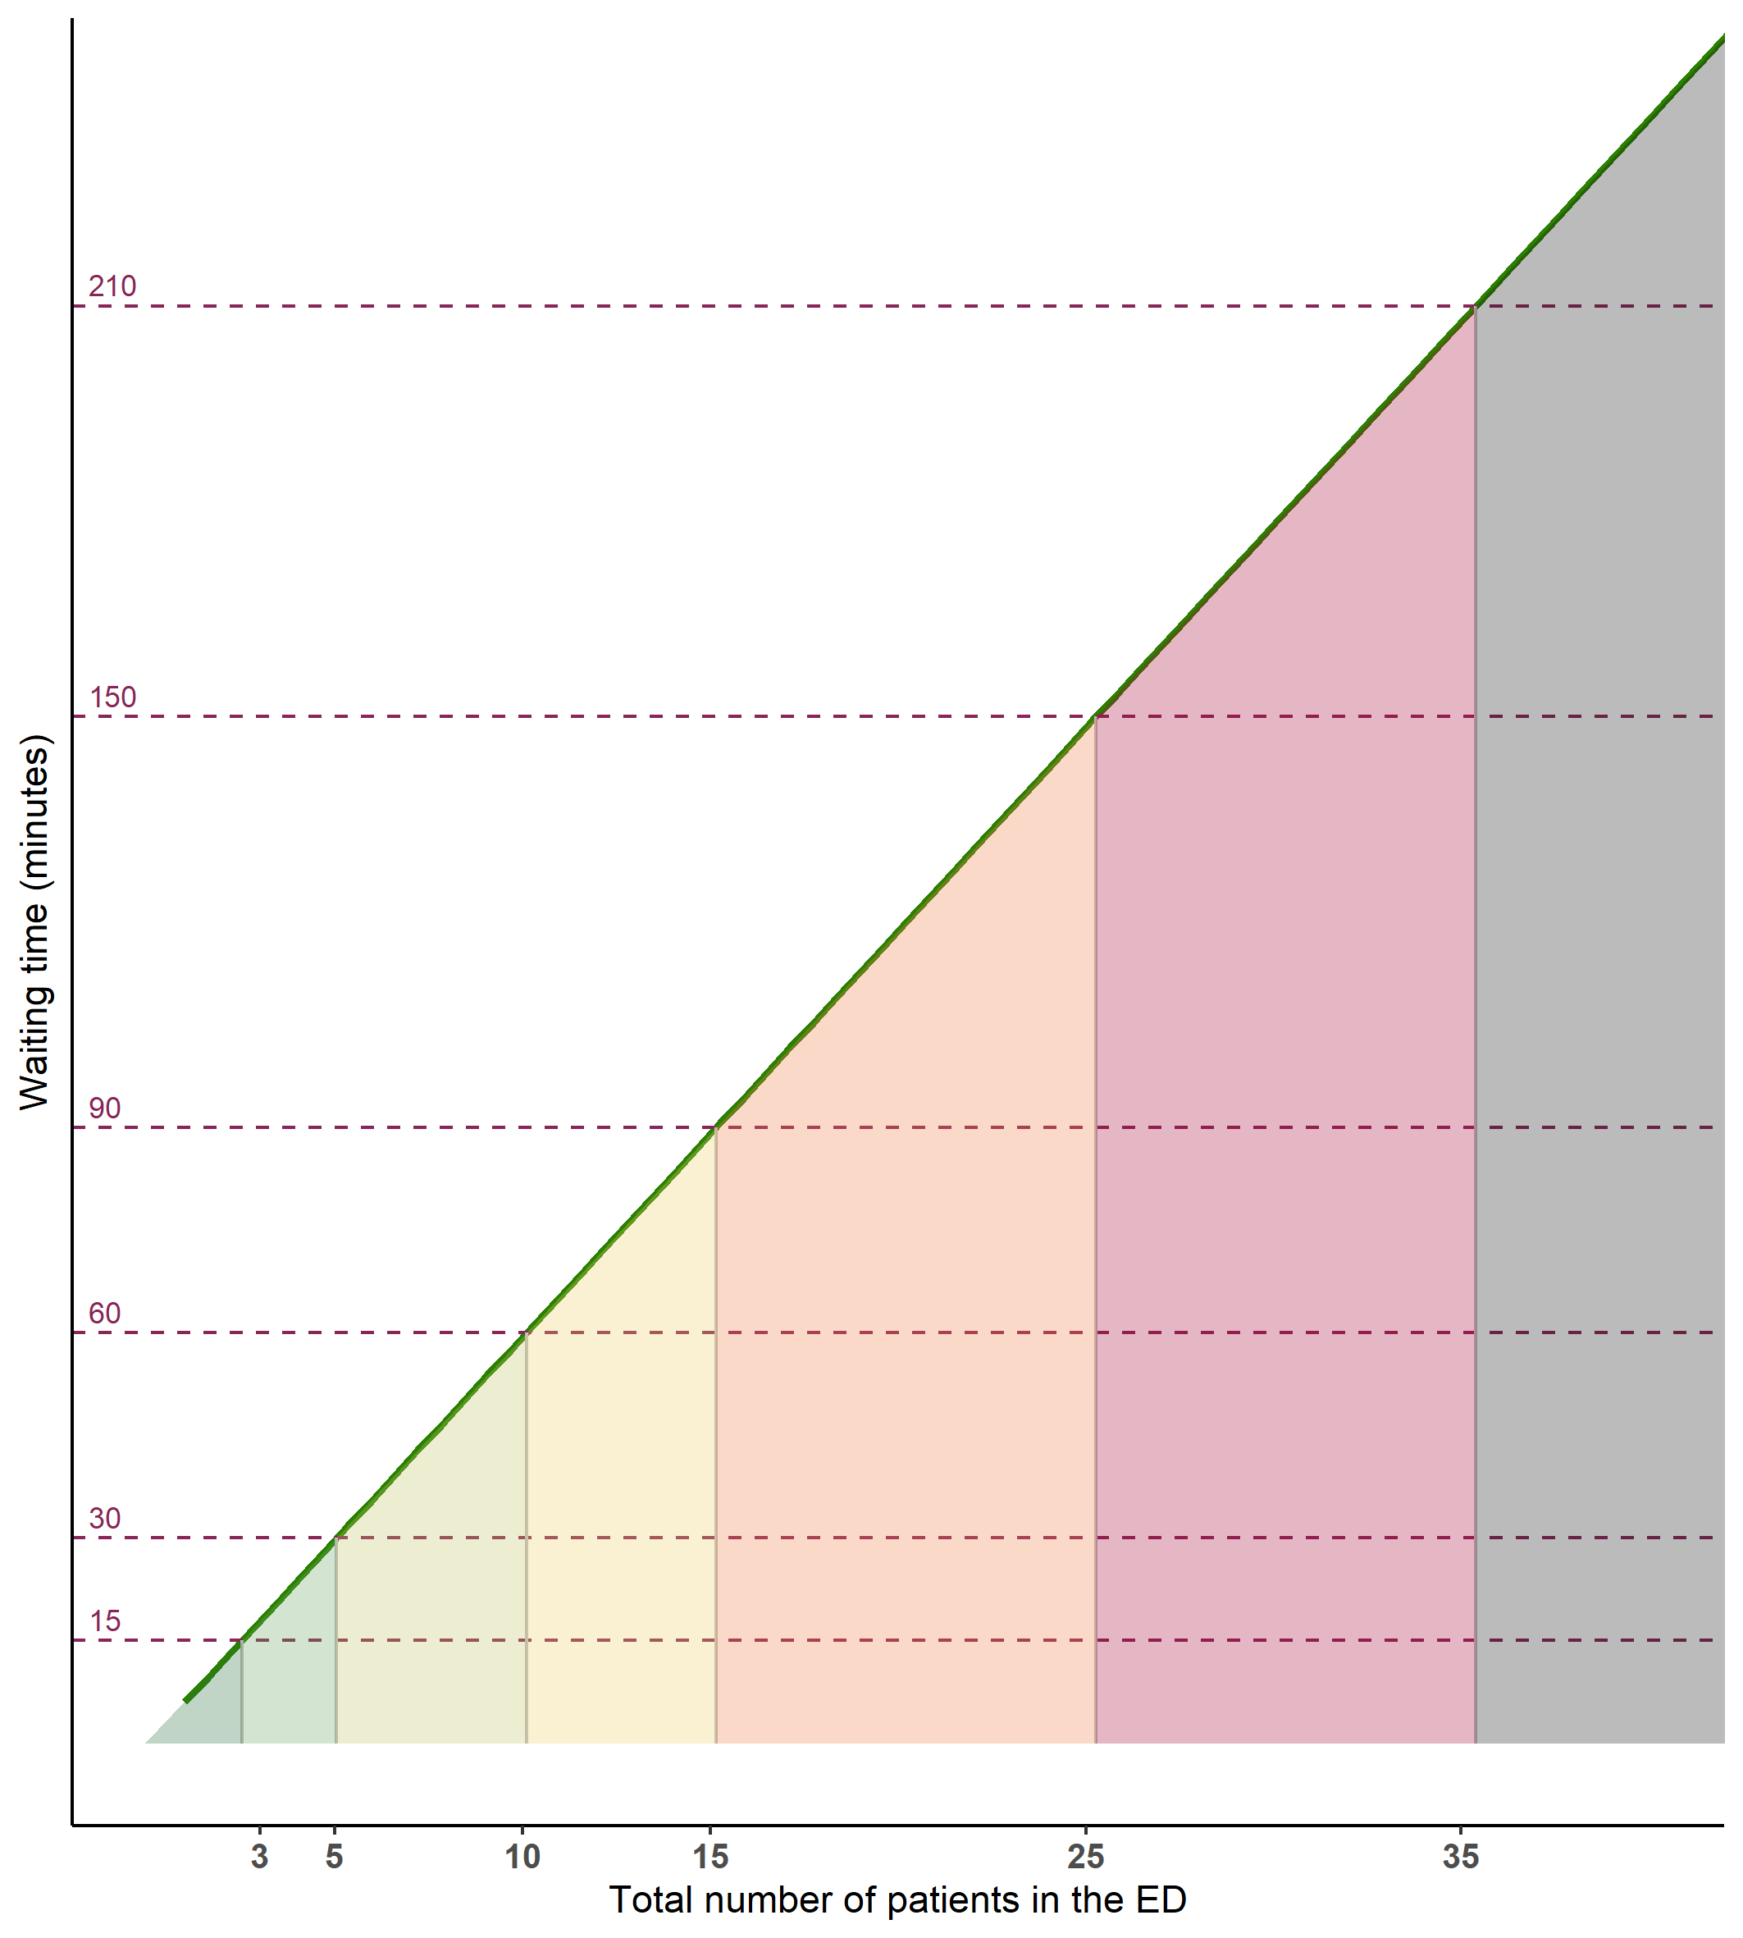

Figure S7. Distribution of the cutoffs of patients by complexity level of the EDs.

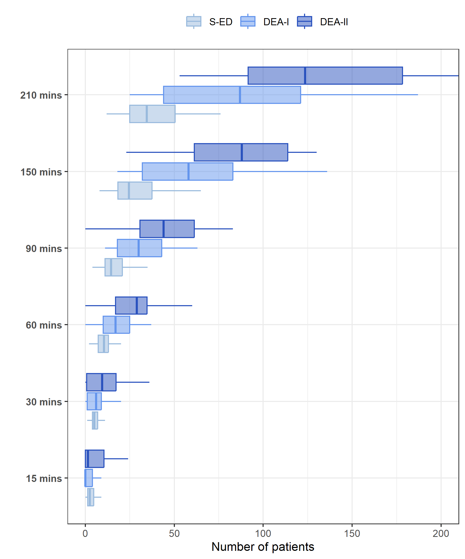

Figure S8. Density distribution of the waiting times of minor or deferrable urgency code patients in the development and validation dataset.

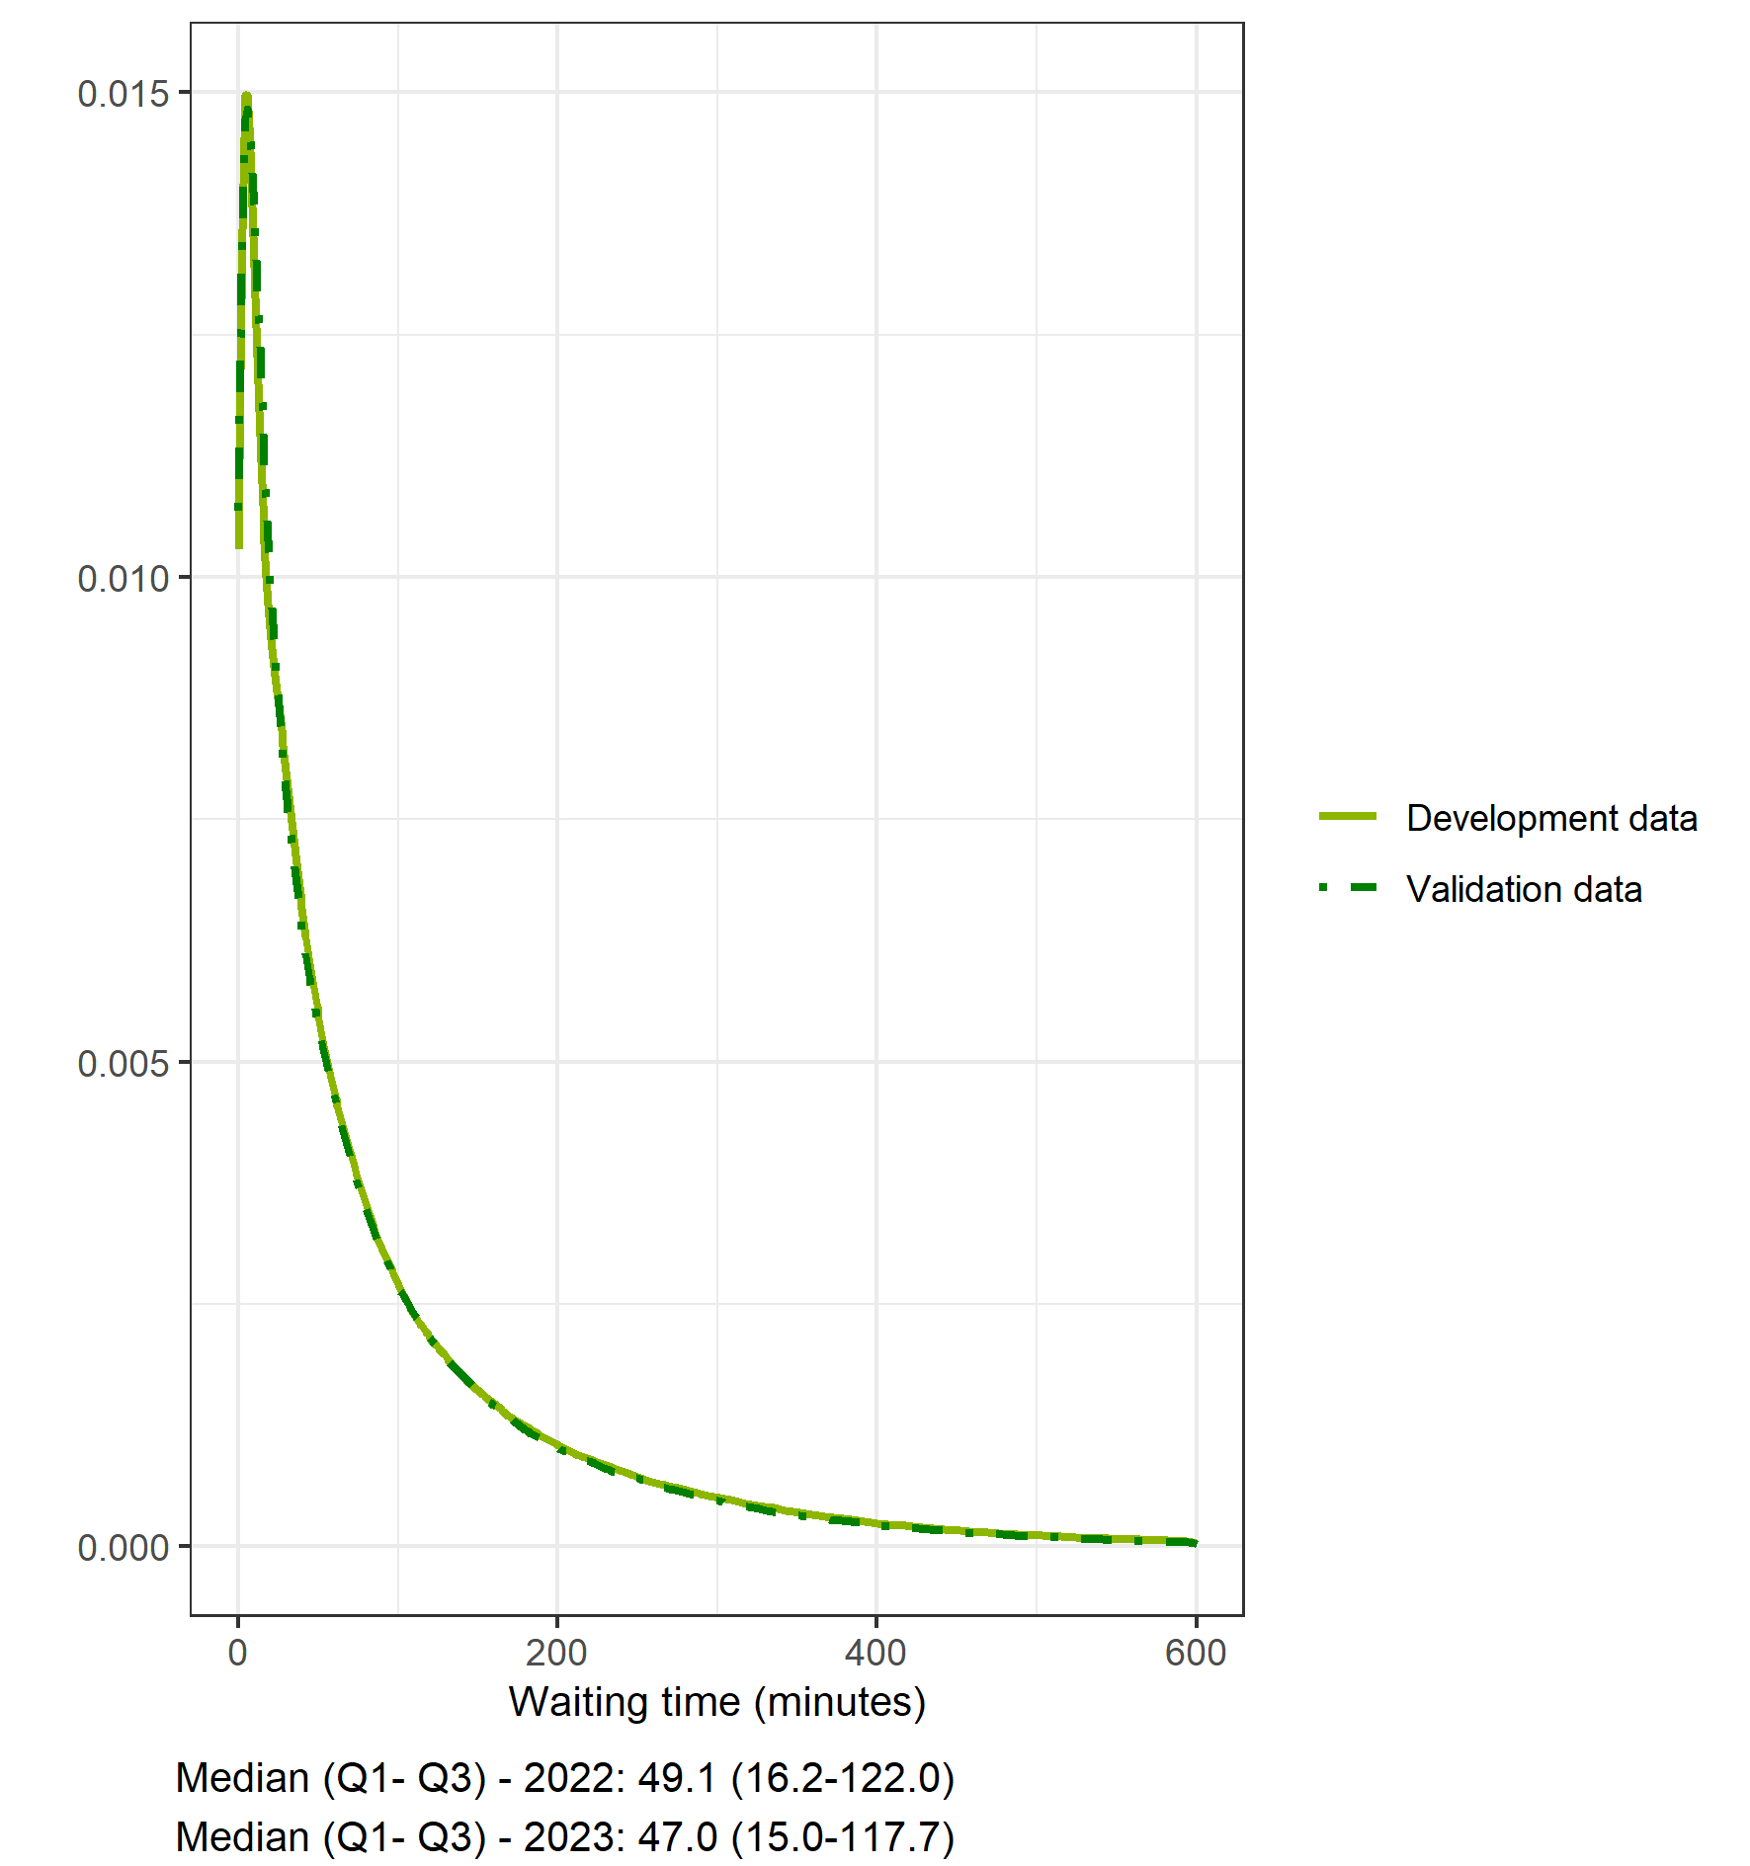

Figure S9. Comparison of the slope coefficients of linear regression models of the waiting time on the number of patients in 2022 and 2023.

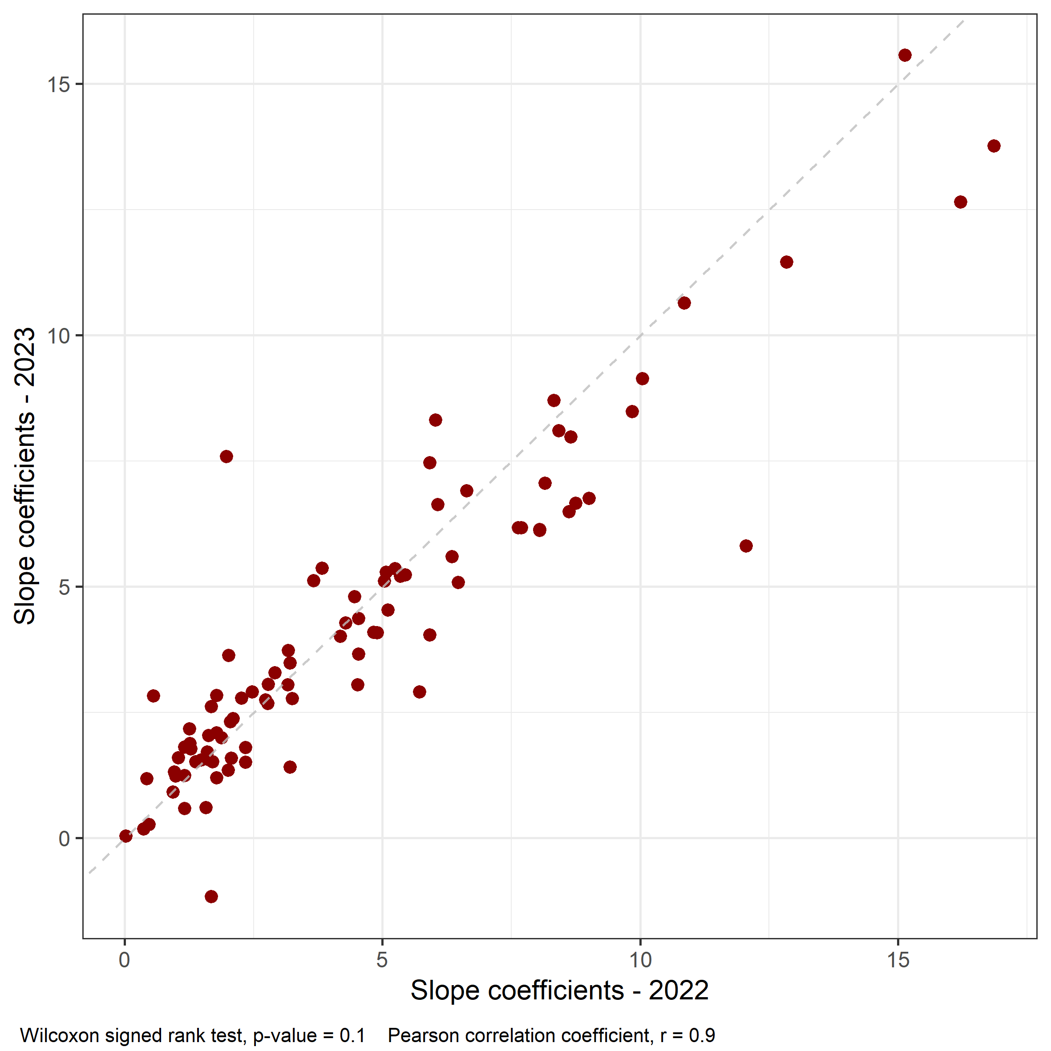
Figure S10. Distribution of the crowding levels in 2022 according to the proposed indicator and NEDOCS in the 38 S-EDs, 41 DEA-I and 12 DEA-II EDs.

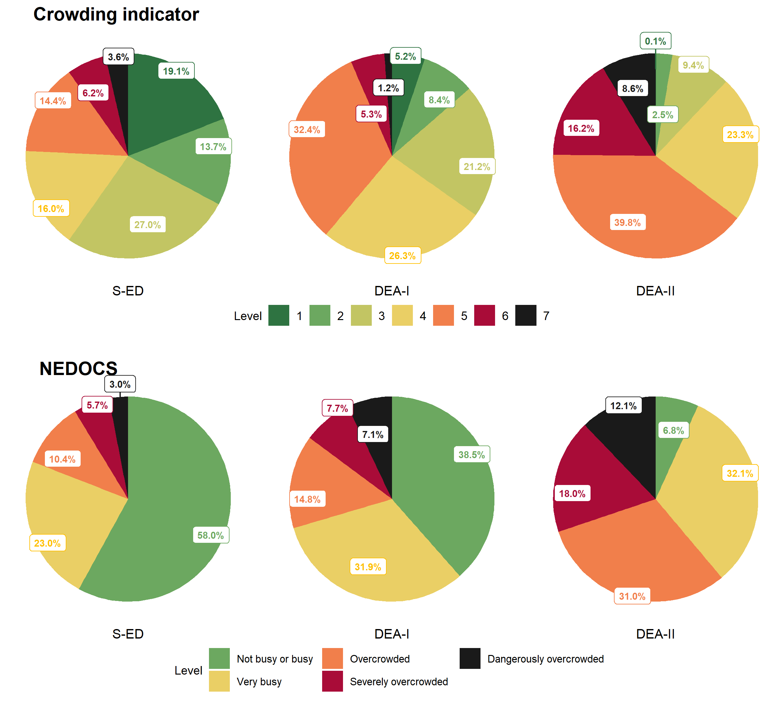

Figure S11. Distribution of the crowding levels in 2023 according to the proposed indicator and NEDOCS in the 38 S-EDs, 41 DEA-I and 12 DEA-II EDs.

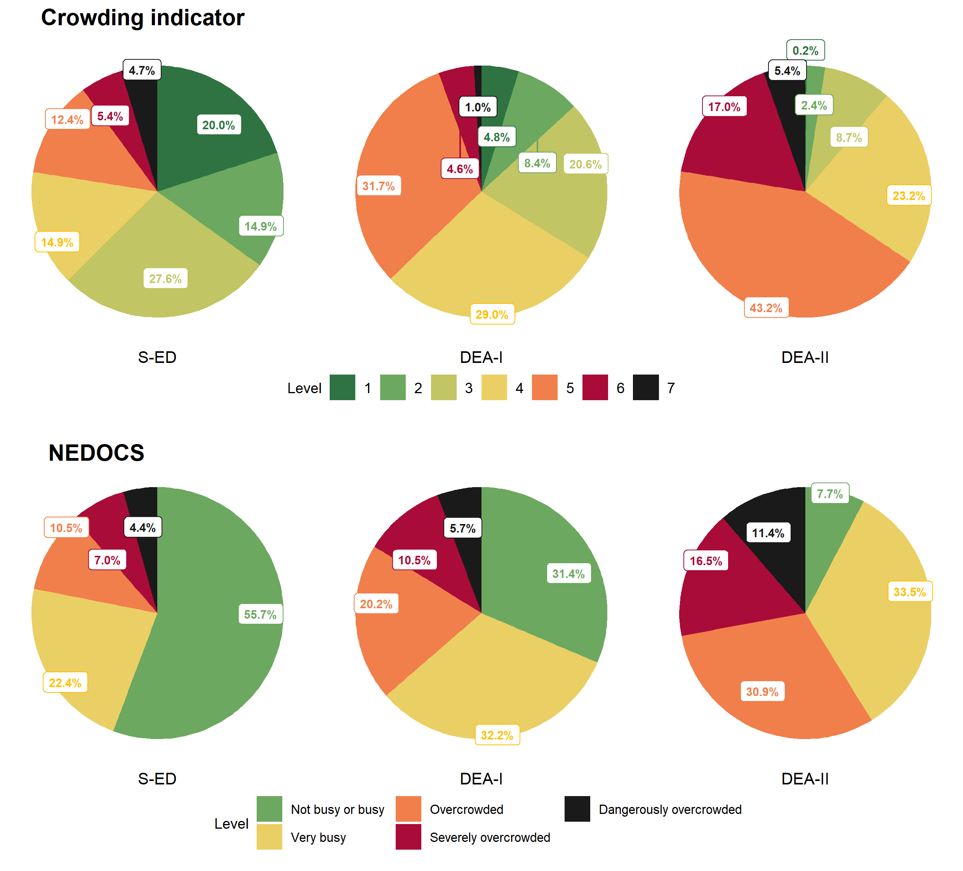

Figure S12. Waiting time for physician initial assessment by the levels of our indicator and the NEDOCS, stratified by triage code in the development dataset (2022).

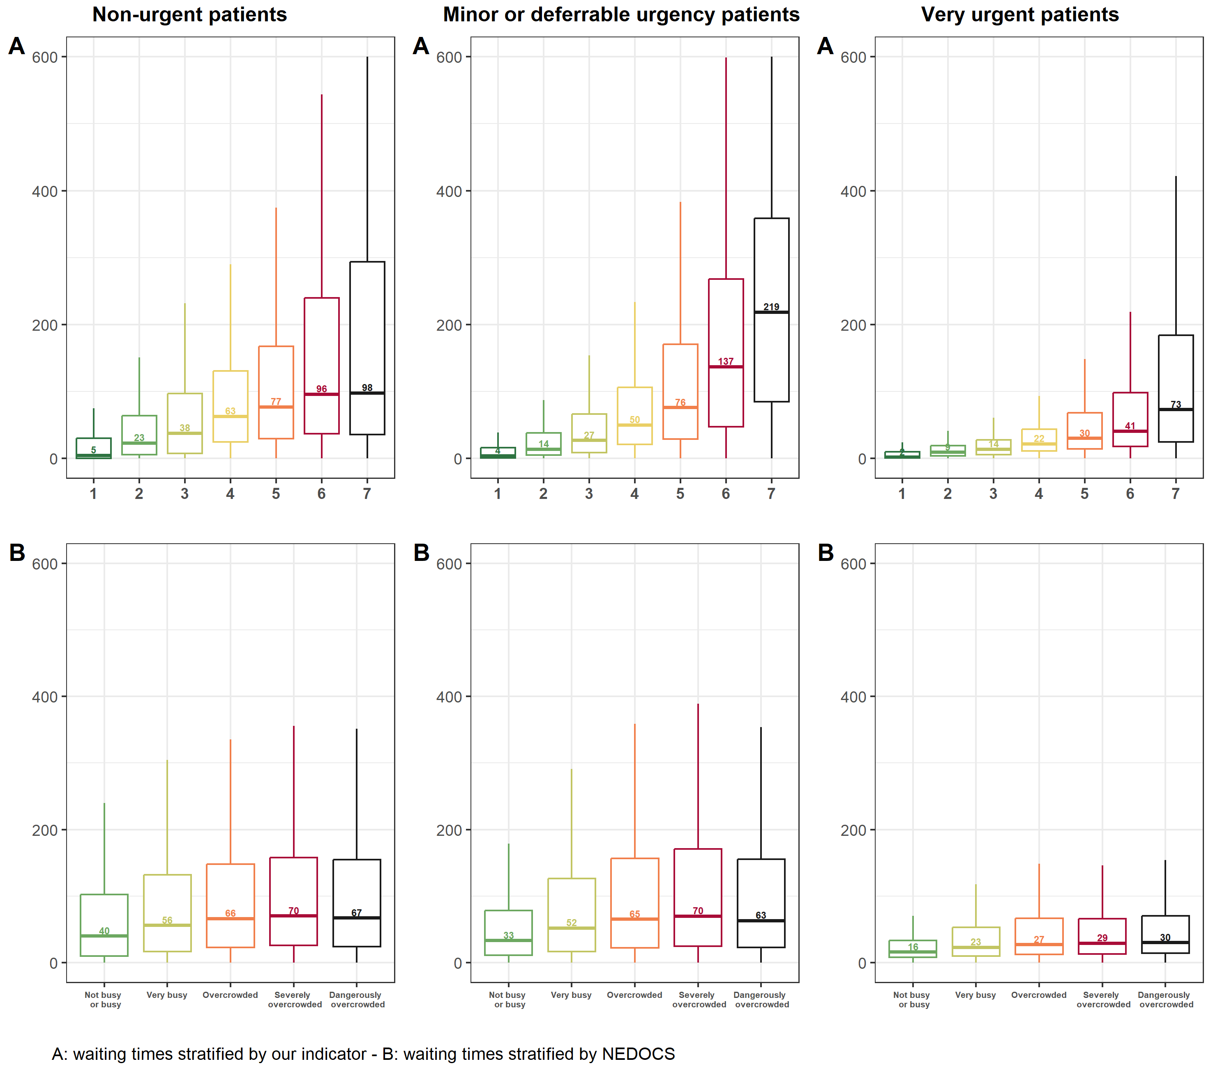

Figure S13. Waiting time for physician initial assessment by the levels of our indicator and the NEDOCS of all patients in the validation dataset (2023).

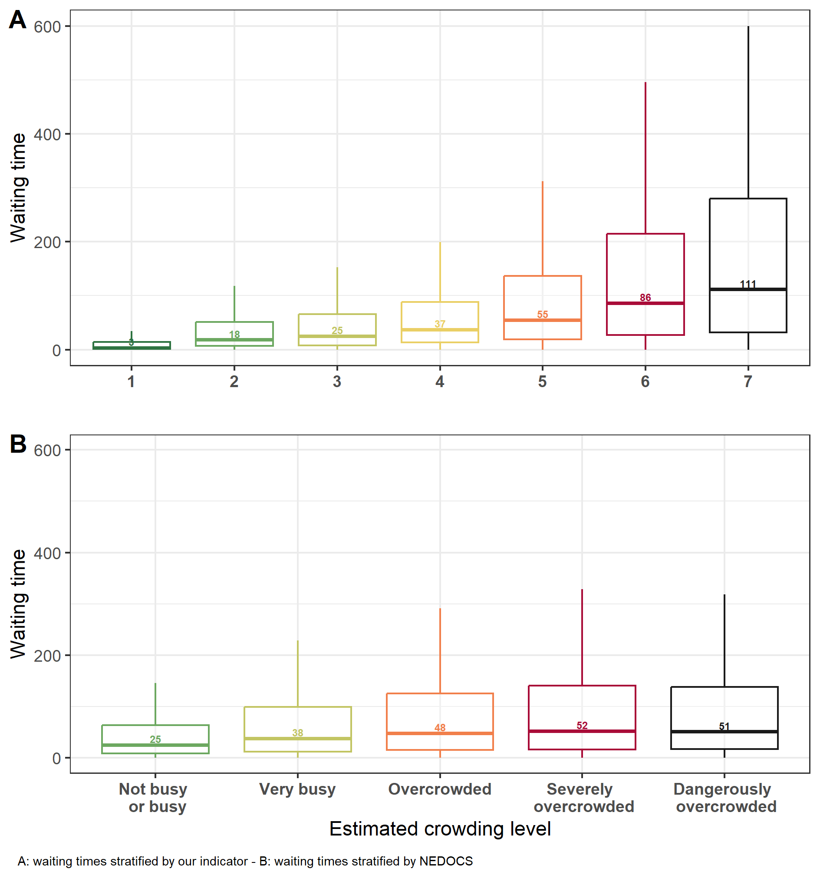

Figure S14. Waiting time for physician initial assessment by the levels of our indicator and the NEDOCS, stratified by triage code in the validation dataset (2023).

