Table S1 Characteristics of patients who failed the first intubation attempt with video laryngoscopy (VL) and direct laryngoscopy (DL), with results from univariable analysis.

Characteristic of patients who failed the first intubation attempt  (N=673) | Initial with VL  (N=61) |  | Initial with DL (N=612) |  | p-value
 | N | % | N | % | p-value
Gender  Male  Female | 40  21 | 65.6  34.4 | 388  224 | 63.4  36.6 | 0.736
Age, mean (±SD) (year) | 60.2±19.8 |  | 61.0±18.2 |  | 0.728
Weight, mean (±SD) (kilogram) | 62.5±15.3 |  | 61.4±15.9 |  | 0.634
Glasgow Coma Scale  3-8  9-13  14-15 | 28  13  20 | 45.9  21.3  32.8 | 306  97  209 | 50.0  15.9  34.1 | 0.541
Physiologic parameters before intubation  Systolic blood pressure, mean (±SD) (mmHg)  Pulse rate, mean (±SD) (bpm)  Respiratory rate, mean (±SD) (per minute)  Oxygen saturation, median (IQR) (%) | 154.4±36.8  113.8±25.5  28.0±11.1  92 (81, 98) |  | 148.9±43.4  106.9±27.2  24.7±14.2  94 (78, 100) |  | 0.366  0.066  0.084  0.977
Indication for intubation  Cardiac arrest  Traumatic cardiac arrest  Other medical encounter  Other traumatic encounter | 4  0  52  5 | 6.6  0  85.2  8.2 | 68  9  462  73 | 11.1  1.5  75.5  11.9 | 0.344
Initial method of intubation  Rapid sequence intubation  Sedation only without paralysis  No medication assisted | 44  13  4 | 72.1  21.3  6.6 | 175  284  153 | 28.6  46.4  25.0 | <0.001
Experience of the first intubator  Low experience  Moderate experience  High experience | 27  13  21 | 44.3  21.3  34.4 | 328  121  163 | 53.6  19.8  26.6 | 0.331
Glottis exposure grade  I = Visualized entire vocal cord  II = Visualized part of vocal cord  III = Visualized epiglottis only  IV = Non-visualized epiglottis | 24  21  11  5 | 39.4  34.4  18.0  8.2 | 217  239  125  31 | 35.4  39.1  20.4  5.1 | 0.634
Induction agent  No used  Diazepam  Midazolam  Etomidate  Ketamine  Propofol | 5  1  8  30  4  13 | 8.2  1.6  13.1  49.2  6.6  21.3 | 161  37  88  194  49  83 | 26.3  6.1  14.4  31.7  8.0  13.5 | 0.005
Neuromuscular blocking agent used | 47 | 77.1 | 170 | 27.8 | <0.001
Difficult intubation indicator  Facial injury  Large incisors  Large tongue  Limited mouth opening  Short hypo-mental distance  Short thyro-hyoid distance  Presence of obstructed airway  Poor neck mobility | 0  1  5  4  3  3  5  6 | 0  1.6  8.2  6.6  4.9  4.9  8.2  9.8 | 21  29  91  108  72  62  36  103 | 3.4  4.7  14.9  17.7  11.8  10.1  5.9  16.8 | 0.142  0.263  0.155  0.027  0.105  0.189  0.471  0.157

Table S2 Intubation conditions of patients who failed the first intubation attempt with video laryngoscopy (VL) and direct laryngoscopy (DL), with results from univariable analysis.

Patients who failed the first intubation attempt  (N=673) | Initial with VL  (N=61) |  | Initial with DL (N=612) |  | p-value
Patients who failed the first intubation attempt  (N=673) | N | % | N | % | p-value
Total number of attempts, median (IQR) | 2 (2, 3) |  | 2 (2, 3) |  | 0.422
Success outcomes  Successful in the second attempt  Successful in the third attempt  Need over three attempts | 42  11  8 | 68.9  18.0  13.1 | 452  104  56 | 73.9  16.9  9.2 | 0.565
Switching for a more experienced intubator  No switching  Switching in the second attempt  Switching in the third attempt  Switching after three attempts | 22  22  10  7 | 36.1  36.1  16.4  11.4 | 220  271  75  46 | 35.9  44.3  12.3  7.5 | 0.985
Cases not used RSI in the first attempt  Change to RSI after failed initial attempt  with non-RSI  Successful after changing | 17  4  2 | 27.9  23.5  11.8 | 437  7  6 | 71.4  1.6  1.4 | <0.001  0.491
Change in intubation procedure  No change  Change from VL to DL  Change from DL to VL | 47  14  N/A | 77.1  22.9  N/A | 596  N/A  16 | 97.4  N/A  2.6 | <0.001

Table S3 Intubation conditions of patients who changed the method after a failed initial attempt with video laryngoscopy (VL) or direct laryngoscopy (DL), including results from univariable analysis.

Outcomes from changing  (N=30) | From VL to DL  (N=14) |  | From DL to VL  (N=16) |  | p-value
Outcomes from changing  (N=30) | N | % | N | % | p-value
Total number of attempts, median (IQR) | 3 (2, 5) |  | 3.5 (2, 5) |  | 0.732
Success outcomes  Successful in the second attempt  Successful in the third attempt  Need over three attempts | 5  3  6 | 35.7  21.4  42.9 | 5  3  8 | 31.3  18.7  50.0 | 0.926
Switching for a more experienced intubator  No switching  Switching | 2  12 | 14.3  85.7 | 3  13 | 18.8  81.2 | 0.743
Adverse event  No adverse event  Hypotension-required IV fluid  Severe hypoxemia  Cardiac arrest | 9  0  5  0 | 64.3  0  38.5  0 | 5  2  6  1 | 31.3  12.5  46.2  6.25 | 0.070

Table S4 Adverse events by intubation method.

Adverse event | Events in all methods  (N=3,424)  n (%) | Events in rapid sequence intubation method (N=1,562)  n (%) | Events in sedation without paralysis  (N=1,029)  n (%)
Hypotension-required IV fluid | 337 (9.84) | 85 (5.44) | 114 (11.08)
Severe hypoxemia | 1,067 (31.16) | 278 (17.79) | 259 (25.17)
Cardiac arrest | 30 (0.88) | 7 (0.45) | 9 (0.87)
Esophageal intubation | 49 (1.43) | 16 (1.02) | 21 (2.04)
Dental trauma | 33 (0.96) | 9 (0.58) | 18 (1.75)
Main stem intubation | 18 (0.53) | 10 (0.64) | 3 (0.29)
Direct airway injury | 10 (0.29) | 1 (0.06) | 6 (0.58)
Aspiration | 8 (0.23) | 4 (0.26) | 4 (0.39)
Laryngospasm | 6 (0.18) | 1 (0.06) | 4 (0.39)
Pneumothorax | 2 (0.06) | 0 | 1 (0.10)

Figure S1 Data collection form.

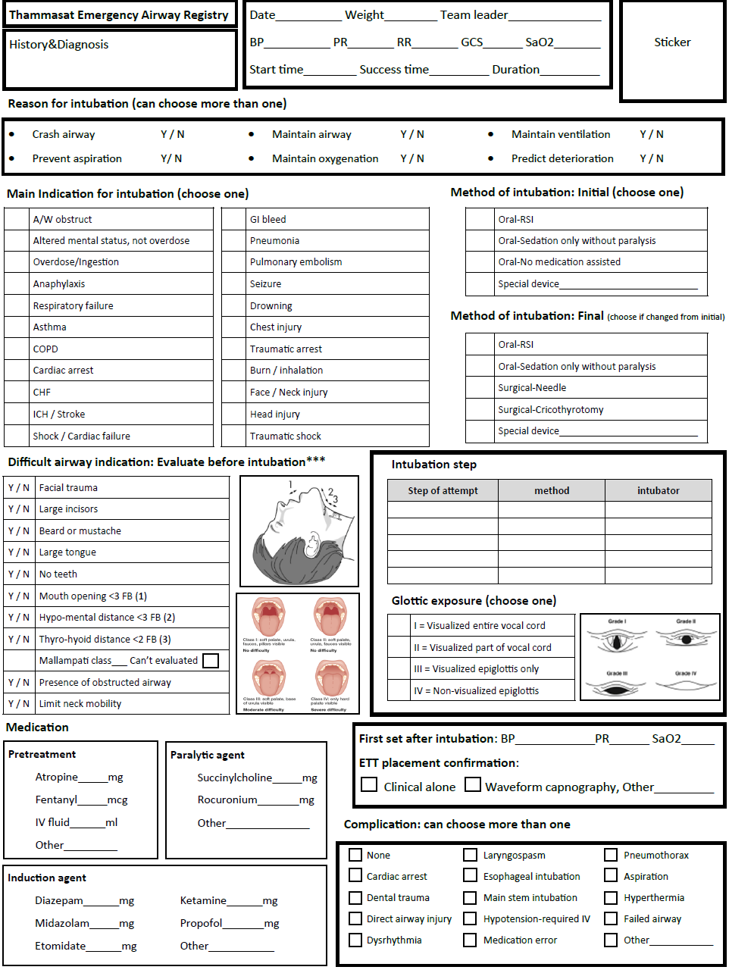
Figure S2 Thammasat Emergency Medicine RSI Med Summary.
