Supplement Figure 2. Kaplan-Meier curves showing the cumulative survival probability among severe and critically injured combat casualties (ISS16-75) during the 2023 war versus 2014 war
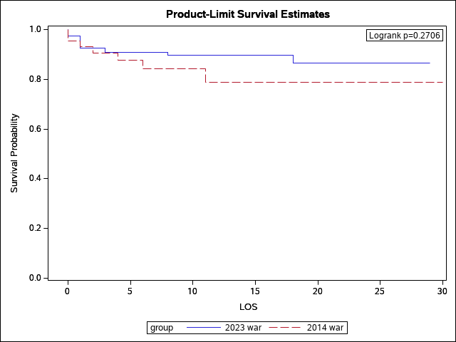
Abbreviation: ISS-injury severity score, LOS-hospital length of stay (in days).

