Supplement Figure 1: English translation of the survey sent to the different organisations in Austria (in German)

Page 1
Survey: Evaluation of prehospital equipment for the control of traumatic haemorrhage on emergency medical equipment in Austria

Page 2
Personal data
Your organisation:
- Austrian Red Cross
- Professional Rescue Vienna
- Samaritan organisation
- ARA Air Rescue
- Martin Air Rescue
- ÖAMTC Air Rescue
- Other:

Your federal state:
- Burgenland
- Carinthia
- Lower Austria
- Upper Austria
- Salzburg
- Styria
- Tyrol
- Vorarlberg
- Vienna

Your resources:
- Emergency ambulance (NAW)
- Ground-based physician response unit (NEF)
- Helicopter Emergency Medical Service (RTH)
- Other:
Your service location:
- ___

Page 3
Equipment
Which of this equipment is currently available to you on your emergency response equipment? Please indicate only the current status, not planned changes!
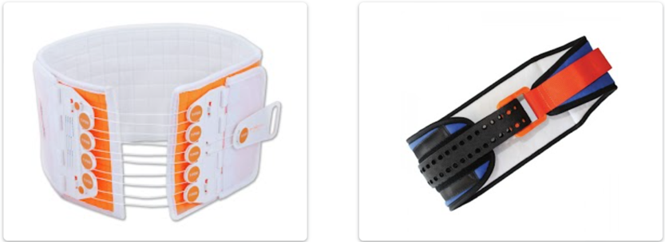
Pelvic binder:
- T-POD
- Sam Pelvic Sling
- Other:

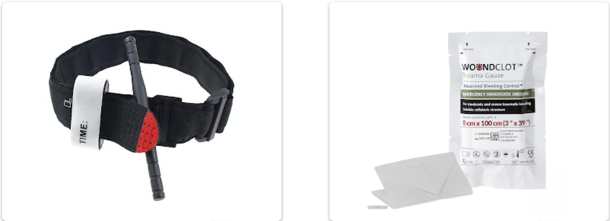
Manual haemostasis:
- Tourniquet
- Haemostatic gauze
- Israeli bandage
- REBOA
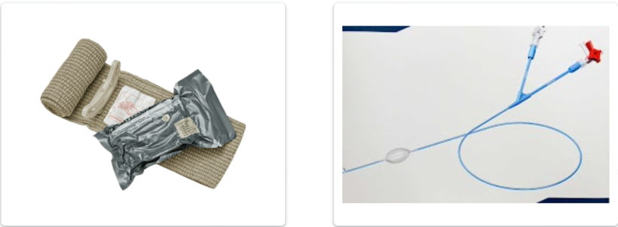
- Thoracotomy set (Clamshell)

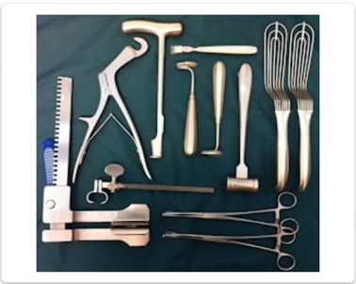

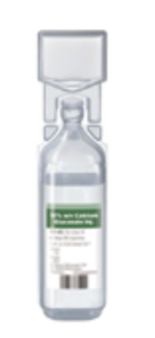

Calcium:
- Yes
- No
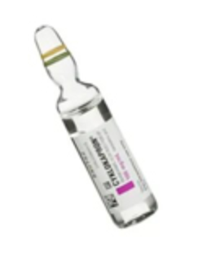
Tranexamic Acid (Vials):
1.
2.
3.
4.
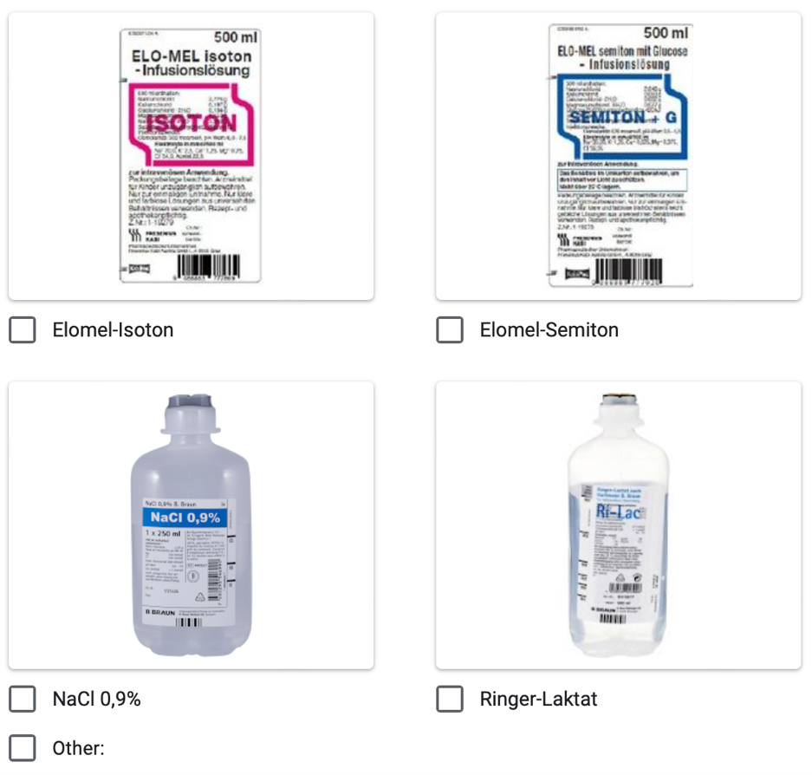
Crystalloids:

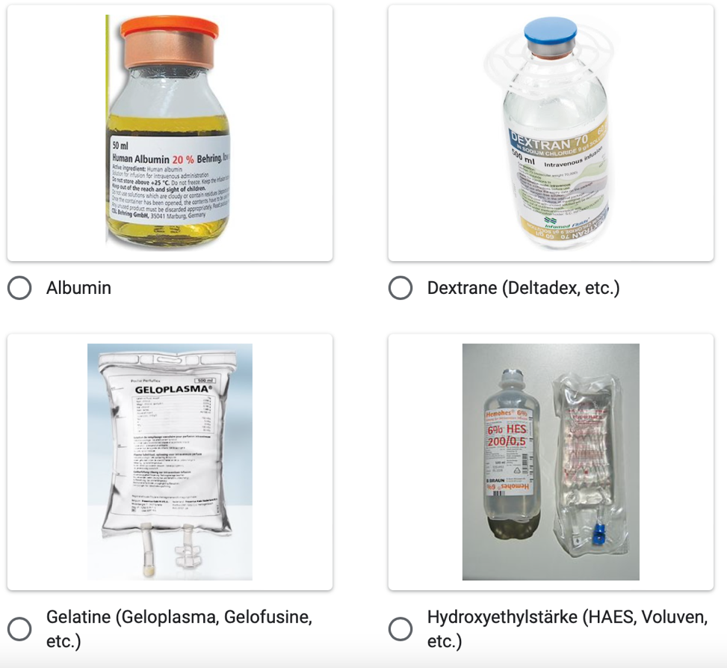

Colloids:

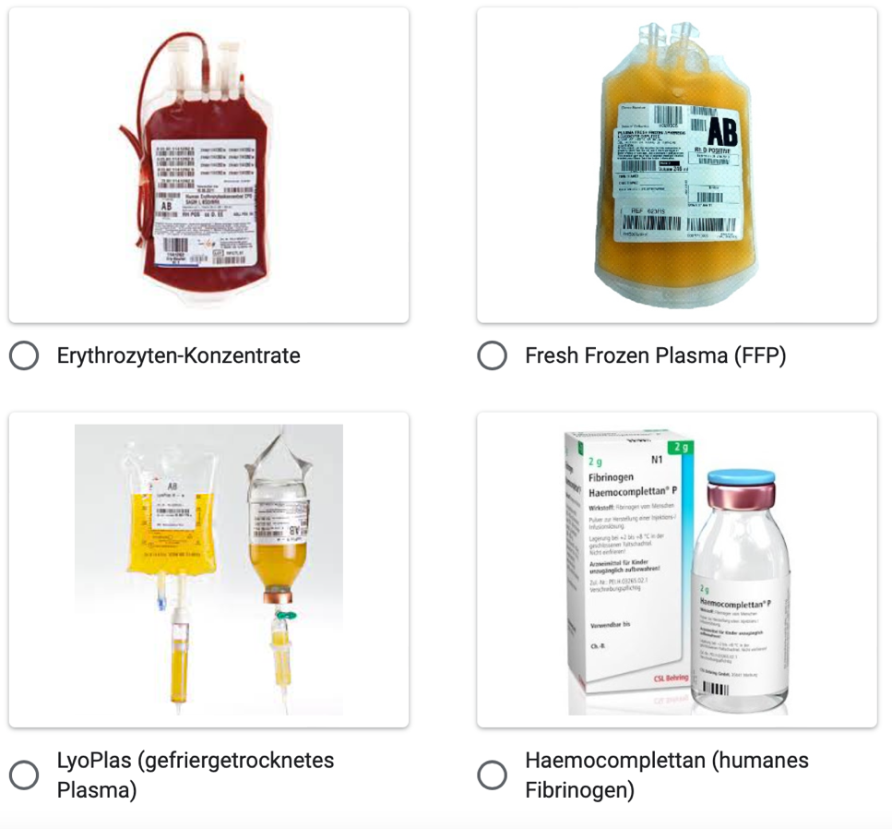
Blood products:

Packed red blood cells

Page 4
Equipment satisfaction
Please describe how you subjectively perceive your equipment.

Do you believe that you have all the necessary materials for the optimal treatment of traumatic haemorrhages on your emergency equipment?
- Yes
- No
If NO, what would you like to have with you and why?
- Freetext

Page 5
END
Thank you for your valued co-operation. If you have any further questions or ideas, we look forward to hearing from you. Contact: Gerald Schützelhofer (g.schuetzelhofer@stud.medunigraz.at) and Dr Michael Eichinger (Michael.eichinger@medunigraz.at)

