A
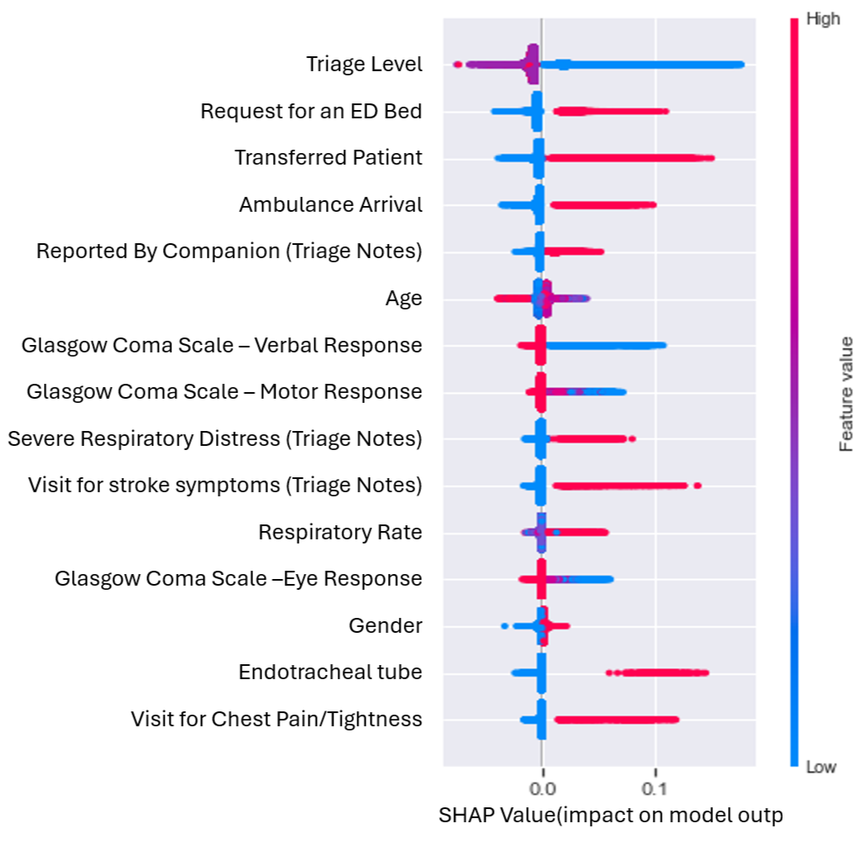
B
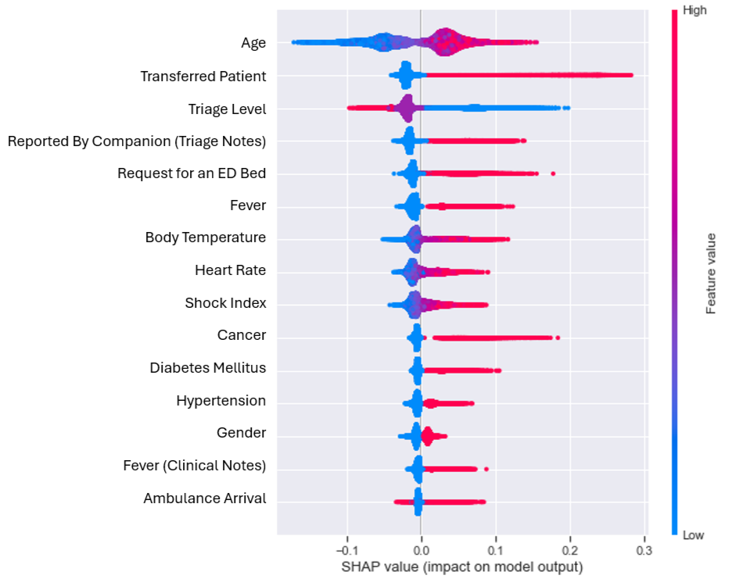
Supplementary Fig. 1 SHAP Summary Plot of the Top 15 Features Ranked by SHAP Value Impact on Model Predictions for (A) Primary Outcome and (B) Secondary Outcome.

