SUPPLEMENTARY MATERIALS

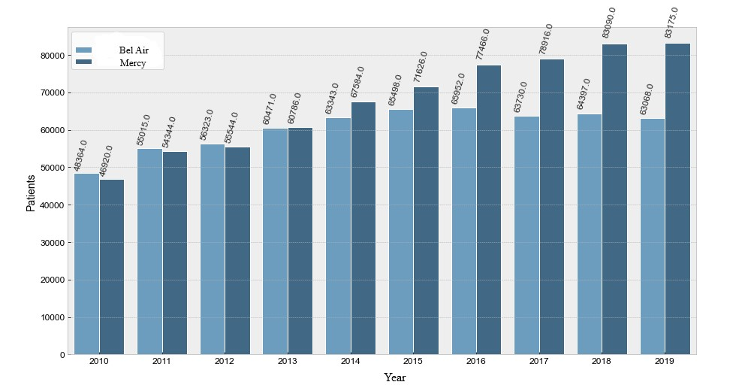
Figure S1: Evolution of admissions per year at the Metz(Mercy) and Thionville (Bel Air) ED between 2010 and 2019

METZ | 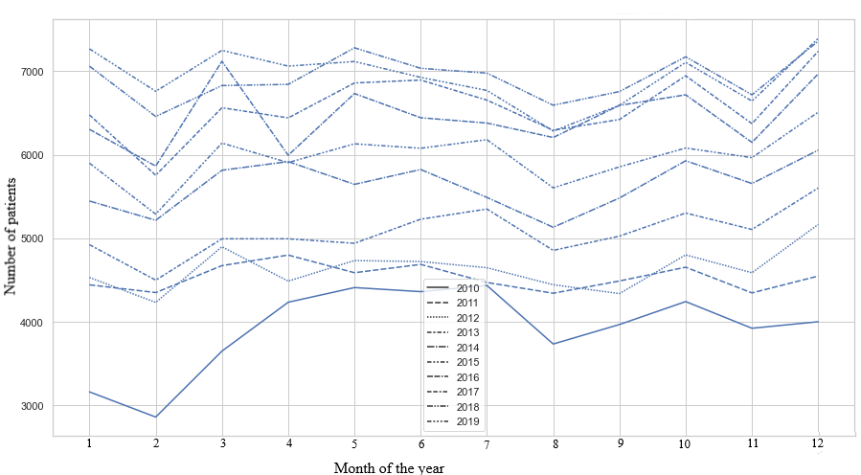
THIONVILLE | 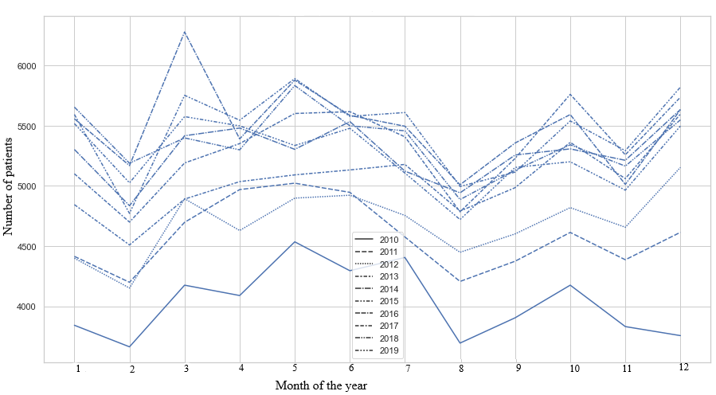

Figure S2: Evolution of admissions per month at the Metz and Thionville ED between 2010 and 2019
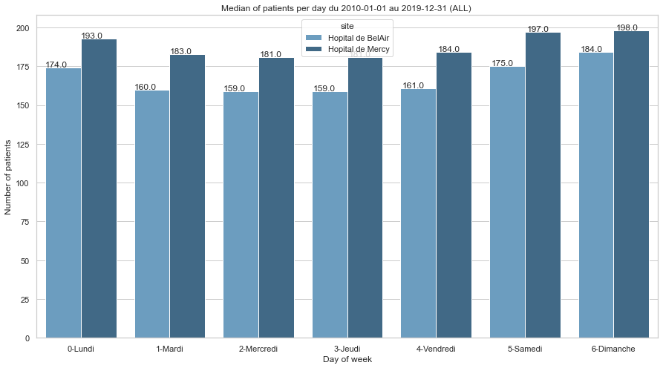

Figure S3: Median admissions per day, depending on the day of the week, at the Metz (Mercy) and Thionville (Bel Air) ED between 2010 and 2019
METZ | 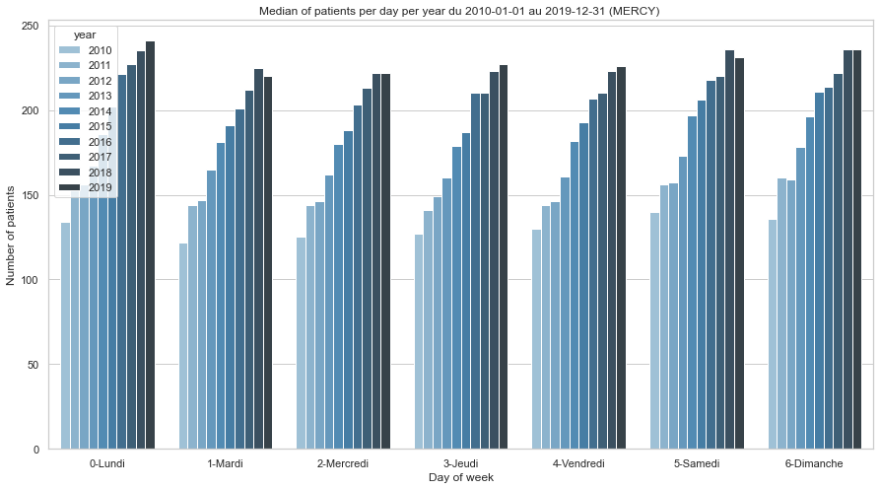
THIONVILLE | 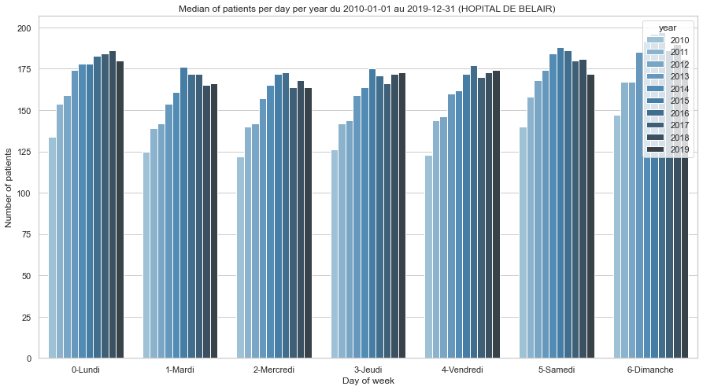

Figure S4: Evolution of admissions per day, depending on the day of the week, at the Metz and Thionville ED beetween 2010 and 2019

METZ | 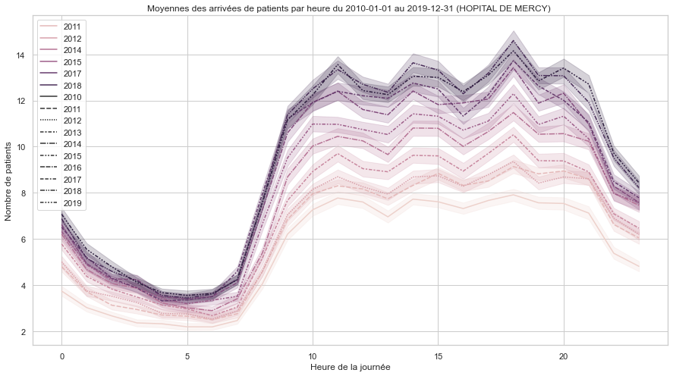
THIONVILLE | 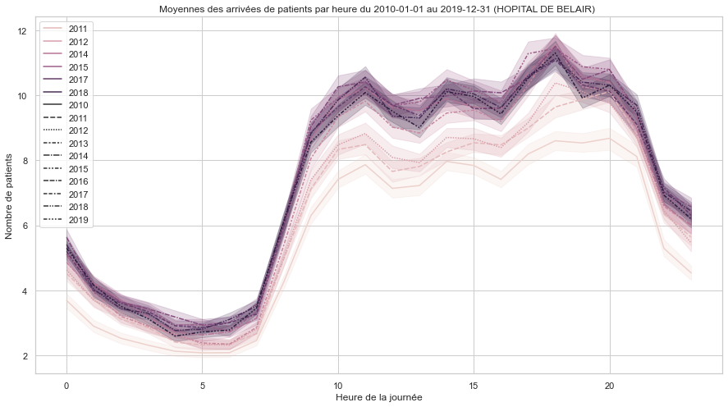

Figure S5: Evolution of admissions per hour at the Metz and Thionville ED between 2010 and 2019

Figure S6: Number of events recorded by category between 2010 and 2019

Metz | 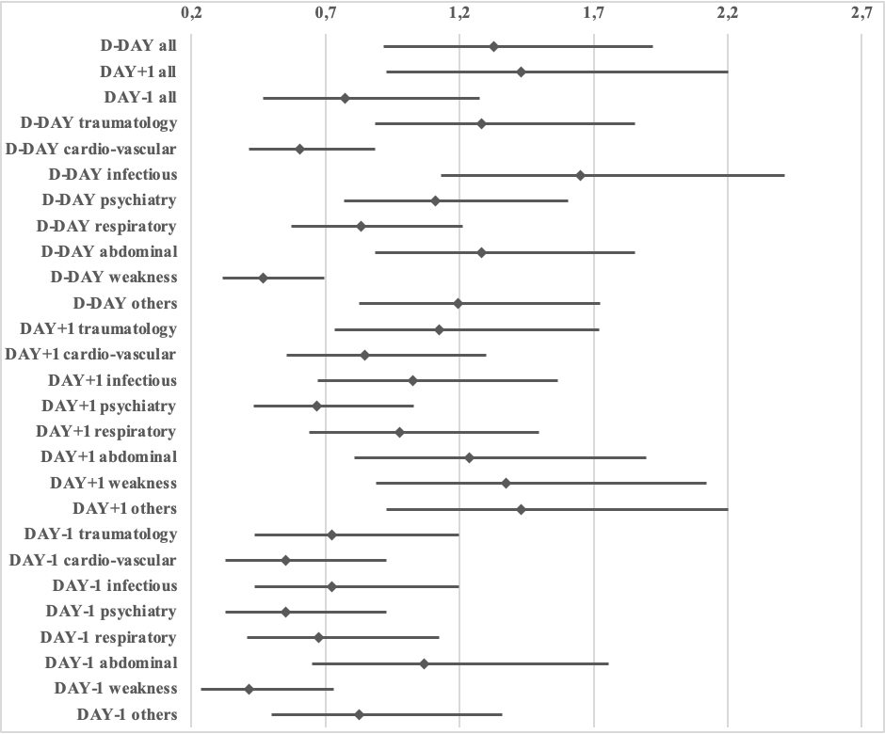
Thionville | 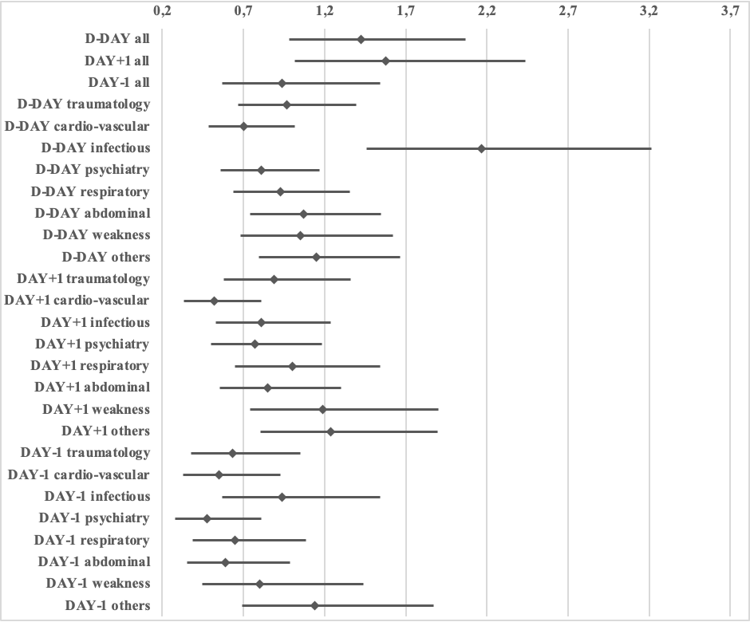
Figure S7. Box slots for national cultural events’

Metz | 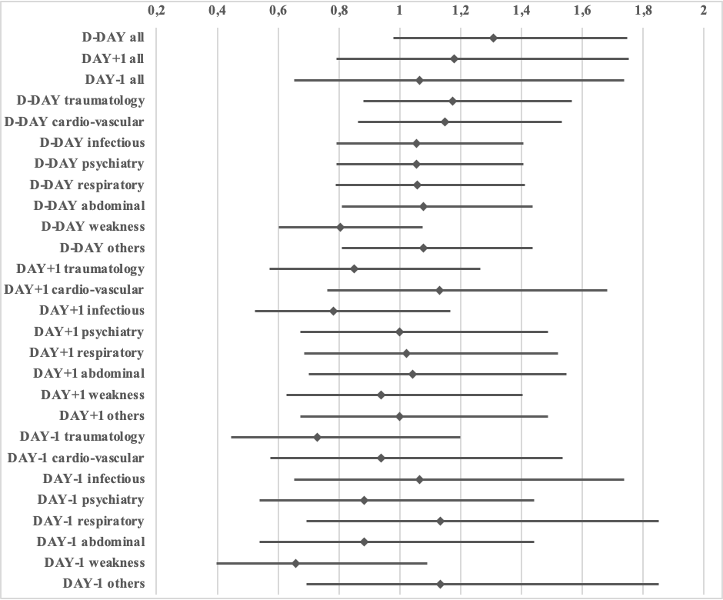
Thionville | 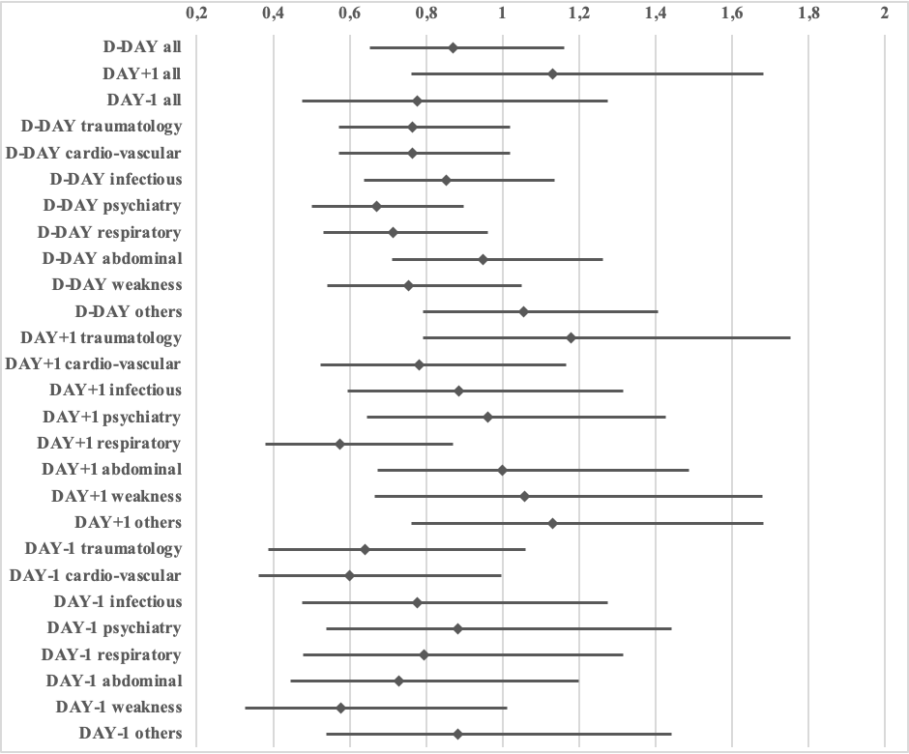
Figure S8. Box plots for local cultural events’

DAY | Type of pathology | NO EVENT |  | ALL EVENTS |  | OUTCOME
DAY | Type of pathology | Admissions/day (mediane) | Standard deviation | Admissions/day (mediane) | Standard deviation | OR | p | low CI | upp CI
D-DAY | all | 181 | 36,37 | 195 | 40,57 | 1.24 | 0,00051 | 1,1 | 1,41
D-DAY | traumatology | 47 | 10,17 | 49 | 10,69 | 1.09 | 0.18382 | 0,96 | 1,23
D-DAY | psychiatry | 15 | 5 | 15 | 4,94 | 0.98 | 0.80009 | 0,87 | 1,11
D-DAY | cardio-vascular | 17 | 6,19 | 17 | 6,08 | 0.96 | 0.52675 | 0,85 | 1,09
D-DAY | respiratory | 5 | 3,22 | 6 | 3,24 | 1.00 | 0.92369 | 0,89 | 1,14
D-DAY | abdominal | 25 | 8,6 | 27 | 9,76 | 1.10 | 0.16382 | 0,96 | 1,24
D-DAY | infectious | 23 | 9,13 | 24 | 11,37 | 1.15 | 0,02683 | 1,02 | 1,3
D-DAY | weakness | 5 | 2,85 | 5 | 2,69 | 0.70 | 0 | 0,61 | 0,79
D-DAY | others | 32 | 9,4 | 34 | 9,92 | 1.14 | 0.03683 | 1,01 | 1,29
DAY+1 | all | 181 | 36,37 | 193 | 39,15 | 1.32 | 0,00037 | 1,13 | 1,53
DAY+1 | traumatology | 47 | 10,17 | 49 | 10,59 | 1.15 | 0.07151 | 0,99 | 1,34
DAY+1 | psychiatry | 15 | 5 | 15 | 4,81 | 0.86 | 0.08441 | 0,75 | 1,02
DAY+1 | cardio-vascular | 17 | 6,19 | 17 | 6,2 | 0.92 | 0.30025 | 0,79 | 1,07
DAY+1 | respiratory | 5 | 3,22 | 6 | 3,16 | 1.01 | 0.87719 | 0,87 | 1,18
DAY+1 | abdominal | 25 | 8,6 | 28 | 9,26 | 1.70 | 0,04217 | 1,01 | 1,36
DAY+1 | infectious | 23 | 9,13 | 24 | 10,82 | 1.10 | 0,23434 | 0,94 | 1,27
DAY+1 | weakness | 5 | 2,85 | 5 | 2,86 | 0.75 | 0,00029 | 0,75 | 0,88
DAY+1 | others | 32 | 9,4 | 35 | 10,14 | 1.16 | 0.05054 | 1 | 1,35
DAY-1 | all | 181 | 36,37 | 190 | 38,83 | 1.17 | 0.07047 | 0,99 | 1,36
D-DAY | all | 165 | 24,3 | 167 | 25,84 | 1.04 | 0.52675 | 0,92 | 1,18
D-DAY | traumatology | 45 | 9,68 | 45 | 9,68 | 0.93 | 0.28208 | 0,83 | 1,06
D-DAY | psychiatry | 9 | 3,48 | 9 | 3,47 | 0.76 | 0,00002 | 0,68 | 0,86
D-DAY | cardio-vascular | 14 | 4,35 | 13 | 4,31 | 0.92 | 0.16382 | 0,81 | 1,04
D-DAY | respiratory | 4 | 2,64 | 4 | 2,61 | 0.84 | 0,00557 | 0,74 | 0,95
D-DAY | abdominal | 24 | 6,26 | 24 | 6,46 | 0.93 | 0.22914 | 0,82 | 1,05
D-DAY | infectious | 19 | 7,91 | 20 | 9,41 | 1.05 | 0.48628 | 0,92 | 1,18
D-DAY | weakness | 3 | 2,6 | 4 | 2,45 | 1.04 | 0.58717 | 0,9 | 1,2
D-DAY | others | 32 | 7,66 | 33 | 8,55 | 0.86 | 0.01927 | 0,76 | 0,98
DAY+1 | all | 165 | 24,3 | 170 | 24,61 | 1.29 | 0,00087 | 1,11 | 1,51
DAY+1 | traumatology | 45 | 9,68 | 46 | 10,24 | 1.16 | 0.06027 | 0,99 | 1,34
DAY+1 | psychiatry | 9 | 3,48 | 9 | 3,54 | 0.79 | 0,00249 | 0,68 | 0,92
DAY+1 | cardio-vascular | 14 | 4,35 | 13 | 4,36 | 0.91 | 0.23434 | 0,79 | 1,06
DAY+1 | respiratory | 4 | 2,64 | 4 | 2,76 | 0.92 | 0.31017 | 0,79 | 1,08
DAY+1 | abdominal | 24 | 6,26 | 24 | 6,1 | 0.96 | 0.56494 | 0,82 | 1,11
DAY+1 | infectious | 19 | 7,91 | 20 | 9,34 | 1.03 | 0.67296 | 0,89 | 1,2
DAY+1 | weakness | 3 | 2,6 | 4 | 2,36 | 1.14 | 0.13699 | 0,96 | 1,35
DAY+1 | others | 32 | 7,66 | 34 | 7,63 | 1.01 | 0.84784 | 0,87 | 1,18
DAY-1 | all | 165 | 24,3 | 166 | 24,23 | 1.01 | 0.86308 | 0,86 | 1,2

Table S1: Association between « all events » and admissions recorded at the Metz and Thionville ED

ED | DAY | DISEASE | NO EVENT |  | NATIONAL CULTURAL EVENTS |  | OUTCOME
ED | DAY | DISEASE | Admissions/day (median) | Standard deviation | Admissions/day (median) | Standard deviation | OR | p | low CI | upp CI
MERCY | D-DAY | all | 181 | 36,37 | 194 | 38,34 | 1.33 | 0.13531 | 0,92 | 1,92
MERCY | D-DAY | traumatology | 47 | 10,17 | 49 | 11,47 | 1.28 | 0.19093 | 0,88 | 1,85
MERCY | D-DAY | psychiatry | 15 | 5 | 16 | 5,76 | 1.11 | 0.57433 | 0,77 | 1,6
MERCY | D-DAY | cardio-vascular | 17 | 6,19 | 16 | 5,51 | 0.61 | 0.00945 | 0,41 | 0,88
MERCY | D-DAY | respiratory | 5 | 3,22 | 5 | 3,28 | 0.83 | 0.34103 | 0,57 | 1,21
MERCY | D-DAY | abdominal | 25 | 8,6 | 27 | 9,53 | 1.28 | 0.19093 | 0,88 | 1,85
MERCY | D-DAY | infectious | 23 | 9,13 | 26 | 13,73 | 1.65 | 0.00945 | 1,13 | 2,41
MERCY | D-DAY | weakness | 5 | 2,85 | 4 | 2,58 | 0.47 | 0.00017 | 0,31 | 0,69
MERCY | D-DAY | others | 32 | 9,4 | 34,5 | 9,43 | 1.19 | 0.34960 | 0,82 | 1,72
MERCY | DAY+1 | all | 181 | 36,37 | 195 | 40,29 | 1.43 | 0.10558 | 0,93 | 2,2
MERCY | DAY+1 | traumatology | 47 | 10,17 | 48 | 10,43 | 1.12 | 0.58788 | 0,73 | 1,72
MERCY | DAY+1 | psychiatry | 15 | 5 | 14 | 4,42 | 0.67 | 0.06705 | 0,43 | 1,03
MERCY | DAY+1 | cardio-vascular | 17 | 6,19 | 17 | 5,89 | 0.85 | 0.44839 | 0,55 | 1,3
MERCY | DAY+1 | respiratory | 5 | 3,22 | 5 | 3,3 | 0.98 | 0.91363 | 0,64 | 1,49
MERCY | DAY+1 | abdominal | 25 | 8,6 | 27 | 10,03 | 1.24 | 0.32988 | 0,81 | 1,9
MERCY | DAY+1 | infectious | 23 | 9,13 | 24 | 13,36 | 1.02 | 0.91363 | 0,67 | 1,57
MERCY | DAY+1 | weakness | 5 | 2,85 | 6 | 2,96 | 1.37 | 0.15531 | 0,89 | 2,12
MERCY | DAY+1 | others | 32 | 9,4 | 36 | 10,07 | 1.43 | 0.10558 | 0,93 | 2,2
MERCY | DAY-1 | all | 181 | 36,37 | 171 | 37,19 | 0.77 | 0.31099 | 0,47 | 1,27
BEL AIR
BEL AIR | D-DAY | all | 165 | 24,3 | 174 | 30,65 | 1.43 | 0.06245 | 0,98 | 2,07
BEL AIR | D-DAY | traumatology | 45 | 9,68 | 45 | 11,41 | 0.97 | 0.85143 | 0,67 | 1,39
BEL AIR | D-DAY | psychiatry | 9 | 3,48 | 9 | 4,11 | 0.81 | 0.26195 | 0,56 | 1,17
BEL AIR | D-DAY | cardio-vascular | 14 | 4,35 | 12 | 4,26 | 0.70 | 0.06245 | 0,48 | 1,02
BEL AIR | D-DAY | respiratory | 4 | 2,64 | 4 | 2,62 | 0.93 | 0.70050 | 0,64 | 1,35
BEL AIR | D-DAY | abdominal | 24 | 6,26 | 25 | 6,8 | 1.07 | 0.70809 | 0,74 | 1,55
BEL AIR | D-DAY | infectious | 19 | 7,91 | 22,5 | 12,15 | 2.17 | 0,00012 | 1,46 | 3,22
BEL AIR | D-DAY | weakness | 3 | 2,6 | 4 | 2,25 | 1.05 | 0.82525 | 0,68 | 1,62
BEL AIR | D-DAY | others | 32 | 7,66 | 35 | 14,46 | 1.15 | 0.45407 | 0,8 | 1,66
BEL AIR | DAY+1 | all | 165 | 24,3 | 175 | 24,19 | 1.56 | 0,04104 | 1,02 | 2,44
BEL AIR | DAY+1 | traumatology | 45 | 9,68 | 45 | 10,04 | 0.89 | 0.58788 | 0,58 | 1,36
BEL AIR | DAY+1 | psychiatry | 9 | 3,48 | 9 | 3,94 | 0.77 | 0.23414 | 0,5 | 1,18
BEL AIR | DAY+1 | cardio-vascular | 14 | 4,35 | 13 | 4,32 | 0.52 | 0,00403 | 0,33 | 0,81
BEL AIR | DAY+1 | respiratory | 4 | 2,64 | 4,5 | 3,17 | 1.00 | 1.00000 | 0,65 | 1,54
BEL AIR | DAY+1 | abdominal | 24 | 6,26 | 24 | 5,51 | 0.85 | 0.44839 | 0,55 | 1,3
BEL AIR | DAY+1 | infectious | 19 | 7,91 | 19 | 12,75 | 0.81 | 0.32988 | 0,53 | 1,24
BEL AIR | DAY+1 | weakness | 3 | 2,6 | 4 | 2,52 | 1.19 | 0.47387 | 0,74 | 1,9
BEL AIR | DAY+1 | others | 32 | 7,66 | 35 | 8,02 | 1.2 | 0.32988 | 0,81 | 1,9
BEL AIR | DAY-1 | all | 165 | 24,3 | 161 | 24,17 | 0.94 | 0.79956 | 0,57 | 1,54

Table S2: Association between ‘national cultural events’ and admissions recorded at the Metz and Thionville ED

ED | DAY | DISEASE | NO EVENT |  | LOCAL CULTURAL EVENTS |  | OUTCOME
ED | DAY | DISEASE | Admissions/day (median) | Standard deviation | Admissions/day (median) | Standard deviation | OR | p | low CI | upp CI
MERCY | D-DAY | all | 181 | 36,37 | 193 | 34,96 | 1.31 | 0.06836 | 0,98 | 1,75
MERCY | D-DAY | traumatology | 47 | 10,17 | 48 | 10,52 | 1.17 | 0.27320 | 0,88 | 1,57
MERCY | D-DAY | psychiatry | 15 | 5 | 16 | 5,45 | 1.05 | 0.71472 | 0,79 | 1,41
MERCY | D-DAY | cardio-vascular | 17 | 6,19 | 18 | 6 | 1.15 | 0.34217 | 0,86 | 1,53
MERCY | D-DAY | respiratory | 5 | 3,22 | 6 | 3,21 | 1.06 | 0.71176 | 0,79 | 1,41
MERCY | D-DAY | abdominal | 25 | 8,6 | 26 | 8,36 | 1.08 | 0.60895 | 0,81 | 1,44
MERCY | D-DAY | infectious | 23 | 9,13 | 24 | 10,82 | 1.05 | 0.71472 | 0,79 | 1,41
MERCY | D-DAY | weakness | 5 | 2,85 | 5 | 2,79 | 0.80 | 0.14116 | 0,6 | 1,08
MERCY | D-DAY | others | 32 | 9,4 | 34 | 8,65 | 1.08 | 0.60895 | 0,81 | 1,44
MERCY | DAY+1 | all | 181 | 36,37 | 185,5 | 34,89 | 1.18 | 0.41955 | 0,79 | 1,75
MERCY | DAY+1 | traumatology | 47 | 10,17 | 46 | 10,61 | 0.85 | 0.41955 | 0,57 | 1,26
MERCY | DAY+1 | psychiatry | 15 | 5 | 15,5 | 4,87 | 1.00 | 1.00000 | 0,67 | 1,49
MERCY | DAY+1 | cardio-vascular | 17 | 6,19 | 18 | 5,76 | 1.13 | 0.54471 | 0,76 | 1,68
MERCY | DAY+1 | respiratory | 5 | 3,22 | 6 | 2,75 | 1.02 | 0.91913 | 0,69 | 1,52
MERCY | DAY+1 | abdominal | 25 | 8,6 | 26 | 8,68 | 1.04 | 0.83990 | 0,7 | 1,55
MERCY | DAY+1 | infectious | 23 | 9,13 | 23 | 10,28 | 0.78 | 0.22664 | 0,52 | 1,17
MERCY | DAY+1 | weakness | 5 | 2,85 | 5 | 3,07 | 0.94 | 0.75828 | 0,63 | 1,4
MERCY | DAY+1 | others | 32 | 9,4 | 33,5 | 9,46 | 1.0 | 1.00000 | 0,67 | 1,49
MERCY | DAY-1 | all | 181 | 36,37 | 187,5 | 35,59 | 1.06 | 0.80265 | 0,65 | 1,74
BEL AIR
BEL AIR | D-DAY | all | 165 | 24,3 | 163 | 24,61 | 0.87 | 0.34217 | 0,65 | 1,16
BEL AIR | D-DAY | traumatology | 45 | 9,68 | 44 | 9,73 | 0.76 | 0.06836 | 0,57 | 1,02
BEL AIR | D-DAY | psychiatry | 9 | 3,48 | 9 | 3,31 | 0.67 | 0,0072 | 0,5 | 0,9
BEL AIR | D-DAY | cardio-vascular | 14 | 4,35 | 14 | 4,17 | 0.76 | 0.06836 | 0,57 | 1,02
BEL AIR | D-DAY | respiratory | 4 | 2,64 | 4 | 2,7 | 0.71 | 0,02606 | 0,53 | 0,96
BEL AIR | D-DAY | abdominal | 24 | 6,26 | 24 | 6,09 | 0.95 | 0.71472 | 0,71 | 1,26
BEL AIR | D-DAY | infectious | 19 | 7,91 | 19 | 9,98 | 0.85 | 0.27320 | 0,64 | 1,14
BEL AIR | D-DAY | weakness | 3 | 2,6 | 3 | 2,57 | 0.75 | 0.09439 | 0,54 | 1,55
BEL AIR | D-DAY | others | 32 | 7,66 | 34 | 7,9 | 1.05 | 0.71472 | 0,79 | 1,41
BEL AIR | DAY+1 | all | 165 | 24,3 | 167 | 25,13 | 1.13 | 0.54471 | 0,76 | 1,68
BEL AIR | DAY+1 | traumatology | 45 | 9,68 | 46 | 10,97 | 1.18 | 0.41955 | 0,79 | 1,75
BEL AIR | DAY+1 | psychiatry | 9 | 3,48 | 9 | 3,42 | 0.96 | 0.83990 | 0,65 | 1,43
BEL AIR | DAY+1 | cardio-vascular | 14 | 4,35 | 14 | 4,13 | 0.78 | 0.22664 | 0,52 | 1,17
BEL AIR | DAY+1 | respiratory | 4 | 2,64 | 4 | 2,32 | 0.57 | 0,0088 | 0,38 | 0,87
BEL AIR | DAY+1 | abdominal | 24 | 6,26 | 24,5 | 5,73 | 1.00 | 1.00000 | 0,67 | 1,49
BEL AIR | DAY+1 | infectious | 19 | 7,91 | 19 | 10,06 | 0.88 | 0.54471 | 0,59 | 1,32
BEL AIR | DAY+1 | weakness | 3 | 2,6 | 4 | 2,49 | 1.06 | 0.81373 | 0,67 | 1,68
BEL AIR | DAY+1 | others | 32 | 7,66 | 33 | 7,57 | 1.13 | 0.54471 | 0,76 | 1,68
BEL AIR | DAY-1 | all | 165 | 24,3 | 162 | 24,66 | 0.78 | 0.31859 | 0,47 | 1,27
Table S3: Association between ‘local cultural events’ and admissions recorded at the Metz and Thionville ED
ED | DAY | DISEASE | NO EVENT |  | EVENTS "LOCAL FESTIVALS" |  | OUTCOME
 |  |  | Admissions/day (median) | Standard deviation | Admissions/day (median) | Standard deviation | OR | p | low CI | upp CI
MERCY | D-DAY | all | 181 | 36,37 | 193 | 34,96 | 1.31 | 0.06836 | 0,98 | 1,75
 |  | traumatology | 47 | 10,17 | 48 | 10,52 | 1.17 | 0.27320 | 0,88 | 1,57
 |  | psychiatry | 15 | 5 | 16 | 5,45 | 01.05 | 0.71472 | 0,79 | 1,41
 |  | cardio-vascular | 17 | 6,19 | 18 | 6 | 1.15 | 0.34217 | 0,86 | 1,53
 |  | respiratory | 5 | 3,22 | 6 | 3,21 | 01.06 | 0.71176 | 0,79 | 1,41
 |  | abdominal | 25 | 8,6 | 26 | 8,36 | 01.08 | 0.60895 | 0,81 | 1,44
 |  | infectious | 23 | 9,13 | 24 | 10,82 | 01.05 | 0.71472 | 0,79 | 1,41
 |  | weakness | 5 | 2,85 | 5 | 2,79 | 0.80 | 0.14116 | 0,6 | 1,08
 |  | others | 32 | 9,4 | 34 | 8,65 | 01.08 | 0.60895 | 0,81 | 1,44
 | DAY+1 | all | 181 | 36,37 | 185,5 | 34,89 | 1.18 | 0.41955 | 0,79 | 1,75
 |  | traumatology | 47 | 10,17 | 46 | 10,61 | 0.85 | 0.41955 | 0,57 | 1,26
 |  | psychiatry | 15 | 5 | 15,5 | 4,87 | 1.00 | 1.00000 | 0,67 | 1,49
 |  | cardio-vascular | 17 | 6,19 | 18 | 5,76 | 1.13 | 0.54471 | 0,76 | 1,68
 |  | respiratory | 5 | 3,22 | 6 | 2,75 | 01.02 | 0.91913 | 0,69 | 1,52
 |  | abdominal | 25 | 8,6 | 26 | 8,68 | 01.04 | 0.83990 | 0,7 | 1,55
 |  | infectious | 23 | 9,13 | 23 | 10,28 | 0.78 | 0.22664 | 0,52 | 1,17
 |  | weakness | 5 | 2,85 | 5 | 3,07 | 0.94 | 0.75828 | 0,63 | 1,4
 |  | others | 32 | 9,4 | 33,5 | 9,46 | 1.0 | 1.00000 | 0,67 | 1,49
 | DAY-1 | all | 181 | 36,37 | 187,5 | 35,59 | 1.06 | 0.80265 | 0,65 | 1,74
BEL AIR
 | D-DAY | all | 165 | 24,3 | 163 | 24,61 | 0.87 | 0.34217 | 0,65 | 1,16
 |  | traumatology | 45 | 9,68 | 44 | 9,73 | 0.76 | 0.06836 | 0,57 | 1,02
 |  | psychiatry | 9 | 3,48 | 9 | 3,31 | 0.67 | 0,0072 | 0,5 | 0,9
 |  | cardio-vascular | 14 | 4,35 | 14 | 4,17 | 0.76 | 0.06836 | 0,57 | 1,02
 |  | respiratory | 4 | 2,64 | 4 | 2,7 | 0.71 | 0,02606 | 0,53 | 0,96
 |  | abdominal | 24 | 6,26 | 24 | 6,09 | 0.95 | 0.71472 | 0,71 | 1,26
 |  | infectious | 19 | 7,91 | 19 | 9,98 | 0.85 | 0.27320 | 0,64 | 1,14
 |  | weakness | 3 | 2,6 | 3 | 2,57 | 0.75 | 0.09439 | 0,54 | 1,55
 |  | others | 32 | 7,66 | 34 | 7,9 | 01.05 | 0.71472 | 0,79 | 1,41
 | DAY+1 | all | 165 | 24,3 | 167 | 25,13 | 1.13 | 0.54471 | 0,76 | 1,68
 |  | traumatology | 45 | 9,68 | 46 | 10,97 | 1.18 | 0.41955 | 0,79 | 1,75
 |  | psychiatry | 9 | 3,48 | 9 | 3,42 | 0.96 | 0.83990 | 0,65 | 1,43
 |  | cardio-vascular | 14 | 4,35 | 14 | 4,13 | 0.78 | 0.22664 | 0,52 | 1,17
 |  | respiratory | 4 | 2,64 | 4 | 2,32 | 0.57 | 0,0088 | 0,38 | 0,87
 |  | abdominal | 24 | 6,26 | 24,5 | 5,73 | 1.00 | 1.00000 | 0,67 | 1,49
 |  | infectious | 19 | 7,91 | 19 | 10,06 | 0.88 | 0.54471 | 0,59 | 1,32
 |  | weakness | 3 | 2,6 | 4 | 2,49 | 01.06 | 0.81373 | 0,67 | 1,68
 |  | others | 32 | 7,66 | 33 | 7,57 | 1.13 | 0.54471 | 0,76 | 1,68
 | DAY-1 | all | 165 | 24,3 | 162 | 24,66 | 0.78 | 0.31859 | 0,47 | 1,27
Table S4: Association between ‘local sporting events’ and admissions recorded at the Metz and Thionville ED

