Figure S1 Comparisons of AuROC between the R-NEWS model and its variants including or excluding temperature and oxygen saturation.

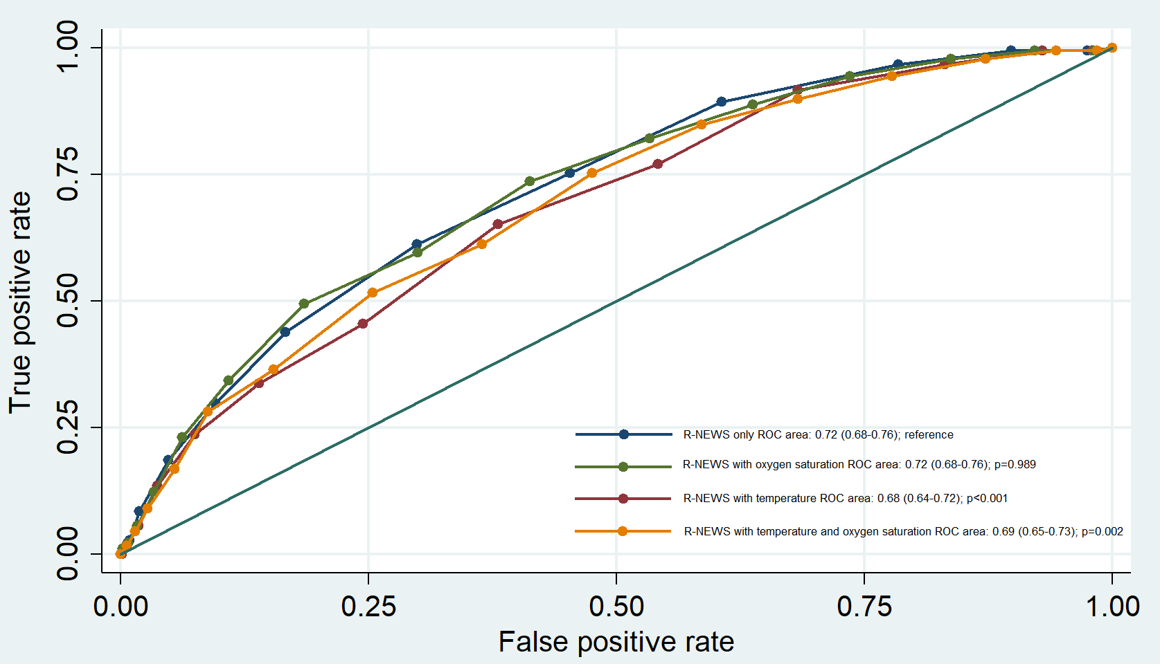
In summary, excluding temperature improved discrimination, excluding oxygen saturation had no impact, and excluding both yielded better performance than models that included them.
Figure S2 The results of internal validation using the bootstrapping method demonstrated the area under the receiver operating characteristic (AuROC) of the R-NEWS model for predicting 28-day mortality in ED patients with suspected sepsis.

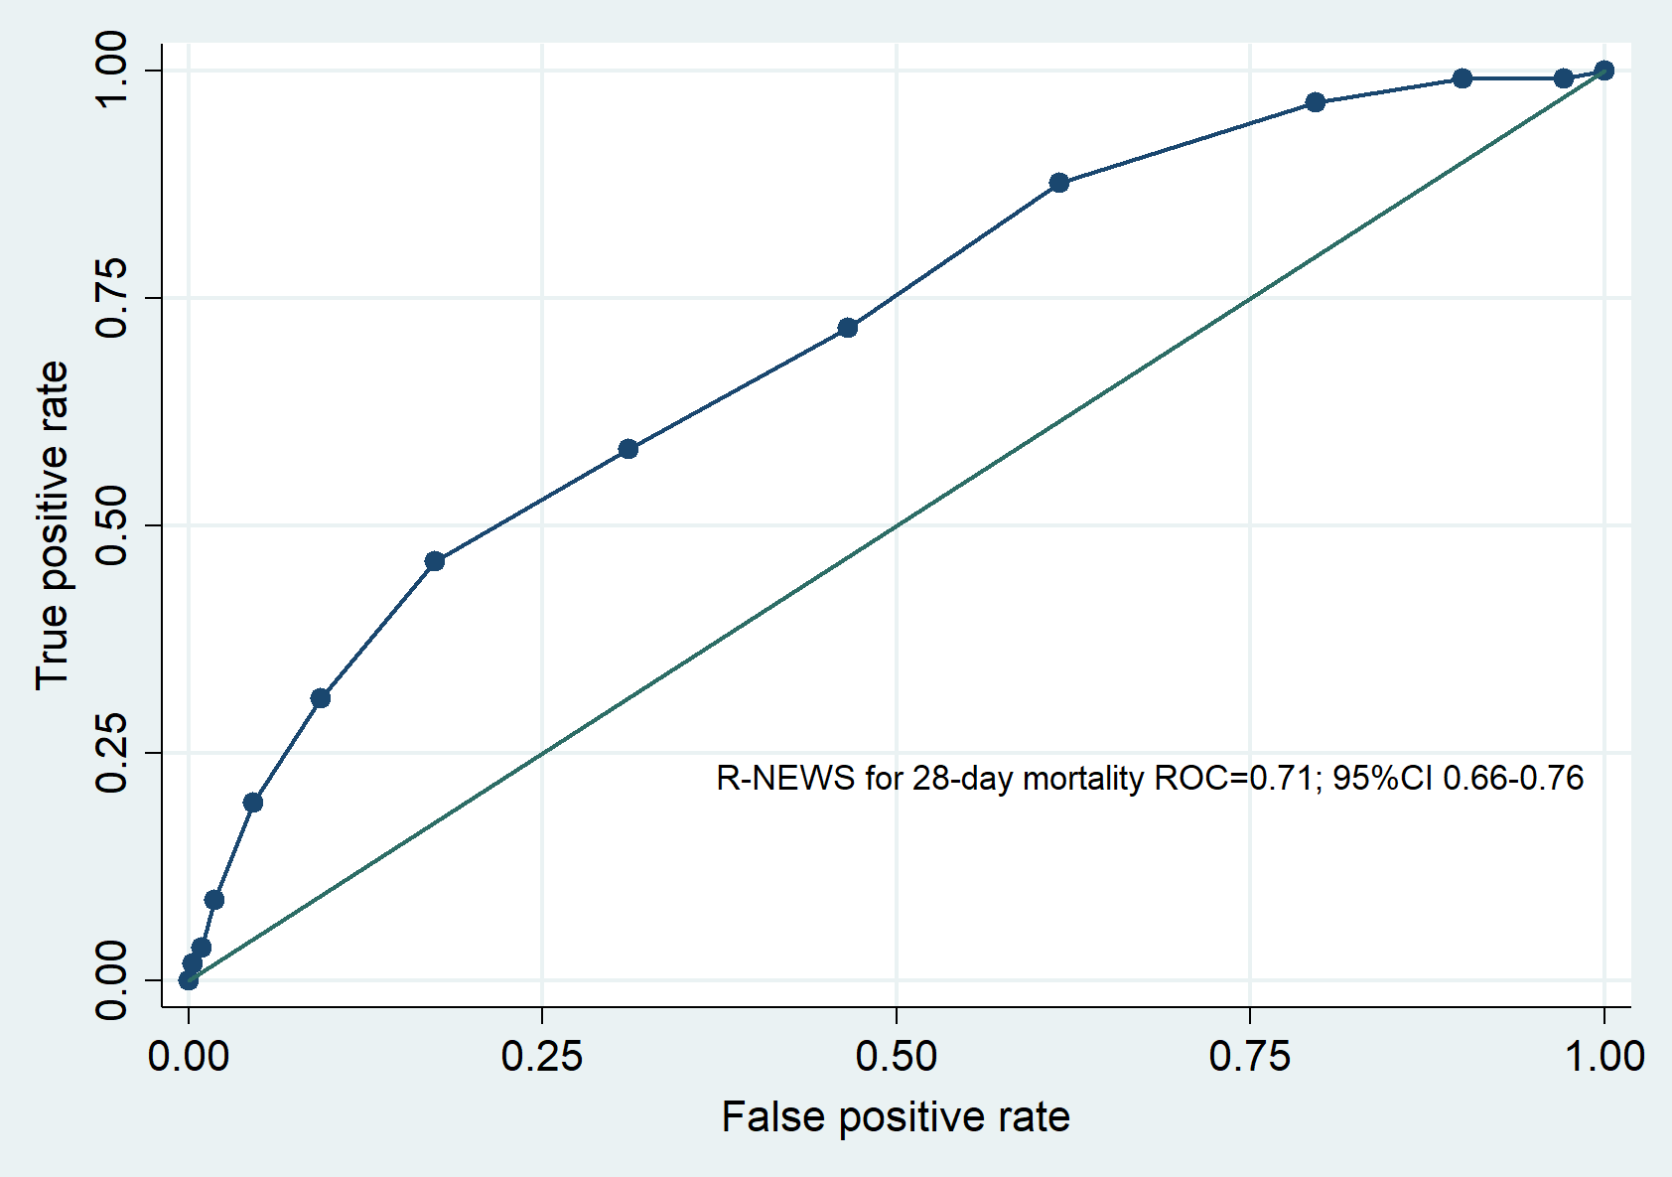
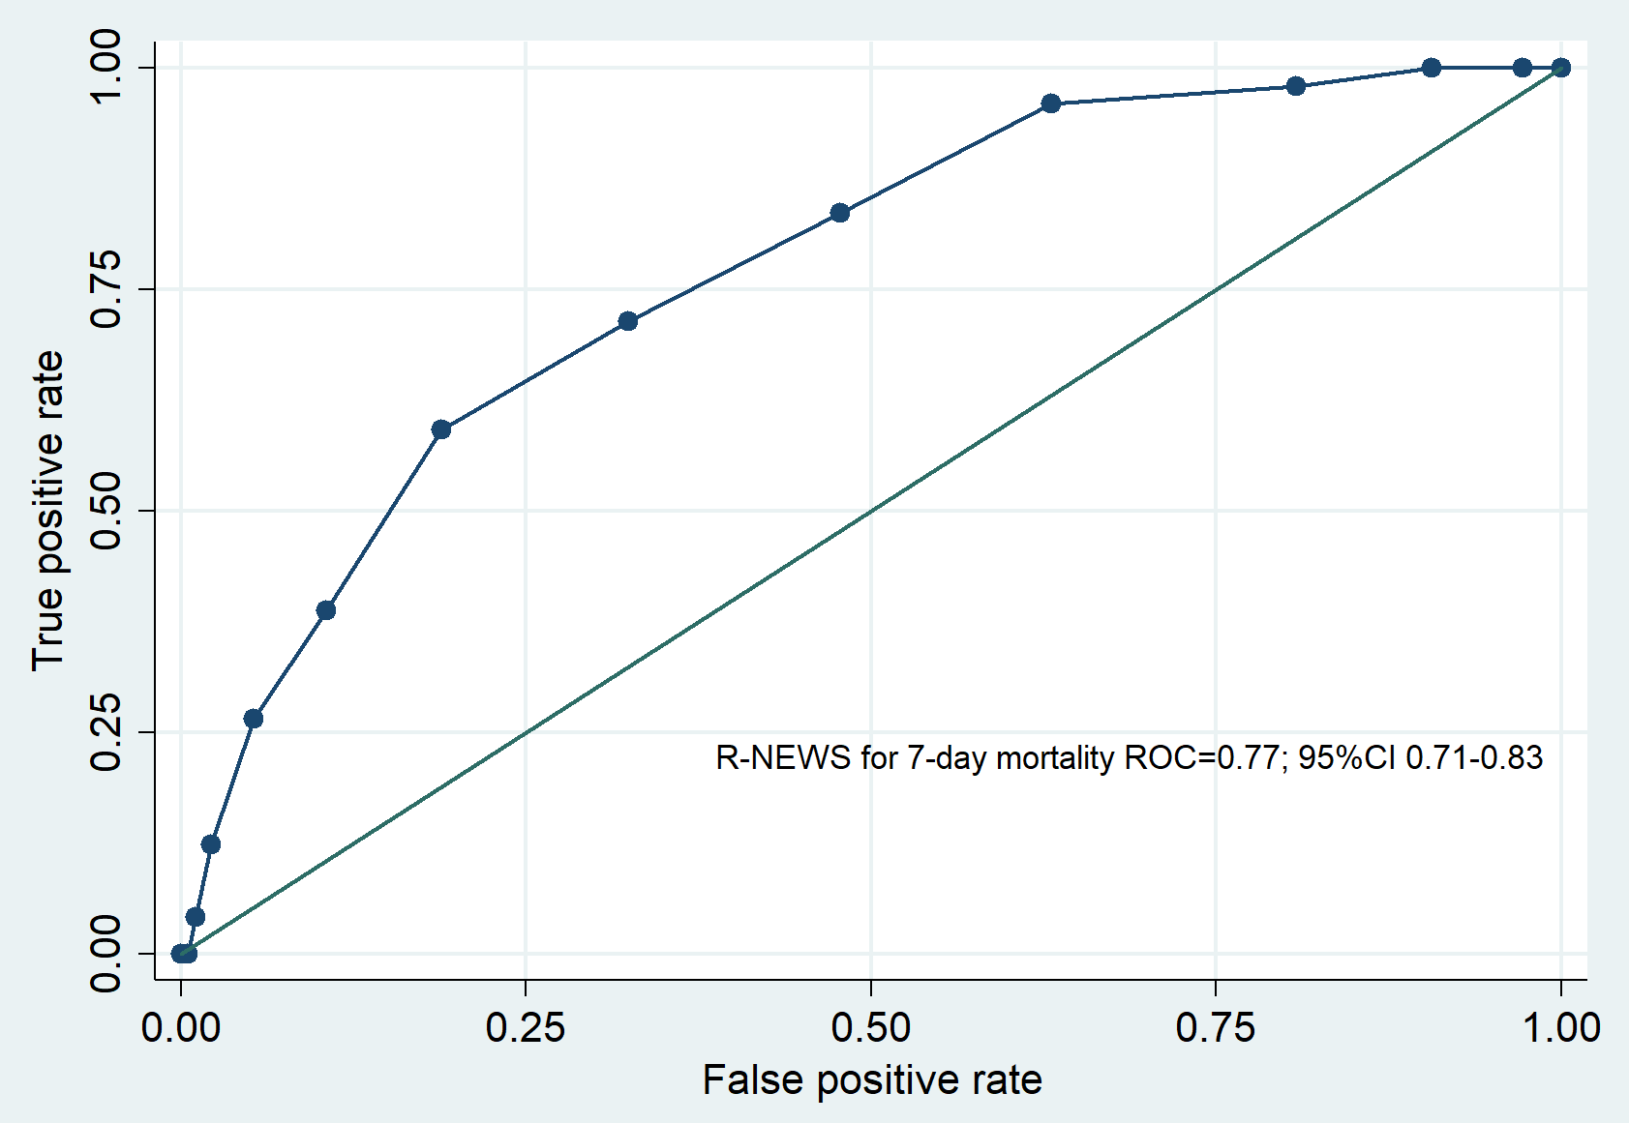
Table S1 Detailed performance metrics of R-NEWS for predicting 28-day mortality.

Cut point | Sensitivity, % | Specificity, % | PPV, % | NPV, % | LR+ | LR-
≥0 | 100 | 0 | N/A | N/A | 1.0 | N/A
≥1 | 99.4 | 2.5 | 13.5 | 96.7 | 1.0 | 0.2
≥2 | 99.4 | 10.2 | 14.5 | 99.2 | 1.1 | 0.1
≥3 | 96.6 | 21.6 | 15.9 | 97.7 | 1.2 | 0.2
≥4 | 89.3 | 39.4 | 18.5 | 96.0 | 1.5 | 0.3
≥5 | 75.3 | 54.7 | 20.3 | 93.5 | 1.7 | 0.5
≥6 | 61.2 | 70.2 | 24.0 | 92.2 | 2.1 | 0.6
≥7 | 43.8 | 83.4 | 28.9 | 90.6 | 2.6 | 0.7
≥8 | 29.8 | 90.4 | 32.3 | 89.3 | 3.1 | 0.8
≥9 | 18.5 | 95.2 | 37.1 | 88.4 | 3.8 | 0.9
≥10 | 8.4 | 98.1 | 40.5 | 87.5 | 4.4 | 0.9
≥11 | 2.8 | 99.1 | 33.3 | 86.9 | 3.2 | 1.0
≥12 | 1.1 | 99.7 | 40.0 | 86.8 | 4.3 | 1.0

Table S2 Distribution of NEWS score categories by 28-day mortality status (death vs survival).

NEWS  (point) | Total  (n=1,342) | Prevalence  (%) | 28-day mortality |  | Survived
NEWS  (point) | Total  (n=1,342) | Prevalence  (%) | n | % | n | %
0 | 11 | 0.8 | 1 | 9.1 | 10 | 90.9
1 | 24 | 1.8 | 0 | 0 | 24 | 100
2 | 27 | 2.0 | 1 | 3.7 | 26 | 96.3
3 | 68 | 5.1 | 3 | 4.4 | 65 | 95.6
4 | 86 | 6.4 | 4 | 4.7 | 82 | 95.3
5 | 104 | 7.8 | 6 | 5.8 | 98 | 94.2
6 | 103 | 7.7 | 6 | 5.8 | 97 | 94.2
7 | 110 | 8.2 | 8 | 7.3 | 102 | 92.7
8 | 150 | 11.2 | 20 | 13.3 | 130 | 86.7
9 | 131 | 9.7 | 26 | 19.9 | 105 | 80.1
10 | 152 | 11.3 | 23 | 15.1 | 129 | 84.9
11 | 115 | 8.6 | 22 | 19.1 | 93 | 80.9
12 | 94 | 7.0 | 12 | 12.8 | 82 | 87.2
13 | 76 | 5.6 | 18 | 23.7 | 58 | 76.3
14 | 45 | 3.3 | 11 | 24.4 | 34 | 75.6
15 | 17 | 1.3 | 9 | 52.9 | 8 | 47.1
16 | 15 | 1.1 | 5 | 33.3 | 10 | 66.7
17 | 13 | 1.0 | 3 | 23.1 | 10 | 76.9
18 | 1 | 0.1 | 0 | 0 | 1 | 100

Table S3 NEWS category–specific predicted probabilities and likelihood ratios (with 95% confidence intervals) for 28-day and 7-day mortality among emergency department patients with suspected sepsis.

Score categorized probability groups | Score | 28-day mortality  (n=178)  n (%) | Survived  (n=1,164)  n (%) | Likelihood ratio of positive | 95% confidence interval | p-value
Low (n=423) | ≤ 6 | 21 (5.0) | 402 (95.0) | 0.34 | 0.22, 0.51 | <0.001
Moderate (n=752) | 7-12 | 111 (14.8) | 641 (85.2) | 1.13 | 0.99, 1.28 | 0.074
High (n=167) | ≥ 13 | 46 (27.5) | 121 (72.5) | 2.49 | 1.84, 3.36 | <0.001
Mean (±SD) |  | 10.2 (±3.2) | 8.0 (±3.5) |  |  | <0.001

Score categorized probability groups | Score | 7-day mortality  (n=87)  n (%) | Survived  (n=1,255)  n (%) | Likelihood ratio of positive | 95% confidence interval | p-value
Low (n=423) | ≤ 6 | 8 (1.9) | 415 (98.1) | 0.28 | 0.14, 0.54 | <0.001
Moderate (n=752) | 7-12 | 52 (6.9) | 700 (93.1) | 1.07 | 0.89, 1.28 | 0.503
High (n=167) | ≥ 13 | 27 (16.2) | 140 (83.8) | 2.78 | 1.96, 3.95 | <0.001
Mean (±SD) |  | 10.8 (±3.0) | 8.2 (±3.5) |  |  | <0.001

TRIPOD Checklist: Prediction Model Development
Section/Topic | Item | Checklist Item | Page
Title and abstract
Title | 1 | Identify the study as developing and/or validating a multivariable prediction model, the target population, and the outcome to be predicted. | 1
Abstract | 2 | Provide a summary of objectives, study design, setting, participants, sample size, predictors, outcome, statistical analysis, results, and conclusions. | 3
Introduction
Background and objectives | 3a | Explain the medical context (including whether diagnostic or prognostic) and rationale for developing or validating the multivariable prediction model, including references to existing models. | 5
Background and objectives | 3b | Specify the objectives, including whether the study describes the development or validation of the model or both. | 7
Methods
Source of data | 4a | Describe the study design or source of data (e.g., randomized trial, cohort, or registry data), separately for the development and validation data sets, if applicable. | 7
Source of data | 4b | Specify the key study dates, including start of accrual; end of accrual; and, if applicable, end of follow-up. | 9
Participants | 5a | Specify key elements of the study setting (e.g., primary care, secondary care, general population) including number and location of centres. | 8
Participants | 5b | Describe eligibility criteria for participants. | 8
Participants | 5c | Give details of treatments received, if relevant. | 9
Outcome | 6a | Clearly define the outcome that is predicted by the prediction model, including how and when assessed. | 9
Outcome | 6b | Report any actions to blind assessment of the outcome to be predicted.
Predictors | 7a | Clearly define all predictors used in developing or validating the multivariable prediction model, including how and when they were measured. | 9
Predictors | 7b | Report any actions to blind assessment of predictors for the outcome and other predictors.
Sample size | 8 | Explain how the study size was arrived at. | 9
Missing data | 9 | Describe how missing data were handled (e.g., complete-case analysis, single imputation, multiple imputation) with details of any imputation method. | 10
Statistical analysis methods | 10a | Describe how predictors were handled in the analyses. | 10
Statistical analysis methods | 10b | Specify type of model, all model-building procedures (including any predictor selection), and method for internal validation. | 10
Statistical analysis methods | 10d | Specify all measures used to assess model performance and, if relevant, to compare multiple models. | 10
Risk groups | 11 | Provide details on how risk groups were created, if done.
Results
Participants | 13a | Describe the flow of participants through the study, including the number of participants with and without the outcome and, if applicable, a summary of the follow-up time. A diagram may be helpful. | 10
Participants | 13b | Describe the characteristics of the participants (basic demographics, clinical features, available predictors), including the number of participants with missing data for predictors and outcome. | 11
Model development | 14a | Specify the number of participants and outcome events in each analysis. | 11
Model development | 14b | If done, report the unadjusted association between each candidate predictor and outcome. | 11
Model specification | 15a | Present the full prediction model to allow predictions for individuals (i.e., all regression coefficients, and model intercept or baseline survival at a given time point). | 11
Model specification | 15b | Explain how to the use the prediction model. | 11
Model performance | 16 | Report performance measures (with CIs) for the prediction model. | 12
Discussion
Limitations | 18 | Discuss any limitations of the study (such as nonrepresentative sample, few events per predictor, missing data). | 18
Interpretation | 19b | Give an overall interpretation of the results, considering objectives, limitations, and results from similar studies, and other relevant evidence. | 18
Implications | 20 | Discuss the potential clinical use of the model and implications for future research. | 19
Other information
Supplementary information | 21 | Provide information about the availability of supplementary resources, such as study protocol, Web calculator, and data sets. | 20
Funding | 22 | Give the source of funding and the role of the funders for the present study. | 21

