Supplementary Materials
Optimal Timing of Antibiotics Administration for Sepsis or Septic Shock in the Emergency Department
Supplementary Figures

Figure S1. Annual in-hospital mortality rate in sepsis patients, 2009-2020.

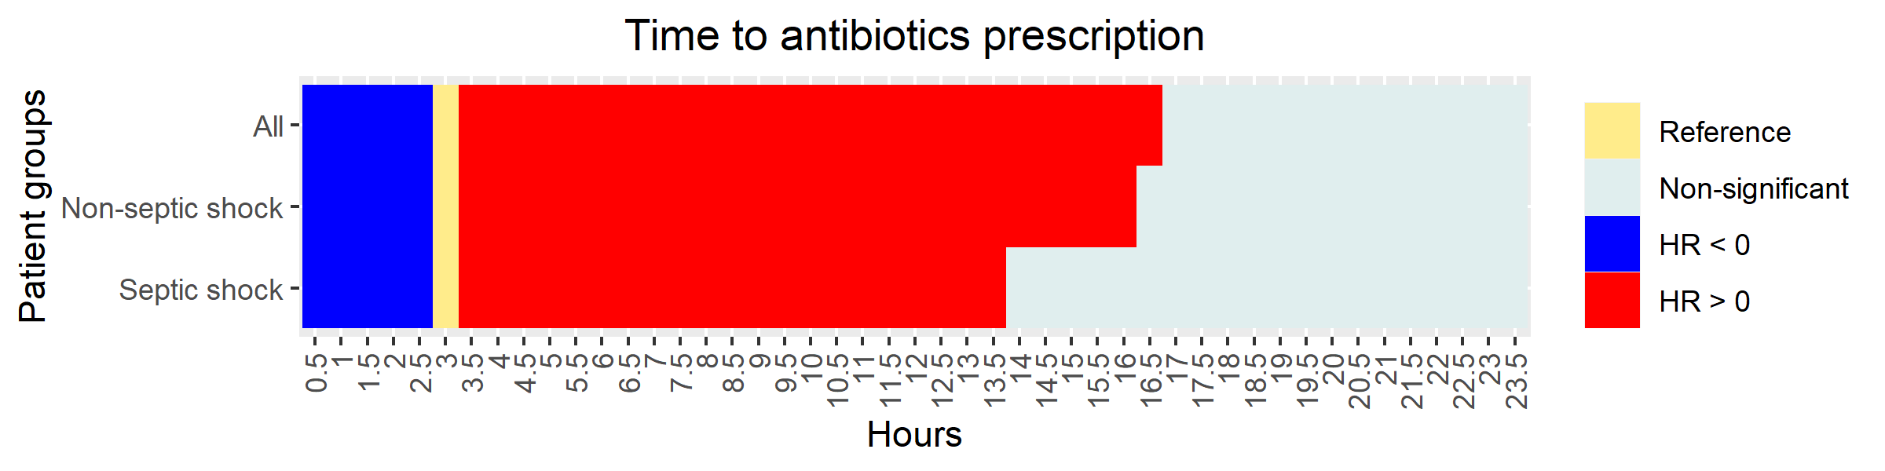

Figure S2. Heat map describing the optimal timing of antibiotics administration in the non-linear model, that is, within 3 hours, no matter whether in septic shock or non-shock patients.

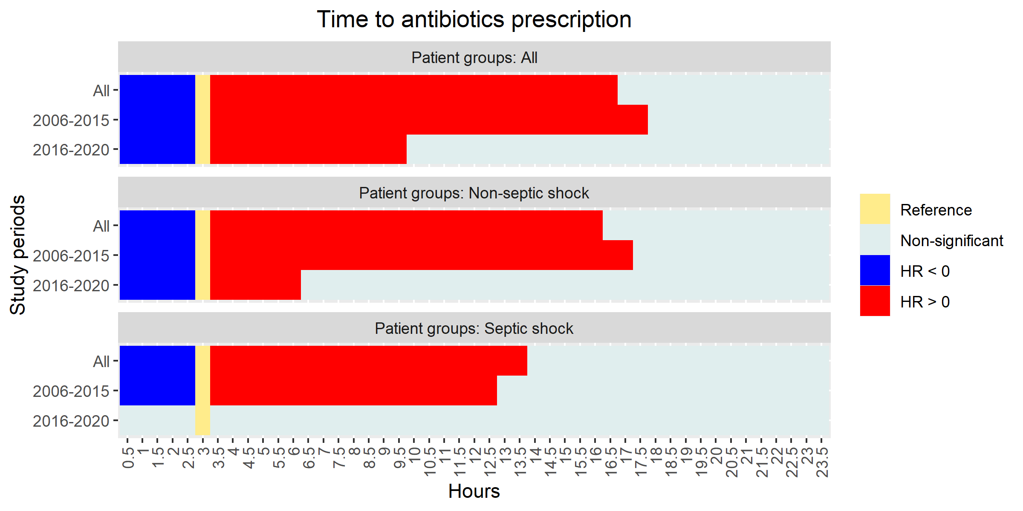
Figure S3. Heat map describing the optimal timing of antibiotics administration in the non-linear model for time restricted subsets, that is, within 3 hours, irrespective of whether in septic shock or non-shock patients.

