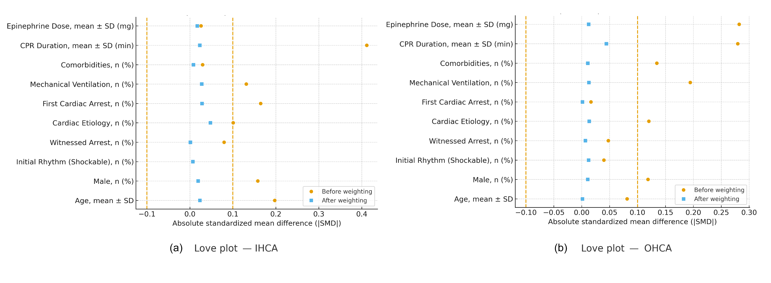
Figure S1. Love plots of standardized mean differences before and after IPTW weighting (OHCA and IHCA).
Note: Dashed line indicates SMD = 0.10 threshold. Post-weighting SMDs were <0.10 for all covariates in each stratum.

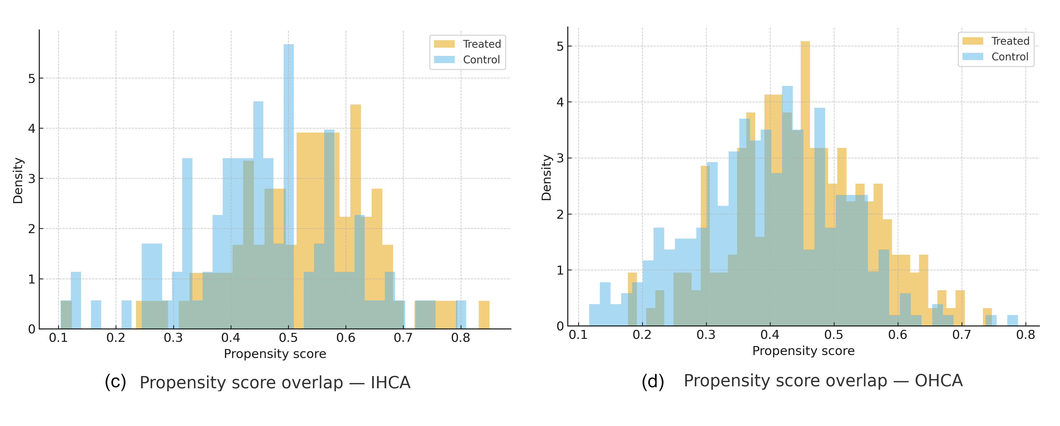
Figure S2. Propensity score overlap by treatment group (density/histogram) within each stratum.
Note: Overlap/common support was adequate after trimming; min–max PS ranges by group are provided in the panel annotations.

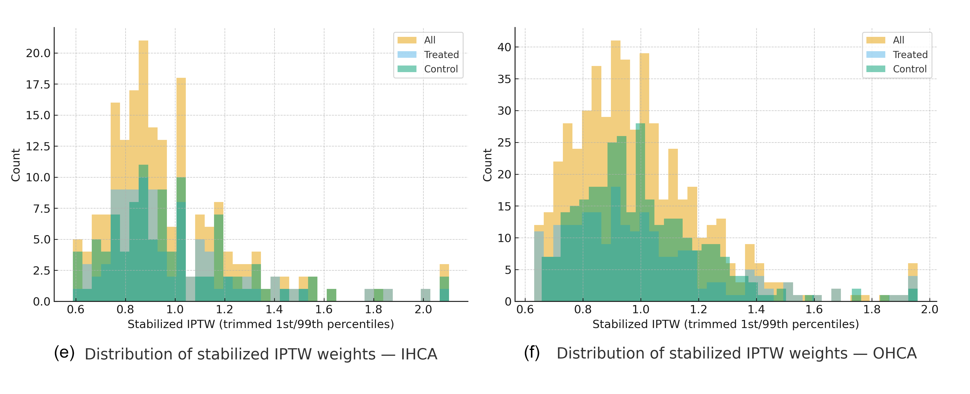
Figure S3. Distribution of stabilized IPTW weights by treatment group and pooled (OHCA and IHCA).
Note: Stabilized weights shown after 1st/99th percentile trimming; vertical lines denote trimming cutoffs. Report median [IQR] and ESS in caption if desired.

