SIMULATION CASE TITLE: Distal Radius Fracture in a Patient with a History of Childhood Trauma

AUTHORS: Taylor Brown MD

PATIENT AGE: 35

CHIEF COMPLAINT: Wrist pain

Brief narrative description of case | This is a 35-year-old patient presenting with R wrist pain after a fall after a ground-level fall. The patient has a distal radius fracture that requires reduction and splinting. Patient has a history of trauma and difficulty tolerating painful procedures.
Primary Learning Objectives | - Demonstrate trauma-informed approach to procedures emphasizing transparency, collaboration and patient empowerment  - Demonstrate grounding techniques to de-escalate a patient with difficulty tolerating a procedure
Critical Actions | - Treat pain aggressively  - Collaborate with patient to offer choice/control during procedure  - Stop immediately when patient displays signs of distress  - De-escalate patient with grounding technique
Learner Preparation | None

Initial Presentation
Initial vital signs | T 97.6, HR 102, BP 137/84, RR 22, O2 sat 99% on RA
Overall Appearance | Learners encounter an SP holding their R wrist. The patient appears to be in significant pain and moderate emotional distress.
Actors and roles in the room at case start | Two faculty needed for case: One to run the simulation and a second to act as a confederate/nurse to be in the room at the start of the case.  One SP or faculty volunteer to be the patient.
HPI | Provided by patient.  This is a 35-year-old patient presenting with R wrist pain after a fall after a ground-level fall. Patient reports tripping on uneven pavement and landing on her outstretched hand. Patient describes sharp pain in the wrist, worsened with movement, and mild swelling.  Provided when asked: She denies head trauma, loss of consciousness, or other injuries. No history of fractures or connective tissue disorders. She takes sertraline for anxiety but does not have a current therapist.
Past Medical/Surgical History | Medications | Allergies | Family History
PTSD, anxiety, depression, IVDU | Sertraline | Seasonal | Unknown. Mother is incarcerated; father is deceased.
Physical Examination
General | Alert, restless, arms crossed, frequently shifting in chair
HEENT | Normal
Neck | Normal
Lungs | Normal
Cardiovascular | Regular tachycardia
Abdomen | Normal
Neurological | Normal
Skin | Normal, no open wounds
Extremities | Mild swelling, tenderness over the distal radius, obvious deformity, intact capillary refill, 2+ radial pulses, limited ROM of fingers on R hand
Psychiatric | Anxious, at times raising voice

Instructor Notes - Changes and CASE Branch Points
Intervention / Time point | Change in Case | Additional Information
After initial history, patient will inquire about pain control | Students should order IV pain medication. | If delay, patient will not allow case to move on until pain is addressed.
After physical exam | RN presents student with XR, student should explain the need for reduction and splinting | If the student does not explain the procedure, the patient will ask to leave
After diagnosis | Patient will demonstrate anxiety about the procedure. They will repeat, “I can’t do this” until students ask an open-ended question. Patient will express history of “difficult childhood” and they “don’t handle pain anymore”. | If students do not ask open-ended question, the case does not move forward.  RN may prompt patient with open-ended questions, such as, “what makes you say that?”.
Before reduction and splinting | Student should make attempt to collaborate with patient regarding procedure. Offer manual reduction vs hanging, IV pain medication vs hematoma block, position of comfort, ect. | If the student does not collaborate and offer modifications, patient will ask to leave.  If students verbalize wanting to perform a conscious sedation, or offer this to the patient, the patient will decline this option.  RN can re-direct by suggesting modifications.
1st attempt at reduction, the patient will demand to stop | Student should immediately stop and check in with patient. If they stop and performing a grounding exercise, patient will agree to a 2nd attempt | If student does not immediately stop the procedure, the patient will try to leave.  If no grounding performed, pt will become increasingly agitated.
After successful 2nd attempt at splinting | Student should provide splint care and follow up instructions | Case ends

Ideal Scenario Flow
Patient will present in moderate distress, appearing emotionally distressed as well. Students will immediately align with patient to address the patient’s pain. They will describe the distal radius fracture, and the requirement for reduction and splinting, using simple language. They will be transparent about potential pain and discomfort. They will identify patient’s extreme anxiety about the procedure due to a history of adversity. They will identify the patient’s primary concern is pain control. They will collaborate with the patient to offer modifications to the procedure to reduce pain. They may also suggest modifications to reduce anxiety. When the patient has difficulty tolerating the procedure, they will stop immediately. They will reassess the patient’s pain and de-escalate the patient using a grounding technique. After this, the patient will tolerate a second attempt successfully.
Anticipated Management Mistakes
- Failure to initially address pain: If learners do not address the patient’s pain at the outset of the case, the patient will not allow the case to progress and will decline physical exam. The patient will clearly state that pain is their primary concern. If learners fail to align with the patient on this in the early part of the case, they will fail to progress given the patient’s distrust of healthcare providers.
- Failure to explain procedure in simple, transparent terms: The patient is very anxious and demonstrates a distrust of healthcare providers related to prior episodes of mistreatment. If the team uses language that the patient would not understand, this will only increase the patient’s anxiety about the procedure and therefore will increase their emotional dysregulation. The RN can re-direct by rephrasing, saying something like, “The doctors need to line up the bones before putting on the splint. It should really help with your pain”.
- Failure to recognize inquire about patient’s reaction out of proportion to diagnosis: If learners fail to inquire about the patient’s emotional state and fail to uncover the patient’s trauma history, they will have difficulty aligning with the patient and building enough trust to walk them through a potentially uncomfortable or painful procedure. If students are struggling, the RN can be the one to ask an open-ended question.
- Failure to modify procedural approach: Learner’s may initially approach the patient with a more paternalistic approach where they walk the patient through how the procedure is typically done. If they fail to identify the patient’s main concern and offer modifications to address the patient’s anxiety, they will fail to earn the patient’s trust, and we will have difficulty progressing with the case or performing the procedure. RN may prompt the team with statement like, “I saw another patient listen to music through the procedure and it really helped”.
- Failure to stop procedure when patient is activated: If learners fail to stop when the patient expresses a desire to stop, they will lose the patience trust. If learners failed to inquire about why the patient asked to stop, failed to reassess pain, or fail to practice a grounding technique, the patient will have difficulty moving forward with the case. If learners are stuck at this phase, the RN may prompt them by checking in with the patient about the patient’s pain or by walking the patient through a short breathing exercise. After this, the patient will tolerate a second attempt.
Supplementary Material:
No Laboratory results available
Stimulus 1 – XR: impacted R distal radius fracture with dorsal angulation
Stimulus 2 – XR post-reduction: interval reduction of R distal radius fracture, now with splint applied.

Supplies needed for case:
- Splinting supplies: 4 inch Orthoglass or plaster, 4 inch web roll, ACE wraps, sling, water source to activate splint materials
- Finger traps/hanging supplies are not necessary. Student may verbalize performing this and may verbalize performing hematoma block.
- Two faculty members: One to run the simulation and a second to act as a confederate/nurse
- One SP/volunteer to be the patient (can be faculty, resident, fellow, or SP)

Stimulus 1: XR

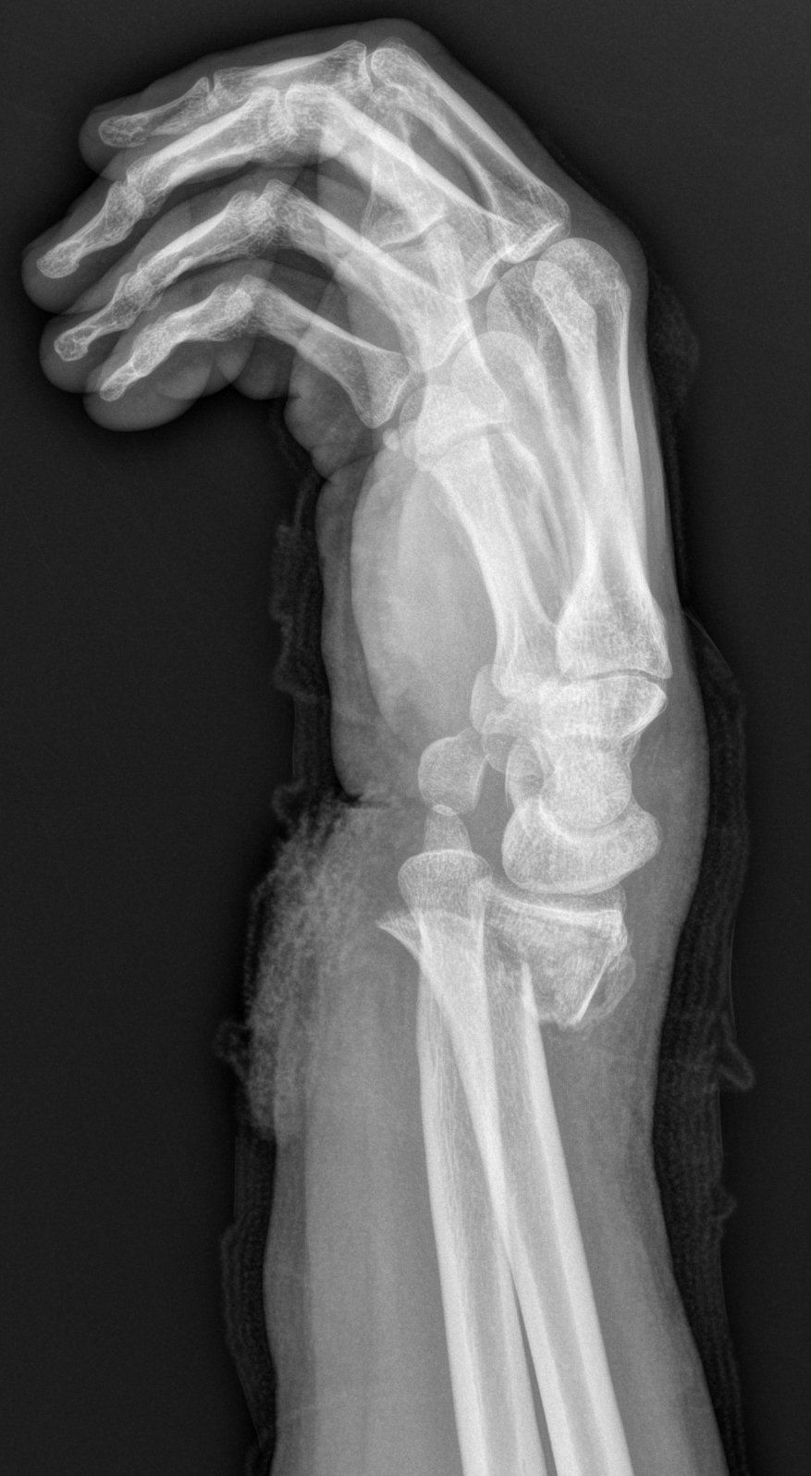

Case courtesy of Andrew Murphy, Radiopaedia.org, rID: 190125

Murphy A, Distal radius fracture. Case study, Radiopaedia.org (Accessed on 25 Mar 2025) https://doi.org/10.53347/rID-190125

Stimulus 2: XR post-reduction

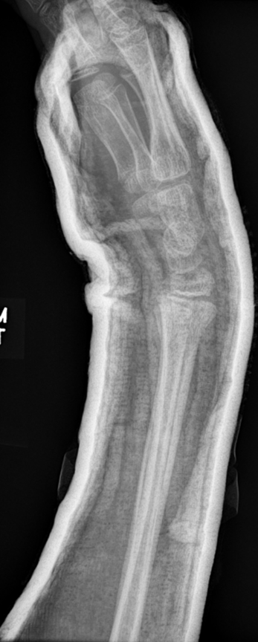

Case courtesy of Anson Chan, Radiopaedia.org, rID: 178093
Chan A, Distal radius fracture. Case study, Radiopaedia.org (Accessed on 25 Mar 2025) https://doi.org/10.53347/rID-178093

