Participant Observation guide
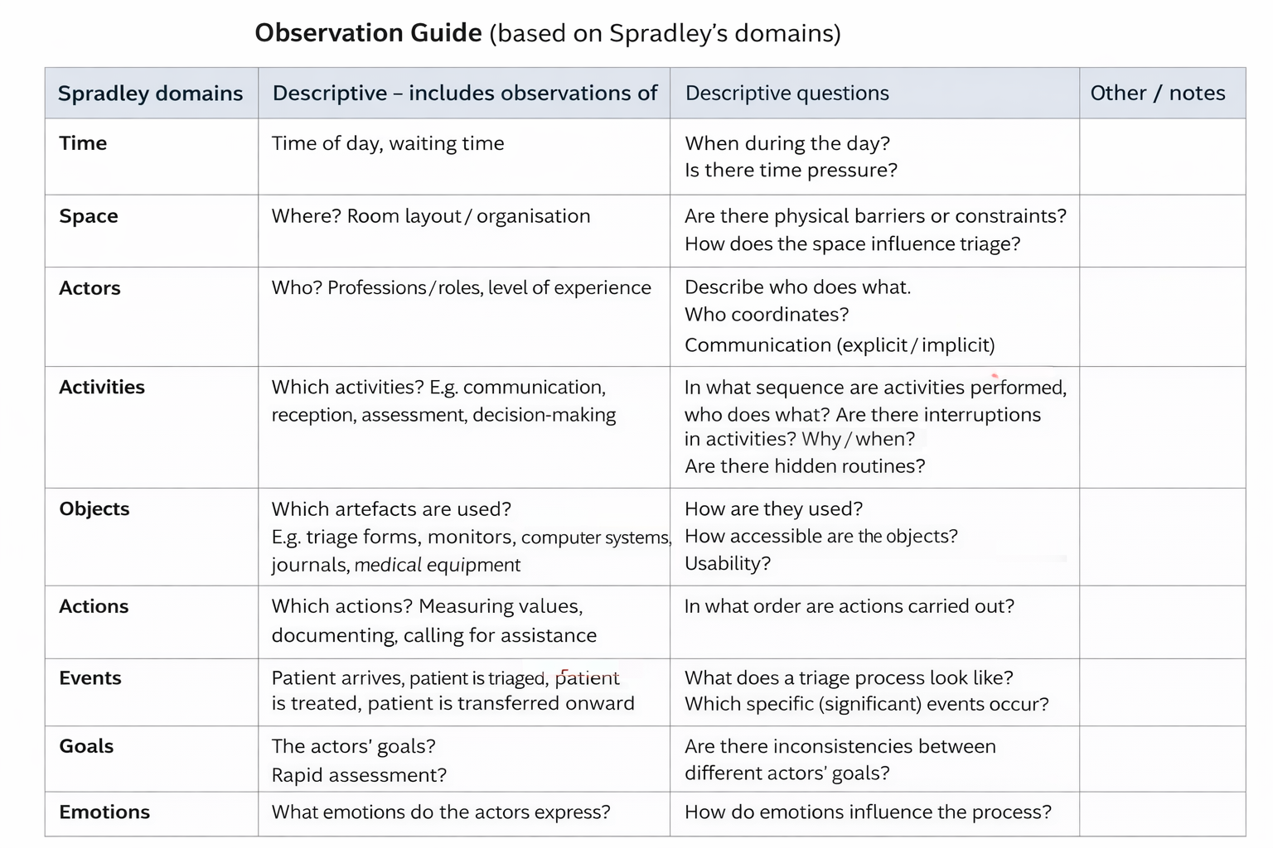
This illustrates the initial observational guide, which were iteratively adapted as observations progressed at each site.

