Table S1: SEARCH STRATEGY

MEDLINE (PubMed) search strategy (Finished by April 2025)
((("deep learning"[All Fields] OR "artificial intelligence"[All Fields] OR "machine learning"[All Fields] OR "convolutional neural networks"[All Fields]) AND ("ultraso*"[All Fields] OR "sonogra*"[All Fields]) AND ("point of care"[All Fields] OR "emergency"[All Fields] OR "bedside"[All Fields] OR "critical care"[All Fields] OR "intensive care"[All Fields] OR "targeted"[All Fields] OR "focused"[All Fields] OR "portable"[All Fields]) ) AND ("accuracy"[All Fields] OR "diagnostic accuracy"[All Fields] OR "sensitivity"[All Fields] OR "specificity"[All Fields]))
#1 "deep learning"[All Fields]
#2 "artificial intelligence"[All Fields]
#3 "machine learning"[All Fields]
#4 "convolutional neural networks"[All Fields]
#5 #1 OR #2 OR #3 OR #4
#6 "ultraso*"[All Fields]
#7 "sonogra*"[All Fields]
#8 #5 AND #6 OR #7
#9 "point of care"[All Fields]
#10 "emergency"[All Fields]
#11 "bedside"[All Fields]
#12 "critical care"[All Fields]
#13 "intensive care"[All Fields]
#14 "targeted"[All Fields]
#15 "focused"[All Fields]
#16 "portable"[All Fields]
#17 #8 AND #9 OR #10 OR #11 OR #12 OR #13 OR #14 OR #15 OR #16
#18 "accuracy"[All Fields]
#19 "diagnostic accuracy"[All Fields]
#20 "sensitivity"[All Fields]
#21 "specificity"[All Fields]
#22 #17 AND #18 OR #19 OR #20 OR #21

Scopus search strategy (Finished by April 2025)
(TITLE-ABS-KEY ("deep learning" OR "artificial intelligence" OR "machine learning" OR "convolutional neural networks") AND TITLE-ABS-KEY ("ultraso*" OR "sonogra*") AND TITLE-ABS-KEY ("point of care" OR "emergency" OR "bedside" OR "critical care" OR "intensive care" OR "targeted" OR "focused" OR "portable") AND TITLE-ABS-KEY ("accuracy" OR "diagnostic accuracy" OR "sensitivity" OR "specificity"))
#1 TITLE-ABS-KEY "deep learning"
#2 TITLE-ABS-KEY "artificial intelligence"
#3 TITLE-ABS-KEY "machine learning"
#4 TITLE-ABS-KEY "convolutional neural networks"
#5 #1 OR #2 OR #3 OR #4
#6 TITLE-ABS-KEY "ultraso*"
#7 TITLE-ABS-KEY "sonogra*"
#8 #5 AND #6 OR #7
#9 TITLE-ABS-KEY "point of care"
#10 TITLE-ABS-KEY "emergency"
#11 TITLE-ABS-KEY "bedside"
#12 TITLE-ABS-KEY "critical care"
#13 TITLE-ABS-KEY "intensive care"
#14 TITLE-ABS-KEY "targeted"
#15 TITLE-ABS-KEY "focused"
#16 TITLE-ABS-KEY "portable"
#17 #8 AND #9 OR #10 OR #11 OR #12 OR #13 OR #14 OR #15 OR #16
#18 TITLE-ABS-KEY "accuracy"
#19 TITLE-ABS-KEY "diagnostic accuracy"

Web of Science (WOS) search strategy (Finished by April 2025)
(( ALL=("deep learning" OR "artificial intelligence" OR "machine learning" OR "convolutional neural networks") AND ALL=("ultraso*" OR "sonogra*") AND ALL=("point of care" OR "emergency" OR "bedside" OR "critical care" OR "intensive care" OR "targeted" OR "focused" OR "portable") AND ALL=("accuracy" OR "diagnostic accuracy" OR "sensitivity" OR "specificity"))
#1 ALL="deep learning"
#2 ALL="artificial intelligence"
#3 ALL="machine learning"
#4 ALL="convolutional neural networks"
#5 #1 OR #2 OR #3 OR #4
#6 ALL="ultraso*"
#7 ALL="sonogra*"
#8 #5 AND #6 OR #7
#9 ALL="point of care"
#10 ALL="emergency"
#11 ALL="bedside"
#12 ALL="critical care"
#13 ALL="intensive care"
#14 ALL="targeted"
#15 ALL="focused"
#16 ALL="portable"
#17 #8 AND #9 OR #10 OR #11 OR #12 OR #13 OR #14 OR #15 OR #16
#18 ALL="accuracy"
#19 ALL="diagnostic accuracy"
#20 ALL="sensitivity"
#21 ALL="specificity"
#22 #17 AND #18 OR #19 OR #20 OR #21

Table S2: Diagnostic accuracy metrics of included studies
Author | Year | AI MODEL | Sens | Spe | TP | FP | TN | FN
Levy | 2023 | DenseNet121 | 0.72 | 0.96 | 48 | 25 | 670 | 19
Levy | 2023 | Inceptionv3 | 0.776 | 1.00 | 52 | 0 | 695 | 15
Levy | 2023 | ResNet50 | 0.90 | 0.86 | 60 | 97 | 598 | 7
Levy | 2023 | vgg11_bn | 0.28 | 0.85 | 19 | 103 | 592 | 48
Levy | 2023 | DenseNet121 | 0.79 | 0.97 | 53 | 24 | 671 | 14
Levy | 2023 | Inceptionv3 | 0.94 | 0.94 | 63 | 42 | 653 | 4
Levy | 2023 | ResNet50 | 0.28 | 0.97 | 19 | 24 | 671 | 48
Levy | 2023 | vgg11_bn | 0.88 | 0.96 | 59 | 29 | 666 | 8
Lin | 2022 | U-net | 0.94 | 0.68 | 151 | 51 | 109 | 9
Jeong | 2023 | AutoML | 0.94 | 0.99 | 94 | 1 | 99 | 6
Jeong | 2023 | AutoML | 0.95 | 0.99 | 95 | 1 | 99 | 5
Leo | 2023 | YoloV3 | 0.96 | 0.94 | 42 | 3 | 47 | 2
Leo | 2023 | U-Net | 0.64 | 0.70 | 28 | 15 | 35 | 16
Leo | 2023 | MaskRCNN | 0.46 | 0.64 | 20 | 18 | 32 | 24
Leo | 2023 | ResNet | 0.59 | 1.00 | 26 | 0 | 50 | 18
Cheng | 2021 | ResNet50-V2 | 0.99 | 0.91 | 2738 | 233 | 2443 | 42
Cheng | 2021 | ResNet50-V2 | 0.99 | 0.91 | 2925 | 165 | 2956 | 72
Sjogren | 2016 | Support Vector Machine | 1.00 | 0.90 | 10 | 1 | 9 | 0
Sjogren | 2016 | Support Vector Machine | 0.75 | 0.99 | 286 | 6 | 435 | 96
Yıldız Potter | 2023 | YoloV3-Darknet-53 | 0.89 | 0.92 | 33 | 3 | 36 | 4
Yıldız Potter | 2023 | U-net | 0.62 | 0.79 | 23 | 8 | 31 | 14
Yıldız Potter | 2023 | MaskRCNN | 0.38 | 0.56 | 14 | 17 | 22 | 23
Yıldız Potter | 2023 | SSD | 0.79 | 0.86 | 29 | 5 | 34 | 8
Sens: Sensitivity, Spe: Specificity, TP: true positive, FP: false positive, TN: true negative, FN: false negative

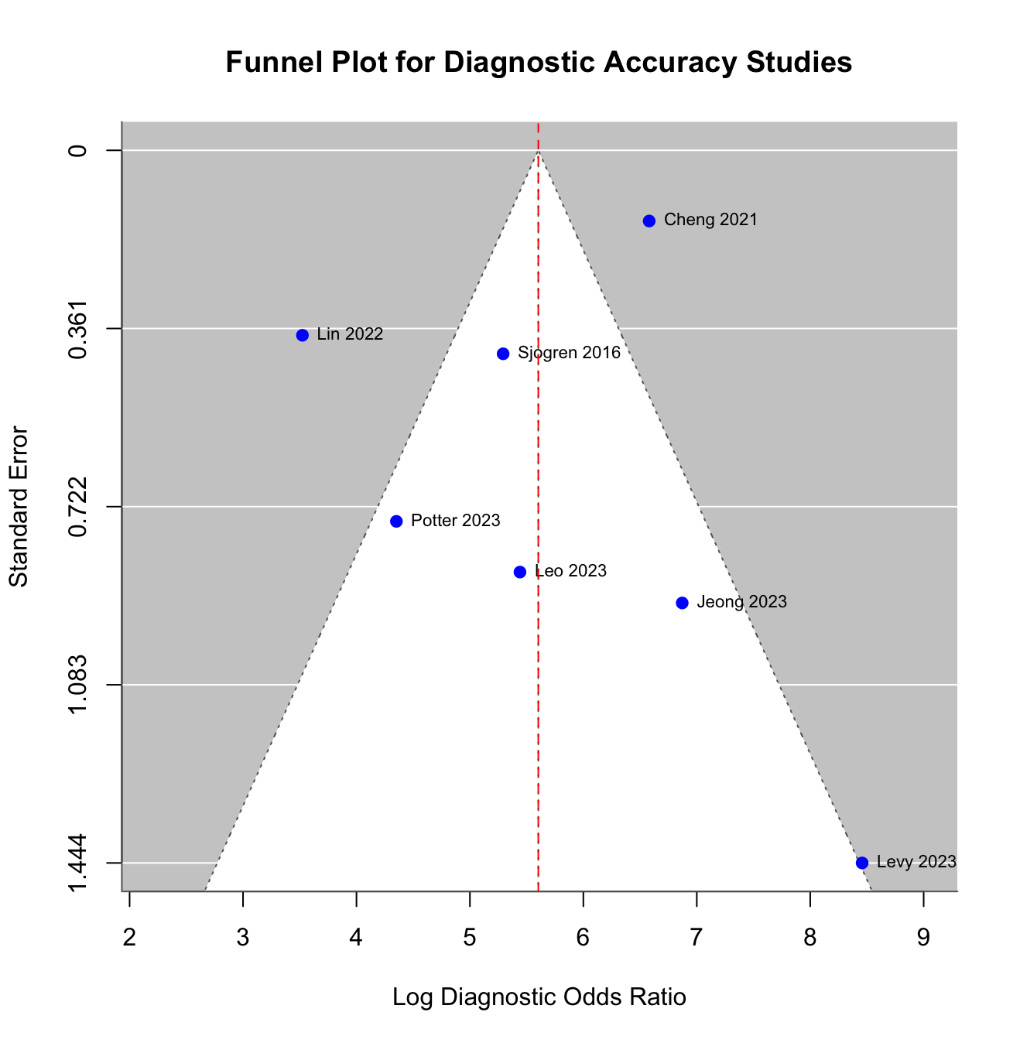
Figure S1: Funnel plot for publication bias assessment

