Supplementary Material 1 – search strings

Embase search, January 2024:
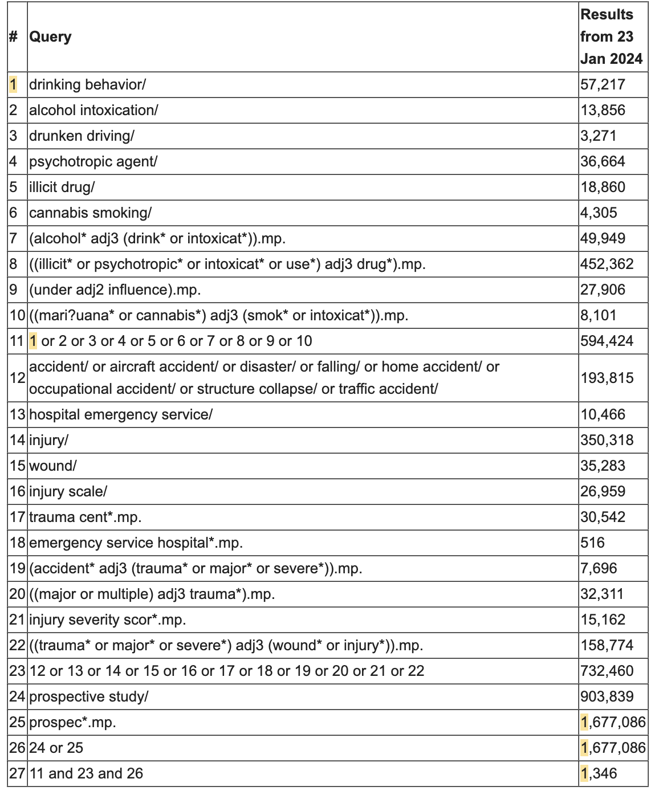

MEDLINE search, January 2024:
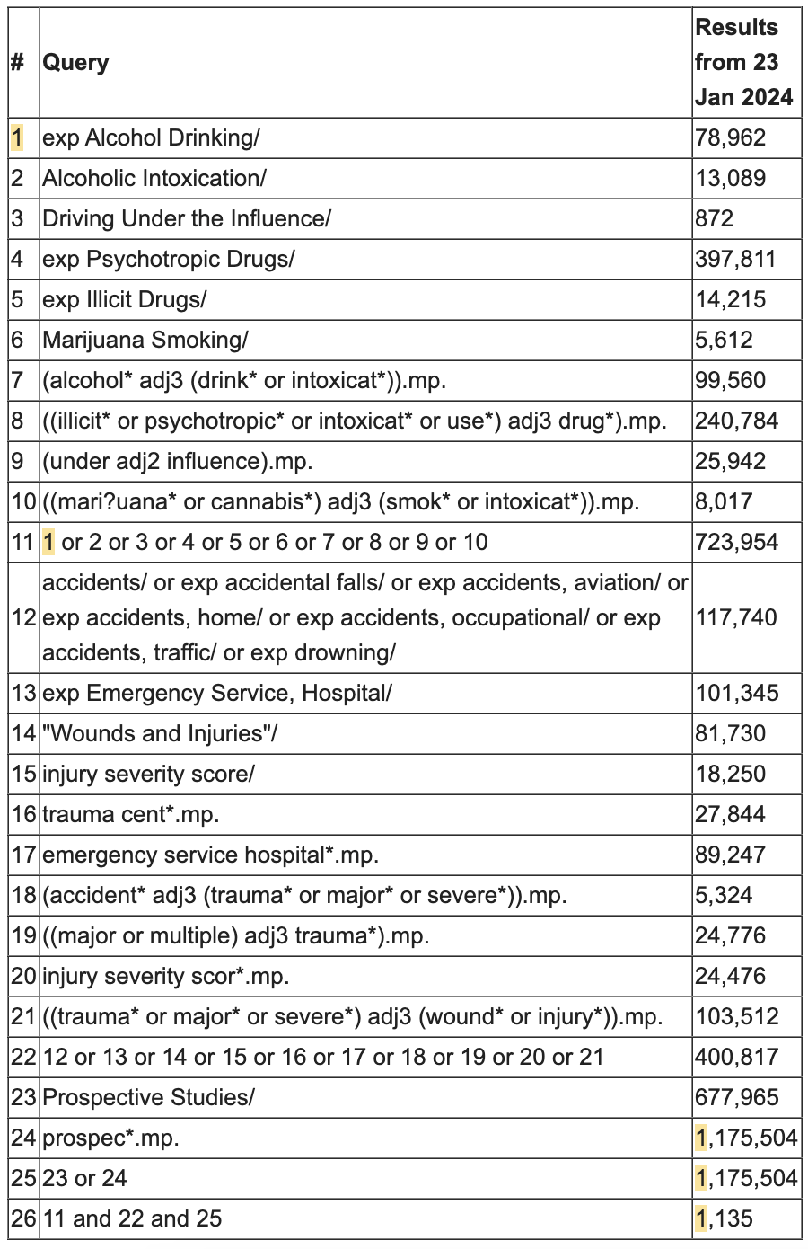
Embase search (top-up), November 2025:
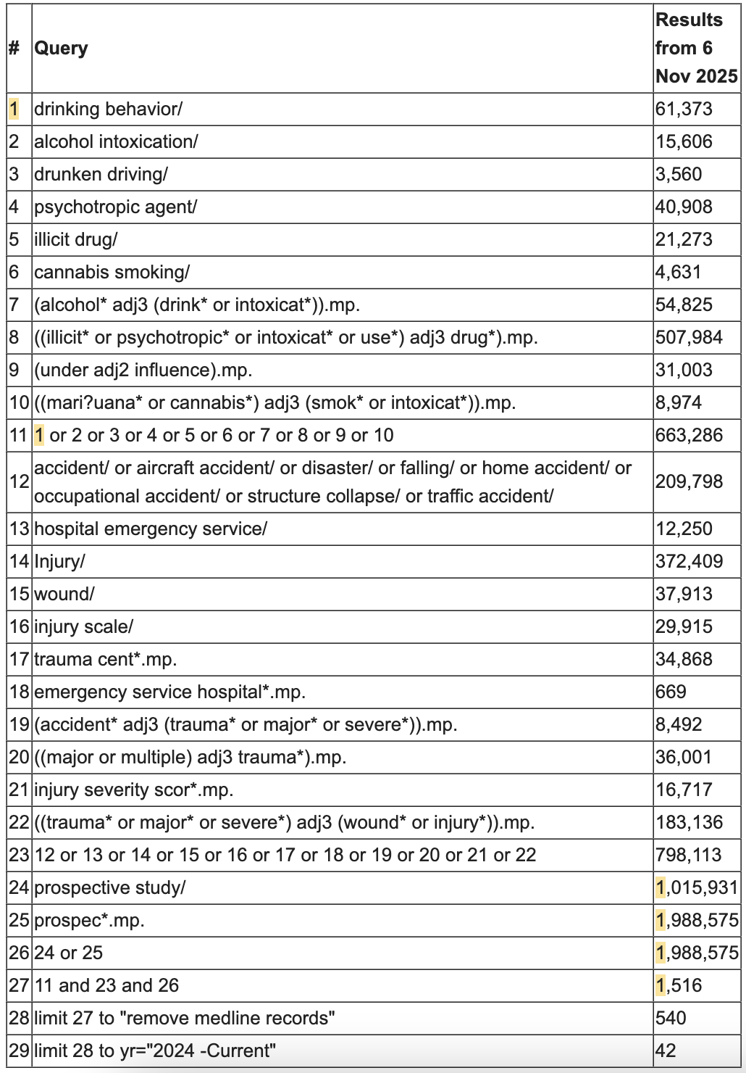

MEDLINE search (top-up), November 2025:
