Additional files
This document contains the following additional files:

Additional file 1 - ACCORD -checklist
(ACcurate COnsensus Reporting Document) Page 2

Additional file 2 – Rapid Literature Review Page 8

Additional file 3 – Statements with, if applicable, changes based
on the previous Delphi-round. Page 13

Additional file 4 – Number of comments per statement,
per sub-group and in total, per Delphi-round Page 18

Additional file 5 - Measures on Stability Page 19

Additional file 1 - ACCORD -checklist (ACcurate COnsensus Reporting Document) [1]
1. Gattrell WT, Logullo P, van Zuuren EJ, et al. ACCORD (ACcurate COnsensus Reporting Document): A reporting guideline for consensus methods in biomedicine developed via a modified Delphi. PLoS Med 2024;21(1), https://doi.org/10.1371/journal.pmed.1004326

n.a. = not applicable
Item  No. | Section | Checklist Item (help text)
T1 | Title | Identify the article as reporting a consensus exercise and state the consensus methods used in the title.  For example, Delphi or nominal group technique.  We have used the modified Delphi procedure and mention this in both the title and in the methods section of the abstract.
I1 | Introduction | Explain why a consensus exercise was chosen over other approaches.  As the literature made clear that no overarching concept was available, we needed a multidisciplinary expert group, including emergency physicians/nurses, persons with lived experience and academics in a steering committee. Thus to guide the process of initial statement development and to guide the process of responding to the comments made by Delphi-panel members.  This procedure is best described in the modified Delphi procedure.  For reasons of limited word-count, we have not elaborated on this in the manuscript.
I2 | Introduction | State the aim of the consensus exercise, including its intended audience and geographical scope (national, regional, global).  Aim: see the final lines of the Introduction  Intended audience: also stated in the aim: research, practice, policy  Geographical scope: In the Introduction, we state the need for establishing international consensus on the definition and scope of mental dysregulation within emergency care.
I3 | Introduction | If the consensus exercise is an update of an existing document, state why an update is needed, and provide the citation for the original document.  n.a.
M1 | Methods  Registration | If the study or study protocol was prospectively registered, state the registration platform and provide a link. If the exercise was not registered, this should be stated.  Recommended to include the date of registration.  The protocol was not prospectively registered. The protocol was published in advance, and is in open access available via https://pubmed.ncbi.nlm.nih.gov/38262647/
M2 | Selection of SC and/or panellists | Describe the role(s) and areas of expertise or experience of those directing the consensus exercise.  For example, whether the project was led by a chair, co-chairs or a steering committee, and, if so, how they were chosen. List their names if appropriate, and whether there were any subgroups for individual steps in the process.  Described in the “Study Design” paragraph, more specifically in the sub-paragraph ‘Organizational structure’.
M3 | Selection of SC and/or panellists | Explain the criteria for panellist inclusion and the rationale for panellist numbers. State who was responsible for panellist selection.  Described in the paragraph ‘Selection of Participants’
M4 | Selection of SC and/or panellists | Describe the recruitment process (how panellists were invited to participate).  Include communication/advertisement method(s) and locations, numbers of invitations sent, and whether there was centralised oversight of invitations or if panellists were asked/allowed to suggest other members of the panel.  Described in the ‘Organization structure’ paragraph, were the role of the country leads is explained.  Additional information on this matter can be found in the ‘Selection of Participants’ section.
M5 | Selection of SC and/or panellists | Describe the role of any members of the public, patients or carers in the different steps of the study.  The role of persons with lived experience is described throughout the paper. We specifically highlight their participation in the paragraph ‘Patient involvement’, including the GRIPP-2-short form.
M6 | Preparatory research | Describe how information was obtained prior to generating items or other materials used during the consensus exercise.  This might include a literature review, interviews, surveys, or another process.  Described in the ‘Development of statements’ paragraph: literature review and expert opinions of the steering committee
M7 | Preparatory research | Describe any systematic literature search in detail, including the search strategy and dates of search or the citation if published already.  Provide the details suggested by the reporting guideline PRISMA and the related PRISMA-Search extension.  Described in the ‘Development of statements’ paragraph: a rapid review was performed. Additional information is provided in the supplemental materials (Additional file 2).
M8 | Preparatory research | Describe how any existing scientific evidence was summarised and if this evidence was provided to the panellists.  The panellists received the information that literature was not informative for development of initial statements, and that the initial statements were developed by the steering committee.  We have added information on the literature review in the supplemental materials as Appendix A2.  For reasons of limited word count, we have not elaborated on this in the paper.
M9 | Assessing consensus | Describe the methods used and steps taken to gather panellist input and reach consensus (for example, Delphi, RAND-UCLA, nominal group technique).  If modifications were made to the method in its original form, provide a detailed explanation of how the method was adjusted and why this was necessary for the purpose of your consensus-based study.  Three Delphi rounds. Described in the ‘The Delphi rounds’ sub-paragraph
M10 | Assessing consensus | Describe how each question or statement was presented and the response options. State whether panellists were able to or required to explain their responses, and whether they could propose new items.  Where possible, present the questionnaire or list of statements as supplementary material.  Panellists could rate their level of agreement with each statement on a 7 point Likert scale (strongly agree, agree, slightly agree, neutral, slightly disagree, disagree, strongly disagree). They also were given the opportunity to give comments on language and content of each statement.  They could do so via an online and anonymous environment.  Described in the ‘The Delphi rounds’ sub-paragraph.
M11 | Assessing consensus | State the objective of each consensus step.  A step could be a consensus meeting, a discussion or interview session, or a Delphi round.  Delphi Round  Described in the ‘The Delphi rounds’ sub-paragraph
M12 | Assessing consensus | State the definition of consensus (for example, number, percentage, or categorical rating, such as ‘agree’ or ‘strongly agree’) and explain the rationale for that definition.  Consensus was considered achieved if at least 75% of the panel members rated either ‘agree’ or ‘strongly agree’ with the statement.  Described in the ‘Closing criteria, measurements and analysis’ section.
M13 | Assessing consensus | State whether items that met the prespecified definition of consensus were included in any subsequent voting rounds.  Statements that reached consensus remained in the consecutive Delphi rounds, and were amendable for changes, based on the comments.  Described in the ‘Closing criteria, measurements and analysis’ section.
M14 | Assessing consensus | For each step, describe how responses were collected, and whether responses were collected in a group setting or individually.  Described in the ‘Closing criteria, measurements and analysis’ section.
M15 | Assessing consensus | Describe how responses were processed and/or synthesised.  Include qualitative analyses of free-text responses (for example, thematic, content or cluster analysis) and/or quantitative analytical methods, if used.  Statistical analyses of levels of agreement, overall and per sub-group. Weighted levels of agreement. Measures for stability.  Comments were analysed independently by two researchers.  Results were put together in a report, per round.  Described in the ‘Closing criteria, measurements and analysis’ section.
M16 | Assessing consensus | Describe any piloting of the study materials and/or survey instruments.  Include how many individuals piloted the study materials, the rationale for the selection of those individuals, any changes made as a result and whether their responses were used in the calculation of the final consensus. If no pilot was conducted, this should be stated.  The online procedure was piloted/tested in the period of development of statements, by the steering committee.  Described in the ‘Development of statements’ section.
M17 | Assessing consensus | If applicable, describe how feedback was provided to panellists at the end of each consensus step or meeting.  State whether feedback was quantitative (for example, approval rates per topic/item) and/or qualitative (for example, comments, or lists of approved items), and whether it was anonymised.  In the second and third round, panel members received feedback from the previous round for each statement including: a) the level of agreement in total and per group, b) their own level of agreement, and c) comment summary.  Described in ‘The Delphi rounds’ section.
M18 | Assessing consensus | State whether anonymity was planned in the study design. Explain where and to whom it was applied and what methods were used to guarantee anonymity.  Delphi panel members participated anonymously. Stated in the ‘Delphi rounds’ section.
M19 | Assessing consensus | State if the steering committee was involved in the decisions made by the consensus panel.  For example, whether the steering committee or those managing consensus also had voting rights.  The steering committee was not involved in the rating process of statements. They were involved in weighing the comments made by panellists, for improvement of statements.  Described in ‘The Delphi rounds’ section.
M20 | Participation | Describe any incentives used to encourage responses or participation in the consensus process.  For example, were invitations to participate reiterated, or were participants reimbursed for their time.  n.a.
M21 | Participation | Describe any adaptations to make the surveys/meetings more accessible.  For example, the languages in which the surveys/meetings were conducted and whether translations or plain language summaries were available.  n.a.
R1 | Results | State when the consensus exercise was conducted. List the date of initiation and the time taken to complete each consensus step, analysis, and any extensions or delays in the analysis.  Timing of the Delphi rounds can be found in figure 1.  The process developed according to the planning. Two weeks per Delphi round, two weeks for analysing, two weeks for the steering committee to respond to the reports.
R2 | Results | Explain any deviations from the study protocol, and why these were necessary.  For example, addition of panel members during the exercise, number of consensus steps, stopping criteria; report the step(s) in which this occurred.  We could not use information in the scientific literature. This is accounted for in the ‘Development of statements’ paragraph and in the Supplemental materials (Additional file 2).
R3 | Results | For each step, report quantitative (number of panellists, response rate) and qualitative (relevant socio-demographics) data to describe the participating panellists.  See Table 3
R4 | Results | Report the final outcome of the consensus process as qualitative (for example, aggregated themes from comments) and/or quantitative (for example, summary statistics, score means, medians and/or ranges) data.  All reported on in the ‘Results’ section
R5 | Results | List any items or topics that were modified or removed during the consensus process. Include why and when in the process they were modified or removed.  All reported on in the ‘Results’ section. All changes can be viewed in Additional file 5.
D1 | Discussion | Discuss the methodological strengths and limitations of the consensus exercise.  Include factors that may have impacted the decisions (for example, response rates, representativeness of the panel, potential for feedback during consensus to bias responses, potential impact of any non-anonymised interactions).  See ‘Strengths and Limitations’ section.
D2 | Discussion | Discuss whether the recommendations are consistent with any pre-existing literature and, if not, propose reasons why this process may have arrived at alternative conclusions.  See ‘Discussion’ section
O1 | Other information | List any endorsing organisations involved and their role.  n.a.
O2 | Other information | State any potential conflicts of interests, including among those directing the consensus study and panellists. Describe how conflicts of interest were managed.  No conflicts of interest to disclose. Stated in Declarations – Competing interests - paragraph
O3 | Other information | State any funding received and the role of the funder.  Specify, for example, any funder involvement in the study concept/design, participation in the steering committee, conducting the consensus process, funding of any medical writing support. This could be disclosed in the methods or in the relevant transparency section of the manuscript. Where a funder did not play a role in the process or influence the decisions reached, this should be specified.  No funding was available for this project. Stated in the Declarations – Funding - part.

Additional file 2 – Search strategy for the Rapid Review
A rapid review was performed to guide the development of the initial statements. Medline, PsychInfo and CINAHL were searched (28th September 2023), using a documented search strategy, to identify internationally applied concepts and definitions pertaining to emotional or behavioral dysregulation in the context of emergency care research. The search-strategy can be found on the next pages.
To structure the analysis, search results were organized into four categories, each representing concepts related to emotional and/or behavioral dysregulation: 1) concepts for mental dysregulation; 2) concepts for externalizing behaviors; 3) concepts for internalizing behaviors; 4) concepts related to suicide attempts and self-injury.
Per category, the ten most recent papers were included. The analysis revealed a diverse range of concepts, most of which lacked definitions, such as ‘behavioral complaints’ and ‘behavioral disturbance’ in Simon et al. [1], ‘psychiatric deterioration in physically-ill patients’, ‘self-injury’, ‘behavioral change in the elderly’ in Keller et al. [2], ‘mental health condition’, ‘trauma and stressor-related disorders’, ‘emotional and behavioral problems’ and ‘mental health issue’ in Mao, Shalaby & Agyapong [3]. None of the included papers described concepts for internalizing behaviors.
In conclusion, the literature review demonstrated a broad variety of concepts, in many cases without definitions, related to emotional or behavioral dysregulation in the context of emergency care. No concepts for internalizing behaviors were found. An overarching definition to inform the emergency care practice and research is lacking.
1. Simon EL, Smalley CM, Muir MM, et al. Agitation Management in the Emergency Department with Physical Restraints: Where Do These Patients End Up? Western Journal of Emergency Medicine 2023;24(3).
2. Keller S, Tilbor E, Shwiki A, et al. Psychiatric referrals to the general hospital emergency department: are we being effective? Front Psychiatry 2023;14.
3. Mao W, Shalaby R, Agyapong VIO. Interventions to Reduce Repeat Presentations to Hospital Emergency Departments for Mental Health Concerns: A Scoping Review of the Literature. Healthcare 2023;11(8):1161.

Pubmed:
Search conducted on September 28, 2023
Search | Query | Records retrieved
#1 | Emergency Nursing[Mesh] OR "Emergency Nurs*"[tiab] OR "Emergency Room Nurs*"[tiab] OR "Trauma Nursing"[tiab] OR Emergency Medical Services[Mesh] OR Hospital Emergency Service[Mesh] OR "Emergency Medical Service*"[tiab] OR "Emergency Care"[tiab] OR "Emergency Health Service*"[tiab] OR "Emergency Department*"[tiab] OR "Emergency Room*"[tiab] OR "Emergency Unit*"[tiab] OR "Emergency Ward*"[tiab] OR "Emergency Hospital*"[tiab] OR "Emergency Service*"[tiab] OR Paramedics[Mesh] OR Paramedic*[tiab] OR "Emergency Physician*"[tiab] OR Ambulance*[tiab] OR "First Responder*"[tiab] | 288,197
#2 | Mental Disorders[Mesh] OR "Mental Disorder*"[tiab] OR "Mental Health Issue*"[tiab] OR "Mental Illness*"[tiab] OR "Mental Health Presentation*"[tiab] OR "Mental Health Problem*"[tiab] OR "Psychiatric Disorder*"[tiab] OR "Psychiatric Disease*"[tiab] OR "Psychiatric Illness*"[tiab] OR "Psychiatric Condition*"[tiab] OR Psychophysiologic Disorders[Mesh] OR "Psychophysiologic Disorder*"[tiab] OR "Psychosomatic Disorder*"[tiab] OR Aggression[Mesh] OR Aggression*[tiab] OR Problem Behavior[Mesh] OR "Problem Behavior*"[tiab] OR "Behavioral Problem*"[tiab] OR "Disruptive Behavior*"[tiab] OR "Behavioral Disorder*"[tiab] OR "Psychologically disturbed"[tiab] OR Self-Injurious Behavior[Mesh] OR "Self Injur*"[tiab] OR "Self Harm"[tiab] OR "Self Destruct*"[tiab] OR "Self Mutilat*"[tiab] OR Suicide[tiab] OR Suicidal[tiab] OR Anxiety[Mesh] OR Anxiety[tiab] OR Delirium[tiab] OR “Learning Disabilit*”[tiab] OR “Learning Disorder*”[tiab] OR “Learning Disturbance*”[tiab] OR Dementia*[tiab] OR ((Substance[tiab] OR Drug[tiab]) AND (Disorder*[tiab] OR Dependence[tiab] OR Abuse[tiab] OR Addiction[tiab])) | 1,960,616
#3 | definition*[tiab] OR define[tiab] OR defining[tiab] OR criteri*[tiab] OR concept*[tiab] OR consensus[tiab] OR determin*[tiab] | 5,816,382
#4 | #1 AND #2 AND #3 | 6,043
#5 | #4: Filter from 2013-2023 | 3,678

CINAHL:
Search conducted on September 28, 2023
Search | Query | Records retrieved
#1 | MH (“Emergency Medical Services+” OR “Emergency Nursing+” OR “Emergency Medical Technicians”) OR TI (“Emergency Nurs*” OR “Emergency Room Nurs*” OR “Trauma Nursing” OR “Emergency Medical Service*” OR “Emergency Care” OR “Emergency Health Service*” OR “Emergency Department*” OR “Emergency Room*” OR “Emergency Unit*” OR “Emergency Ward*” OR “Emergency Hospital*” OR “Emergency Service*” OR Paramedic* OR “Emergency Physician*” OR Ambulance* OR “First Responder*”) OR AB (“Emergency Nurs*” OR “Emergency Room Nurs*” OR “Trauma Nursing” OR “Emergency Medical Service*” OR “Emergency Care” OR “Emergency Health Service*” OR “Emergency Department*” OR “Emergency Room*” OR “Emergency Unit*” OR “Emergency Ward*” OR “Emergency Hospital*” OR “Emergency Service*” OR Paramedic* OR “Emergency Physician*” OR Ambulance* OR “First Responder*”) | 184,411
#2 | (MH (“Mental Disorders+” OR Suicide+ OR “Self-Injurious Behavior” OR Anxiety+) OR TI (“Mental Disorder*” OR “Mental Health Issue*” OR “Mental Illness*” OR “Mental Health Presentation*” OR “Psychiatric Disorder*” OR “Psychiatric Disease*” OR “Psychiatric Illness*” OR “Psychiatric Condition*” OR “Psychophysiologic Disorder*” OR “Psychosomatic Disorder*” OR Aggression* OR Aggressive OR “Problem Behavior*” OR “Behavioral Problem*” OR “Behavior Problem*” OR “Behavior Disorder*” OR “Disruptive Behavior*” OR “Behavioral Disorder*” OR “Psychologically disturbed” OR “Self Injur*” OR “Self Harm” OR “Self Destruct*” OR “Self Mutilat*” OR Suicide OR Suicidal OR Anxiety OR Delirium OR “Learning Disabilit*” OR “Learning Disorder*” OR “Learning Disturbance*”OR Dementia* OR ((Substance OR Drug) AND (Disorder* OR Dependence OR Abuse OR Addiction))) OR AB (“Mental Disorder*” OR “Mental Health Issue*” OR “Mental Illness*” OR “Mental Health Presentation*” OR “Psychiatric Disorder*” OR “Psychiatric Disease*” OR “Psychiatric Illness*” OR “Psychiatric Condition*” OR “Psychophysiologic Disorder*” OR “Psychosomatic Disorder*” OR Aggression* OR Aggressive OR “Problem Behavior*” OR “Behavioral Problem*” OR “Behavior Problem*” OR “Behavior Disorder*” OR “Psychologically disturbed” OR “Self Injur*” OR “Self Harm” OR “Self Destruct*” OR “Self Mutilat*” OR Suicide OR Suicidal OR Anxiety OR Delirium OR “Learning Disabilit*” OR “Learning Disorder*” OR “Learning Disturbance*”OR Dementia* OR ((Substance OR Drug) AND (Disorder* OR Dependence OR Abuse OR Addiction))) | 852,698
#3 | TI(definition* OR define OR defining OR criteri* OR concept* OR consensus OR determin*) OR AB (definition* OR define OR defining OR criteri* OR concept* OR consensus OR determin*) | 1,092,891
#4 | #1 AND #2 AND #3 | 3,312
#5 | #4: Limiters - Published Date: 20130101-20231231 | 2,256

Psycinfo:
Search conducted on September 28, 2023
Search | Query | Records retrieved
#1 | DE (“Emergency Services+” OR “Emergency Personnel+”) OR TI (“Emergency Nurs*” OR “Emergency Room Nurs*” OR “Trauma Nursing” OR “Emergency Medical Service*” OR “Emergency Care” OR “Emergency Health Service*” OR “Emergency Department*” OR “Emergency Room*” OR “Emergency Unit*” OR “Emergency Ward*” OR “Emergency Hospital*” OR “Emergency Service*” OR Paramedic* OR “Emergency Physician*” OR Ambulance* OR “First Responder*”) OR AB (“Emergency Nurs*” OR “Emergency Room Nurs*” OR “Trauma Nursing” OR “Emergency Medical Service*” OR “Emergency Care” OR “Emergency Health Service*” OR “Emergency Department*” OR “Emergency Room*” OR “Emergency Unit*” OR “Emergency Ward*” OR “Emergency Hospital*” OR “Emergency Service*” OR Paramedic* OR “Emergency Physician*” OR Ambulance* OR “First Responder*”) | 21,373
#2 | ((DE (“Mental Disorders+” OR “Behavior Disorders+” OR “Behavior Problems+” OR “Aggressive Behavior+” OR “Self-Destructive Behavior+” OR Anxiety+) OR TI (“Mental Disorder*” OR “Mental Health Issue*” OR “Mental Illness*” OR “Mental Health Presentation*” OR “Psychiatric Disorder*” OR “Psychiatric Disease*” OR “Psychiatric Illness*” OR “Psychophysiologic Disorder*” OR “Psychosomatic Disorder*” OR Aggression* OR Aggressive OR “Problem Behavior*” OR “Behavioral Problem*” OR “Behavior Problem*” OR “Behavior Disorder*” OR “Disruptive Behavior*” OR “Behavioral Disorder*” OR “Psychologically disturbed” OR “Self Injur*” OR “Self Harm” OR “Self Destruct*” OR “Self Mutilat*” OR Suicide OR Suicidal OR Anxiety OR Delirium OR “Learning Disabilit*” OR “Learning Disorder*” OR “Learning Disturbance*”OR Dementia* OR ((Substance OR Drug) AND (Disorder* OR Dependence OR Abuse OR Addiction))) OR AB (“Mental Disorder*” OR “Mental Health Issue*” OR “Mental Illness*” OR “Mental Health Presentation*” OR “Psychiatric Disorder*” OR “Psychiatric Disease*” OR “Psychiatric Illness*” OR “Psychophysiologic Disorder*” OR “Psychosomatic Disorder*” OR Aggression* OR Aggressive OR “Problem Behavior*” OR “Behavioral Problem*” OR “Behavior Problem*” OR “Behavior Disorder*” OR “Disruptive Behavior*” OR “Behavioral Disorder*” OR “Psychologically disturbed” OR “Self Injur*” OR “Self Harm” OR “Self Destruct*” OR “Self Mutilat*” OR Suicide OR Suicidal OR Anxiety OR Delirium OR “Learning Disabilit*” OR “Learning Disorder*” OR “Learning Disturbance*”OR Dementia* OR ((Substance OR Drug) AND (Disorder* OR Dependence OR Abuse OR Addiction)))) | 719,047
#3 | TI(definition* OR define OR defining OR criteri* OR concept* OR consensus OR determin*) OR AB (definition* OR define OR defining OR criteri* OR concept* OR consensus OR determin*) | 1,235,395
#4 | #1 AND #2 AND #3 | 1,457
#5 | #4: Limiters - Publication Year: 2013-2023 | 880

After controlling for language and duplicates within Rayyan a set of 3535 publications was retrieved.

Additional file 3– Statements with, if applicable, changes based on the previous Delphi-round.
The column below ‘Delphi round’ shows the round and the level of agreement on the statement in that round. This information helps inform wording changes made to the statements and subsequent changes in the levels of agreement in following rounds. The level of agreement is the percentage of panel members that rated the statement with either ‘strongly agree’ or ‘agree’, ≥75% was the threshold for the claim of consensus in this study.
In the row after ‘Round 1’ the initial statements are presented, as developed by the steering committee. These statements were rated by the panel members in round 1.
In the row after ‘Round 2’ the statements with, if applicable, changes made based on round 1 are presented. These statements were rated by the panel members in round 2.
In the row after ‘Round 3’ the statements with, if applicable, changes made based on round 2 are presented. These statements were rated by the panel members in round 3.
Two minor changes on language were made after round 3 (statements 2.2 and 4.2).
Changes made, based on the previous round, are in bold print.
The version of each statement with a green background, is the final version of the statement.

Category 1: statements on why the concept of mental dysregulation is relevant for emergency care
Number | Delphi round  Level of agreement (%) | Statement
1.1 | Round 1  80.53% | In practice and research in the pre-hospital (i.e., ambulance) and Emergency Department settings, there is no uniformly used and defined term for Mental Dysregulation in patients. A wide variety of terms (including ‘emotional disturbance’, ‘behavioral disturbance’, ‘agitation’) is used. This leads to inconsistencies in research examining this construct and consequently impacts the provision of care.
1.1 | Round 2  90.00% | In practice and research in the pre-hospital (i.e., ambulance) and Emergency Department settings, there is no uniformly used and defined term for Mental Dysregulation in patients. A wide variety of terms (including ‘emotional disturbance’, ‘behavioral disturbance’, ‘agitation’) is used. This leads to inconsistencies in research and impacts the provision of care.
1.1 | Round 3  92.13% | No changes
1.2 | Round 1  92.04% | Recognition by pre-hospital (i.e., ambulance) and Emergency Department staff of Mental Dysregulation and anticipating accordingly, strongly influences the quality of communication and interactions between the healthcare professionals and patients experiencing Mental Dysregulation. Consequently, it can have a profound impact on the provision of timely, safe, and quality acute care for patients experiencing Mental Dysregulation. This concept is therefore of crucial importance in the pre-hospital and Emergency Department process as described in this statement.
1.2 | Round 2  95.00% | No changes
1.2 | Round 3  95.51% | No changes
1.3 | Round 1  80.53% | Pre-hospital (i.e., ambulance) and Emergency Department settings are complex and unpredictable environments in which the reasons for patient presentation are, in many cases, initially unknown. Therefore, the origin of Mental Dysregulation and associated illness, trauma, disorders and other circumstances are in many cases not clear.
1.3 | Round 2  86.00% | No changes
1.3 | Round 3  89.89% | Pre-hospital (i.e., ambulance) and Emergency Department settings are complex and unpredictable environments. The reasons patients present for Pre-hospital (i.e., ambulance) and Emergency Department care may initially be unknown. Therefore, the origin of any one patient’s Mental Dysregulation and associated illness, trauma, disorders and other circumstances are not always clear.
1.4 | Round 1  80.53% | To guide the diagnostic and treatment process, relevant information about the (possible) origin of the patient’s problems or psychiatric background is provided during handover, or is visible in electronic patients files. This comes along with two identified and related risks:  ⦁ Mental health related stigma and associated negative attitudes;  ⦁ Diagnostic overshadowing (mistakenly attributing of somatic complaints to mental health problems)  Both risks may cause or increase Mental Dysregulation.
1.4 | Round 2  86.00% | To guide the diagnostic and treatment process, relevant information about the (possible) origin of the patient’s problems or psychiatric background is provided during handover, or is visible in electronic patients files. Apart from obvious benefits, this comes along with two identified and related risks:  ⦁ Mental health related stigma and associated negative attitudes;  ⦁ Diagnostic overshadowing (mistakenly attributing somatic complaints to mental health problems)  Both risks may cause or increase Mental Dysregulation.
1.4 | Round 3  87.64% | No changes
1.5 | Round 1  89.38% | Timely and appropriate assessment and management Mental Dysregulation plays an important role in the correct identification and treatment of underlying medical (both physical and mental health related) issues that may be contributing to or masked by a state of Mental Dysregulation.
1.5 | Round 2  91.00% | No changes
1.5 | Round 3  91.01% | Timely and appropriate assessment and management of Mental Dysregulation plays an important role in the correct identification and treatment of underlying medical (both physical and mental health related) issues that may be contributing to or masked by a state of Mental Dysregulation.
Category 2: statements on defining the concept
Number | Delphi round | Statement
2.1 | Round 1  81.42% | Mental Dysregulation is not an illness or disorder. It is a state all human beings can move in and out of when facing conditions that exceed ones means of regulating their responses to these conditions. As such this state can be present in patients in pre-hospital (i.e. ambulance) and Emergency Department care. It is a state that has different levels of severity and requires careful assessment and asking ‘how can we help this person to regulate?’
2.1 | Round 2  87.00% | No changes
2.1 | Round 3  87.64% | Mental Dysregulation is not an illness or disorder. It is a state all human beings of all ages can move in and out of when facing conditions that exceed ones means of regulating their responses to these conditions. As such this state can be present in patients in pre-hospital (i.e. ambulance) and Emergency Department care. It is a state that has different levels of severity and requires careful assessment and asking ‘how can we help this person to regulate?’
2.2 | Round 1  71.68% | Mental Dysregulation is defined as an element of a person’s mental state, influencing communication and interaction between the patient and healthcare professionals, characterized by thoughts and feelings of unsafety, loss of control, disturbed emotions or disturbed behaviors.
2.2 | Round 2  84.00% | Mental Dysregulation is defined as an alteration in a person’s mental state that affects communication and interactions with others, including healthcare professionals. It manifests through behaviors or actions that may indicate feelings of unsafety, loss of control, or altered emotional responses and behavioral patterns.
2.2 | Round 3  91.01% | No changes
2.2 | After round 3 | Mental Dysregulation is defined as a temporary alteration in a person’s mental state that affects communication and interactions with others, including healthcare professionals. It manifests through behaviors or actions that may indicate feelings of unsafety, loss of control, or altered emotional responses and behavioral patterns.
2.3 | Round 1  71.68% | When the level of this mental state causes the patient significant distress or interferes with the patient’s treatment or leads to considerable disruption of communication or the surrounding environment, the patient is considered to be experiencing Mental Dysregulation.
2.3 | Round 2 | The Steering Committee decided, based on the comments of Delphi panel members, that this statement contradicts statements 2.1 and 2.2. The statement is therefore dropped from the study.
2.3 | Round 3 | See Round 2; statement is dropped.
2.4 | Round 1  75.22% | Related emotions and behaviors can be directed externally (examples: raised voice, psychomotor agitation, threatening behavior, property destruction, treatment refusal) as well as internally (examples: social withdrawal, inattention, avoidance, depressed mood, emotional numbness, dissociation). Although the latter may be recognized less often, in both cases the patient is considered to experience Mental Dysregulation
2.4 | Round 2  80.00% | Related emotions and behaviors can be directed outwardly (examples: raised voice, psychomotor agitation, threatening behavior, property destruction, treatment refusal) as well as inwardly (examples: social withdrawal, inattention, avoidance, depressed mood, emotional numbness, dissociation). Although the latter may be recognized less often, in both cases the patient is considered to experience Mental Dysregulation.
2.4 | Round 3  82.02% | No changes
Category 3: statements on identifying associated factors and circumstances
Number | Delphi round | Statement
3.1 | Round 1  88.50% | Mental Dysregulation can be associated with a wide variety of factors and/or circumstances such as somatic problems, mental problems, physical injury or illness, both physical and psychological trauma and (withholding of) medications.
3.1 | Round 2  91.00% | Mental Dysregulation can be associated with a wide variety of factors and/or circumstances such as somatic problems, mental problems, substance use, physical injury or illness, both physical and psychological trauma and (withholding of) medications.
3.1 | Round 3  89.89% | No changes
3.2 | Round 1  81.42% | Mental Dysregulation may arise or increase as a consequence of environmental factors patients experience during pre-hospital/ED care (examples: bright lights/ loud noise in the emergency department; sound of an ambulance; long waiting times).
3.2 | Round 2  82.00% | No changes
3.2 | Round 3  85.39% | No changes
3.3 | Round 1  74.34% | Mental Dysregulation may arise or increase as a consequence of interactions patients experience during pre-hospital/ED care’ (examples: experiences of neglect; prejudice; stigma).
3.3 | Round 2  80.00% | Mental Dysregulation may arise or increase as a consequence of interactions patients experience or have previously experienced during pre-hospital/ED care (examples: experiences of neglect; prejudice; stigma).
3.3 | Round 1  79.78% | No changes
3.4 | Round 1  83.19% | Mental Dysregulation may arise or increase as a consequence of combinations of these associated factors as mentioned in the previous statements (statements no. 3.1, 3.2 and 3.3).
3.4 | Round 2  87.00% | No changes
3.4 | Round 3  88.76% | No changes
Category 4: statements on types of mental dysregulation and on levels of severity
Number | Delphi round | Statement
4.1 | Round 1  64.60% | When a person experiences no significant Mental Dysregulation this person is considered to be Regulated. The person feels like she or he can deal with what is happening in life. Stress or pressure might be present, but it doesn’t influence the person too much.  When stress and trauma occurs, a person can experience Mental Dysregulation towards Hyperarousal or towards Hypoarousal.
4.1 | Round 2  79.00% | Mental Regulation exists when a person can cope with life's challenges without substantial emotional imbalance. This balance can be disrupted by a range of factors, such as stress or trauma, leading to Mental Dysregulation. This manifests as either hyperarousal (heightened reactivity) or hypoarousal (diminished responsiveness) to stimuli and experiences.
4.1 | Round 3  83.15% | No changes
4.2 | Round 1  63.72% | When a person experiences HYPERAROUSAL this person may experience one or more feelings like anxiety, anger, being out of control, being overwhelmed. The person’s body wants to fight or run away.  When a person experiences HYPOAROUSAL this person may experience one or more feelings like ‘spacy’, ‘zoned out’, ‘numb’, ‘frozen’. The person’s body wants to shut down.  Shifting to Hyper- or Hypoarousal is a response of the body (more specific: the nervous system) outside of the individuals control once they leave the ‘Regulated’ state.
4.2 | Round 2  72.00% | When individuals leave their regulated state, they can automatically shift into hyperarousal or hypoarousal without conscious control. Hyperarousal triggers fight-or-flight responses, causing anxiety, anger, or feelings of being overwhelmed. Hypoarousal leads to shutdown/frozen responses, resulting in numbness, spaciness, or zoned-out. Both are involuntary protective mechanisms, activated by the body.
4.2 | Round 3  80.90% | When individuals leave their regulated state, they can automatically shift into hyperarousal or hypoarousal without conscious control. Characteristics of hyperarousal are, for example, panic, anxiety, irritability, anger, triggering fight-or-flight responses. Characteristics of hypoarousal are, for example numbness, spaciness, or zoned-out, triggering shutdown/frozen responses. Both are involuntary protective mechanisms, activated by the body.
4.2 | After round 3 | When individuals leave their regulated state, they can automatically shift into hyperarousal or hypoarousal without conscious control. Characteristics of hyperarousal are, for example, panic, anxiety, irritability, anger, triggering fight-or-flight responses. Characteristics of hypoarousal are, for example numbness, spaciness, or zoned-out, triggering shutdown/freeze-responses. Both are involuntary protective mechanisms, activated by the body.
4.3 | Round 1  80.53% | As activities related to Hyperarousal are oriented outward, they are more easily identifiable for healthcare professionals than the inward oriented activities of Hypoarousal. However, both are of equal importance and equally burdensome for the patient. Therefore, both types of dysregulation require equal recognition to provide necessary and appropriate care.
4.3 | Round 2  85.00% | Outward-oriented activities of Hyperarousal are more easily identifiable for healthcare professionals than the inward oriented activities of Hypoarousal. However, both are of equal importance and equally burdensome for the patient. Therefore, both types of Mental Dysregulation require equal recognition to provide appropriate care.
4.3 | Round 3  85.39% | No changes
4.4 | Round 1  65.49% | Mental Dysregulation is an element of a person’s mental state that is prone to changes. The presence or absence of the types of Mental Dysregulation (Hyperarousal and Hypoarousal) and shifting from one type to the other can happen in moments.
4.4 | Round 2  76.00% | Mental Dysregulation is an element of a person’s mental state that is prone to changes. The occurrence or disappearance of Hyperarousal and Hypoarousal and shifting from one type to the other can happen gradually, but can also happen in moments. These changes can include going in and out of a regulated state.
4.4 | Round 3  78.65% | No changes
4.5 | Round 1  67.26% | The severity of experiencing Mental Dysregulation exists on a continuum using the following descriptions of levels of severity: low, moderate, severe and very severe, for both Hyperarousal and Hypoarousal. The severity of Mental Dysregulation can shift along this continuum over time, at times quite rapidly, including into and out of the “not evident” level: Regulated.
4.5 | Round 2  70.00% | The severity of experiencing Mental Dysregulation exists on a continuum using the following descriptions of levels of severity: low, moderate, severe and very severe, for both Hyperarousal and Hypoarousal. (Final sentence of this statement changed and added to statement 4.4)
4.5 | Round 3  75.28% | The severity of experiencing Mental Dysregulation exists on a continuum using the following descriptions of levels of severity: mild, moderate and severe, (deleting: ‘very severe’) for both Hyperarousal and Hypoarousal. Changes in levels of severity can happen gradually, but can also happen in moments.
Category 5: statements on the name of the concept
Number | Delphi round | Statement
5.1 | Round 1  84.96% | The name of the concept for Mental Dysregulation should be chosen in such a way that it  1) covers the broad range of patients  a. that are treated in the pre-hospital (i.e. ambulance) and Emergency Department settings  b. both with and without formal mental health diagnoses  c. experiencing Mental Dysregulation  2) avoids stigmatizing patients.
5.1 | Round 2  90.00% | The name of the concept for Mental Dysregulation should be chosen in such a way that it:  1) encompasses all patients  a. that are treated in the pre-hospital (i.e. ambulance) and Emergency Department settings  b. both with and without formal mental health diagnoses  c. experiencing Mental Dysregulation  2) avoids stigmatizing patients.
5.1 | Round 3  91.01% | No changes
5.2 | Round 1  68.14% | The name of the concept Mental Dysregulation (MD) fits for its purpose.
5.2 | Round 2  66.00% | The name of the concept Mental Dysregulation fits for purpose.
5.2 | Round 3  77.53% | The name of the concept Mental Dysregulation is fit for purpose.

Additional file 4 – Number of comments per statement, per sub-group and in total, per Delphi-round
PWLE: Persons with lived experience
HCP: Healthcare professionals
Acad: Academics
State-ment | Round 1 |  |  |  | Round 2 |  |  |  | Round 3
State-ment | PWLEs  N=46 | HCPs  N=43 | Acad  N=43 | Total  N=112 | PWLEs  N=21 | HCPs  N=38 | Acad  N=41 | Total  N=100 | PWLEs  N=18 | HCPs  N=33 | Acad  N=38 | Total  N=89
1.1 | 8 | 7 | 11 | 26 | 1 | 1 | 1 | 3 | 1 | 0 | 1 | 2
1.2 | 5 | 5 | 15 | 25 | 0 | 0 | 2 | 2 | 0 | 0 | 1 | 1
1.3 | 3 | 4 | 8 | 15 | 2 | 1 | 5 | 8 | 1 | 1 | 1 | 3
1.4 | 7 | 5 | 12 | 24 | 1 | 3 | 6 | 10 | 1 | 0 | 1 | 2
1.5 | 2 | 2 | 9 | 13 | 1 | 0 | 1 | 2 | 1 | 0 | 1 | 2
2.1 | 4 | 4 | 11 | 19 | 2 | 0 | 6 | 8 | 1 | 0 | 2 | 3
2.2 | 4 | 6 | 10 | 20 | 3 | 2 | 4 | 9 | 0 | 1 | 1 | 2
2.3 | 5 | 3 | 7 | 15 | n/a | n/a | n/a | n/a | n/a | n/a | n/a | n/a
2.4 | 4 | 4 | 5 | 13 | 1 | 1 | 3 | 5 | 0 | 1 | 0 | 1
3.1 | 4 | 4 | 3 | 11 | 4 | 0 | 2 | 6 | 0 | 1 | 0 | 1
3.2 | 6 | 5 | 7 | 18 | 0 | 1 | 2 | 3 | 1 | 0 | 1 | 2
3.3 | 5 | 5 | 5 | 15 | 2 | 1 | 3 | 6 | 1 | 0 | 1 | 2
3.4 | 2 | 0 | 3 | 5 | 0 | 0 | 0 | 0 | 0 | 0 | 1 | 1
4.1 | 4 | 4 | 8 | 16 | 4 | 2 | 4 | 10 | 0 | 1 | 0 | 1
4.2 | 6 | 3 | 5 | 14 | 3 | 0 | 8 | 11 | 0 | 1 | 3 | 4
4.3 | 5 | 4 | 4 | 13 | 1 | 0 | 3 | 4 | 0 | 0 | 0 | 0
4.4 | 3 | 3 | 4 | 10 | 2 | 1 | 5 | 8 | 0 | 0 | 0 | 0
4.5 | 4 | 4 | 3 | 11 | 3 | 1 | 4 | 8 | 1 | 1 | 2 | 4
5.1 | 6 | 5 | 8 | 19 | 2 | 0 | 2 | 4 | 0 | 0 | 0 | 0
5.2 | 2 | 5 | 8 | 15 | 1 | 1 | 6 | 8 | 2 | 1 | 3 | 6
Total | 89 | 82 | 146 | 317 | 33 | 15 | 67 | 115 | 10 | 8 | 19 | 37
 | Mean number of comments per statement in Round 1. 317:20 = 16 |  |  |  | Mean number of comments per statement in Round 2. 115:19 = 6 |  |  |  | Mean number of comments per statement in Round 3. 37:19 = 2

Additional file 5 - Measures on Stability
Stability measures of Responses comparing Round 1 vs Round 2
Figure 1. Measure on stability between two rounds (round 1 and round 2) using Standard Deviation (SD).
The y – axis represents the SD, while the x-axis represents the nineteen statements. The orange and the blue dashed lines represent the SD for round 1 and round 2 respectively, while the orange and the blue smooth lines represent the polynomial fits for round 1 and round 2 respectively.
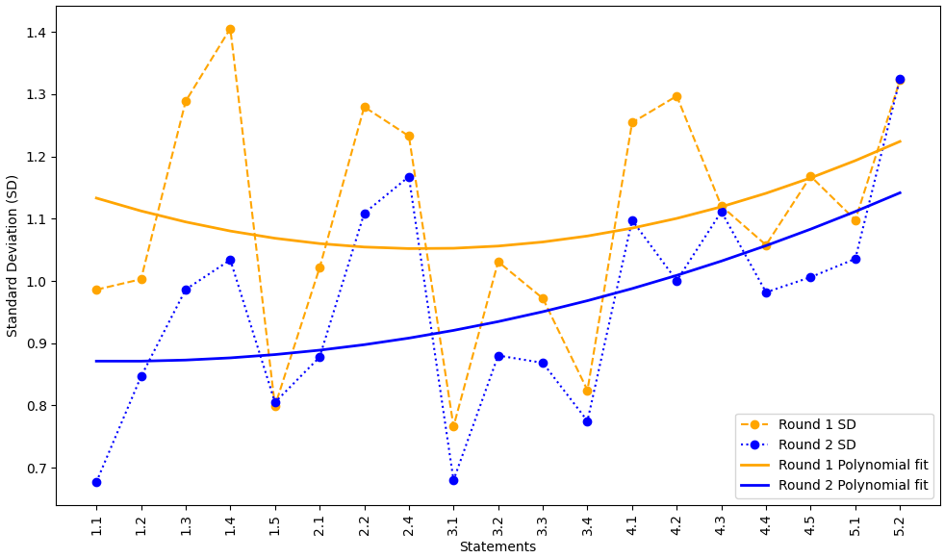

Figure 2. Measure on stability between two rounds (round 1 and round 2) using Interquartile Range (IQR).
The y – axis represents the IQR, while the x-axis represents the nineteen statements. The orange and the blue dashed lines represent the IQR for round 1 and round 2 respectively, while the orange and the blue smooth lines represent the polynomial fits for round 1 and round 2 respectively.

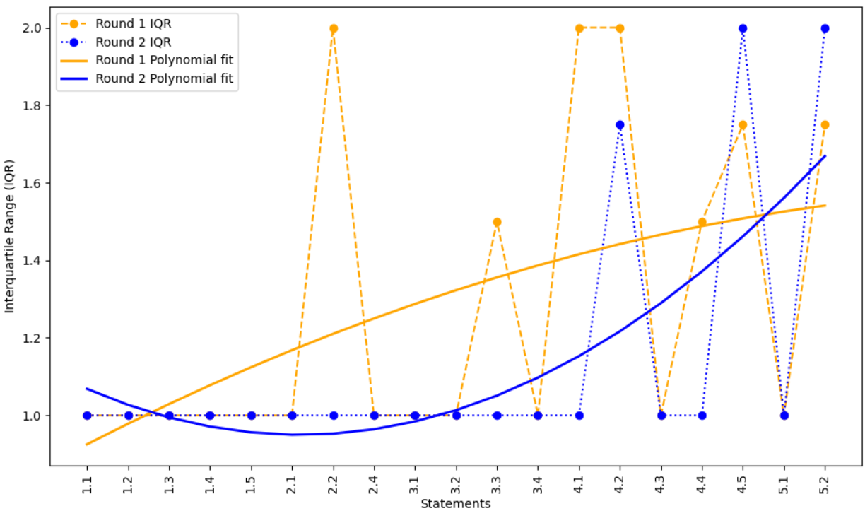

Stability measures of Responses comparing Round 2 vs Round 3
Figure 3. Measure on stability between two rounds (round 2 and round 3) using Standard Deviation (SD).
The y – axis represents the SD while the x-axis represents the nineteen statements. The blue and the black dashed lines represent the SD for round 2 and round 3 respectively, while the blue and the black smooth lines represent the polynomial fits for round 2 and round 3 respectively.
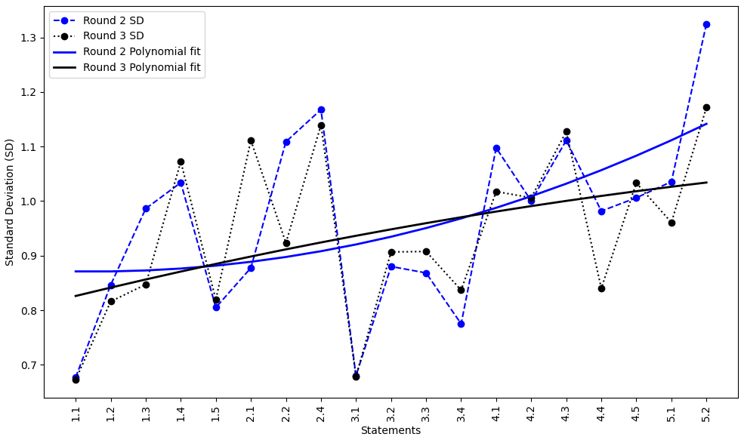

Figure 4. Measure on stability between two rounds (round 2 and round 3) using Interquartile Range (IQR).
The y – axis represents the IQR, while the x-axis represents the nineteen statements. The blue and the black dashed lines represent the IQR for round 2 and round 3 respectively, while the blue and the black smooth lines represent the polynomial fits for round 2 and round 3 respectively.

