Additional Figure S1
Figure S1
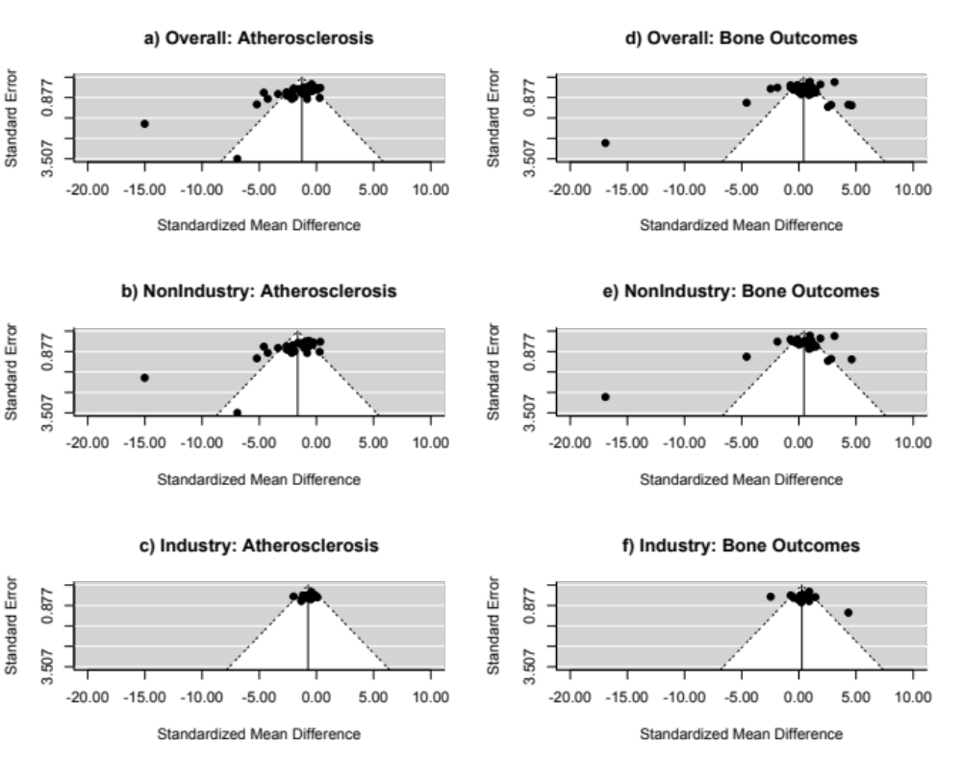
Funnel plots. Data from meta-analyses of atherosclerosis studies (a-c) and bone studies (d-f). Funnel plots show standard error plotted against standardized mean difference with diagonal lines showing the expected 95% confidence intervals around the summary estimate. In the absence of heterogeneity, 95% of studies should lie within the diagonal lines.

