Additional Figure S3
Figure S3

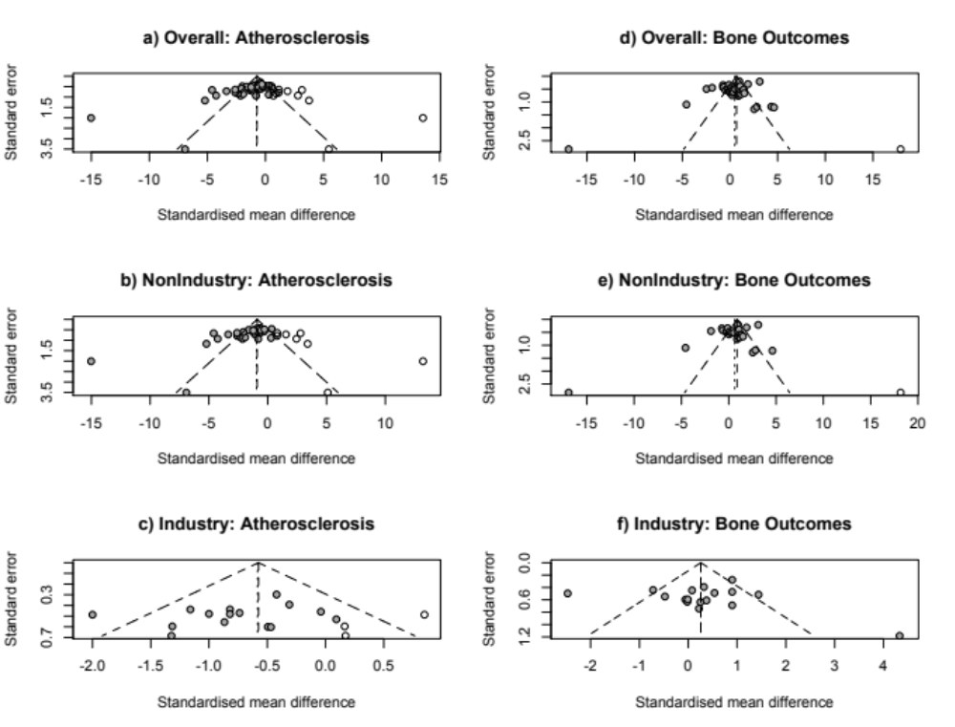
Trim and Fill Method. Data from meta-analyses of atherosclerosis studies (a-c) and bone studies (d-f). Funnel plots show the standard error plotted against the standardized mean difference. Additional missing studies that were imputed using this method are open circles on the plots.

