Additional file 5: Figure A1 and A2 – scatter plot of the point estimates of Fleiss’ K versus Krippendorff’s alpha and empirical coverage probability of the asymptotic confidence interval for Fleiss' K.
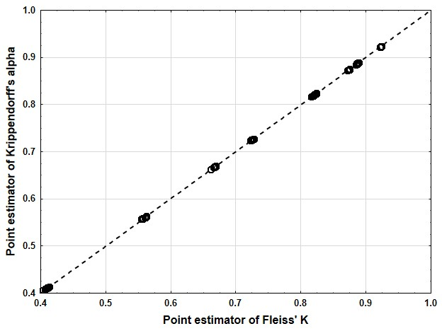
Figure A 1: Scatter plot of the point estimates (as mean over the 1000 simulation runs) of Fleiss’ K versus Krippendorff’s alpha. The dashed diagonal line represents equality.

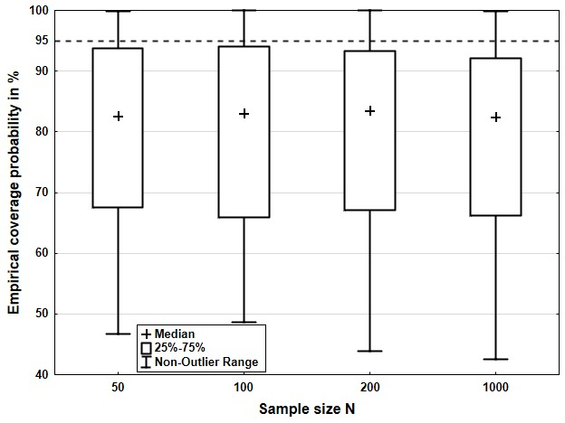
Figure A 2: Empirical coverage probability of the asymptotic confidence interval for Fleiss’ K with increasing sample size. The dotted line indicates the theoretical coverage probability of 95%.

