 | GWEST Men | IMPROVe Men | IMPROVe Women
Valence  Mean Score Change (SD) | 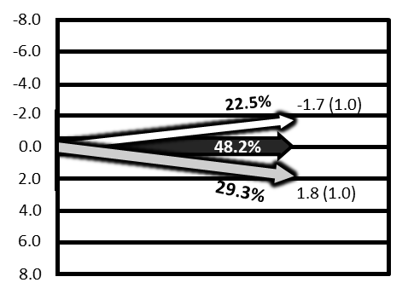 | 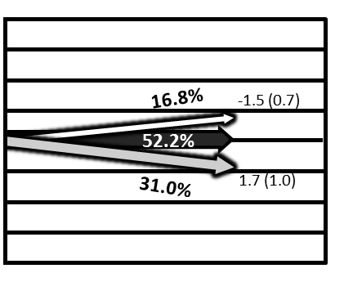 | 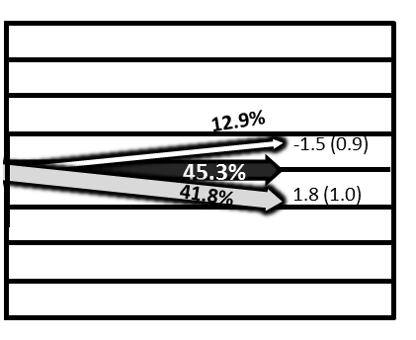 | Happier  Sadder
Arousal  Mean Score Change (SD) | 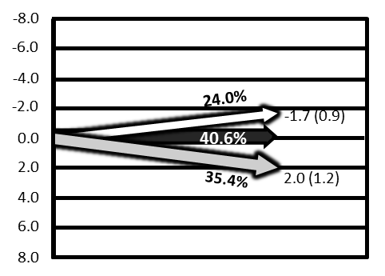 | 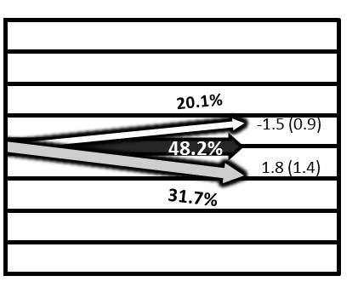 | 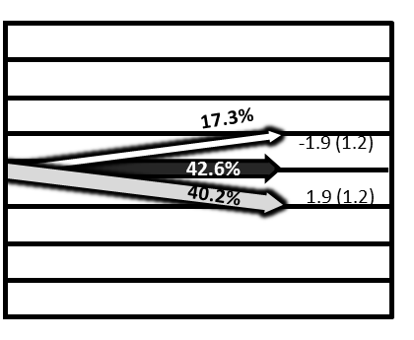 | Calmer  Tenser
Happier or Calmer
No Change
Sadder or Tenser

