Additional file 2
Subset of the YFS cohort used for the BMI trajectory analysis

Table S1. The total number (No.) of participants seen at each clinic year and their ages

Year | No. | YOBª | 77 | 74 | 71 | 68 | 65 | 62
1980 | 2149 | Ages | 3* | 6 | 9 | 12 | 15 | 18
1983 | 2149 |  |  | 6 | 9 | 12 | 15 | 18 | 21
1986 | 1970 |  |  |  | 9 | 12 | 15 | 18 | 21 | 24
2001 | 2167 |  |  |  |  |  | 24 | 27 | 30 | 33 | 36 | 39
2007 | 2058 |  |  |  |  |  |  | 30 | 33 | 36 | 39 | 42 | 45
2011 | 1890 |  |  |  |  |  |  |  | 34 | 37 | 40 | 43 | 46 | 49
ª:YOB (year of birth), corresponds to the 6 birth cohorts represented in the study sample.
*: Observations made on 3 years old were excluded from the analyses).

Figure S1. Density plot of the number of BMI measures per YFS participants in the subset of the cohort used for the BMI trajectory analysis.

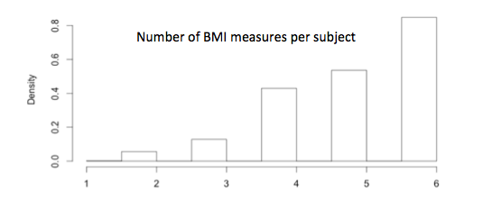

Figure S2. Average BMI values in kg/m² at each age stratified by T2DM group (pink, no adult T2DM; blue, Adult T2DM), with error bars representing the mean BMI ± SD (standard deviation).

