Additional file 8.

Table S1. Results of mixed models with age as a categorical predictor and log-insulin as a continuous predictor: LS means contrasts (No adult T2DM vs. adult T2DM) and significance at each age, averaged over levels of sex.

Age | Estimate* (kg/m²) | SE | t-ratio | p-value
3 | 1.52 | 1.04 | 1.455 | 0.14
6 | 0.54 | 0.71 | 0.76 | 0.44
9 | 0.26 | 0.56 | 0.47 | 0.63
12 | -0.87 | 0.50 | -1.72 | 0.0851
15 | -1.11 | 0.44 | -2.52 | 0.0115
18 | -1.30 | 0.42 | -3.05 | 0.002
21 | -1.45 | 0.51 | -2.8 | 0.005
24 | -1.56 | 0.59 | -2.64 | 0.008
27 | -0.93 | 1.33 | -0.70 | 0.48
30 | -4.01 | 0.72 | -5.54 | <.0001
33 | -2.62 | 0.55 | -4.77 | <.0001
37 | -5.00 | 0.51 | -9.73 | <.0001
40 | -4.39 | 0.43 | -10.17 | <.0001
43 | -3.19 | 0.49 | -6.4 | <.0001
46 | -3.39 | 0.47 | -7.17 | <.0001
49 | -4.94 | 0.56 | -8.81 | <.0001

*: the estimated contrast is obtained from a log(insulin) adjusted model (Degree of freedom is equal to 2339)

Figure S1. Pairwise comparisons of Least-square means of BMI and 95% CIs at each age in each T2DM status group, averaged over levels of sex

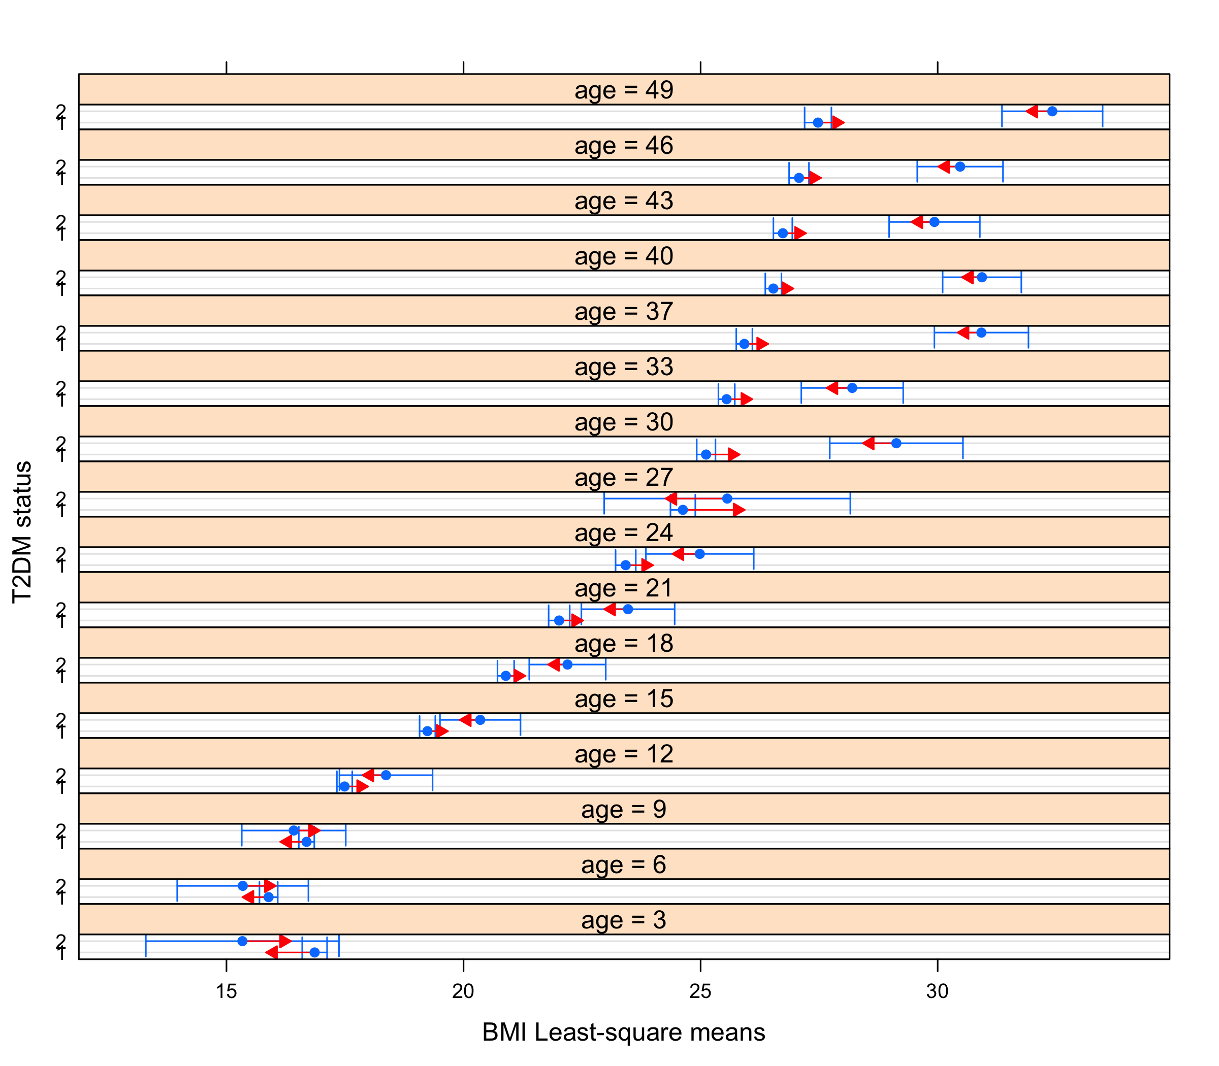
Blue intervals represent the 95% CI for each predicted BMI LS-mean. Red comparisons arrows show which LS-means differ significantly from one another based on whether or not they overlap. Comparisons are made using a 0.05 Tukey-adjusted significance level.

Table S2. LS means contrasts (No adult T2DM vs. adult T2DM) and significance at each age, at each level of sex.

Age | Estimate  (kg/m²) | SE | t-ratio | p-value
Females
3 | 0.76 | 1.67 | 0.456 | 0.64
6 | -1.01 | 1.01 | -0.10 | 0.91
9 | -0.28 | 0.74 | -0.37 | 0.70
12 | -0.53 | 0.64 | -0.87 | 0.41
15 | -0.6 | 0.58 | -1.07 | 0.28
18 | -1.29 | 0.61 | -2.1 | 0.03
21 | -1.61 | 0.74 | -2.2 | 0.003
24 | -2.48 | 0.85 | -2.9 | 0.003
27 | -0.18 | 1.37 | -0.13 | 0.89
30 | -4.01 | 0.94 | -5.54 | <.0001
33 | -2.62 | 0.55 | -5.1 | <.0001
37 | -5.45 | 0.78 | -8.1 | <.0001
40 | -5.93 | 0.60 | -9.8 | <.0001
43 | -3.69 | 0.71 | -5.15 | <.0001
46 | -5.18 | 0.4 | -7.35 | <.0001
49 | -6.4 | 0.81 | -7.87 | <.0001
Males
3 | 2.28 | 1.35 | 1.82 | 0.06
6 | 1.19 | 0.99 | 1.20 | 0.22
9 | 0.82 | 0.84 | 0.97 | 0.33
12 | -1.21 | 0.65 | -1.50 | 0.12
15 | -1.60 | 0.44 | -2.43 | 0.015
18 | -1.31 | 0.57 | -2.27 | 0.03
21 | -1.28 | 0.71 | -1.8 | 0.06
24 | -0.64 | 0.81 | -0.78 | 0.43
27 | -1.68 | 2.23 | -0.74 | 0.47
30 | -2.81 | 1.09 | -2.51 | 0.009
33 | -1.26 | 0.78 | -1.6 | 0.1097
37 | -4.50 | 0.41 | -5.83 | <.0001
40 | -2.9 | 0.68 | -4.6 | <.0001
43 | -3.19 | 0.69 | -3.8 | <.0001
46 | -3.39 | 0.62 | -2.5 | 0.01
49 | -3.47 | 0.76 | -4.51 | <.0001

Figure S2. Pairwise comparisons of Least-square means of BMI and 95% CIs at each age in each T2DM status group and sex group combination
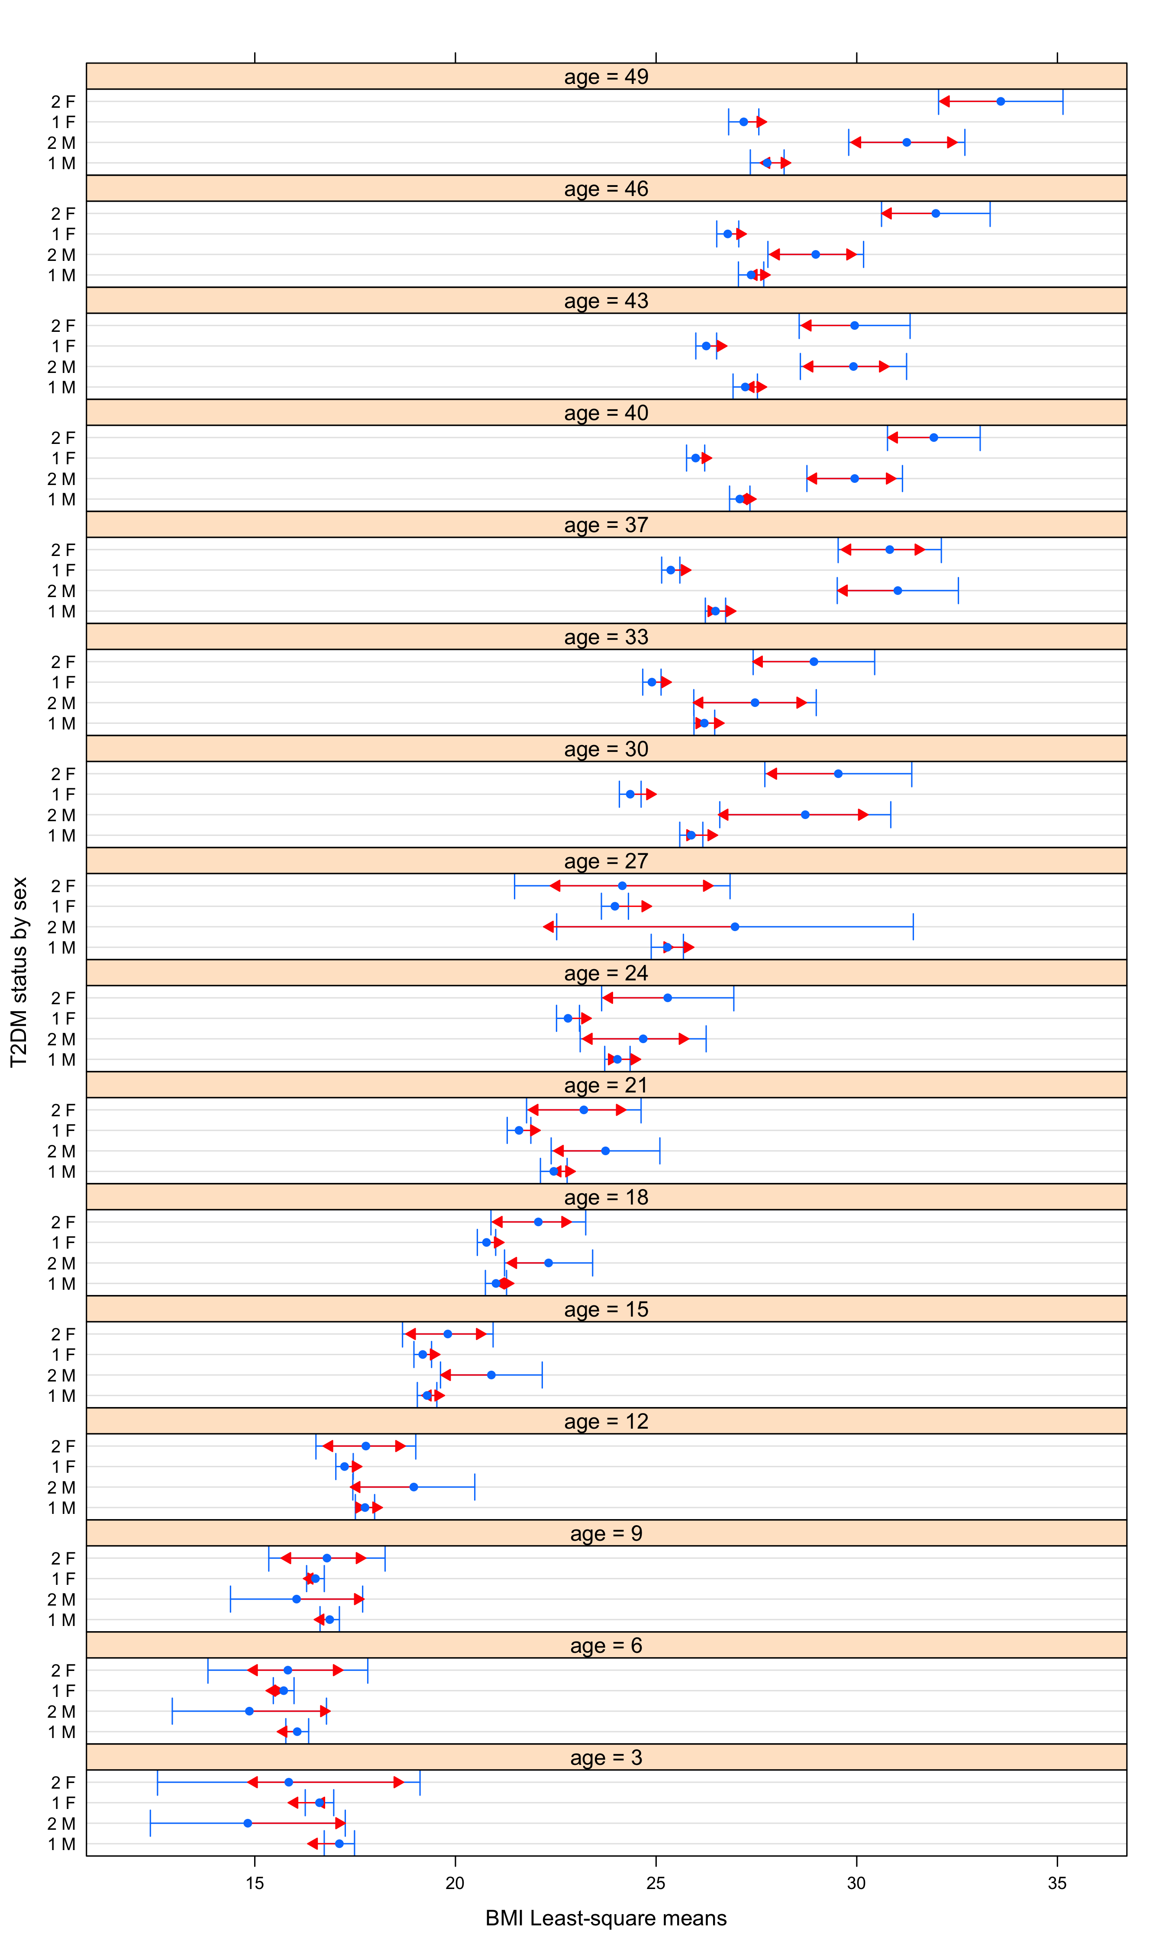
Blue intervals represent the 95% CI for each predicted BMI LS-mean. Red comparisons arrows show which LS-means differ significantly from one another based on whether or not they overlap. Comparisons are made using a 0,05 Tukey-adjusted significance level.

