Additional files
Table S1. LSAC respondents by wave of data collection
Infant cohort | Wave 1  2004 | Wave 2  2006 | Wave 3  2008 | Wave 4  2010 | Wave 5  2012
Age (years) | 0 – 1 | 2 – 3 | 4 -5 | 6 - 7 | 8 - 9
Number of participants | 5107 | 4606 | 4386 | 4242 | 4085
Unit non-response |  | 10% | 14% | 17% | 20%
Child cohort | Wave 1  2004 | Wave 2  2006 | Wave 3  2008 | Wave 4  2010 | Wave 5  2012
Age (years) | 4 – 5 | 6 – 7 | 8 – 9 | 10 – 11 | 12 - 13
Number of participants | 4983 | 4464 | 4331 | 4169 | 3956
Unit non-response |  | 10% | 13% | 16% | 21%

Simulation of complete data
The simulation study was based on the child cohort of the Longitudinal Study of Australian Children (LSAC), which had a participation of 4983 children in its first wave of data collection (Supplementary Table 1). Data were generated as specified below for each child i= 1,..., N, where N = 5000 for waves j=1,…,5. A total of 1000 datasets were simulated.
Parameters used in the simulation process were chosen to mimic the LSAC data and are presented in Supplementary Table 2. Refer to Table 1 in the main text for information on the variable labels used in the simulation equations specified below.
- Generated maternal age at child birth (m_age_{i}) from a normal distribution.

- Generated maternal education (m_education_{i}) as a time independent variable, from a logistic regression model (Equation S1) conditional on maternal age at child birth.

$logit \left\{\operatorname{Pr}\left({m_education}_{i}=1\right)\right\}= π_{0}+ π_{1}{m_age}_{i}$ (S1)

- Generated maternal smoking (m_smoking_{i}) as a time independent variable, from a logistic regression model (Equation S2) conditional on maternal age at child birth and maternal education at baseline.

$logit \left\{\operatorname{Pr}\left({m_smoking}_{i}=1\right)\right\}= τ_{0}+ τ_{1}{m_age}_{i} + τ_{2}[{m_education}_{i}=1]$ (S2)

- Generated study child’s sex (sex_{i}) by randomly assigning a p% of respondents to be female.

- Generated study child’s birth weight (birthweight_{i}) from a linear regression model (Equation S3) conditional on maternal age at child birth, maternal education, maternal smoking and study child’s sex.

$${birthweight}_{i}= γ_{0}+ γ_{1}{m_age}_{i}+ γ_{2}\left[{m_education}_{i}=1\right]+ γ_{3}\left[{m_smoking}_{i}=1\right]+ γ_{4}\left[{sex}_{i}=1\right]+ φ_{i}$$
(S3)
Where $φ_{i}$ is identically and independently distributed as; $φ_{i}\sim N (0, σ_{φ}^{2})$

- Generated study child’s age for wave 1 (scage_{i1}) from a normal distribution as; ${scage}_{i1} \sim N (57, {2.6}^{2})$. The study child’s age for the succeeding waves was generated by adding the time gap between the waves to the age of the preceding wave (24 months) (Equation S4).
${scage}_{ij}= 24+ {scage}_{ij-1}$ (S4)

- Generated time dependent variables; study child’s sleep problems (sleep_prob_{ij}) and BMI for age z-scores (bmiz_{ij}), for waves 1 to 5 as mentioned in the main text, using following steps;
- Generated sleep problems at wave 1 using a logistic regression model (Equation S5).
$$logit \left\{\operatorname{Pr}\left({sleep_prob}_{i,1}=1\right)\right\}= η_{0}+ η_{1}\left[{m_education}_{i}=1\right]+η_{2}\left[{sex}_{i}=1\right]+ η_{3}{birthweight}_{i}+ η_{4}{m_age}_{i}$$
(S5)
- Generated bmiz for waves j=1,…,5 using a linear mixed effects model (Equation S6).
${bmiz}_{ij}=\left(θ_{0}+a_{0i}\right)+{{θ_{1}{sleep_prob}_{i1}+(θ}_{2}+a_{1i}){scage}_{ij}+{(θ}_{3}{+a_{2i})scage_sq}_{ij}+ θ}_{4}\left[{m_education}_{i}=1\right]+ θ_{5}\left[{m_smoking}_{i}=1\right]+ θ_{6}\left[{sex}_{i}=1\right]+θ_{7}{birthweight}_{i}+ θ_{8}{m_age}_{i}{+ ε}_{ij}$ (S6)
where $ε_{ij}$ is identically and independently distributed $\sim N (0, σ_{ε}^{2})$ . scage_sq_{ij} was derived as the squared term of scage_{ij} to incorporate the non-linear relationship between BMI for age z-scores with time. The random intercept a₀, and random slopes a₁ and a₂ were drawn from a multivariate normal distribution. The mean and variance-covariance matrices, which were used to draw these random effects from a multivariate normal distribution, were obtained from the observed LSAC child cohort data.
- Sleep problems for wave j=2,…,5 were then generated using a logistic regression model as mentioned in the main text (Equation S7). The simulation model was designed to mimic the model for the epidemiological analysis, so that the true parameter value is known.
$logit \left\{\operatorname{Pr}\left({sleep_prob}_{i,j}=1\right)\right\}= λ_{0}+ λ_{1}{bmiz}_{i,j-1} { + λ}_{2}{[m_education}_{i}=1]+λ_{3}{[sex}_{i}=1]+λ_{4}{birthweight}_{i}+λ_{5}{m_age}_{i} +{ λ}_{6}{[sleep_prob}_{i,j-1}=1]$ (S7)
Table S2: Details of the parameters used in the data generation models
Variable Generated |  | Explanatory Variable |  | Parameter Value
Maternal age at child birth (years) |  |  | Mean | 30
Maternal age at child birth (years) |  |  | Standard deviation | 5
Maternal education |  | Constant | $$π_{0}$$ | -1.3
Maternal education |  | Maternal age, years | $$π_{1}$$ | 0.1
Maternal smoking |  | Constant | $$τ_{0}$$ | 2.5
Maternal smoking |  | Maternal age, years | $$τ_{1}$$ | -0.1
Maternal smoking |  | Maternal education_{Completed} | $$τ_{2}$$ | -0.6
Study child’s sex |  | Female proportion | p | 0.5
Study child’s birth weight (kg) |  | Constant | $$γ_{0}$$ | 3.4
Study child’s birth weight (kg) |  | Maternal age, years | $$γ_{1}$$ | 0.01
Study child’s birth weight (kg) |  | Maternal education_{Completed} | $$γ_{2}$$ | 0.05
Study child’s birth weight (kg) |  | Maternal smoking_{Yes} | $$γ_{3}$$ | -0.1
Study child’s birth weight (kg) |  | Study child’s sex_{Female} | $$γ_{4}$$ | -0.1
Study child’s birth weight (kg) |  | Error term | Mean | 0
Study child’s birth weight (kg) |  | Error term | Standard deviation $σ_{φ}$ | 0.6
Study child’s age at wave 1 (months) |  |  | Mean | 57
Study child’s age at wave 1 (months) |  |  | Standard deviation | 2.6
Sleep problems at wave 1 |  | Constant | $$η_{0}$$ | 1.1
Sleep problems at wave 1 |  | Maternal education_{Completed} | $$η_{1}$$ | -0.2
Sleep problems at wave 1 |  | Study child’s sex_{Female} | $$η_{2}$$ | -0.1
Sleep problems at wave 1 |  | Birth weight, kg | $$η_{3}$$ | -0.2
Sleep problems at wave 1 |  | Maternal age, years | $$η_{4}$$ | 0.01
BMI for age z-scores |  | Constant | $$θ_{0}$$ | -0.1
BMI for age z-scores |  | Sleep problem at wave 1_{Yes} | $$θ_{1}$$ | 0.5
BMI for age z-scores |  | Study child’s age, months | $$θ_{2}$$ | -0.001
BMI for age z-scores |  | Study child’s age squared | $$θ_{3}$$ | -0.00005
BMI for age z-scores |  | Maternal education_{Completed} | $$θ_{4}$$ | -0.1
BMI for age z-scores |  | Maternal smoking_{Yes} | $$θ_{5}$$ | 0.5
BMI for age z-scores |  | Study child’s sex_{Female} | $$θ_{6}$$ | -0.002
BMI for age z-scores |  | Birth weight, kg | $$θ_{7}$$ | 0.3
BMI for age z-scores |  | Maternal age, years | $$θ_{8}$$ | 0.001
BMI for age z-scores |  | Error term | Mean | 0
BMI for age z-scores |  | Error term | Standard deviation $σ_{ε}$ | 0.6
BMI for age z-scores |  | Random Effects  - Standard deviation  - Correlations | b₀  b₁  b₂  b₀ b₁  b₀ b₂  b₁ b₂ | 1.8  0.03  0.0001  -0.9  0.8  -0.97
Sleep problems measured at waves j=2,…,5 |  | Constant | $$λ_{0}$$ | -1.2
Sleep problems measured at waves j=2,…,5 |  | bmiz at previous wave | $$λ_{1}$$ | 0.1 / 0.4ª
Sleep problems measured at waves j=2,…,5 |  | Maternal education_{Completed} | $$λ_{2}$$ | -0.6
Sleep problems measured at waves j=2,…,5 |  | Study child’s sex_{Female} | $$λ_{3}$$ | -0.4
Sleep problems measured at waves j=2,…,5 |  | Birth weight, kg  Maternal age, years  Sleep problem at previous wave_{Yes} | $$λ_{4}$$  $$λ_{5}$$  $$λ_{6}$$ | -0.5  0.1  1.7
Abbreviations: bmiz, BMI for age z-scores; kg, kilograms.
ª We simulated data for sleep problems for waves j=2,…,5 using two odds ratios (ORs) 1.1 (log(OR)=0.1) and 1.5 (log(OR)=0.4) to represent a weak and strong association between bmiz measured at a previous wave and sleep problems measured at a later wave.

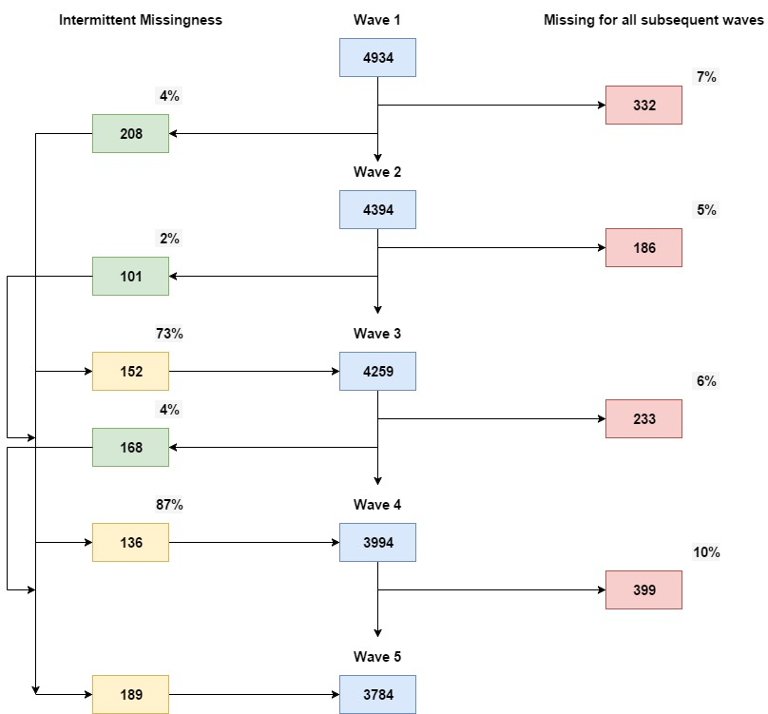
Figure S1. Missing data patterns for BMI for age z-scores (bmiz) in the original child cohort of the Longitudinal Study of Australian Children. Percentage of respondents who had all bmiz measurements missing after each wave is presented using missing for all subsequent waves, and who had bmiz measured at a later wave are presented as intermittent missingness.

Table S3. Performance of various methods for handling 25% missingness in BMI for age z-scores; true ORª=1.1(log(OR)=0.1)
Performance Measure | Method
 | Complete Case Analysis | FCS | MVNI | two-fold FCS (width=1)^{c} | two-fold FCS (width=2)^{d}
MCAR
Absolute Bias^{b} | 0.001 | 0.001 | 0.001 | 0.001 | 0.001
Relative Bias (%) | 0.54 | 0.56 | 0.54 | 1.26 | 0.57
Empirical SE^{b} | 0.017 | 0.016 | 0.016 | 0.017 | 0.017
Model-based SE^{b} | 0.016 | 0.016 | 0.016 | 0.016 | 0.016
Coverage (%) | 94.5 | 94.8 | 94.6 | 94.6 | 94.4
RMSE | 0.017 | 0.016 | 0.016 | 0.017 | 0.017
MAR (weak)
Absolute Bias^{b} | 0.007 | 0.000 | 0.000 | 0.000 | 0.000
Relative Bias (%) | 7.02 | 0.24 | 0.26 | 0.23 | 0.09
Empirical SE^{b} | 0.017 | 0.016 | 0.016 | 0.016 | 0.016
Model-based SE^{b} | 0.016 | 0.016 | 0.016 | 0.016 | 0.016
Coverage (%) | 92.4 | 94.5 | 94.4 | 94.7 | 94.7
RMSE | 0.018 | 0.016 | 0.016 | 0.016 | 0.016
MAR (strong)
Absolute Bias^{b} | 0.008 | 0.000 | 0.000 | 0.001 | 0.001
Relative Bias (%) | 8.44 | 0.27 | 0.30 | 1.26 | 0.87
Empirical SE^{b} | 0.017 | 0.016 | 0.016 | 0.016 | 0.016
Model-based SE^{b} | 0.016 | 0.016 | 0.016 | 0.016 | 0.016
Coverage (%) | 90.6 | 94.7 | 94.7 | 94.5 | 94.6
RMSE | 0.019 | 0.016 | 0.016 | 0.016 | 0.016
Abbreviations: Empirical SE, empirical standard error; FCS, fully conditional specification; MAR, missing at random; MCAR, missing completely at random; Model-based SE, model based standard error; MVNI, multivariate normal imputation; RMSE, root mean square error; two-fold FCS, two-fold fully conditional specification algorithm.
ªTrue OR represents the true odds ratio between sleep problems and BMI for age z-scores.
^{b}Monte Carlo standard error did not exceed 0.0006.
^{c}Results for the two-fold FCS with a time window width of 1, that is, including immediately adjacent time points.
^{d}Results for the two-fold FCS with a time window width of 2, that is, including two adjacent time points.
Table S4. Performance of various methods for handling 25% missingness in BMI for age z-scores; true ORª=1.5(log(OR)=0.4)
Performance Measure | Method
 | Complete Case Analysis | FCS | MVNI | two-fold FCS (width=1)^{c} | two-fold FCS (width=2)^{d}
MCAR
Absolute Bias^{b} | 0.001 | 0.001 | 0.001 | 0.003 | 0.001
Relative Bias (%) | 0.19 | 0.13 | 0.13 | 0.67 | 0.24
Empirical SE^{b} | 0.017 | 0.017 | 0.017 | 0.017 | 0.017
Model-based SE^{b} | 0.017 | 0.017 | 0.017 | 0.017 | 0.017
Coverage (%) | 95.6 | 95.3 | 95.2 | 94.8 | 95.2
RMSE | 0.017 | 0.017 | 0.017 | 0.017 | 0.017
MAR (weak)
Absolute Bias^{b} | 0.007 | 0.000 | 0.000 | 0.002 | 0.001
Relative Bias (%) | 1.82 | 0.12 | 0.11 | 0.42 | 0.12
Empirical SE^{b} | 0.017 | 0.017 | 0.017 | 0.017 | 0.017
Model-based SE^{b} | 0.017 | 0.017 | 0.017 | 0.017 | 0.017
Coverage (%) | 92.2 | 94.4 | 94.7 | 94.1 | 94.9
RMSE | 0.019 | 0.017 | 0.017 | 0.017 | 0.017
MAR (strong)
Absolute Bias^{b} | 0.010 | 0.000 | 0.000 | 0.000 | 0.001
Relative Bias (%) | 2.48 | 0.08 | 0.07 | 0.00 | 0.17
Empirical SE^{b} | 0.017 | 0.017 | 0.017 | 0.017 | 0.017
Model-based SE^{b} | 0.017 | 0.017 | 0.017 | 0.017 | 0.017
Coverage (%) | 91.7 | 95.8 | 95.6 | 95.7 | 95.3
RMSE | 0.020 | 0.017 | 0.017 | 0.017 | 0.016
Abbreviations: Empirical SE, empirical standard error; FCS, fully conditional specification; MAR, missing at random; MCAR, missing completely at random; Model-based SE, model based standard error; MVNI, multivariate normal imputation; RMSE, root mean square error; two-fold FCS, two-fold fully conditional specification algorithm.
ªTrue OR represents the true odds ratio between sleep problems and BMI for age z-scores.
^{b}Monte Carlo standard error did not exceed 0.0006.
^{c}Results for the two-fold FCS with a time window width of 1, that is, including immediately adjacent time points.
^{d}Results for the two-fold FCS with a time window width of 2, that is, including two adjacent time points.
Table S5. Performance of various methods for handling 50% missingness in BMI for age z-scores; true ORª=1.5(log(OR)=0.4)
Performance Measure | Method
 | Complete Case Analysis | FCS | MVNI | two-fold FCS (width=1)^{c} | two-fold FCS (width=2)^{d}
MCAR
Absolute Bias^{b} | 0.001 | 0.000 | 0.000 | 0.004 | 0.001
Relative Bias (%) | 0.24 | 0.03 | 0.03 | 1.08 | 0.33
Empirical SE^{b} | 0.018 | 0.018 | 0.018 | 0.018 | 0.018
Model-based SE^{b} | 0.019 | 0.018 | 0.018 | 0.018 | 0.018
Coverage (%) | 96.4 | 95.3 | 95.4 | 94.3 | 94.7
RMSE | 0.018 | 0.018 | 0.018 | 0.019 | 0.018
MAR (weak)
Absolute Bias^{b} | 0.016 | 0.000 | 0.000 | 0.003 | 0.000
Relative Bias (%) | 4.06 | 0.10 | 0.09 | 0.69 | 0.09
Empirical SE^{b} | 0.019 | 0.018 | 0.018 | 0.018 | 0.018
Model-based SE^{b} | 0.019 | 0.018 | 0.018 | 0.018 | 0.018
Coverage (%) | 86.5 | 95.1 | 94.6 | 94.2 | 94.6
RMSE | 0.025 | 0.018 | 0.018 | 0.019 | 0.018
MAR (strong)
Absolute Bias^{b} | 0.023 | 0.000 | 0.000 | 0.001 | 0.002
Relative Bias (%) | 5.64 | 0.02 | 0.02 | 0.32 | 0.56
Empirical SE^{b} | 0.019 | 0.018 | 0.018 | 0.018 | 0.018
Model-based SE^{b} | 0.018 | 0.018 | 0.018 | 0.018 | 0.018
Coverage (%) | 76.0 | 95.5 | 96.0 | 95.5 | 95.3
RMSE | 0.029 | 0.018 | 0.018 | 0.018 | 0.018
Abbreviations: Empirical SE, empirical standard error; FCS, fully conditional specification; MAR, missing at random; MCAR, missing completely at random; Model-based SE, model based standard error; MVNI, multivariate normal imputation; RMSE, root mean square error; two-fold FCS, two-fold fully conditional specification algorithm.
ªTrue OR represents the true odds ratio between sleep problems and BMI for age z-scores.
^{b}Monte Carlo standard error did not exceed 0.0006.
^{c}Results for the two-fold FCS with a time window width of 1, that is, including immediately adjacent time points.
^{d}Results for the two-fold FCS with a time window width of 2, that is, including two adjacent time points.
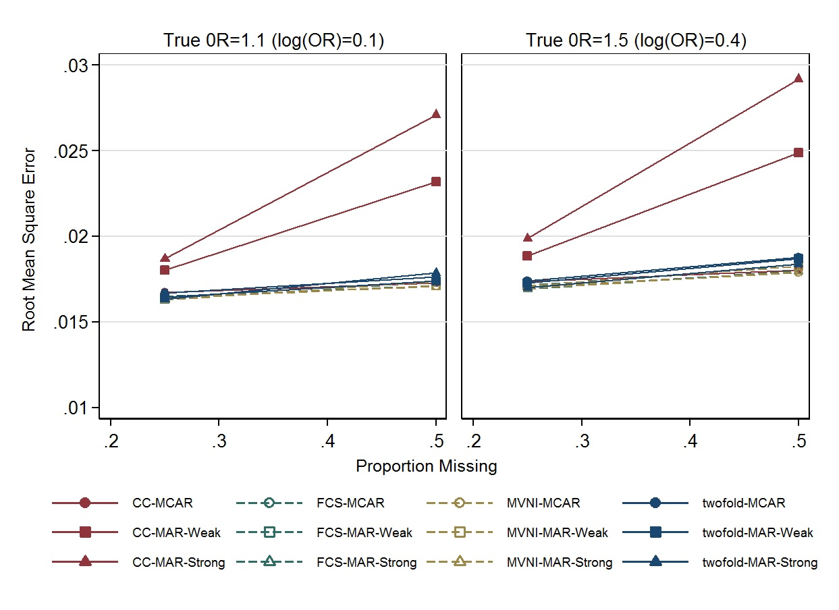
Figure S2. Root mean square error for complete case analysis (CC), fully conditional specification (FCS), multivariate normal imputation (MVNI), and two-fold fully conditional specification (two-fold FCS) for increasing proportions of missing data (0.25, 0.5) under three missing data scenarios and two simulation scenarios; true OR represents the true odds ratio between sleep problems and BMI for age z-scores.
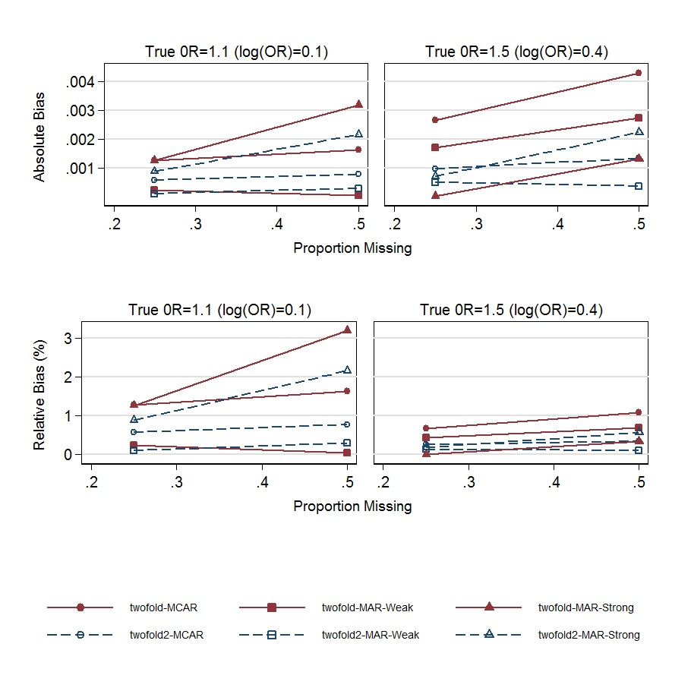
Figure S3. Absolute bias and Relative bias (%) for two-fold fully conditional specification (two-fold FCS) algorithm with time window width 1 and time window width 2 (twofold2) for increasing proportions of missing data (0.25, 0.5) under three missing data scenarios and two simulation scenarios; true OR represents the true odds ratio between sleep problems and BMI for age z-scores.
ª Relative bias is calculated as absolute bias relative to the value of the true parameter. As the value of the true parameter (log(OR)) increases from 0.1 to 0.4 in the second simulation scenario, the magnitude of the relative bias drops even though the absolute bias shows a slight increase.
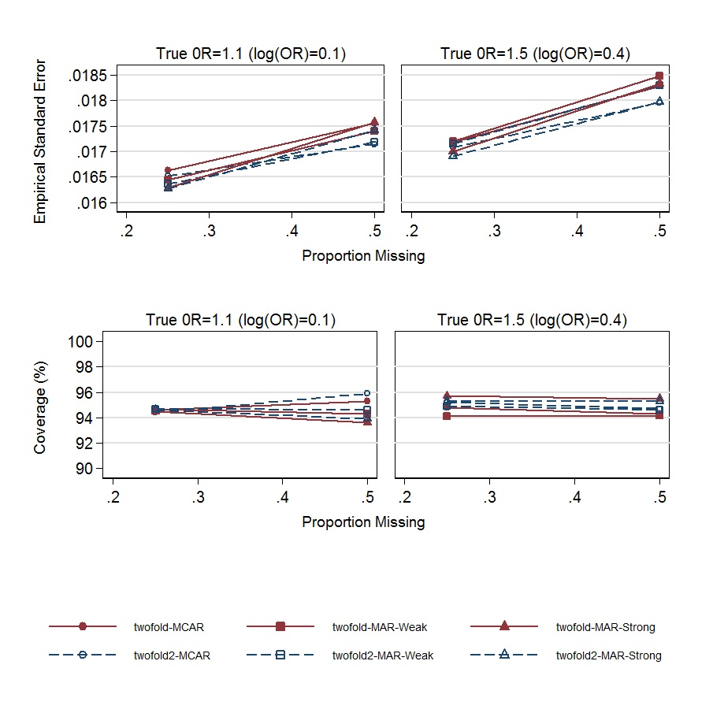
Figure S4. Empirical standard error and Coverage (%) for two-fold fully conditional specification (two-fold FCS) algorithm with time window width 1 and time window width 2 (twofold2) for increasing proportions of missing data (0.25, 0.5) under three missing data scenarios and two simulation scenarios; true OR represents the true odds ratio between sleep problems and BMI for age z-scores.

