Additional file 6
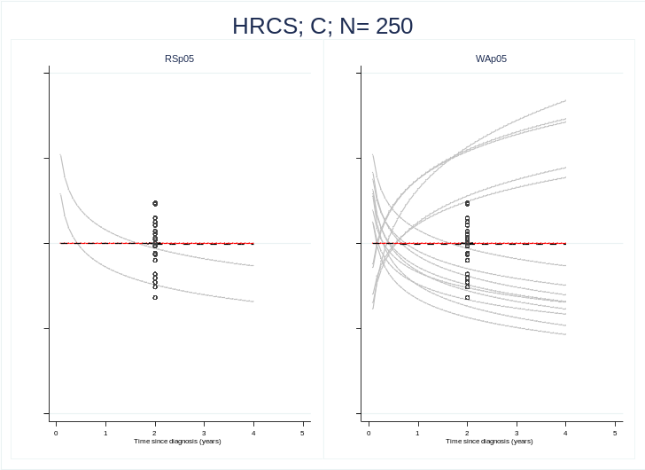
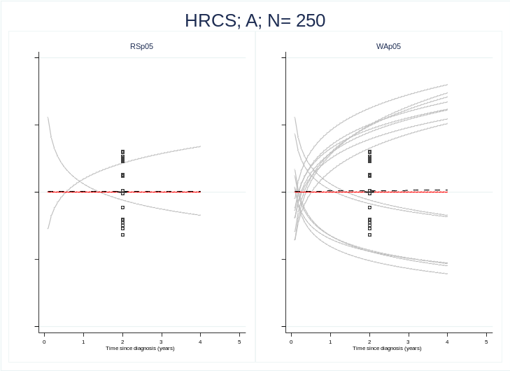
Effect of the extra binary variable in the models selected by each algorithm, scenario A-D

