Supplementary Appendix C. Plausible unweighted and weighted methods of analyses for counts, time to event, and multivariate analysis.

1. BIVARIATE TESTS

Unweighted - Fisher’s Exact Test
A participate with any one of the three component outcomes is counted as having an event for the analysis.

Treatment A (n, %): 168 (34%)
Treatment B (n, %): 174 (35%)
Treatment Effect: Odds Ratio, 0.96 (95% CI: 0.73 – 1.26, p=0.79)

R Code:
TAB <- table(wide$Treatment, wide$Event)
fisher.test(TAB, conf.int = TRUE)

Weighted – Wilcoxon Rank Sums Tests
Similar to a global rank analysis, the component weights are multiplied by each outcome event and summed for each study participant. The rank sums of each Treatment group are compared using the Wilcoxon Rank Sums test with the effect determined using a Probability Index Model.

Treatment A (mean weight, sd): 0.21 (0.38)
Treatment B (mean weight, sd): 0.28 (0.44)
Probability of Treatment Benefit (A vs. B): 6% (95% CI: 5 – 19%), p=0.26

R Code:
library("pim")
wilcox.test(wide$WeightEvent ~ wide$Treatment,conf.int = TRUE)
pim1<-pim(WeightEvent ~ Treatment, data = wide)
summary(pim1)
confint(pim1)

2. TIME TO EVENT ANALYSIS

Unweighted - Time to Event Analysis
A Cox Proportional Hazard model was fit to the data. Only the first component event to occur was accounted for in the time to event analysis.

Treatment Effect: Hazard Ratio, 1.02 (95% CI: 0.83 – 1.27, p=0.83)

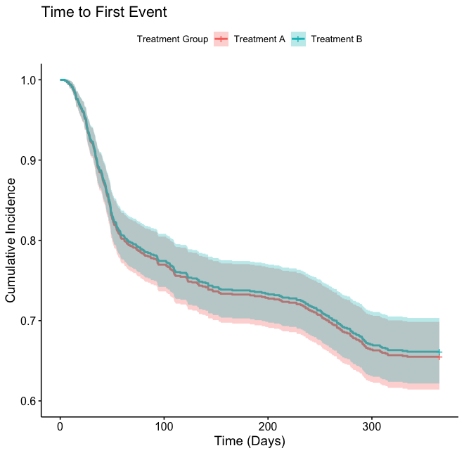

R Code:
library("survival")
fit3 <- coxph(Surv(EventDays, Event) ~ Treatment, data = wide)
summary(fit3)

Unweighted - Time to Event Analysis with Repeated Events
In this second, unweighted Cox Proportional Hazard model, multiple events were allowed in the model.

Treatment Effect: Hazard Ratio, 1.02 (95% CI: 0.84 – 1.24, p=0.80)

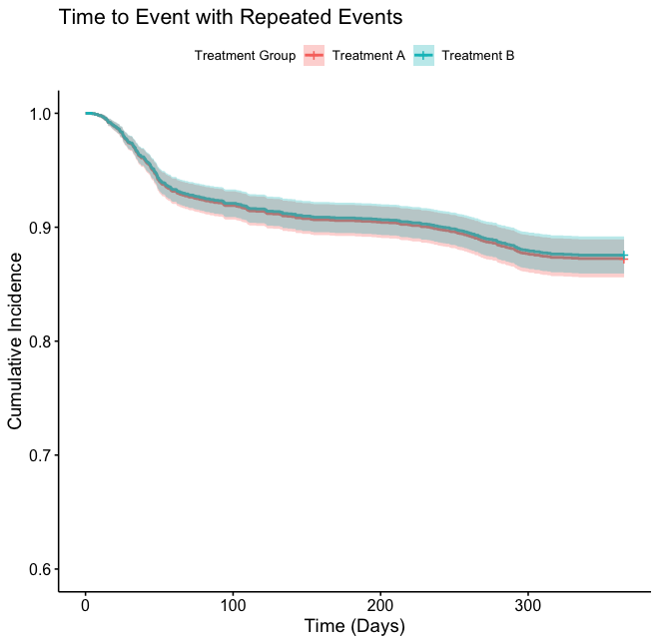

R Code:
library("survival")
fit1 <- coxph(Surv(TimetoEvent, Event) ~ Treatment + cluster (ID), data=long)
summary(fit1)

Weighted - Time to Event Analysis with Repeated Events
The third time to event model weighted the Cox Proportional Hazard model, and multiple events were allowed.

Treatment Effect: Hazard Ratio, 0.72 (95% CI: 0.57 – 0.90, p<0.01)

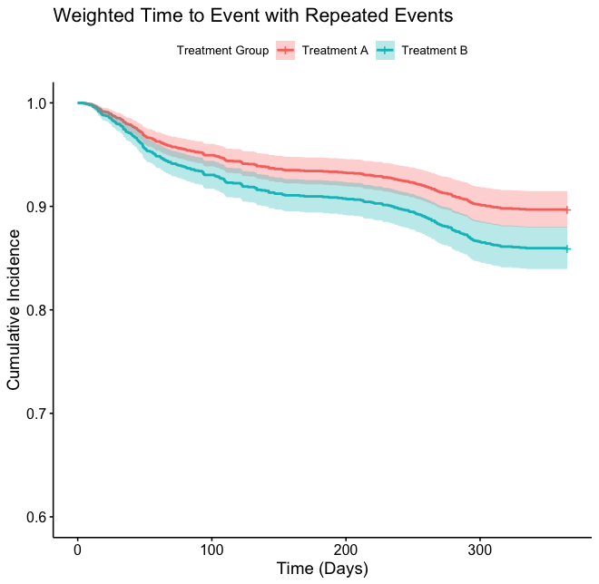

R Code:
library("survival")
fit2 <- coxph(Surv(TimetoEvent, Event) ~ Treatment + cluster (ID),weights = EventWeight, data=long)
summary(fit2)

3. MULTIVARIATE METHODS

Unweighted - Random Effects Model
The data was fit with a binomial generalized linear model that allowed for repeated events by including a random intercept for the subject ID.

Treatment Effect: Odds Ratio, 1.01 (95% CI: 0.81 – 1.25, p=0.93)

R Code:
library("lme4")
library("broom.mixed")
fit4<-glmer(Event ~ Treatment + (1|ID), family = binomial, data=long, nAGQ = 9)
summary(fit4)
tidy(fit4,conf.int=TRUE, exponentiate = TRUE, effects="fixed")

Weighted - Random Effects Model
The data was fit with a binomial generalized linear model that allowed for repeated events by including a random intercept for the subject ID.

Treatment Effect: Odds Ratio, 0.70 (95% CI: 0.53 – 0.91, p<0.01)

R Code:
library("lme4")
library("broom.mixed")
fit5<-glmer(Event ~ Treatment + (1|ID), family = binomial, weights = EventWeight, data=long, nAGQ = 9)
summary(fit5)
tidy(fit5,conf.int=TRUE, exponentiate = TRUE, effects="fixed")

