Novel Citation-Based Search Method for Scientific Literature:
A Validation Study

A.C.J.W. Janssens,*¹ M. Gwinn¹, J.E. Brockman¹, K. Powell², M. Goodman¹
SUPPLEMENTARY TABLES AND FIGURES

Supplementary Figure 1 Overview of the search methods

Co-citation search
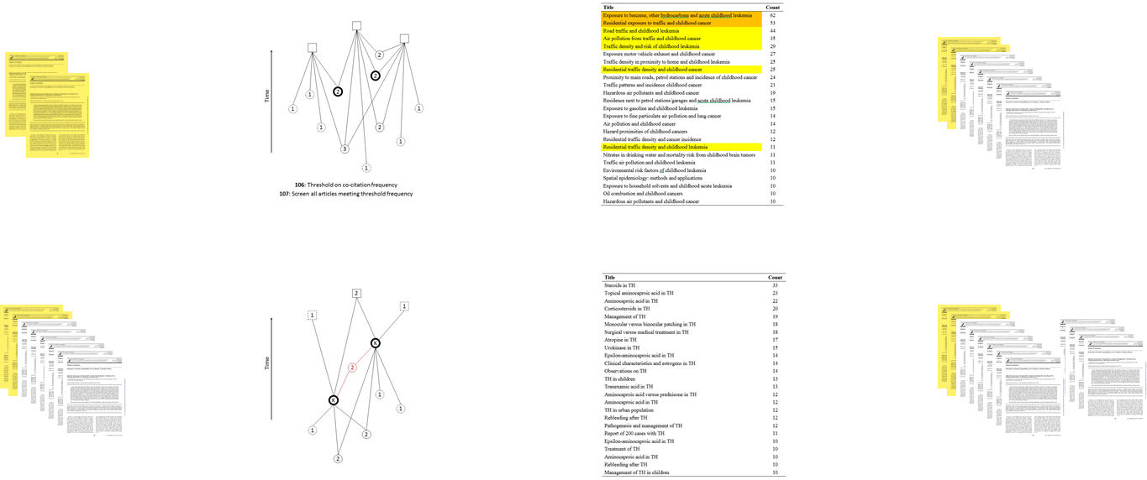
Query articles Search Screened articles Retrieved articles

Citation search
Query articles Search Screened articles Retrieved articles

Articles retrieved by the co-citation search were used as query articles for the citation search. Searches were conducted using our web tool (see Methods). We screened results of both searches to find the articles included in the published review.

Supplementary Figure 2 How CoCites works in practice: an example


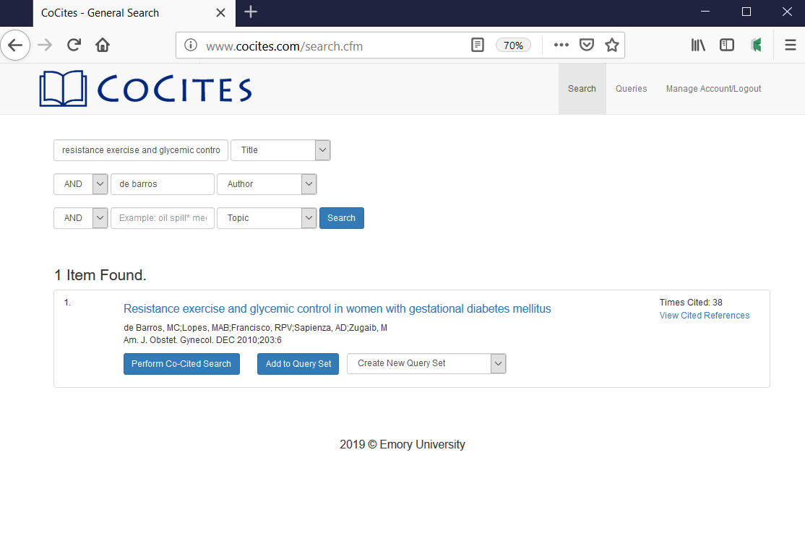
Supplementary Figure 2 (continued)
The co-citation search returned 311 articles that were co-cited more than once with the article of De Barros et al. (Fig. 3b). The frequency is the number of times an article is co-cited with the query article. For example, the article of Brankston et al. is cited 97 times and co-cited with De Barros et al. 16 times.
The first article is the query article. Note that its frequency is 35 instead of 38, which means the article was cited 3 times by articles that are not indexed in WOS (see methods).

Fig. 3b
In this example, we aim to find related articles for:
De Barros et al. Resistance exercise and glycemic control in women with gestational diabetes mellitus. Am J Obstet Gynecol 2010.
The first step is to find this article in our web tool. Fig 3a shows that the article is cited 38 times.
To run the co-citation search, we click the button “Perform Co-Cited Search.”
Fig. 3a
 | Title | Year | Times Cited | Freq
1 | Resistance exercise and glycemic control in women with gestational diabetes mellitus | 2010 | 38 | 35
2 | Resistance exercise decreases the need for insulin in overweight women with gestational diabetes mellitus | 2004 | 97 | 16
3 | Effects of a partially home-based exercise program for women with gestational diabetes | 1997 | 77 | 13
4 | A walking intervention improves capillary glucose control in women with gestational diabetes mellitus: a pilot study | 2008 | 52 | 12
5 | Regular Exercise During Pregnancy to Prevent Gestational Diabetes A Randomized Controlled Trial | 2012 | 95 | 12
6 | Hyperglycemia and adverse pregnancy outcomes | 2008 | 2019 | 11
7 | Randomized trial of diet versus diet plus cardiovascular conditioning on glucose-levels in gestational diabetes | 1989 | 126 | 9
8 | Prevention of Gestational Diabetes Feasibility issues for an exercise intervention in obese pregnant women | 2010 | 86 | 8
9 | A lifestyle intervention of weight-gain restriction: diet and exercise in obese women with gestational diabetes mellitus | 2007 | 119 | 8
10 | Simple lifestyle recommendations and the outcomes of gestational diabetes. A 2x2 factorial randomized trial | 2014 | 26 | 8
11 | No effect of the FitFor2 exercise programme on … in pregnant women who were overweight and at risk for gestational diabetes | 2012 | 73 | 7
12 | Guidelines of the American College of Obstetricians and Gynecologists for exercise during pregnancy and the postpartum period | 2003 | 299 | 7
13 | Exercise during pregnancy improves maternal glucose screen at 24-28 weeks: a randomised controlled trial | 2012 | 80 | 7
14 | Physical Activity Before and During Pregnancy and Risk of Gestational Diabetes Mellitus A meta-analysis | 2011 | 185 | 7
15 | A Multicenter, Randomized Trial of Treatment for Mild Gestational Diabetes. | 2009 | 931 | 7
16 | Exercise in gestational diabetes - an optional therapeutic approach | 1991 | 107 | 7
17 | Effect of treatment of gestational diabetes mellitus on pregnancy outcomes | 2005 | 1556 | 7
18 | Summary and recommendations of the Fifth International Workshop-Conference on Gestational Diabetes Mellitus | 2007 | 652 | 6
19 | A comparison of glyburide and insulin in women with gestational diabetes mellitus | 2000 | 474 | 6
20 | IAD-PGS Recommendations on the Diagnosis and Classification of Hyperglycemia in Pregnancy | 2010 | 1682 | 6
21 | Aerobic exercise and submaximal functional capacity in overweight pregnant women - A randomized trial | 2005 | 69 | 6
22 | Effect of exercise intensity and duration on ... glucose responses in pregnant women at low and high risk for gestational diabetes | 2012 | 31 | 6
23 | Exercise Training in Pregnancy Reduces Offspring Size without Changes in Maternal Insulin Sensitivity | 2010 | 123 | 6
24 | Home-Based Exercise Training Improves Capillary Glucose Profile in Women with Gestational Diabetes | 2014 | 25 | 6
25 | Exercise during pregnancy and gestational diabetes-related adverse effects: a randomised controlled trial | 2013 | 63 | 6

Fig. 3c
The table in Fig. 3c shows the top 25 results of the co-citation search. Like the query article, most articles are about exercise (red) and gestational diabetes (blue) and published around the same time as the query article or earlier. Note that the highly-cited articles (cited >500 times) in the list are ‘generic’ articles on gestational diabetes; all others are on exercise and gestational diabetes.
Next, to find recent related articles, we perform a citation search on the top 10 articles on exercise and gestational diabetes in Fig. 3c (which is articles #1-11, excluding #6). We select these articles and add them to the query set, see “Add to query set” button in Fig. 3b.

Supplementary Figure 2 (continued)
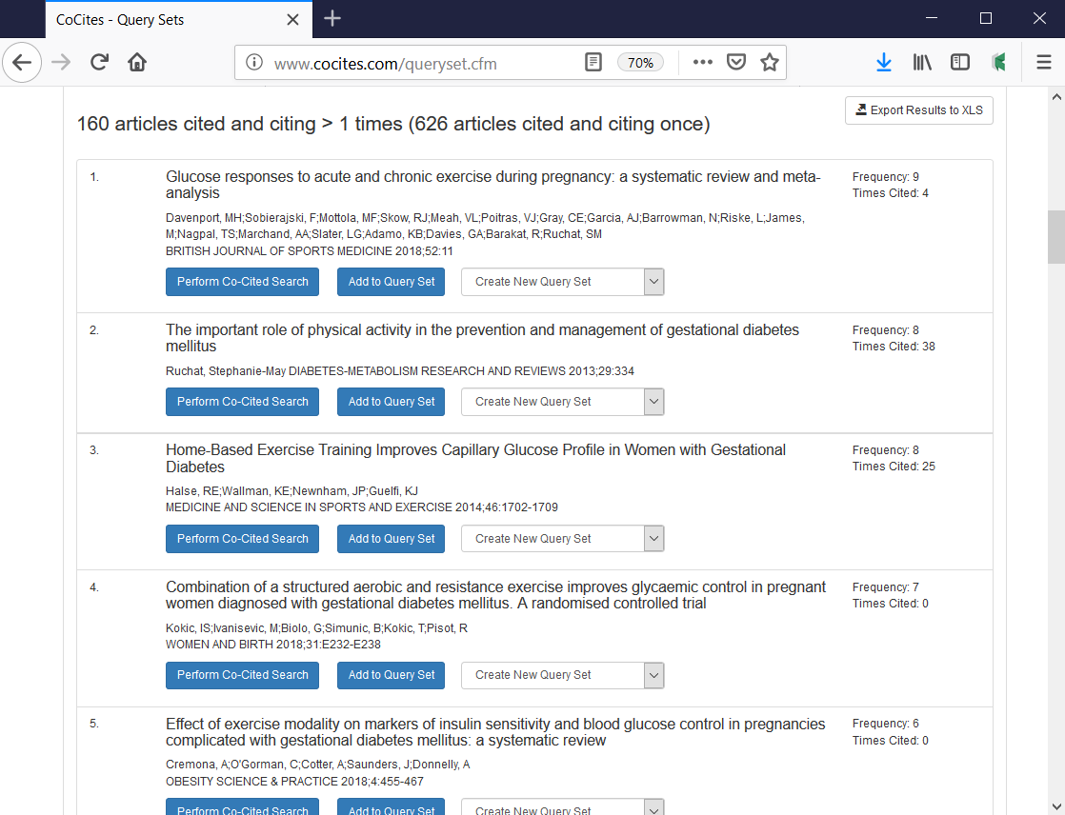

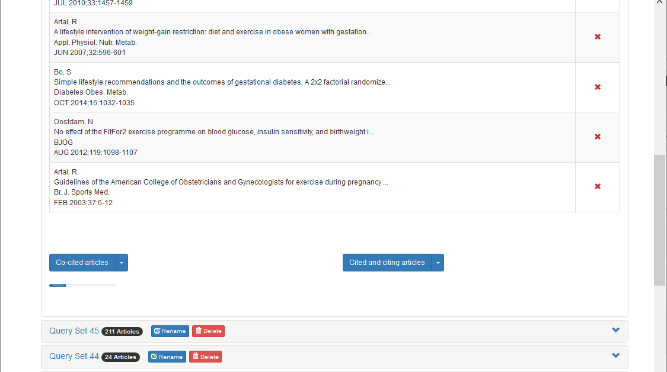
Supplementary Figure 2 (continued)
Fig. 3e shows the results of the citation search. The frequency is now the citation frequency. For each article, the frequency is the sum of the number of query articles that cite the article and the number of query articles that are cited by the article (see Methods).
Fig. 3e
Fig. 3d
Fig. 3d shows the new query set (the list is truncated presentation, the search included the 10 articles).
To run the citation search, we click the button “Cited and citing articles.” (The button “Co-cited articles” performs the same co-citation search as previous but on the entire query set.)
 | Title | Year | Times Cited | Freq
1 | Glucose responses to acute and chronic exercise during pregnancy: a systematic review and meta-analysis | 2018 | 4 | 9
2 | The important role of physical activity in the prevention and management of gestational diabetes mellitus | 2013 | 38 | 8
3 | Home-Based Exercise Training Improves Capillary Glucose Profile in Women with Gestational Diabetes | 2014 | 25 | 8
4 | Combination of ... and resistance exercise improves glycaemic control in pregnant women ... with gestational diabetes mellitus | 2018 | 0 | 7
5 | Effect of exercise modality on … blood glucose control in pregnancies complicated with gestational diabetes mellitus | 2018 | 0 | 6
6 | Impact of prenatal exercise on neonatal and childhood outcomes: a systematic review and meta-analysis | 2018 | 4 | 6
7 | Simple lifestyle recommendations and the outcomes of gestational diabetes. A 2x2 factorial randomized trial | 2014 | 25 | 6
8 | Exercise and gestational diabetes mellitus | 2014 | 0 | 6
9 | Physical Activity and Gestational Diabetes Mellitus | 2014 | 5 | 6
10 | Resistance Exercise in Pregnancy and Outcome | 2016 | 2 | 5
11 | The efficacy of physiotherapy for the prevention and treatment of prenatal symptoms: a systematic review | 2015 | 1 | 5
12 | Randomized trial of diet versus diet plus cardiovascular conditioning on glucose-levels in gestational diabetes | 1989 | 126 | 5
13 | Interventions to improve physical activity during pregnancy: a systematic review on … | 2017 | 2 | 5
14 | The Effect of Self-care Educational/Training Interventions on the Outcomes of Gestational Diabetes: A Review Article | 2018 | 1 | 5
15 | Physical activity during pregnancy is associated with a lower prevalence of gestational diabetes mellitus in Vietnam | 2018 | 0 | 5
16 | Home-Based Exercise Improves Fitness and Exercise Attitude and Intention in Women with GDM | 2015 | 15 | 4
17 | Exercise improves glycaemic control in women diagnosed with gestational diabetes mellitus: a systematic review | 2016 | 9 | 4
18 | Effect of physical activity during pregnancy on mode of delivery | 2014 | 27 | 4
19 | Role of exercise in reducing the risks of gestational diabetes mellitus in obese women | 2016 | 0 | 4
20 | Treatments for women with gestational diabetes mellitus: an overview of Cochrane systematic reviews | 2018 | 1 | 4
21 | The Role of Exercise in the Prevention and Treatment of Gestational Diabetes Mellitus | 2008 | 22 | 4
22 | Resistance exercise decreases the need for insulin in overweight women with gestational diabetes mellitus | 2004 | 97 | 4
23 | Role of Exercise in Reducing Gestational Diabetes Mellitus | 2016 | 5 | 4
24 | Exercise for pregnant women with gestational diabetes for improving maternal and fetal outcomes | 2017 | 13 | 4
25 | Exercise Recommendations in Women with Gestational Diabetes Mellitus | 2010 | 3 | 4

Fig. 3f
The table in Fig. 3f shows the first 25 results of the citation search. Like the articles in the query set, all articles on the list are on exercise and gestational diabetes and most are of recent date.
The articles in the query set were published between 1997 and 2014, with one exception published in 1989. Thus, articles in the list that were published after 2014 are all citing the query articles, but article #12, published in 1989, must have been cited by 5 out of 10 query articles. The last article, published in 2010, was citing or cited by 4 query articles in total.

Supplementary Figure 3 Justification for selecting the 25 top-ranked articles

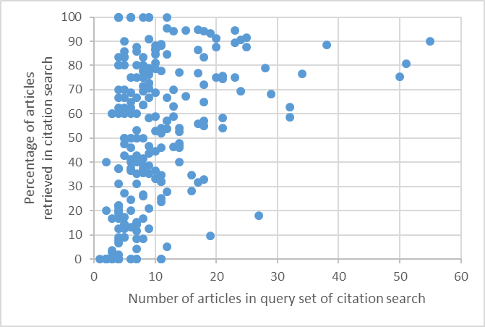

Supplementary Table 1 Examples of reviews in which CoCites showed poor performance—and a possible solution

Review | Number included articles | Number citing articles | Similarity index | Search 1: Co-citation ranking* | Search 2: Citation ranking** | Percentage retrieved articles | Solution:  Citation Ranking Top 25 | Percentage retrieved articles new
1 | 10 | 22 | 0.27 | 2 | 0 | 20% | 1 | 30%
2 | 5 | 293 | 4.2*** | 1 | 0 | 20% | 3 | 80%
3 | 17 | 260 | 0.26 | 3 | 0 | 27% | 4 | 64%
4 | 7 | 49 | 0.36 | 2 | 0 | 28% | 5 | 100%
5 | 12 | 141 | 0.32 | 3 | 1 | 33% | 8 | 92%
6 | 14 | 73 | 0.31 | 5 | 0 | 36% | 1 | 43%
7 | 8 | 58 | 0.55 | 3 | 0 | 38% | 3 | 75%
8 | 16 | 1779 | 0.3 | 4 | 2 | 38% | 5 | 56%
9 | 13 | 64 | 0.46 | 4 | 1 | 38% | 3 | 54%
10 | 17 | 82 | 0.31 | 7 | 0 | 41% | 5 | 71%
11 | 25 | 98 | 0.73 | 11 | 0 | 44% | 8 | 76%
12 | 9 | 486 | 0.46 | 4 | 0 | 44% | 3 | 78%

These twelve reviews had all included articles in PubMed, a similarity index higher than 0.2, and more than 20 citing articles (Table 3, first row). The percentage of retrieved articles refers to the results of both searches combined. The proposed solution applied citation ranking to the 25 top-ranked results of co-citation ranking (see Methods).
* Includes the two query articles.
** Includes only articles retrieved in addition to those found by co-citation ranking.
*** This is one of the two reviews for which the similarity index was out of bounds (>1). In this case, the query articles were cited 427 and 5 times. The total number of citations is then 432, but the number of unique citations was 399. The difference between these numbers indicates the overlap in citations but is here larger than the lowest number of citations. This is possible because we can only obtain unique citations to articles that are indexed in WOS, whereas the citation count includes non-indexed articles too.

Supplementary Table 2 Five examples of top-ranked results for the five reviews in which C performed worst.
Red numbers indicate query articles

Beyond the mean: A systematic review on the correlates of daily intraindividual variability of sleep/wake patterns
Bei et al. SLEEP MEDICINE REVIEWS. 2016.
Percentage of included articles retrieved: 9%
 | Title | Times Cited | Frequency
1 | The sleep of remitted bipolar outpatients: a controlled naturalistic study using actigraphy | 112 | 59
2 | Daily activities and sleep quality in college students | 107 | 58
3 | Sleep-related functioning in euthymic patients with bipolar disorder, patients with insomnia, … | 196 | 39
4 | Actigraphic assessment of circadian activity and sleep patterns in bipolar disorder | 163 | 36
5 | THE PITTSBURGH SLEEP QUALITY INDEX - A NEW INSTRUMENT FOR PSYCHIATRIC PRACTICE AND RESEARCH | 8290 | 29
6 | A systematic review of manic and depressive prodromes | 198 | 24
7 | Sleep and circadian rhythms in bipolar disorder: Seeking synchrony, harmony, and regulation | 264 | 24
8 | Temporal relation between sleep and mood in patients with bipolar disorder | 106 | 19
9 | Social zeitgebers and biological rhythms – a unified approach to understanding the etiology of depression | 346 | 18
10 | A self assessment questionnaire to determine morningness eveningness in human circadian rhythms | 2302 | 17
11 | Sleep schedules and daytime functioning in adolescents | 867 | 16
12 | Diagnostic and Statistical Manual of Mental Disorders: DSM-IV TR | 42341 | 16
13 | RATING-SCALE FOR MANIA - RELIABILITY, VALIDITY AND SENSITIVITY | 4434 | 16
14 | Rate of switch from depression into mania after therapeutic sleep deprivation in bipolar depression | 164 | 16
15 | Interpersonal and social rhythm therapy: Managing the chaos of bipolar disorder | 301 | 15
16 | SLEEP REDUCTION AS A FINAL COMMON PATHWAY IN THE GENESIS OF MANIA | 255 | 15
17 | Morning-evening preference: Sleep pattern spectrum and lifestyle habits among Japanese junior high school pupils | 92 | 15
18 | Circadian activity rhythm abnormalities in ill and recovered bipolar I disorder patients | 85 | 15
19 | THE SOCIAL RHYTHM METRIC - AN INSTRUMENT TO QUANTIFY THE DAILY RHYTHMS OF LIFE | 159 | 13
20 | Evaluation of 3 circadian-rhythm questionnaires with suggestions for an improved measure of morningness | 521 | 13
21 | The prospective impact of sleep duration on depression and mania | 68 | 13
22 | The relationship between lifestyle regularity and subjective sleep quality | 55 | 12
23 | Two-year outcomes for interpersonal and social rhythm therapy in individuals with bipolar I disorder | 390 | 12
24 | Recommendations for a standard research assessment of insomnia | 487 | 12
25 | Circadian preference, sleep and daytime behaviour in adolescence | 357 | 12

Taxane acute pain syndrome (TAPS) in patients receiving taxane-based chemotherapy for breast cancer-a systematic review
Fernandes et al. SUPPORTIVE CARE IN CANCER. 2016.
Percentage of included articles retrieved: 10%
 | Title | Times Cited | Frequency
1 | Phase III trial comparing … with docetaxel plus cyclophosphamide as adjuvant therapy for operable breast cancer | 279 | 228
2 | Doxorubicin and paclitaxel versus … as first-line therapy for women with metastatic breast cancer: … trial | 210 | 198
3 | Adjuvant docetaxel for node-positive breast cancer | 625 | 115
4 | Effects of chemotherapy and hormonal therapy for early breast cancer on recurrence and 15-year survival: … | 3754 | 104
5 | Improved outcomes from adding sequential paclitaxel but not from escalating doxorubicin dose in an adjuvant chemotherapy regimen for patients with node-positive primary breast cancer | 736 | 101
6 | Use of chemotherapy plus a monoclonal antibody against HER2 for metastatic breast cancer that overexpresses HER2. | 6133 | 97
7 | Docetaxel and … as first-line chemotherapy for metastatic breast cancer: Results of a … phase III trial | 244 | 95
8 | Doxorubicin and paclitaxel versus … as first-line chemotherapy in metastatic breast cancer: The EORTCancer … trial | 152 | 94
9 | Phase III trial of doxorubicin, paclitaxel, and the combination … as … chemotherapy for metastatic breast cancer: … | 400 | 91
10 | Sequential adjuvant epirubicin-based and docetaxel chemotherapy for node-positive breast cancer patients: … | 364 | 89
11 | Superior survival with capecitabine plus docetaxel combination therapy in … advanced breast cancer: … | 723 | 86
12 | Prospective randomized trial of docetaxel versus doxorubicin in patients with metastatic breast cancer | 489 | 84
13 | Randomized trial of … chemotherapy as postoperative adjuvant treatment of node-positive primary breast cancer: … | 874 | 81
14 | Trastuzumab plus adjuvant chemotherapy for operable HER2-positive breast cancer | 3088 | 76
15 | Paclitaxel after doxorubicin plus cyclophosphamide as adjuvant chemotherapy for node-positive breast cancer: … | 360 | 68
16 | Trastuzumab after adjuvant chemotherapy in HER2-positive breast cancer | 2785 | 66
17 | Docetaxel With Cyclophosphamide Is Associated With an Overall Survival Benefit Compared With Doxorubicin and …. | 260 | 64
18 | Prospective randomized trial of docetaxel versus mitomycin plus vinblastine in patients with metastatic breast cancer … | 408 | 62
19 | Paclitaxel versus doxorubicin as first-line single-agent chemotherapy for metastatic breast cancer: … | 245 | 59
20 | Weekly paclitaxel in the adjuvant treatment of breast cancer | 422 | 49
21 | Cytotoxic and hormonal treatment for metastatic breast cancer: A systematic review of published randomized trials … | 360 | 48
22 | Randomized phase III study of docetaxel compared with paclitaxel in metastatic breast cancer | 305 | 47
23 | Initial paclitaxel improves outcome compared with … chemotherapy as front-line therapy in … breast cancer | 144 | 47
24 | Paclitaxel by 3-hour infusion in combination with … in women with untreated metastatic breast cancer … | 494 | 43
25 | Paclitaxel plus bevacizumab versus paclitaxel alone for metastatic breast cancer | 1890 | 41

Association between maternal nutritional status in pregnancy and offspring cognitive function during childhood and adolescence; a systematic review
Veena et al. BMC PREGNANCY AND CHILDBIRTH. 2016.
Percentage of included articles retrieved: 11%
 | Title | Times Cited | Frequency
1 | Maternal vitamin D status during pregnancy and child outcomes | 322 | 216
2 | Maternal vitamin D intake during pregnancy and early childhood wheezing | 356 | 107
3 | Maternal intake of vitamin D during pregnancy and risk of recurrent wheeze in children at 3 y of age | 391 | 105
4 | Infant vitamin D supplementation and allergic conditions in adulthood - Northern Finland Birth Cohort 1966 | 224 | 90
5 | Maternal vitamin D intake during pregnancy is inversely associated with asthma and … in 5-year-old children | 236 | 82
6 | Vitamin D deficiency | 5721 | 74
7 | Neurodevelopmental effects of maternal nutritional status and … methylmercury from … fish during pregnancy | 99 | 72
8 | Cord-Blood 25-Hydroxyvitamin D Levels and Risk of Respiratory Infection, Wheezing, and Asthma | 234 | 57
9 | Dairy food, calcium and vitamin D intake in pregnancy, and wheeze and eczema in infants | 146 | 53
10 | Is vitamin D deficiency to blame for the asthma epidemic? | 272 | 52
11 | Serum Vitamin D Levels and Markers of Severity of Childhood Asthma in Costa Rica | 317 | 50
12 | Maternal vitamin D status during pregnancy and childhood bone mass at age 9 years: a longitudinal study | 405 | 46
13 | Reversing the defective induction of IL-10-secreting regulatory T cells in glucocorticoid-resistant asthma patients | 353 | 40
14 | Randomized trial of vitamin D supplementation to prevent seasonal influenza A in schoolchildren | 351 | 38
15 | Relationship between serum 25-hydroxyvitamin D and pulmonary function in the Third NHANES | 322 | 37
16 | Maternal 25-hydroxyvitamin D and parathyroid hormone concentrations and offspring birth size | 172 | 37
17 | Cognitive deficit in 7-year-old children with prenatal exposure to methylmercury | 970 | 36
18 | Toll-like receptor triggering of a vitamin D-mediated human antimicrobial response | 1831 | 35
19 | Serum 25-hydroxyvitamin D and IgE - a significant but nonlinear relationship | 119 | 35
20 | Maternal vitamin D deficiency increases the risk of preeclampsia | 363 | 34
21 | VITAMIN-D SUPPLEMENTS IN PREGNANT ASIAN WOMEN - EFFECTS ON CALCIUM STATUS AND FETAL GROWTH | 236 | 33
22 | Genes, factor X, and allergens: what causes allergic diseases? | 80 | 32
23 | Does Vitamin D Intake During Infancy Promote the Development of Atopic Allergy? | 100 | 32
24 | Vitamin D Supplementation During Pregnancy: Double-Blind, Randomized Clinical Trial of Safety and Effectiveness | 292 | 31
25 | Prenatal methylmercury exposure from ocean fish consumption in the Seychelles child development study | 327 | 31

A Systematic Review of Metastatic Hepatocellular Carcinoma to the Spine
Goodwin et al. WORLD NEUROSURGERY. 2016.
Percentage of included articles retrieved: 12%
 | Title | Times Cited | Frequency
1 | Advanced hepatocellular carcinoma with distant metastases, successfully treated by a combination therapy of … | 38 | 36
2 | Percutaneous sacroplasty for hemorrhagic metastases from hepatocellular carcinoma | 34 | 26
3 | Combined … therapy for advanced hepatocellular carcinoma with tumor thrombi in the major portal branches | 164 | 24
4 | Augmentation of … is associated with up-regulation of p27(Kip1) in human hepatocellular carcinoma cells | 75 | 15
5 | Clinical pilot study of <therapy> for patients with locally advanced hepatocellular carcinoma | 79 | 14
6 | Treatment of hepatocellular carcinoma with <therapy>; role of type I interferon receptor expression | 104 | 14
7 | Percutaneous sacroplasty for the treatment of sacral insufficiency fractures | 64 | 14
8 | Sacroplasty by CT and fluoroscopic guidance: Is the procedure right for your patient? | 35 | 13
9 | Antineoplastic activity of the combination of <therapy> against experimental and human malignancies | 355 | 13
10 | Combination therapy … for advanced hepatocellular carcinoma with portal venous invasion | 151 | 13
11 | Partial contribution of … pathway to antitumor effects of <therapy> against hepatocellular carcinoma | 61 | 12
12 | Interferon alfa receptor expression and growth inhibition by interferon alfa in human liver cancer cell lines | 116 | 12
13 | Percutaneous sacroplasty: Long-axis injection technique | 36 | 12
14 | Percutaneous osteoplasty as a treatment for painful malignant bone lesions of the pelvis and femur | 59 | 12
15 | Sacroplasty: A treatment for sacral insufficiency fractures | 80 | 12
16 | Sacroplasty: A new treatment for sacral insufficiency fracture | 88 | 11
17 | Percutaneous sacroplasty for osteoporotic sacral insufficiency fractures: a … pilot study | 73 | 11
18 | PMMA cementoplasty in symptomatic metastatic lesions of the S1 vertebral body | 39 | 11
19 | CT-guided sacroplasty in advanced sacral destruction secondary to tumour infiltration | 15 | 11
20 | Integration of interferon-alpha/beta signalling to p53 responses in tumour suppression and antiviral defence | 542 | 11
21 | <therapy> induces apoptosis through IFN-alpha/beta receptor in human hepatocellular carcinoma cells | 57 | 11
22 | TOXICITY AND RESPONSE CRITERIA OF THE EASTERN-COOPERATIVE-ONCOLOGY-GROUP | 4743 | 11
23 | Randomized controlled trial of interferon treatment for advanced hepatocellular carcinoma | 175 | 10
24 | A novel chemotherapy for advanced hepatocellular carcinoma with tumor thrombosis of the main trunk … | 123 | 10
25 | Phase II trial of <therapy> for treatment of hepatocellular carcinoma | 112 | 10

Impact of lifestyle interventions on depressive symptoms in individuals at-risk of, or with, type 2 diabetes mellitus: A systematic review and meta-analysis of randomized controlled trials
Cezaretto et al. NUTRITION METABOLISM AND CARDIOVASCULAR DISEASES. 2016.
Percentage of included articles retrieved: 13%
 | Title | Times Cited | Frequency
1 | The pathways study - A randomized trial of collaborative care in patients with diabetes and depression | 407 | 333
2 | Effectiveness of the diabetes education and self management for ongoing and newly diagnosed (DESMOND) programme for people with newly diagnosed type 2 diabetes: cluster randomised controlled trial | 283 | 183
3 | The prevalence of comorbid depression in adults with diabetes - A meta-analysis | 1767 | 113
4 | Collaborative care management of late-life depression in the primary care setting - A randomized controlled trial | 1242 | 98
5 | Association of depression and diabetes complications: A meta-analysis | 804 | 86
6 | Cognitive behavior therapy for depression in type 2 diabetes mellitus - A randomized, controlled trial | 325 | 82
7 | The effectiveness of depression care management on diabetes-related outcomes in older patients | 178 | 82
8 | Depression and poor glycemic control - A meta-analytic review of the literature | 849 | 77
9 | Depression and diabetes - Impact of depression symptoms on adherence, function, costs | 791 | 73
10 | The PHQ-9 - Validity of a brief depression severity measure | 6255 | 67
11 | Fluoxetine for depression in diabetes - A randomized double-blind placebo-controlled trial | 271 | 62
12 | Effects of nortriptyline on depression and glycemic control in diabetes: Results of a … trial | 254 | 60
13 | Collaborative Care for Patients with Depression and Chronic Illnesses. | 589 | 53
14 | The association of comorbid depression with mortality in patients with type 2 diabetes | 317 | 50
15 | Collaborative care for depression - A cumulative meta-analysis and review of longer-term outcomes | 636 | 49
16 | Relationship of depression and diabetes self-care, medication adherence, and preventive care | 452 | 49
17 | Depression predicts increased incidence of adverse health outcomes in older Mexican Americans with type 2 diabetes | 287 | 47
18 | Collaborative management to achieve treatment guidelines – impact on depression in primary care | 1008 | 47
19 | Cost-effectiveness of systematic depression treatment among people with diabetes mellitus | 171 | 46
20 | Comorbid depression is associated with increased health care use and expenditures in individuals with diabetes | 376 | 45
21 | Validation and utility of a self-report version of PRIME-MD - The PHQ primary care study | 3470 | 42
22 | Structured patient education: the Diabetes X-PERT Programme makes a difference | 150 | 41
23 | Effectiveness of self management training in type 2 diabetes - A systematic review of randomized controlled trials | 955 | 39
24 | The prevalence of co-morbid depression in adults with Type 2 diabetes: a systematic review and meta-analysis | 466 | 37
25 | Self-management education for adults with type 2 diabetes - A meta-analysis of the effect on glycemic control | 739 | 36

Supplementary Table 3 Finding highly cited articles using a search that starts with infrequently cited articles

a. Number of reviews for which (second) highest-cited query articles were retrieved at ranking threshold
 | Ranking threshold |  |  |  | All | Not found | Total
 | Top 10 | Top 25 | Top 50 | Top 100 | All | Not found | Total
Highest-cited | 43 | 50 | 53 | 59 | 59 | 1 | 60
Second highest-cited | 22 | 33 | 38 | 41 | 54 | 6 | 60
Total | 65 | 83 | 91 | 100 | 113 | 7 | 120

b. Number of included articles that were retrieved at ranking threshold*
 | Ranking threshold
 | Top 10 | Top 25 | Top 50 | Top 100 | All
None | 8 | 3 | 3 | 1 | 1
1-4 | 48 | 31 | 23 | 19 | 17
5-9 | 4 | 26 | 30 | 32 | 30
>=10 | 0 | 0 | 4 | 8 | 12
Total | 60 | 60 | 60 | 60 | 60

This analysis was restricted to the reviews (n=60) that had all included articles in PubMed, a similarity index higher than 0.2, and more than 20 citing articles (Table 3, row 1) and had included 10 or more articles.
* The two highest-cited query articles are not considered.

