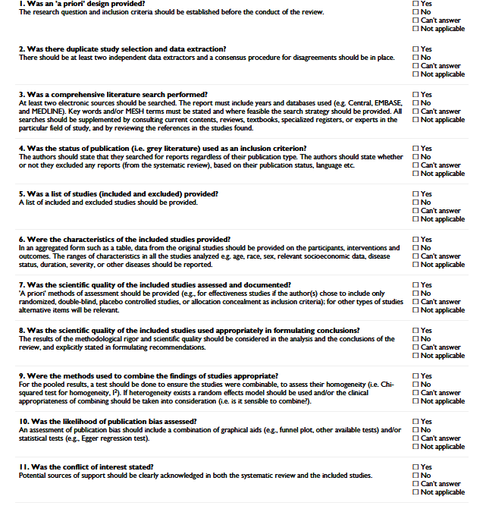
Additional File 1: AMSTAR checklist (1)

1. Shea BJ, Grimshaw JM, Wells GA, Boers M, Andersson N, Hamel C, et al. Development of AMSTAR: a measurement tool to assess the methodological quality of systematic reviews. BMC Med Res Methodol. 2007;7:10.

