Additional file 1
“Outbreaks of publications about emerging infectious diseases: the case of
SARS-CoV-2 and Zika virus”

Aziz Mert Ipekci, Diana Buitrago-Garcia, Kaspar Walter Meili, Fabienne Krauer, Nirmala Prajapati, Shabnam
Thapa, Lea Wildisen, Lucia Araujo Chaveron, Lukas Baumann, Sanam Shah, Tessa Whiteley, Gonzalo Solís-
García, Foteini Tsotra, Ivan Zhelyazkov, Hira Imeri, Nicola Low, Michel Jacques Counotte
Table of Contents
Additional file 1 1
Supplementary Text 1. Search strategy 2
Supplementary Table S2. Number and proportion of publications on Zika virus by category and publication type. 3
Supplementary Table S3. Number and proportion of publications on SARS-CoV-2 by category and publication type. 4
Supplementary Figure S1. Proportion of different study designs of published research on SARS-CoV-2 (SARS-CoV-2) and Zika virus (ZIKV) over time, without preprint publications. 5
Supplementary Figure S2. Number of different study designs of published research on SARS-CoV-2 (SARS-CoV-2) and Zika virus (ZIKV) over time. 6
Supplementary Figure S3. Time to the first 20 publications in a study design, for SARS-CoV-2 infections (SARS-CoV-2) and Zika virus infections (Zika virus), excluding preprint publications. 7
Supplementary Figure S4. The proportion of preprint publications compared to and peer-reviewed publications for SARS-CoV-2 by study design and week. 8

Supplementary Text 1. Search strategy
COVID:
EMBASE:
(SARS coronavirus/ OR middle east respiratory syndrome/ OR severe acute respiratory syndrome/ OR (coronavirus* OR corona virus* OR HCoV* or ncov* OR covid or covid19 OR sars-cov* or sarscov* or Sars-coronavirus* OR Severe Acute Respiratory Syndrome Coronavirus*).mp.) and 20191201:20301231.(dc).
MEDLINE:
("coronavirus"[MH] OR "coronavirus infections"[MH] OR "coronavirus"[TW] OR "corona virus"[TW] OR "HCoV"[TW] OR "nCov"[TW] OR "covid"[TW] OR "covid19"[TW] OR "Severe Acute Respiratory Syndrome Coronavirus 2"[TW] OR "SARS-CoV2"[TW] OR "SARS-CoV 2"[TW] OR "SARS Coronavirus 2"[TW] OR "MERS-CoV"[TW]) AND (2019/1/1:3000[PDAT])
From 01.04.2020, we retrieve the currate BioRxiv/MedRxiv dataset [https://connect.medrxiv.org/relate/content/181 ]
https://ispmbern.github.io/covid-19/living-review/collectingdata.html
Zika: All sources: Zika OR ZIKV OR “Zika virus”
Additional information is provided here: https://journals.plos.org/plosmedicine/article?id=10.1371/journal.pmed.1002203#pmed.1002203.s002

Supplementary Table S2. Number and proportion of publications on Zika virus by category and publication type.
 | Preprint  (N=98) | Peer-reviewed  (N=2188) | Overall  (N=2286)
Study design group
Epi | 31 (31.6%) | 521 (23.8%) | 552 (24.1%)
Basic | 37 (37.8%) | 215 (9.8%) | 252 (11.0%)
Other | 30 (30.6%) | 1452 (66.4%) | 1482 (64.8%)
Source
MedRxiv | 0 (0%) | 0 (0%) | 0 (0%)
BioRxiv | 98 (100%) | 0 (0%) | 98 (4.3%)
EMBASE | 0 (0%) | 356 (16.3%) | 356 (15.6%)
Pubmed | 0 (0%) | 1832 (83.7%) | 1832 (80.1%)
Study design
Case report | 1 (1.0%) | 128 (5.9%) | 129 (5.6%)
Case series | 2 (2.0%) | 92 (4.2%) | 94 (4.1%)
Case-control study | 0 (0%) | 5 (0.2%) | 5 (0.2%)
Cohort study | 0 (0%) | 13 (0.6%) | 13 (0.6%)
Cross-sectional study | 0 (0%) | 27 (1.2%) | 27 (1.2%)
Diagnostic study | 0 (0%) | 30 (1.4%) | 30 (1.3%)
Ecological study | 3 (3.1%) | 9 (0.4%) | 12 (0.5%)
Guidelines | 0 (0%) | 22 (1.0%) | 22 (1.0%)
Modelling study | 22 (22.4%) | 52 (2.4%) | 74 (3.2%)
Other | 6 (6.1%) | 37 (1.7%) | 43 (1.9%)
Outbreak or surveillance report | 0 (0%) | 33 (1.5%) | 33 (1.4%)
Qualitative study | 0 (0%) | 23 (1.1%) | 23 (1.0%)
Review | 0 (0%) | 82 (3.7%) | 82 (3.6%)
Trial | 0 (0%) | 1 (0.0%) | 1 (0.0%)
Animal experiment | 8 (8.2%) | 45 (2.1%) | 53 (2.3%)
In vitro experiment | 8 (8.2%) | 79 (3.6%) | 87 (3.8%)
Biochemical/protein structure studies | 10 (10.2%) | 62 (2.8%) | 72 (3.1%)
Sequencing and phylogenetics | 21 (21.4%) | 57 (2.6%) | 78 (3.4%)
Within-host modelling | 0 (0%) | 0 (0%) | 0 (0%)
Basic research review | 0 (0%) | 34 (1.6%) | 34 (1.5%)
Non-original | 8 (8.2%) | 1248 (57.0%) | 1256 (54.9%)
Mosquito | 9 (9.2%) | 109 (5.0%) | 118 (5.2%)

Supplementary Table S3. Number and proportion of publications on SARS-CoV-2 by category and publication type.
 | Preprint  (N=1244) | Peer-reviewed  (N=4050) | Overall  (N=5294)
Study design group
Epi | 909 (73.1%) | 1874 (46.3%) | 2783 (52.6%)
Basic | 194 (15.6%) | 218 (5.4%) | 412 (7.8%)
Other | 141 (11.3%) | 1958 (48.3%) | 2099 (39.6%)
Source
MedRxiv | 950 (76.4%) | 0 (0%) | 950 (17.9%)
BioRxiv | 294 (23.6%) | 0 (0%) | 294 (5.6%)
EMBASE | 0 (0%) | 676 (16.7%) | 676 (12.8%)
Pubmed | 0 (0%) | 3374 (83.3%) | 3374 (63.7%)
Study design
Case report | 5 (0.4%) | 231 (5.7%) | 236 (4.5%)
Case series | 67 (5.4%) | 264 (6.5%) | 331 (6.3%)
Case-control study | 13 (1.0%) | 24 (0.6%) | 37 (0.7%)
Cohort study | 70 (5.6%) | 105 (2.6%) | 175 (3.3%)
Cross-sectional study | 94 (7.6%) | 125 (3.1%) | 219 (4.1%)
Diagnostic study | 73 (5.9%) | 61 (1.5%) | 134 (2.5%)
Ecological study | 36 (2.9%) | 24 (0.6%) | 60 (1.1%)
Guidelines | 3 (0.2%) | 264 (6.5%) | 267 (5.0%)
Modelling study | 413 (33.2%) | 122 (3.0%) | 535 (10.1%)
Other | 45 (3.6%) | 166 (4.1%) | 211 (4.0%)
Outbreak or surveillance report | 23 (1.8%) | 78 (1.9%) | 101 (1.9%)
Qualitative study | 4 (0.3%) | 25 (0.6%) | 29 (0.5%)
Review | 66 (5.3%) | 475 (11.7%) | 541 (10.2%)
Trial | 17 (1.4%) | 10 (0.2%) | 27 (0.5%)
Animal experiment | 17 (1.4%) | 14 (0.3%) | 31 (0.6%)
In vitro experiment | 40 (3.2%) | 21 (0.5%) | 61 (1.2%)
Biochemical/protein structure studies | 116 (9.3%) | 66 (1.6%) | 182 (3.4%)
Sequencing and phylogenetics | 118 (9.5%) | 65 (1.6%) | 183 (3.5%)
Within-host modelling | 14 (1.1%) | 2 (0.0%) | 16 (0.3%)
Basic research review | 5 (0.4%) | 116 (2.9%) | 121 (2.3%)
Non-original | 5 (0.4%) | 1792 (44.2%) | 1797 (33.9%)

Supplementary Figure S1. Proportion of different study designs of published research on SARS-CoV-2 (SARS-CoV-2) and Zika virus (ZIKV) over time, without preprint publications.
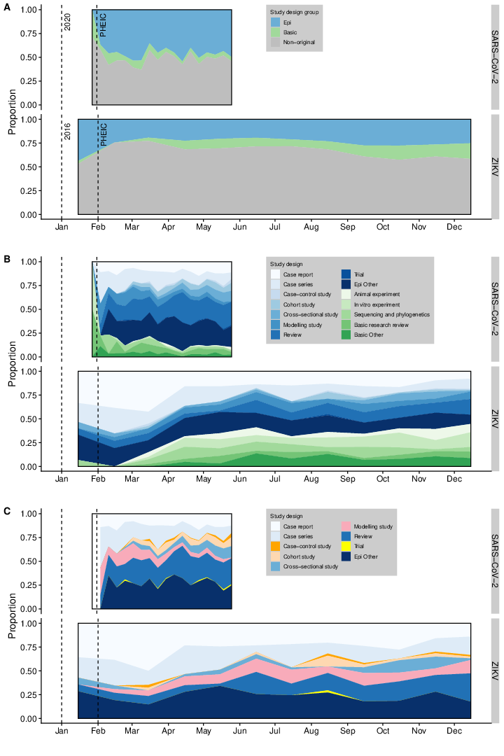
Epidemiological (Epi), basic research and non-original research (A); Epidemiological and basic research by study design (B); epidemiological research by study design (C). PHEIC: Public Health Emergency of International Concern.

Supplementary Figure S2. Number of different study designs of published research on SARS-CoV-2 (SARS-CoV-2) and Zika virus (ZIKV) over time.
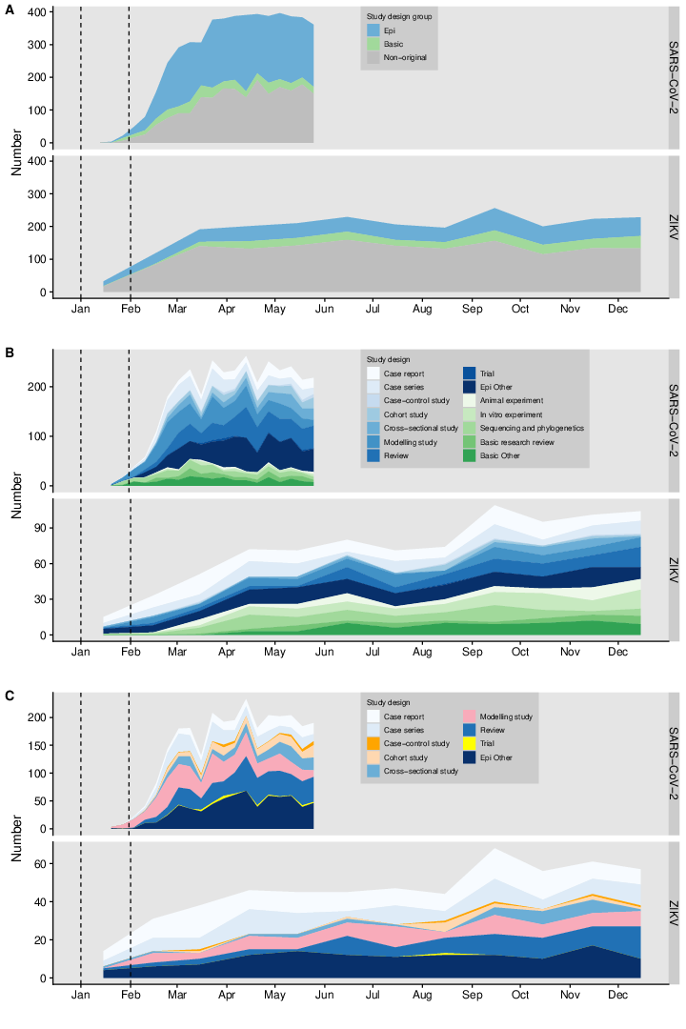
Epidemiological (Epi), basic research and non-original research (A); Epidemiological and basic research by study design (B); epidemiological research by study design (C). PHEIC: Public Health Emergency of International Concern.

Supplementary Figure S3. Time to the first 20 publications in a study design, for SARS-CoV-2 infections (SARS-CoV-2) and Zika virus infections (Zika virus), excluding preprint publications.
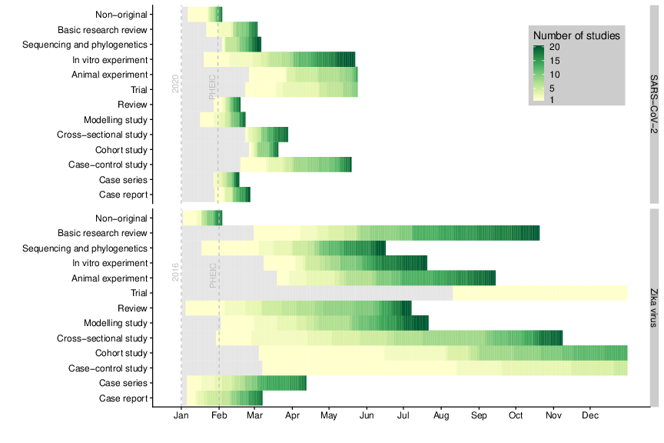

Supplementary Figure S4. The proportion of preprint publications compared to and peer-reviewed publications for SARS-CoV-2 by study design and week.
