Additional file 1. The assessment methods to identify comorbid conditions in patients with cancer using claims-based data
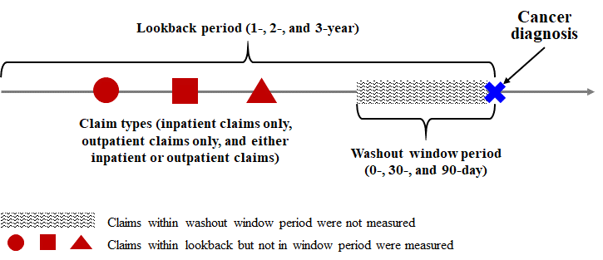
 |  |  |  |  |  | Ascertainment period
 |  |  |  |  |  | Washout window period |  |  | Lookback period
 |  |  | Claim types |  |  | Washout window period |  |  | Lookback period
 |  |  |  |  |  | No WP |  |  | 1-year
 |  |  |  |  |  | No WP |  |  | 2-year
 |  |  |  |  |  | No WP |  |  | 3-year
 |  |  | Either inpatient or outpatient claims |  |  | 30-day |  |  | 1-year
 |  |  | Either inpatient or outpatient claims |  |  | 30-day |  |  | 2-year
 |  |  | Either inpatient or outpatient claims |  |  | 30-day |  |  | 3-year
 |  |  |  |  |  | 90-day |  |  | 1-year
 |  |  |  |  |  | 90-day |  |  | 2-year
 |  |  |  |  |  | 90-day |  |  | 3-year
2,979 Korean cancer patients in 2006 |  |  |  |  |  | No WP |  |  | 1-year
2,979 Korean cancer patients in 2006 |  |  |  |  |  | No WP |  |  | 2-year
2,979 Korean cancer patients in 2006 |  |  |  |  |  | No WP |  |  | 3-year
2,979 Korean cancer patients in 2006 |  |  | Inpatient  claims only |  |  | 30-day |  |  | 1-year
2,979 Korean cancer patients in 2006 |  |  | Inpatient  claims only |  |  | 30-day |  |  | 2-year
2,979 Korean cancer patients in 2006 |  |  | Inpatient  claims only |  |  | 30-day |  |  | 3-year
2,979 Korean cancer patients in 2006 |  |  |  |  |  | 90-day |  |  | 1-year
2,979 Korean cancer patients in 2006 |  |  |  |  |  | 90-day |  |  | 2-year
2,979 Korean cancer patients in 2006 |  |  |  |  |  | 90-day |  |  | 3-year
 |  |  |  |  |  | No WP |  |  | 1-year
 |  |  |  |  |  | No WP |  |  | 2-year
 |  |  |  |  |  | No WP |  |  | 3-year
 |  |  | Outpatient  claims only |  |  | 30-day |  |  | 1-year
 |  |  | Outpatient  claims only |  |  | 30-day |  |  | 2-year
 |  |  | Outpatient  claims only |  |  | 30-day |  |  | 3-year
 |  |  |  |  |  | 90-day |  |  | 1-year
 |  |  |  |  |  | 90-day |  |  | 2-year
 |  |  |  |  |  | 90-day |  |  | 3-year

