Methodological aspects for accelerometer-based assessment of physical activity in heart failure and health
Schwendinger F.¹, Wagner J.¹, Infanger D.¹, Schmidt-Trucksäss A.¹, & Knaier R.^{1,2,3}

¹ Division of Sports and Exercise Medicine, Department of Sport, Exercise and Health, University of Basel, Basel, Switzerland
² Division of Sleep Medicine, Harvard Medical School, Boston, MA, USA.
³ Medical Chronobiology Program, Division of Sleep and Circadian Disorders, Departments of Medicine and Neurology, Brigham and Women's Hospital, Boston, MA, USA.

Corresponding author: Arno Schmidt-Trucksäss (AST), arno.schmidt-trucksaess@unibas.ch;
Tel: +41 (0) 61 2074741; Fax: +41 (0) 61 2074742; Department of Sport, Exercise and Health, University of Basel, Birsstrasse 320 B, 4052 Basel, Switzerland; ORCID: 0000-0002-4662-3911

Fabian Schwendinger (FS), fabian.schwendinger@unibas.ch; ORCID: 0000-0001-7795-1478

Jonathan Wagner (JW), jonathan.wagner@unibas.ch; ORCID: 0000-0002-3436-588X

Denis Infanger (DI), denis.infanger@unibas.ch; ORCID: 0000-0001-9028-7110

Raphael Knaier (RK), raphael.knaier@unibas.ch; ORCID: 0000-0002-0244-7768

Table 1. Linear mixed model results with estimates of daily physical activity (min) ± SE for patients with heart failure and healthy individuals.
 | HEART (n = 56) |  |  |  |  | HEALTH (n = 299)
Variable | Estimate† |  | SE | 95% CI |  |  | Estimate† | SE | 95% CI
Sedentary time
Monday | 622.4 |  | 17.1 | 588.1 to 656.8 |  |  | 612.0 | 5.9 | 600.3 to 623.6
Tuesday | 632.8 |  | 17.3 | 598.1 to 667.6 |  |  | 625.8 | 6.2 | 613.5 to 638.0
Wednesday | 631.0 |  | 16.9 | 597.0 to 665.0 |  |  | 617.0 | 6.0 | 605.2 to 628.7
Thursday | 622.8 |  | 16.4 | 589.9 to 655.8 |  |  | 613.0 | 5.9 | 601.5 to 624.6
Friday | 636.1 |  | 16.4 | 603.1 to 669.1 |  |  | 618.8 | 6.1 | 606.8 to 630.7
Saturday | 627.2 |  | 16.3 | 594.5 to 660.0 |  |  | 572.5 | 5.6 | 561.4 to 583.5
Sunday | 650.5 |  | 16.6 | 617.2 to 683.8 |  |  | 599.1 | 5.8 | 587.7 to 610.5
LPA
Monday |  | 238.0 | 11.2 | 215.5 to 260.4 |  |  | 247.2 | 3.7 | 240.0 to 254.5
Tuesday |  | 237.8 | 11.3 | 215.3 to 260.4 |  |  | 246.9 | 3.8 | 239.4 to 254.3
Wednesday |  | 242.4 | 11.1 | 220.1 to 264.7 |  |  | 241.7 | 3.7 | 234.4 to 248.9
Thursday |  | 235.2 | 10.9 | 213.3 to 257.1 |  |  | 244.9 | 3.6 | 237.7 to 252.1
Friday |  | 248.2 | 10.9 | 226.3 to 270.2 |  |  | 257.4 | 3.8 | 250.0 to 264.9
Saturday |  | 236.0 | 10.9 | 214.2 to 257.8 |  |  | 260.7 | 3.7 | 253.5 to 267.9
Sunday |  | 213.3 | 10.9 | 191.4 to 235.1 |  |  | 227.9 | 3.6 | 220.9 to 235.0
MPA
Monday |  | 87.6 | 6.5 | 74.5 to 100.8 |  |  | 107.1 | 2.7 | 101.8 to 112.3
Tuesday |  | 83.5 | 6.6 | 70.3 to 96.7 |  |  | 108.8 | 2.8 | 103.3 to 114.2
Wednesday |  | 81.5 | 6.5 | 68.4 to 94.5 |  |  | 107.6 | 2.7 | 102.3 to 112.9
Thursday |  | 81.6 | 6.4 | 68.8 to 94.3 |  |  | 109.2 | 2.7 | 103.9 to 114.4
Friday |  | 84.4 | 6.4 | 71.7 to 97.2 |  |  | 112.2 | 2.8 | 107.6 to 117.7
Saturday |  | 76.0 | 6.3 | 63.3 to 88.7 |  |  | 112.8 | 2.7 | 107.6 to 118.1
Sunday |  | 69.3 | 6.4 | 56.5 to 82.2 |  |  | 98.3 | 2.6 | 93.3 to 103.4
VPA
Monday |  | 1.4 | 0.5 | 0.4 to 2.5 |  |  | 7.8 | 0.7 | 6.3 to 9.2
Tuesday |  | 2.7 | 0.5 | 1.6 to 3.8 |  |  | 8.7 | 0.8 | 7.2 to 10.2
Wednesday |  | 1.6 | 0.5 | 0.6 to 2.7 |  |  | 6.8 | 0.7 | 5.3 to 8.3
Thursday |  | 1.9 | 0.5 | 0.8 to 2.9 |  |  | 8.0 | 0.7 | 6.5 to 9.4
Friday |  | 1.6 | 0.5 | 0.6 to 2.6 |  |  | 6.8 | 0.8 | 5.3 to 8.3
Saturday |  | 1.8 | 0.5 | 0.8 to 2.8 |  |  | 7.6 | 0.7 | 6.2 to 9.0
Sunday |  | 1.5 | 0.5 | 0.5 to 2.5 |  |  | 10.3 | 0.7 | 8.9 to 11.8
Supplementary tables

†adjusted for V̇O_{2peak}, sex, age, and wear time. Abbreviations: HEART, patients with heart failure; HEALTH, healthy individuals; LPA, light physical activity; MPA, moderate physical activity; V̇O_{2peak}, peak oxygen uptake; SE, standard error.
Table 1 continued.
 | HEART (n = 56) |  |  |  |  | HEALTH (n = 299)
Variable | Estimate† |  | SE | 95% CI |  |  | Estimate† | SE | 95% CI
MVPA
Monday |  | 89.1 | 6.7 | 75.6 to 102.5 |  |  | 114.5 | 2.9 | 108.7 to 120.3
Tuesday |  | 86.2 | 6.8 | 72.6 to 99.7 |  |  | 116.9 | 3.1 | 110.9 to 122.9
Wednesday |  | 83.1 | 6.7 | 69.7 to 96.5 |  |  | 114.4 | 3.0 | 108.6 to 120.3
Thursday |  | 83.4 | 6.5 | 70.3 to 96.6 |  |  | 116.9 | 2.9 | 111.1 to 122.7
Friday |  | 86.1 | 6.5 | 73.0 to 99.2 |  |  | 118.8 | 3.0 | 112.8 to 124.8
Saturday |  | 77.8 | 6.5 | 64.7 to 90.8 |  |  | 120.3 | 2.9 | 114.5 to 126.1
Sunday |  | 70.8 | 6.6 | 57.7 to 84.0 |  |  | 107.6 | 2.9 | 102.0 to 113.2
MVPA (10 min bouts)
Monday |  | 13.9 | 3.5 | 6.9 to 20.9 |  |  | 26.7 | 2.0 | 22.7 to 30.7
Tuesday | 11.8 |  | 3.5 | 4.7 to 18.8 |  |  | 28.6 | 2.1 | 24.4 to 32.8
Wednesday | 11.6 |  | 3.4 | 4.7 to 18.5 |  |  | 25.9 | 2.1 | 21.9 to 30.0
Thursday | 14.3 |  | 3.3 | 7.6 to 21.0 |  |  | 27.5 | 2.0 | 23.5 to 31.4
Friday | 15.3 |  | 3.3 | 8.6 to 21.9 |  |  | 26.0 | 2.1 | 21.9 to 30.1
Saturday | 13.5 |  | 3.3 | 6.8 to 20.1 |  |  | 30.5 | 2.0 | 26.5 to 34.4
Sunday | 13.9 |  | 3.4 | 7.1 to 20.6 |  |  | 37.5 | 2.0 | 33.5 to 41.4
TPA
Monday | 326.6 |  | 15.9 | 294.6 to 358.5 |  |  | 364.4 | 5.3 | 353.9 to 374.9
Tuesday | 322.5 |  | 16.0 | 290.4 to 354.5 |  |  | 366.2 | 5.5 | 355.3 to 377.2
Wednesday | 325.9 |  | 15.8 | 294.2 to 357.6 |  |  | 358.6 | 5.4 | 348.0 to 369.2
Thursday | 318.7 |  | 15.5 | 287.7 to 349.8 |  |  | 363.7 | 5.3 | 353.3 to 374.2
Friday | 334.0 |  | 15.5 | 303.9 to 365.2 |  |  | 378.7 | 5.5 | 367.9 to 389.4
Saturday | 313.6 |  | 15.4 | 282.6 to 344.5 |  |  | 383.1 | 5.3 | 372.7 to 393.5
Sunday | 283.7 |  | 15.4 | 252.8 to 314.7 |  |  | 339.7 | 5.3 | 329.3 to 350.1

†adjusted for V̇O_{2peak}, sex, age, and wear time. Abbreviations: HEART, patients with heart failure; HEALTH, healthy individuals; MVPA, moderate-to-vigorous physical activity; 10 min bouts, minutes accumulated in activity periods of ≥ 10 min; VPA, vigorous physical activity; TPA, total physical activity; V̇O_{2peak}, peak oxygen uptake; SE, standard error.

Table 2. Linear mixed model results with estimates of daily physical activity (min) ± SE for patients with heart failure and healthy individuals.
 | HEART (n = 56) |  |  |  |  | HEALTH (n = 299)
Variables | Estimate† | SE | 95% CI | P-value |  | Estimate† | SE | 95% CI | P-value
Weekdays vs. weekend
Sedentary time | 10.4 | 7.7 | -4.7 to 25.6 | .178 |  | -31.6 | 3.7 | -38.7 to -24.4 | < .001***
LPA | -15.9 | 4.0 | -23.7 to -8.1 | < .001*** |  | -2.9 | 2.1 | -6.9 to 1.2 | .169
MPA | -6.6 | 1.5 | -9.5 to -3.6 | < .001*** |  | -3.2 | 1.5 | -6.1 to -0.3 | .033*
MVPA | -6.4 | 1.5 | -9.4 to -3.5 | < .001*** |  | -2.1 | 1.6 | -5.3 to 1.1 | .198
VPA | -0.1 | 0.2 | -0.6 to 0.3 | .555 |  | 1.3 | 0.5 | 0.3 to 2.4 | .013*
TPA | -27.0 | 5.5 | -37.7 to -16.2 | < .001*** |  | -4.3 | 3.1 | -10.4 to 1.9 | .176

†adjusted for V̇O_{2peak}, sex, age, and wear time. * P < .05; ** P < .01; *** P < .001. Abbreviations: HEART, patients with heart failure; HEALTH, healthy individuals; LPA, light physical activity; MPA, moderate physical activity; MVPA, moderate-to-vigorous physical activity; VPA, vigorous physical activity; TPA, total physical activity; V̇O_{2peak}, peak oxygen uptake; SE, standard error.

Supplementary figure

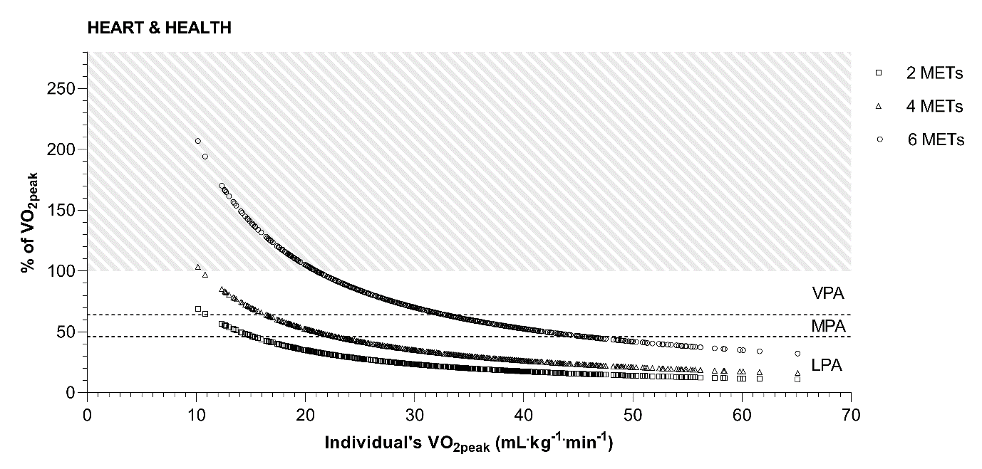
Figure 1. Cardiorespiratory response in % of V̇O_{2peak} to exercising at 2, 3, and 6 METs across the cardiorespiratory fitness spectrum (V̇O_{2peak} range = 10.2 – 65.1
mL.kg^{-1.}min⁻¹) including patients with heart failure (HEART) and healthy individuals (HEALTH). The V̇O_{2peak} of all participants is displayed on the x-axis. The relative intensity in % of the subjects’ V̇O_{2peak} that would be required to exercise at the three absolute intensities (2, 3, and 6 METs) is depicted on the y-axis. Intensity categories are marked by the dashed lines. LPA is defined as 0 to < 46% of V̇O_{2peak}, MPA as 46 to < 64% of V̇O_{2peak}, and VPA as 64 to 100% of V̇O_{2peak}.² The hatched area symbolizes the intensity that cannot be maintained for a prolonged time, as it exceeds the individual’s cardiorespiratory fitness. Abbreviations: LPA, light physical activity; MPA, moderate physical activity; VPA, vigorous physical activity; V̇O_{2peak}, peak oxygen uptake.

