Appendix B, Figure 1. AUC sensitivity analysis requiring 0 days prior observation

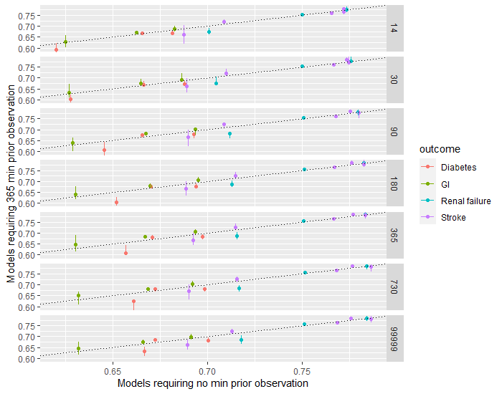Figure 1 - the AUC value of the models that were trained using a population of paients that were required to have 0 days prior observation (x-axis) plotted against the AUC value of the models that were trained using a population of paients that were required to have 365 days prior observation (y-axis) matched on covariate lookback, outcome and database. The vertical lines are the confidence intervals of the AUC.
The x-axis is the model performance requiring 0 days prior observation and the y-axis is the model performance requiring 365 days observation and each dot is a paired outcome and database. The dots are distributed around the diagonal indicating that there is not a sufficient change in model performance. The results are restricted to internally validated model performances. (NOTE: 99999 indicates all time)
Appendix B, Figure 2. Sensitivity analysis requiring 730 days prior observation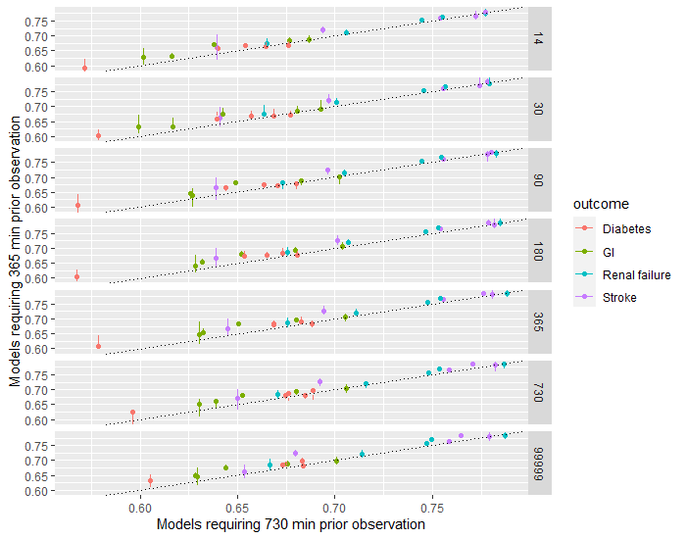Figure 2 - the AUC value of the models that were trained using a population of paients that were required to have 730 days prior observation (x-axis) plotted against the AUC value of the models that were trained using a population of paients that were required to have 365 days prior observation (y-axis) matched on covariate lookback, outcome and database. The vertical lines are the confidence intervals of the AUC.
The x-axis is the model performance requiring 730 days prior observation and the y-axis is the model performance requiring 365 days observation and each dot is a paired outcome and database. The dots are distributed around the diagonal indicating that there is not a sufficient change in model performance. The results are restricted to internally validated model performances. (NOTE: 99999 indicates all time)

Table 2. Percentage of subjects excluded due to minimum prior observation period requirement
Outcome | Database | Total Population (N) | % Population with at least 365 days prior observation  (%) | % Population with at least 730 days prior observation  (%)
Stroke | CCAE | 688011 | 0.6943 | 0.5006
Stroke | OPTUM | 555849 | 0.7513 | 0.5796
Stroke | MDCD | 166774 | 0.6823 | 0.5243
Stroke | MDCR | 46696 | 0.7971 | 0.6368
Stroke | Panther | 1667849 | 0.7495 | 0.6772
Gastrointestinal bleeding | CCAE | 700384 | 0.6705 | 0.4683
Gastrointestinal bleeding | OPTUM | 556913 | 0.688 | 0.4915
Gastrointestinal bleeding | MDCD | 178419 | 0.6663 | 0.4888
Gastrointestinal bleeding | MDCR | 51084 | 0.7681 | 0.5927
Gastrointestinal bleeding | Panther | 1688161 | 0.7912 | 0.7143
Renal impairment | CCAE | 721671 | 0.5695 | 0.4068
Renal impairment | OPTUM | 536981 | 0.5544 | 0.4037
Renal impairment | MDCD | 164979 | 0.5229 | 0.3686
Renal impairment | MDCR | 49495 | 0.635 | 0.4868
Renal impairment | Panther | 1608521 | 0.7165 | 0.6318
Diabetes | CCAE | 587205 | 0.3453 | 0.2207
Diabetes | OPTUM | 458033 | 0.3126 | 0.2034
Diabetes | MDCD | 128517 | 0.3061 | 0.19
Diabetes | MDCR | 42306 | 0.3031 | 0.1979
Diabetes | Panther | 1294517 | 0.5686 | 0.474

