Figure 4. Mean number of predictors in internally validated models by lookback across two chronic (Diabetes and Renal Impairment) and two acute (Gastrointestinal bleeding and Stroke) cohorts over five US databases.
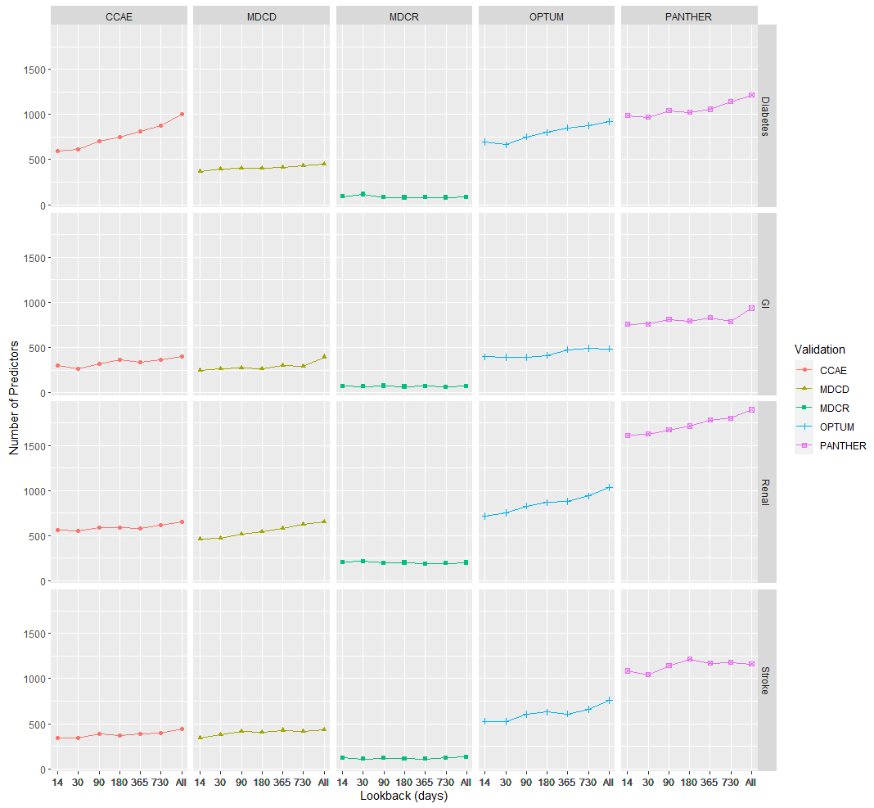
Database

