Supplemental File 2: Additional details for simulated populations and datasets

Table of Contents
Supplemental File 2: Additional details for simulated populations and datasets 1
Scenario descriptions 2
Population survival curves 3
Population fitted values (estimands) 4
Proportion of samples accrued by each level of proportion of events 5
Number of nonconverging or implausible fits across all four scenarios 6
Proportion identifying the true distribution as best-fitting across all four scenarios 7

Scenario descriptions
Four scenarios were conducted to examine two levels of accrual and event rates, made up of a combination of short (approximately 9 months maximum accrual time, 9 months median event time) or long times (approximately 30 months maximum accrual time, 30 months median event time) (Table S2-1). The accrual time range was chosen after reviewing published statistical analysis plans in oncology trials, including lung, breast, and hematologic cancers. The factorial design permitted an assessment of any relationship between accrual time relative to event time. Each scenario was conducted with $n_{sim}$= 5,000 repetitions.
Table S2-1. Scenario descriptions
Scenarios |  | Accrual time
 |  | Short | Long
Event time | Short (high rate) | 1 (Base)-High event rate, short accrual | 2-High event rate, long accrual
Event time | Long (low rate) | 3-Low event rate, short accrual | 4-Low event rate, long accrual

Population survival curves
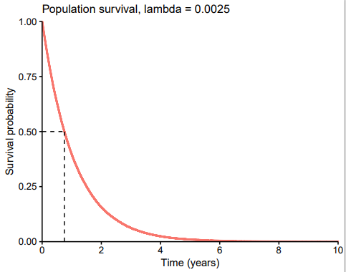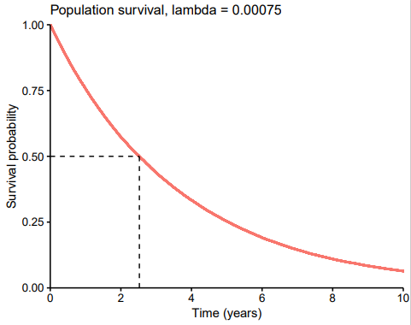
Figure S2-1 Population survival curves for lambda = 0.0025 (scenarios 1 and 2) and for lambda = 0.00075 (scenarios 3 and 4).

Population fitted values (estimands)
Table S2-2. Population fitted values for each scenario (times measured in days)
 | Scenario 1 | Scenario 2 | Scenario 3 | Scenario 4
Rate | 0.00253 (0.00251 – 0.00255) | 0.00249 (0.0247 – 0.251) | 0.000745 (0.000739 – 0.000752) | 0.000754 (0.000747 – 0.000760)
Max accrual time | 9 months | 30 months | 9 months | 30 months
OS Median | 274 (272 – 277) | 278 (276 – 281) | 930 (922 – 938) | 920 (912 – 928)
One-year survival | 39.7% (39.4% – 40.0%) | 40.3% (39.4% – 40.6%) | 76.2% (76.0% – 76.4%) | 75.9% (75.8% – 76.1%)
Time horizon, TH_{pop} | 1822 (1806 – 1837) | 1849 (1832 – 1866) | 6177 (6123 – 6236) | 6112 (6057 – 6169)
RMST at TH_{pop} | 392 (388 – 395) | 397 (394 – 400) | 1328 (1316 – 1339) | 1315 (1304 – 1326)
Max event time | 3,808 | 4,946 | 15,685 | 13,129

Proportion of samples accrued by each level of proportion of events
As patients accrued to study cohorts over time, analysis after a small proportion of events can be conducted before the full target population has accrued. When accrual time and event times were similar (scenarios 1 and 4), on average about 30% of events had been observed by the time trials regularly had accrued the full target sample size. In circumstances where trial design dictates that data not be analyzed until a minimum time after the full target sample size had accrued, there would often be a reasonable proportion of events already observed; the exception of which being when the event time is long (i.e., event rate is very low) in relation to accrual time (scenario 3).
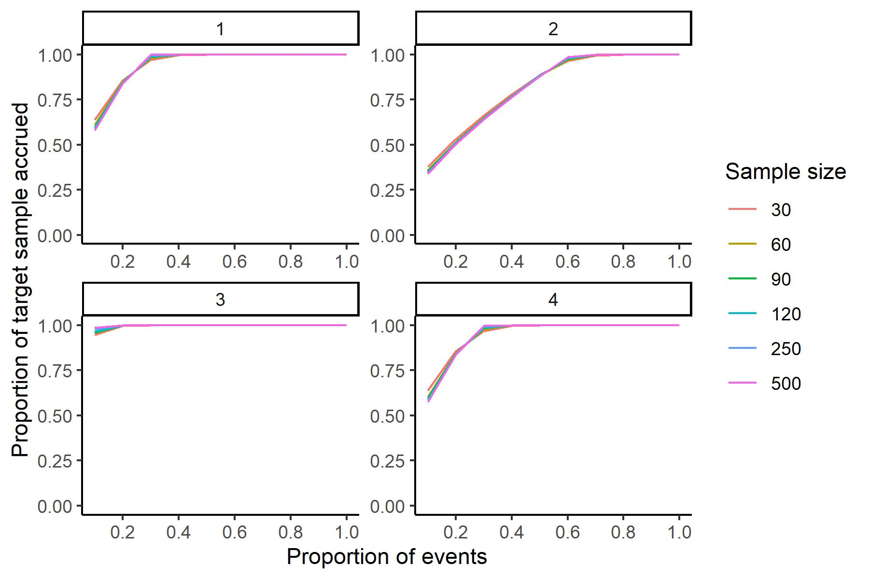
Figure S2-2 Proportion of target sample size accrued at each level of proportion of events for each scenario
Scenarios: 1- high event rate, short accrual
2- high event rate, long accrual
3- low event rate, short accrual
4- low event rate, long accrual

Number of nonconverging or implausible fits across all four scenarios
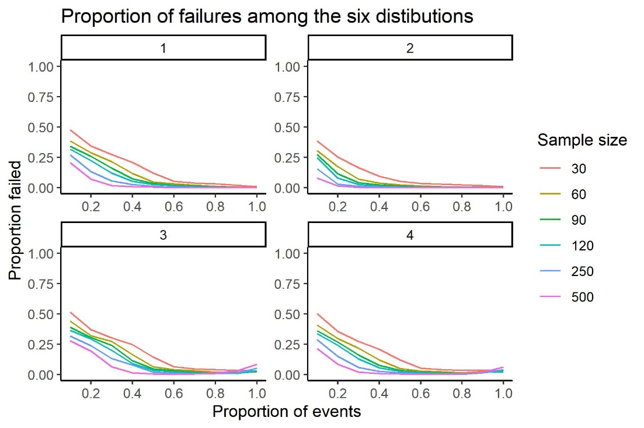
Figure S2-3 Proportion of fitted models (across 5,000 repetitions and 6 distributions for each) that failed to converge or produced implausible results for each sample size and level of proportion of events
Scenarios: 1- high event rate, short accrual
2- high event rate, long accrual
3- low event rate, short accrual
4- low event rate, long accrual

Proportion identifying the true distribution as best-fitting across all four scenarios
Figure S2-4 Proportion of repetitions in the simulation that identified the best-fitting distribution to be the true exponential distribution, according to AIC or BIC in each scenario
Scenarios: 1- high event rate, short accrual
2- high event rate, long accrual
3- low event rate, short accrual
4- low event rate, long accrual

