Supplementary table 1. Performances of our proposed meta-analysis method and the other methods in comparison when the set of differentially expressed genes vary between experiments. The sample sizes of the experiments are $N_{i}=N_{i-1}+6$, $i=2,…,10$ and $N_{1}=20$.

Setting | Method | Performance assessment measure
Setting | Method | Sensitivity | Specificity | FDR | FNR
1 | Fisher | 1.00 | 0.99 | 0.06 | 0.00
1 | EAMA | 1.00 | 0.99 | 0.08 | 0.00
1 | BACON adjusted Fisher | 1.00 | 0.99 | 0.06 | 0.00
1 | weighted Z | 1.00 | 0.99 | 0.05 | 0.00
1 | EB adjusted weighted Z | 1.00 | 1.00 | 0.03 | 0.00
1 | BACON adjusted weighted Z | 1.00 | 0.99 | 0.05 | 0.00
2 | Fisher | 1.00 | 0.77 | 0.68 | 0.00
2 | EAMA | 0.99 | 1.00 | 0.02 | 0.00
2 | BACON adjusted Fisher | 0.99 | 1.00 | 0.03 | 0.00
2 | weighted Z | 0.96 | 0.31 | 0.87 | 0.02
2 | EB adjusted weighted Z | 1.00 | 0.99 | 0.11 | 0.00
2 | BACON adjusted weighted Z | 0.99 | 1.00 | 0.05 | 0.00
3 | Fisher | 1.00 | 0.99 | 0.05 | 0.00
3 | EAMA | 1.00 | 1.00 | 0.04 | 0.00
3 | BACON adjusted Fisher | 1.00 | 0.99 | 0.05 | 0.00
3 | weighted Z | 1.00 | 1.00 | 0.05 | 0.00
3 | EB adjusted weighted Z | 1.00 | 0.99 | 0.07 | 0.00
3 | BACON adjusted weighted Z | 1.00 | 1.00 | 0.05 | 0.00

Supplementary figure 1. Performances of the meta-analysis methods with unequal sample sizes of the experiments.
This figure shows the average sensitivity, specificity, and FNR values over 500 independent Monte-Carlo iterations of the proposed method and all the other methods in comparison. Results are shown for all three simulation settings. The sample sizes of the experiments are $N_{i}=N_{i-1}+10$, $i=2,…,10$ and $N_{1}=80$.

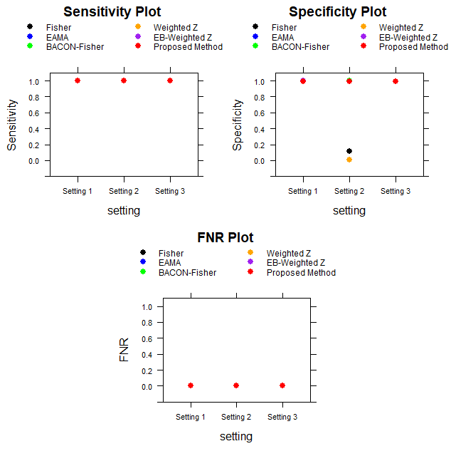

Supplementary figure 2. Performances of the meta-analysis methods with reduced and unequal sample sizes of the experiments.
This figure shows the average sensitivity, specificity, and FNR values over 500 independent Monte-Carlo iterations of the proposed method and all the other methods in comparison. Results are shown for all three simulation settings. The sample sizes of the experiments are $N_{i}=N_{i-1}+6$, $i=2,…,10$ and $N_{1}=20$.

