SUPPLEMENTARY MATERIALS

KMSubtraction: Reconstruction of unreported subgroup survival data utilizing published Kaplan-Meier survival curves

Joseph J. Zhao¹; Nicholas L. Syn¹, MBBS; Benjamin Kye Jyn Tan¹; Dominic Wei Ting Yap¹; Chong Boon Teo¹; Yiong Huak Chan^{2,} *, PhD; Raghav Sundar^{1, 3, 4, 5, 6,} *, MBBS, PhD
¹ Yong Loo Lin School of Medicine, National University of Singapore, Singapore
² Biostatistics Unit, Yong Loo Lin School of Medicine, National University of Singapore, Singapore
³ Department of Haematology-Oncology, National University Health System, Singapore
⁴ Cancer and Stem Cell Biology Program, Duke-NUS Medical School, Singapore
⁵ The N.1 Institute for Health, National University of Singapore, Singapore
⁶ Singapore Gastric Cancer Consortium
* Joint corresponding author

Supplementary Guide
The vignette is made available on github: https://github.com/josephjzhao/KMSubtraction

Supplementary Table 1 Simulation parameters

The independent variable (denoted by red boxes) follows according to the following arithmetic sequence: $\lim_{n→m}{(a+(1-n)}*b)$
Variable being investigated | Size of overall cohort (N_{overall}) | Proportion of reported subgroup (P_{subgroup}) | Proportion of patients with censorship in overall cohort  (P_{overall, censored}) | Proportion of patients with censorship in subgroup cohort  (P_{subgroup, censored}) | Proportion of missing data (P_{missing}) | Number of number-at-risk table intervals  (N_{interval}) | Number of Monte Carlo iterations  (i)
N_{overall} | $$a=50,$$  $$b=1000,$$  $$m=20$$ | 0.50 | 0.50 | 0.50 | 0.00 | 8 | 5000
P_{subgroup} | 500 | $$a=0.01,$$  $$b=0.05,$$  $$m=20$$ | 0.50 | 0.50 | 0.00 | 8 | 5000
P_{overall, censored} | 500 | 0.50 | $$a=0.01,$$  $$b=0.05,$$  $$m=20$$ | * | 0.00 | 8 | 5000
P_{subgroup, censored} | 500 | 0.50 | * | $$a=0.01,$$  $$b=0.05,$$  $$m=20$$ | 0.00 | 8 | 5000
P_{missing} | 500 | 0.50 | 0.50 | 0.50 | $$a=0.01,$$  $$b=0.05,$$  $$m=19$$ | 8 | 5000
N_{interval} | 500 | 0.50 | 0.50 | 0.50 | 0.00 | $$a=2,$$  $$b=1,$$  $$m=19$$ | 5000

* Since the subgroups are dichotomous, the relationship between P_{overall, censored} and P_{subgroup, censored} is bounded by
$\frac{Psubgroup*Poverall, censored }{Psubgroup, censored}=\frac{Nsubgroup, censored}{Noverall, censored}≤1$
Thus, when the proportion of censored patients from the overall and subgroup cohorts were investigated as the independent variable, we arbitrarily defined $\frac{Nsubgroup, censored}{Noverall, censored}=0.5$.
This gives $Psubgroup, censored=\frac{Psubgroup*Poverall, censored}{0.5}$ _{and} $Poverall, censored=\frac{0.5*Psubgroup, censored}{Psubgroup}$
when the proportion of censored patients from the overall and subgroup cohorts were investigated respectively.
Supplementary Table 2 Significant outcomes of Tukey multiple pairwise-comparisons between each matching algorithm

Comparison of matching algorithms | Parameters |  |  |  |  |  | Difference (95% CI) | p
Comparison of matching algorithms | Size of overall cohort (N_{overall}) | Proportion of reported subgroup (P_{subgroup}) | Proportion of patients with censorship in overall cohort  (P_{overall, censored}) | Proportion of patients with censorship in subgroup cohort  (P_{subgroup, censored}) | Proportion of missing data (P_{missing}) | Number of number-at-risk table intervals  (N_{interval}) | Difference (95% CI) | p
Logistic/Bipartite | 500 | 0.86 | 0.50 | 0.50 | 0.00 | 8 | 0.003166297 (0.001300484 to 0.005032110) | <0.001
Mahalanobis/Logistic | 500 | 0.86 | 0.50 | 0.50 | 0.00 | 8 | -0.002886512 (-0.004752325 to -0.001020700) | <0.001
Logistic/Bipartite | 500 | 0.91 | 0.50 | 0.50 | 0.00 | 8 | 0.005700769 ( 0.003834957 to 0.007566582) | <0.001
Mahalanobis/Logistic | 500 | 0.91 | 0.50 | 0.50 | 0.00 | 8 | -0.007242428 (-0.009108240 to -0.005376615) | <0.001
Logistic/Bipartite | 500 | 0.96 | 0.50 | 0.50 | 0.00 | 8 | 0.010563824 (0.008698011 to 0.012429636) | <0.001
Mahalanobis/Bipartite | 500 | 0.96 | 0.50 | 0.50 | 0.00 | 8 | -0.017536851 (-0.019402664 to -0.015671039) | <0.001
Mahalanobis/Logistic | 500 | 0.96 | 0.50 | 0.50 | 0.00 | 8 | -0.028100675 (-0.029966488 to -0.026234863) | <0.001

Abbreviations: Logistic, nearest neighbor matching with distances defined by logistic regression; Bipartite, minimal cost bipartite matching; Mahalanobis, Mahalanobis distance matching; CI, confidence interval.

Supplementary Figure 1 Running mean plots demonstrating simulation convergence
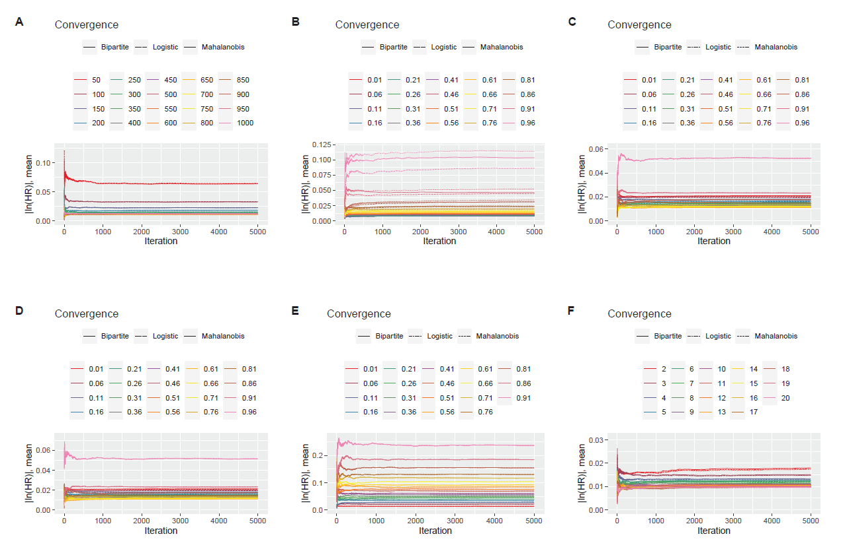
Running mean plots demonstrating simulation convergence for (A) Size of dataset (B) Proportion of reported subgroup (C) Proportion of patients with censorship in the overall cohort (D) Proportion of patients with censorship in the subgroup cohort (E) Proportion of missing data (F) Number of number-at-risk table intervals

Supplementary Code

# Implemented in R-4.1.0
main_wd="C:/Users/jzhao/OneDrive/Research_Cloud/NUH_NCIS/KMSubtraction/"
setwd(main_wd)

# number of Monte Carlo iterations per scenario
n.mc=5000
# set number of cores
detectCores()
n.cores=6

#### DOWNLOAD libraries ####
package.name=c(# unique to KMSubtraction
"MatchIt", "wakefield", "magick", "RcppHungarian", "scales", "IPDfromKM", "svglite", "rsvg", "blandr", "KMSubtraction",
# data manipulation
"tidyverse", "reshape", "readr", "readxl", "dplyr", "tidyr", "lubridate", "tibble", "plyr", "devtools", "stringr", "stringi",
# parallel processing
"doParallel", "parallel", "foreach", "doSNOW",
# survival analysis
"survminer", "survival",
# misc
"cluster", "ResourceSelection", "progress"
)

for (package.name in package.name){
if (!require(package.name, character.only = TRUE)){
install.packages(package.name, character.only = TRUE)
library(package.name, character.only = TRUE)} else {library(package.name, character.only = TRUE)}}

#### LOAD functions ####
seq_sim=function(x){seq(from=as.numeric(str_extract(x, "^(\\d|\\.)*(?=;)")),
to=as.numeric(str_extract(x, "(?<=;)(\\d|\\.)*(?=;)")),
as.numeric(str_extract(x, "(?<=;)(\\d|\\.)*$")))}

#### LOAD Simulation parameters ####
simulation_parameters=data.frame(outcome = c("outcome_size", "outcome_subgroup", "outcome_censorship_overall", "outcome_censorship_subgroup", "outcome_missing", "outcome_interval"),
n = c("50;1000;50", "500;500;0", "500;500;0", "500;500;0", "500;500;0", "500;500;0"),
subgroup.p = c("0.5;0.5;0", "0.01;0.99;0.05", "0.5;0.5;0", "0.5;0.5;0", "0.5;0.5;0", "0.5;0.5;0"),
censor_overall.p = c("0.5;0.5;0", "0.5;0.5;0", "0.01;0.99;0.05","0.5;0.5;0", "0.5;0.5;0", "0.5;0.5;0"),
censor_subgroup.p = c("0.5;0.5;0", "0.5;0.5;0", "0.5;0.5;0", "0.01;0.99;0.05", "0.5;0.5;0", "0.5;0.5;0"),
missing.p = c("0;0;0", "0;0;0", "0;0;0", "0;0;0", "0.01;0.91;0.05", "0;0;0"),
interval = c("8;8;0", "8;8;0", "8;8;0", "8;8;0", "8;8;0", "2;20;1"),
mc = rep(paste0("1;", n.mc,";1" ), 6))

# count the total number of iterations
iterations=0

for (r in 1:nrow(simulation_parameters)){
row.iterations=1
for (c in 2:ncol(simulation_parameters)){
row.iterations=row.iterations*length(seq_sim(simulation_parameters[r,c]))
}
iterations=row.iterations+iterations
}

print(paste0("Total number of iterations: ", iterations))

set.seed(NULL)

#### Prepare parallel processing settings ####
registerDoParallel(n.cores)
registerDoSNOW(makeSOCKcluster(n.cores))

# progress bar
pb <- txtProgressBar(min=1, max=iterations, style=3)
progress <- function(n) setTxtProgressBar(pb, n)
opts <- list(progress=progress)

#### Simulation ####
df_out=NULL
i.outcome=1
system.time({
df_out=
foreach (i.outcome = 1:length(simulation_parameters$outcome), .options.snow=opts, .combine=rbind) %:%
foreach (i.n = 1:length(seq_sim(simulation_parameters$n[i.outcome])), .options.snow=opts, .combine=rbind) %:%
foreach (i.censor_overall = 1:length(seq_sim(simulation_parameters$censor_overall.p[i.outcome])), .options.snow=opts, .combine=rbind) %:%
foreach (i.censor_subgroup = 1:length(seq_sim(simulation_parameters$censor_subgroup.p[i.outcome])), .options.snow=opts, .combine=rbind) %:%
foreach (i.subgroup = 1:length(seq_sim(simulation_parameters$subgroup.p[i.outcome])), .options.snow=opts, .combine=rbind) %:%
foreach (i.missing = 1:length(seq_sim(simulation_parameters$missing.p[i.outcome])), .options.snow=opts, .combine=rbind) %:%
foreach (i.interval = 1:length(seq_sim(simulation_parameters$interval[i.outcome])), .options.snow=opts, .combine=rbind) %:%
foreach (i.mc = 1:length(seq_sim(simulation_parameters$mc[i.outcome])), .options.snow=opts, .combine=rbind) %dopar% {
library(survival)
library(survminer)
library(wakefield)
library(svglite)
library(magick)
library(stringi)
library(stringr)
library(dplyr)
library(tidyr)
library(tidyverse)
library(scales)
library(svglite)
library(rsvg)
library(IPDfromKM)
library(readr)
library(RcppHungarian)
library(dplyr)
library(MatchIt)
library(survRM2)
library(blandr)
library(KMSubtraction)

#### 0_Define parameters ####
outcome=simulation_parameters$outcome[i.outcome]

# assumptions and settings
mc=seq_sim(simulation_parameters$mc[i.outcome])
n=seq_sim(simulation_parameters$n[i.outcome])
censor_overall.p=seq_sim(simulation_parameters$censor_overall.p[i.outcome])
censor_subgroup.p=seq_sim(simulation_parameters$censor_subgroup.p[i.outcome])
missing.p=seq_sim(simulation_parameters$missing.p[i.outcome])
subgroup.p=seq_sim(simulation_parameters$subgroup.p[i.outcome])
interval=seq_sim(simulation_parameters$interval[i.outcome])

#### 1_Create simulation data ####
if (outcome=="outcome_censorship_overall"){
censor_subgroup.p[i.censor_subgroup]=(subgroup.p[i.subgroup]*censor_overall.p[i.censor_overall])/0.5
}

if (outcome=="outcome_censorship_subgroup"){
censor_overall.p[i.censor_overall]=(0.5*censor_subgroup.p[i.censor_subgroup])/(subgroup.p[i.subgroup])
}

# number of patients per subgroup
n.subgroup=round(subgroup.p[i.subgroup]*n[i.n],0)
n.opposingsubgroup=round((n[i.n]-n.subgroup),0)

# number of censored patients in the opposing subgroup
n.censoroverall=round(censor_overall.p[i.censor_overall]*n[i.n], 0)
n.censorsubgroup=round(censor_subgroup.p[i.censor_subgroup]*n.subgroup,0)
n.censoroppsingsubgroup=n.censoroverall-n.censorsubgroup
censor_opposingsubgroup.p=n.censoroppsingsubgroup/n.opposingsubgroup

# generating simulated data
df_overall=NULL
df_overall$time=rweibull(n.subgroup+n.opposingsubgroup, shape=1,scale=5)

df_overall$status=c(rep(0, n.censorsubgroup),
rep(1, n.subgroup-n.censorsubgroup),
rep(0, n.censoroppsingsubgroup),
rep(1, n.opposingsubgroup-n.censoroppsingsubgroup))

df_overall$subgroup=c(rep(1, n.subgroup),
rep(0, n.opposingsubgroup))

df_overall$subgroup[df_overall$subgroup==0]=r_sample_binary(length(df_overall$subgroup[df_overall$subgroup==0]), x = c(NA,0), prob = c(missing.p[i.missing], 1-missing.p[i.missing]), name = "Binary")

df_overall=data.frame(df_overall)
df_subgroup=subset(df_overall, df_overall$subgroup==1)

group=paste0("_n",n[i.n],
"_subgroup", subgroup.p[i.subgroup],
"_censoroverall", censor_overall.p[i.censor_overall],
"_censorsubgroup", censor_subgroup.p[i.censor_subgroup],
"_missing", missing.p[i.missing],
"_interval", interval[i.interval],
"_mc", mc[i.mc])

if(nrow(df_subgroup)==0){
stop("Subgroup=0")
}

km_overall=survfit(Surv(time, status) ~ 1, data=df_overall)
km_subgroup=survfit(Surv(time, status) ~ 1, data=df_subgroup)

df_overall_clicks=getxycoordinates(df_overall, label=paste0("overall",group))
df_subgroup_clicks=getxycoordinates(df_subgroup, label=paste0("subgroup",group))

#### 2_Reconstruction ####
# at risk tables
df_overall_risktable=ggsurvtable(km_overall, data=df_overall, break.time.by = (max(df_overall$time)/interval[i.interval]))$risk.table$data[,2:3]
df_subgroup_risktable=ggsurvtable(km_subgroup, data=df_subgroup, break.time.by = (max(df_subgroup$time)/interval[i.interval]))$risk.table$data[,2:3]

# overall
df_overall_recon=getIPD(prep=preprocess(dat=df_overall_clicks,
trisk=df_overall_risktable$time,
nrisk=df_overall_risktable$n.risk,
maxy=1),
armID=1, tot.events=NULL)$IPD

# subgroup
df_subgroup_recon=getIPD(prep=preprocess(dat=df_subgroup_clicks,
trisk=df_subgroup_risktable$time,
nrisk=df_subgroup_risktable$n.risk,
maxy=1),
armID=1, tot.events=NULL)$IPD

#### 3_Matching ####
match.algo=c("bipartite", "maha", "logit")

tbl=NULL
for (i.match in match.algo){

df_match=KMSubtractionMatch(df_overall_recon, df_subgroup_recon, matching=i.match)$data

df_match$strata="matched"
df_overall$strata="original"

df_combined=bind_rows(df_match, df_overall)

# survival analysis
sum.cox=coxph(formula = Surv(time, status) ~ strata, data=subset(df_combined, df_combined$subgroup==0)) %>% summary
GT=coxph(formula = Surv(time, status) ~ strata, data=subset(df_combined, df_combined$subgroup==0)) %>% cox.zph

# collate
tbl=rbind(tbl,c(outcome=outcome,
n=n[i.n],
subgroup.p=subgroup.p[i.subgroup],
censorship_overall.p=censor_overall.p[i.censor_overall],
censorship_subgroup.p=censor_subgroup.p[i.censor_subgroup],
missing.p=missing.p[i.missing],
interval=interval[i.interval],
mc=mc[i.mc],

logrank=sum.cox$sctest[3],
HR=sum.cox$coefficients[2],
TE=sum.cox$coefficients[1],
se=sum.cox$coefficients[3],
GT.p=GT$table[1,3],

matching=i.match))

}

#### 4_Export ####
tbl

}
})

# clear parallel processing
stopImplicitCluster()
close(pb)
stopCluster(makeSOCKcluster(n.cores))

#### Export as csv ####
# cleaning
df_out=data.frame(df_out)
df_out[,-grep("matching|outcome", colnames(df_out))]=apply(df_out[,-grep("matching|outcome", colnames(df_out))],2, as.numeric)

# write
write.csv(df_out, paste0("df_run.csv"))

