Appendix
Figure 1: Random forest algorithm for prediction. Ntree, the number of trees to grow in the forest, is a parameter of the random forest algorithm. The ntree parameter is easy to tune, large numbers such as 500 and 1,000 are generally considered large enough when estimating the forest. The increase in predictive accuracy plateaus with an increase in ntree, with the timing of the plateau varying with each dataset considered. We selected an ntree of 500, an iteration after where our predictive accuracy plateaued as assessed by plotting the mean accuracy as ntree varied.

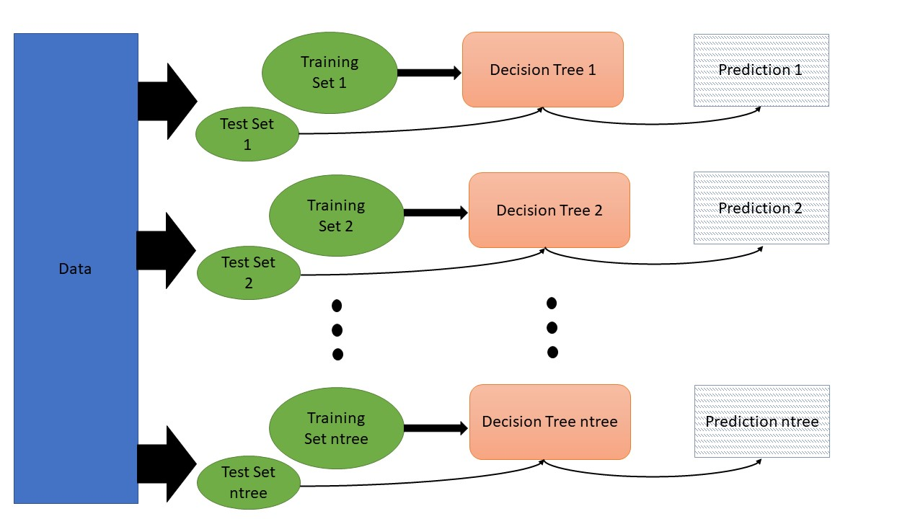

Figure 2: Decision tree construction and prediction from random forest algorithm. A second parameter of the random forest algorithm is mtry, the number of variables randomly sampled as candidates at each split in the tree. To select mtry, we fit a range of models for mtry=2 to the total number of covariates considered, 9, and selected the value which minimized the OOB error. In our data, mtry=2 minimized the OOB error.

