Additional File 2

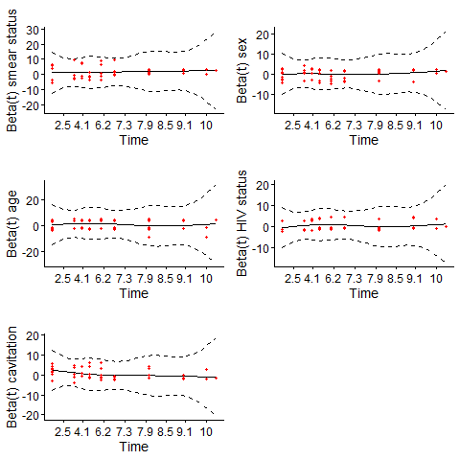
Figure 1. Schoenfeld residual plots for each predictor included in cox proportional hazards models. Method for handling missing data: available case analysis A), last observation carried forward B), multiple imputation by fully conditional specification C). Only residuals for first imputed data set for MI are shown.
A)

B)
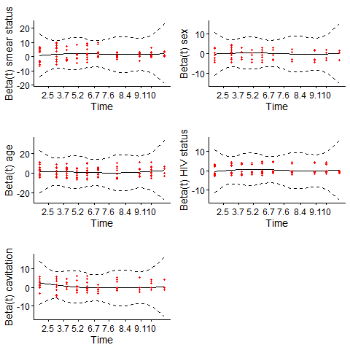

C)
