The probability of cure is calculated according to the following formula:
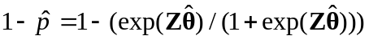

The possibility of a cure( unadjusted) | Censorship percentage | Variable
0.37|0.46 | 57.9|57.0 | Age(>33|<=33)
0.38|0.74 | 51.5|87.7 | Gender (Male| Female)
0.49|0.36 | 66.8|47.3 | Marital Status (Married| Single)
0.75|0.23 | 86.0|33.4 | Antiretroviral therapy (Yes |No)
0.51|0.26 | 66.2|39.0 | Tuberculosis infection (Yes| No)
0.71|0.41 | 84.4|56.6 | Education (High |Low)
0.44|0.37 | 56.3|59.4 | Imprisonment(Yes |No)
0.40|0.49 | 52.5|71.8 | Drug Abuse(Yes |No)
0.37|0.46 | 51.8|61.6 | Occupational status (Employed| Unemployed)
0.36|0.61 | 45.1|82.8 | Modes of HIV transmission (Injecting drug users| Other)
Table S1. Estimation unadjusted probability of cure.

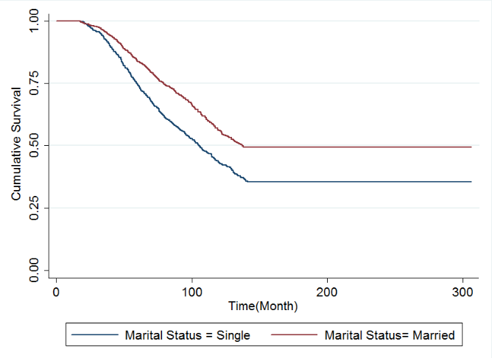  (b) | 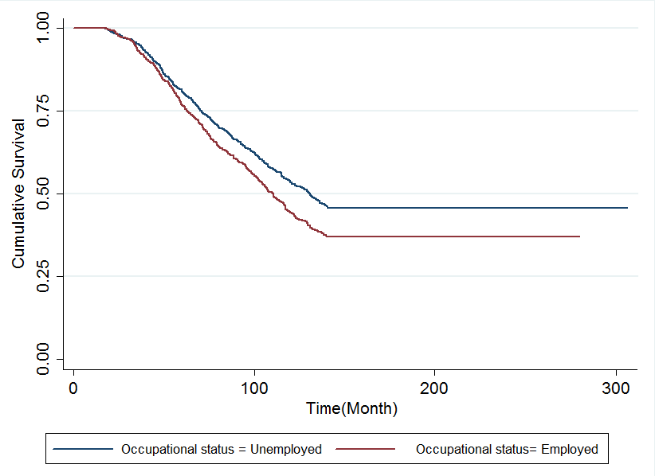  (a)
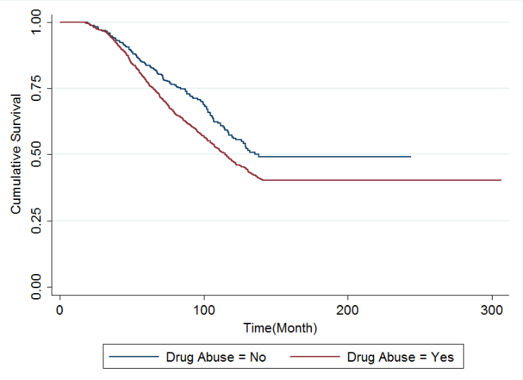  (d) | 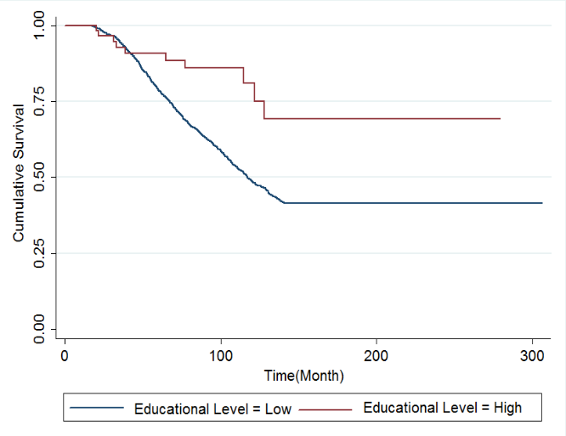  (c)
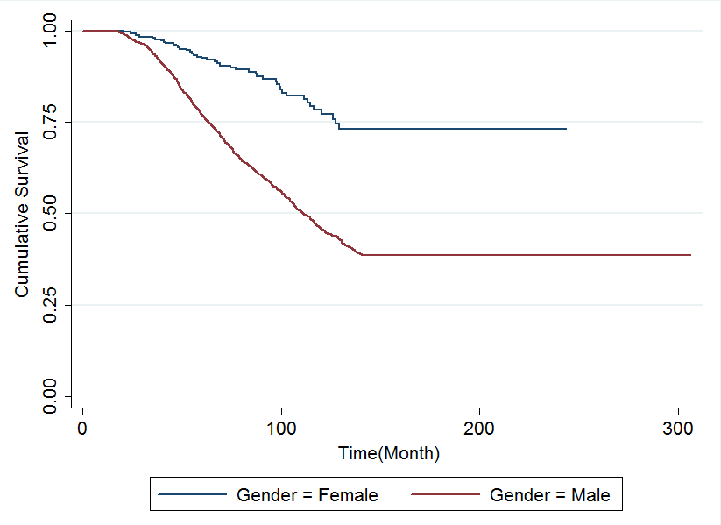  (f) | 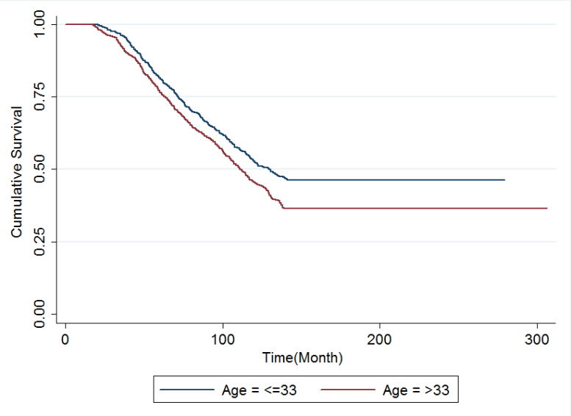  (e)
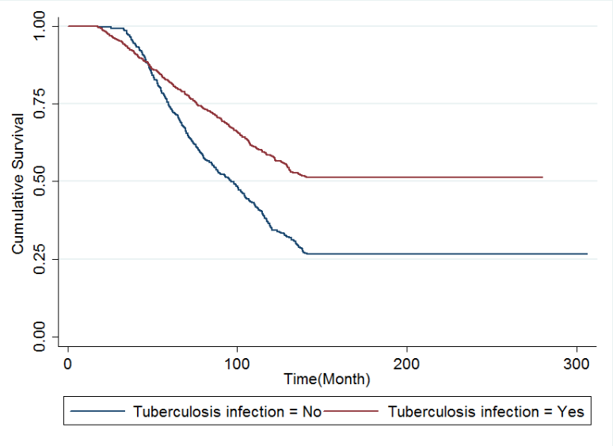
(g)

Figure S1. (a) Kaplan-Meier survival curves for occupational status; (b) Kaplan-Meier survival curves for marital status; (c) Kaplan-Meier survival curves for education; (d) Kaplan-Meier survival curves for drug abuse: (e) Kaplan-Meier survival curves for age; (f) Kaplan-Meier survival curves for gender; (g) Kaplan-Meier survival curves for tuberculosis infection

