Power and sample size calculation for incremental net benefit in cost effectiveness analyses with applications to trials conducted by the Canadian Cancer Trials Group
Appendix

Table 1: Incremental net benefit values as a function of the willingness-to-pay threshold
Trial | ∆E (Years) | ∆C (CAD) | b(λ) Value
Trial | ∆E (Years) | ∆C (CAD) | b(50,000) | b(100,000) | b(150,000)
BR.10 | 1.04 | 7,441 | 44,559 | 96,559 | 148,559
BR.21 | 0.146 | 12,289 | -4,989 | 2,311 | 9,611
CO.17 (all patients) | 0.08 | 23,969 | -19,969 | -15,969 | -11,969
CO.17 (KRAS) | 0.18 | 33,617 | -24,617 | -15,617 | -6,617
LY.12* | -0.01 | -14,464 | 13,964 | 13,464 | 12,964

∆E: effectiveness difference between the treatment and the control groups in years
∆C: cost difference between the treatment and the control groups in Canadian Dollars
λ: Willingness-to-pay threshold in dollars
b( ): Incremental net benefit function
* LY.12 is a non-inferiority design. For LY.12, survival is defined as the restricted mean QALY from randomization to stem cell mobilization.

Figure 1: Impact of the correlation coefficient on the sample size power function curve, at the willingness-to-pay threshold of $100,000, where $H_{0}: b\left(λ\right)=0, versus H_{1}:b\left(λ\right)≠0$, where ${b(λ)}_{δ}$ was defined using a frequentist method.
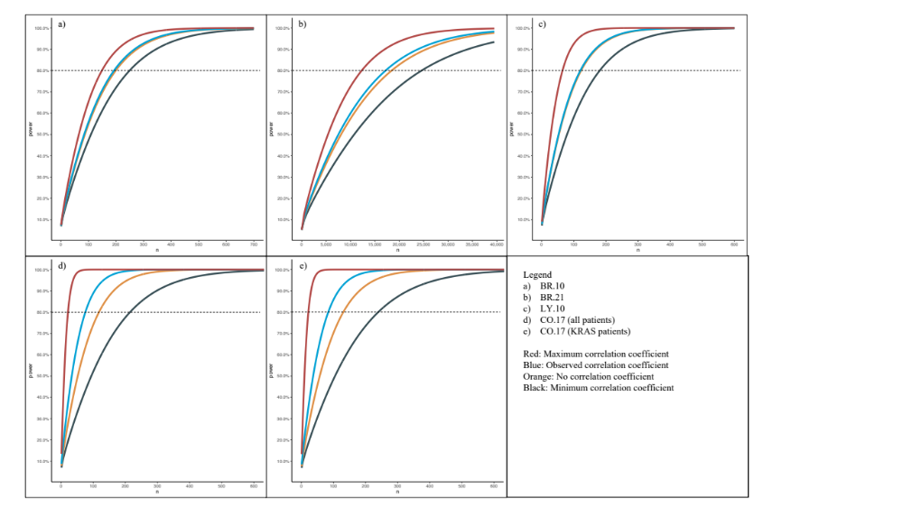

Figure 2: Impact of the correlation coefficient on the sample size power function curve, at the willingness-to-pay threshold of $100,000, where $H_{0}: b\left(λ\right)=0$, versus $H_{1}:b\left(λ\right)≠0$
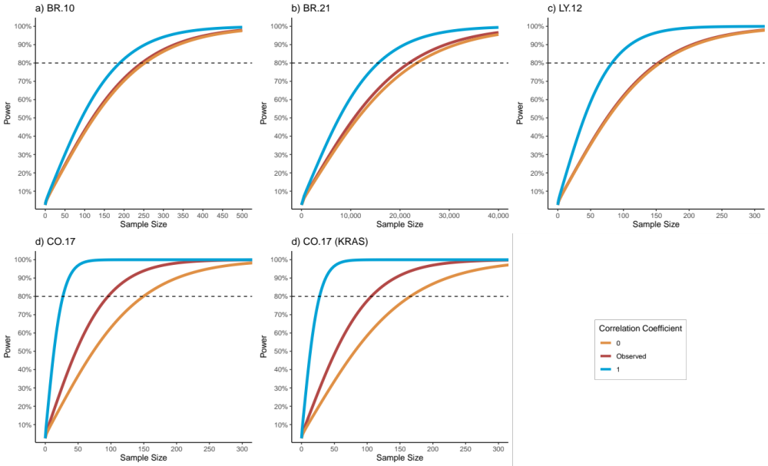

Figure 3: Impact of the willingness-to-pay threshold on the sample size power function curve, at the correlation coefficient observed in the respective trial, where $H_{0}: b\left(λ\right)=0$, versus $H_{1}:b\left(λ\right)≠0$
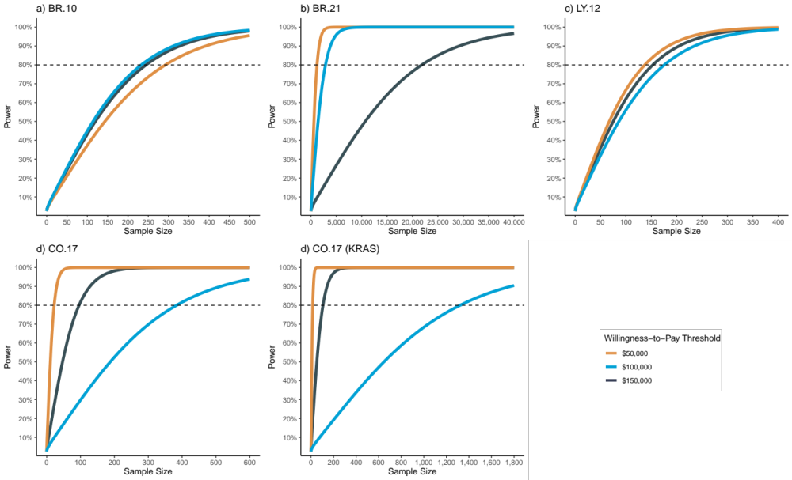

Figure 4: Contour plots of the correlation coefficient ($ρ$) and the willingness-to-pay value ($b\left(λ\right)$ ) with respect to the variance of $b\left(λ\right)$.
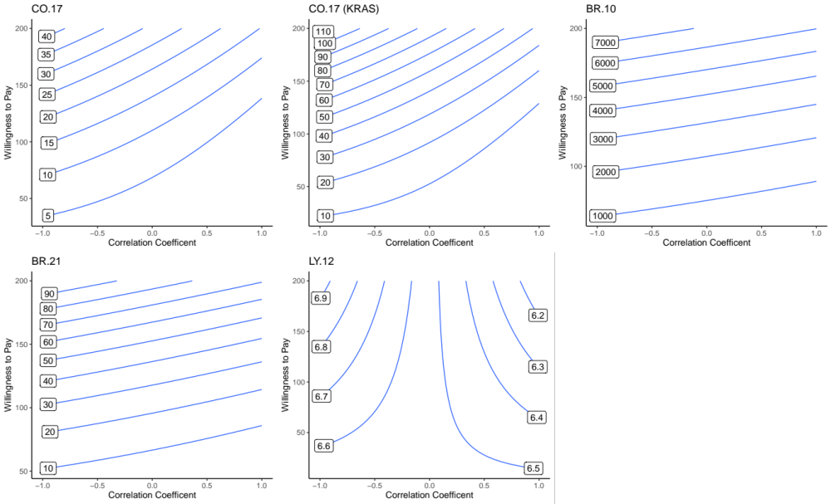
Figure 5: Illustrative example of possible input parameters to the online program (http://statapps.tk/icer_samplesize) for the BR.21 trial.
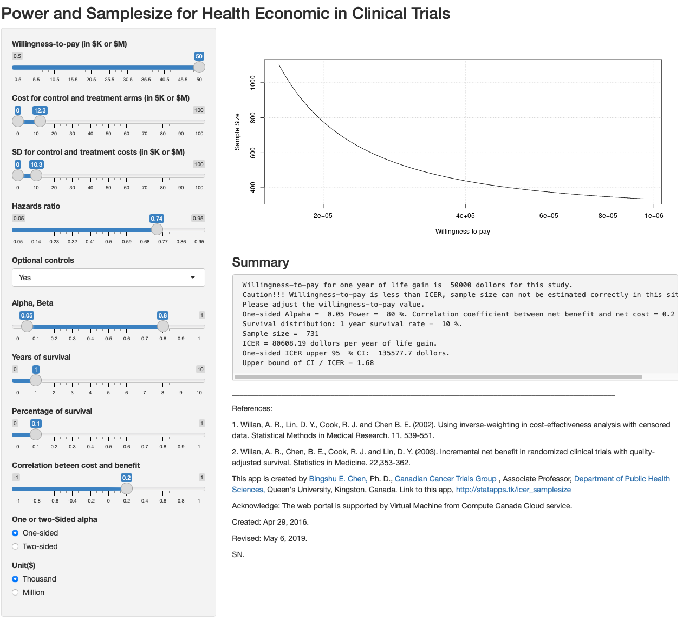
Legend: SD: standard deviation, ICER: incremental cost effectiveness ratio, CI: confidence interval,

