Supplementary figure 1. Performance of the two component items of screening tool between the SpA cases and the non-SpA rheumatic controls (n=150)

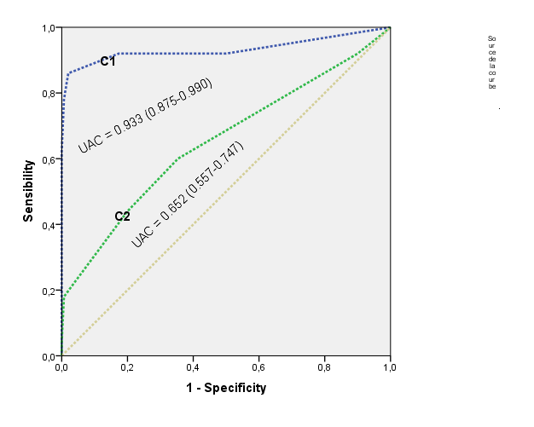

C1: the 1st component  Do you have stiffness in back lasting for >30 minutes ?  Do you have back pain awakening you the 2nd half of the night ?  Does physical exercise improve your back pain ?  Does NSAID improve your back pain ?  Do you have buttock pain ?  Do you have back pain ?  Do you have heel pain ?  Do you have urethritis ? | C2 : the 2nd component  Do you have joint swelling ?  Do you have joint pain ?  Do you have joint swelling in more than 3 joints ?

