Appendix to “Survival analysis under imperfect record linkage using historic census data”

By Arielle K. Marks-Anglin, Frances K. Barg, Michelle Ross, Douglas J. Wiebe, and Wei-Ting Hwang

Appendix
Figure A.1: Empirical bias and model-based confidence intervals for ${\hat{β}}_{1}$ under imputation model misspecification: (1) imputation model excludes $Z_{i}$, (2) imputation model includes interaction between $X_{i}$ and $Z_{i}$. MAR stting with both $T_{i}$ and $R_{i}$ dependent on $X_{i}$ and $Z_{i}$.
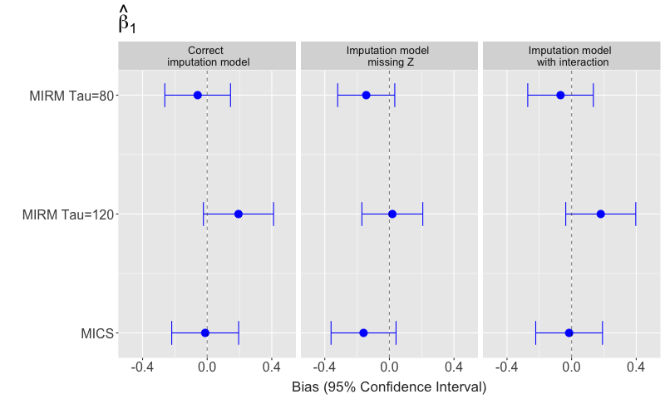

Figure A.2: Empirical bias and model-based confidence intervals for ${\hat{α}}_{1}$ under imputation model misspecification: (1) imputation model excludes $Z_{i}$, (2) imputation model includes interaction between $X_{i}$ and $Z_{i}$. MAR stting with both $T_{i}$ and $R_{i}$ dependent on $X_{i}$ and $Z_{i}$.
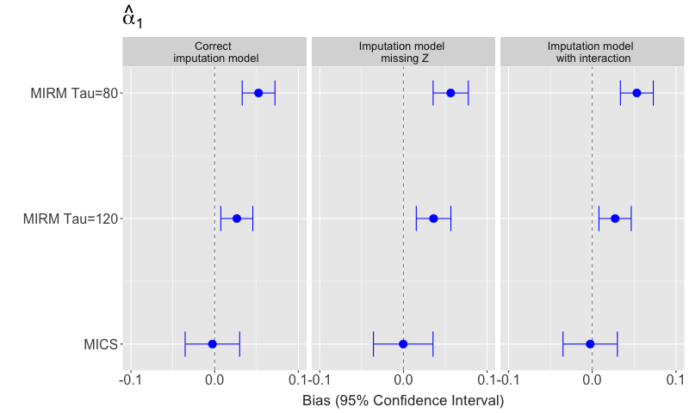

Figure A.3: Empirical bias for ${\hat{M}}_{0}$ and ${\hat{M}}_{1}$ under imputation model misspecification: (1) imputation model excludes $Z_{i}$, (2) imputation model includes interaction between $X_{i}$ and $Z_{i}$. MAR stting with both $T_{i}$ and $R_{i}$ dependent on $X_{i}$ and $Z_{i}$.
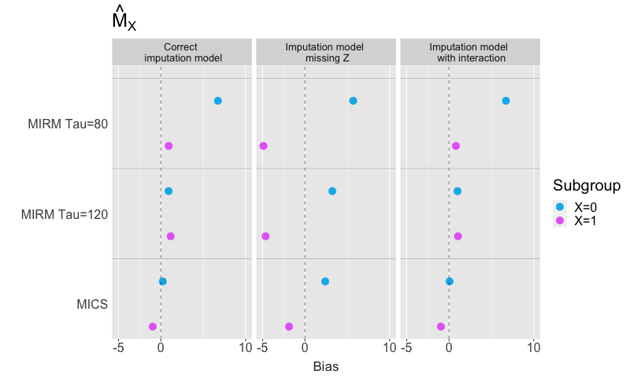

Figure A.4: Empirical bias for ${\hat{M}}_{00}$, ${\hat{M}}_{01}$, ${\hat{M}}_{10}$ and ${\hat{M}}_{11}$ under imputation model misspecification: (1) imputation model excludes $Z_{i}$, (2) imputation model includes interaction between $X_{i}$ and $Z_{i}$. MAR stting with both $T_{i}$ and $R_{i}$ dependent on $X_{i}$ and $Z_{i}$.
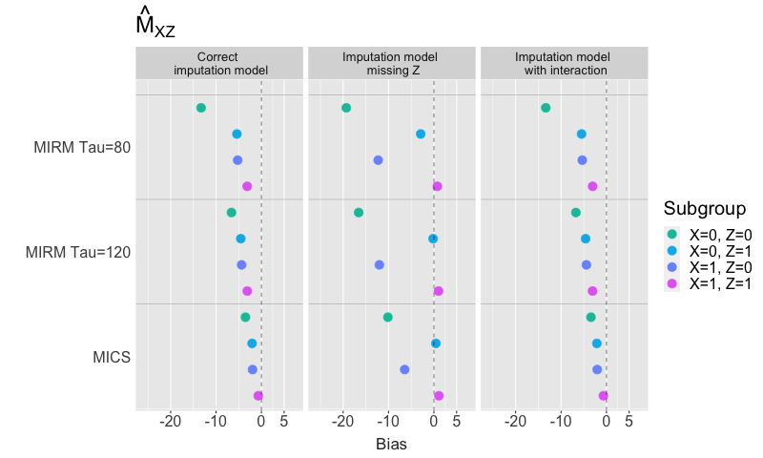

Figure A.5: Histogram of observed and imputed event times for unequivocal matches in Ambler dataset.
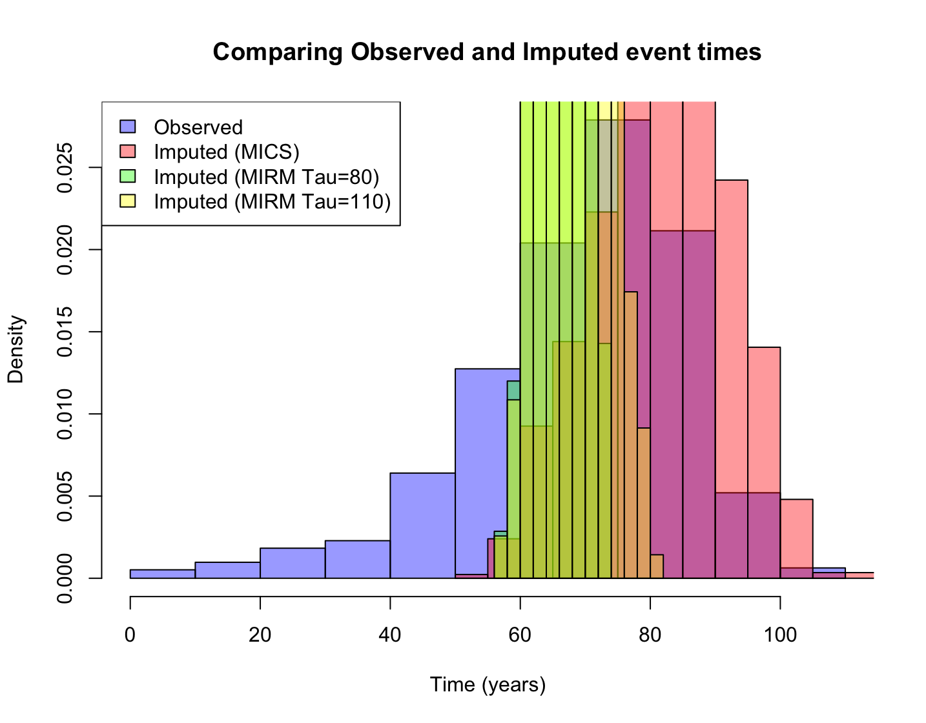

Figure A.6: Kaplan-Meier plot with observed and imputed event times for unequivocal matches in Ambler dataset.
